**Candidate Project Changes Made Outside of Original Scope of Requirements**

* Per the requirements in the pdf, a carton can only hold 10 items and an item can only be placed in one carton (realizing as I’m writing this the AllowItemInMultipleCartons app setting is not needed as that will always be false as they are SN specific, it’s redundant and doesn’t need to be there), I added keys to the app settings section of the web.config. I did this mainly in the instance the carton size changes and at some point can hold more or less than 10 items, that value can be changed in one place.

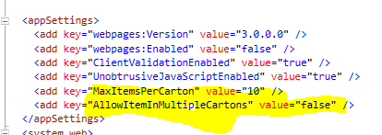

* UI friendly error view setup through web.config and ErrorController added. Basic with not much detail.

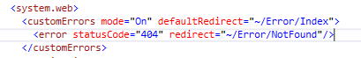

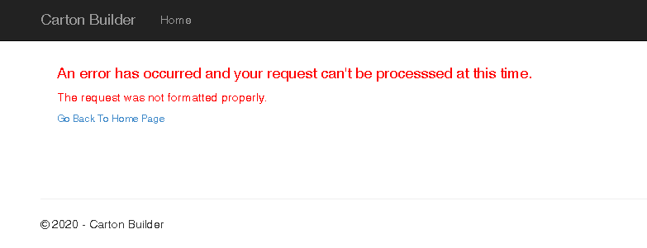

* Log4net has been added through nuget to log actual exception (note empty logs folder part of git commit).

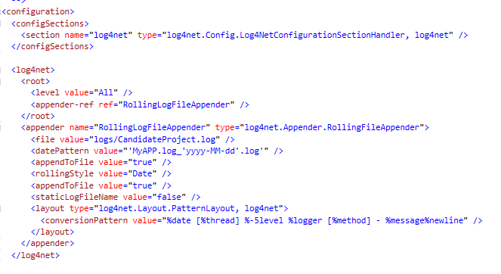

* Moved “Back to List” link to _Layout.cshtml

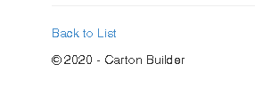

* Also added DisplayName property Attribute to view model properties

**Changes I would have liked to implement but did not due to scope and time constraint**

I guess you could call this my developer wish list or if time was not a factor would’ve tried to implement. Maybe next iteration 😉

* Initially was using jQuery UI Dialog widget for user alerts and confirmation but did not want to add an unsupported package as it stopped being updated after 1.12.1 and did not want to create an issue in the future development.
  + Alternatively, I investigated adding a bootstrap dialog but have already spent more than the suggested 30-45 mins.
* On the Add and Remove equipment views would have liked to have been able to add some jQuery ajax calls to make it more asynchronous and avoid the post backs refreshing the screen to provide a better user experience.
* I also would have created filters or drop-down lists on the add equipment page so the user would not have to scroll all the way down towards the bottom of the page to add equipment.

Just a few things I was hoping to get to for some “bonus points” 😊