**Overview of changes made to comply with Candidate Project pdf revisions.**

**Last remaining development item for this iteration:**

1. Implement the RemoveEquipmentOnCarton action on the CartonController, right now it is just throwing a BadRequest.

In code comments as Development item #1, before remove click

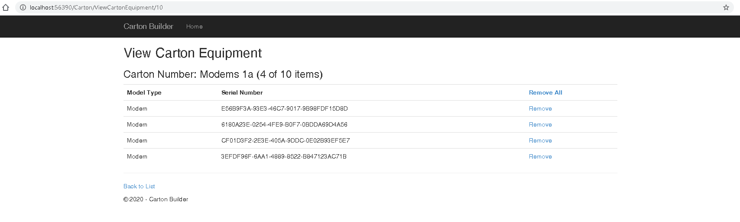

Confirmation is displayed after remove is clicked.

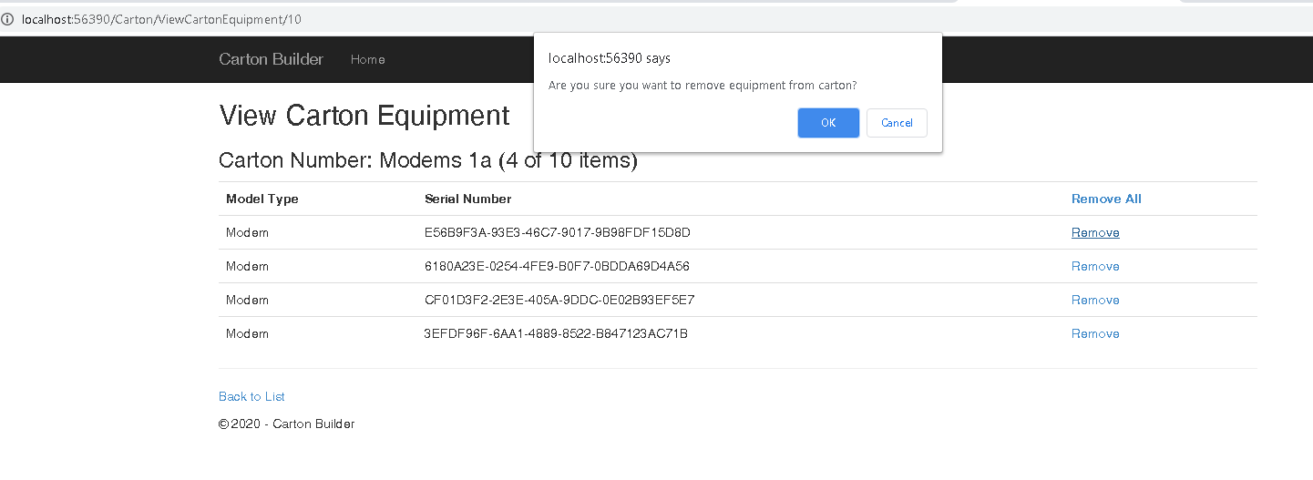

If cancel is clicked, the equipment remains in the carton, but if the user clicks “Ok” the equipment is removed from the carton and the item count is updated. Screen shot below shows same carton after user clicks “Ok” to confirm removal.

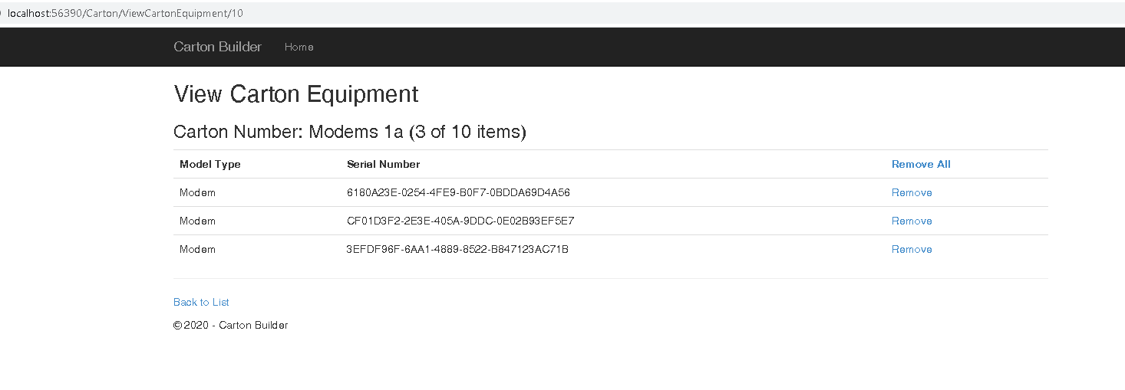

**Our customers has reported the following bugs:**

1. We can delete empty cartons from the system, but cannot delete cartons that have items. We should be able to delete a carton at any time.

Index view from my developer testing, here you will see the current list of cartons as well as the equipment count of each carton (customer request #1). Notice Modems 1a exists in current list.

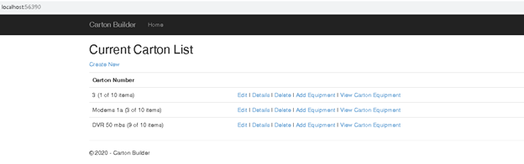

After clicking delete from the index page, the user is taken to a delete confirmation view. I have added the display of the items in the carton to this confirmation screen as well and the carton is not empty.

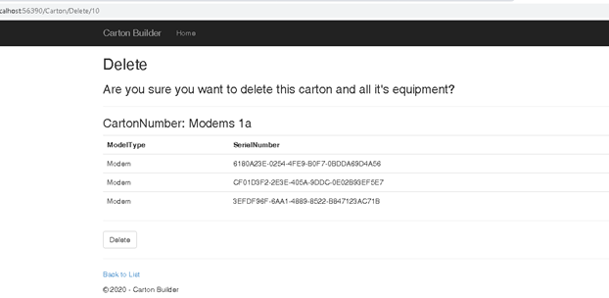

After clicking the delete button, the carton details are removed as well as the carton from the database and the user is redirected back to the home/index view where you can see the carton has been removed.

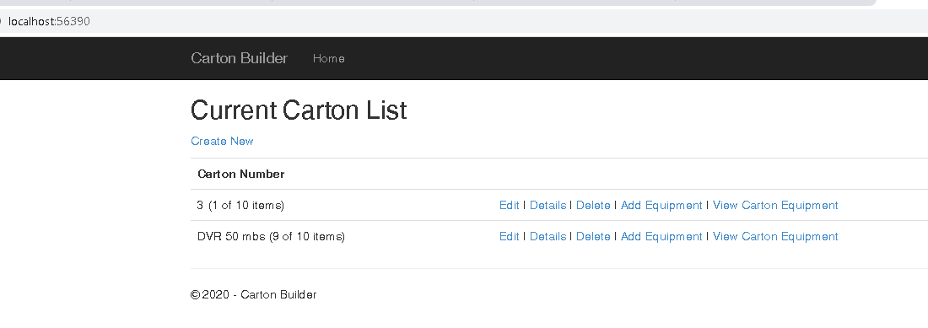

1. We can add the same piece of equipment to 2 different cartons, this doesn’t make sense. We should only be able to add a piece of equipment to 1 carton, once a piece of equipment is on a carton it should be unavailable to place on another carton.

Carton 3 in this example has equipment in it, with equipmentId of 1 shown here:

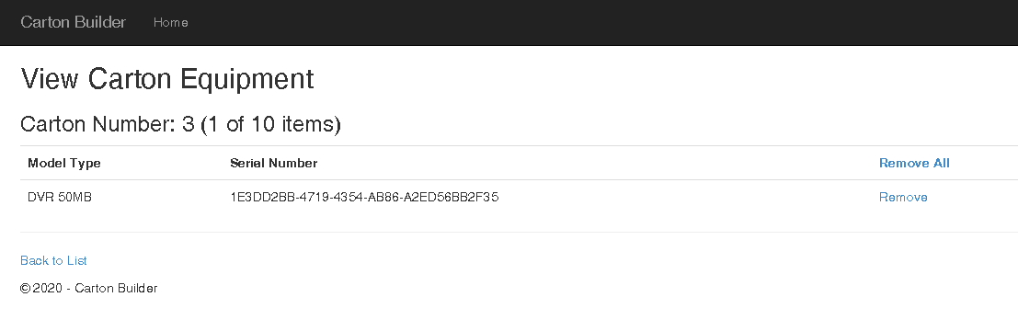

When the user attempts to add this equipment to the same carton or any other carton they will receive an error message stating the item can only be in one carton. Below is a screen shot of what the user would see when trying to add this equipment to another carton, first item in the list.

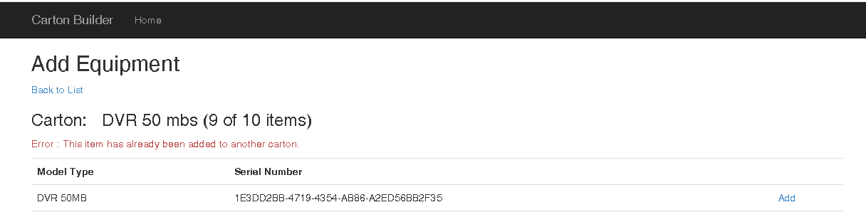

1. Our cartons can physically hold up to 10 pieces of equipment, but the application allows us to put an unlimited number of equipment on the carton, please only allow up to 10 pieces of equipment on the carton.

Here the user just added the 10th item to the carton, a success message is displayed, and the item count is now 10 of 10. Below is the error displayed when the user attempts to add additional equipment to this carton.

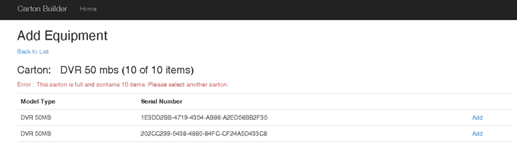

Our customers have asked for the following enhancements:

1. The carton index screen should show the # of pieces of equipment on the carton

Carton equipment count is displayed on the Index screen, and as seen on the View Carton Equipment view as well as the Add Equipment view.



1. We need a quick way to remove all the items from the carton with 1 click.

On the View Carton Equipment View, a Remove All action link has been added which will remove all the equipment items from the carton, but not delete the carton itself. This carton can still be deleted from the Index view before emptying out the equipment, but this feature is also available. When Remove All is clicked, the user is prompted with a confirmation dialog.

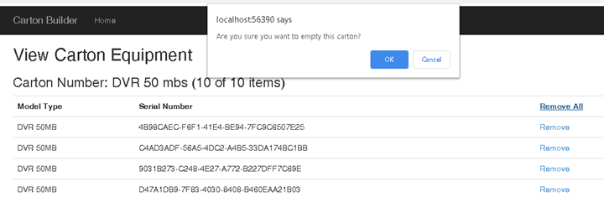

Result of user clicking ok, here you can see all the items have been removed.

