Ryan Carey

IST 454

Professor Rawel

10/11/2019

Ethernet / IP Packet Breakdown

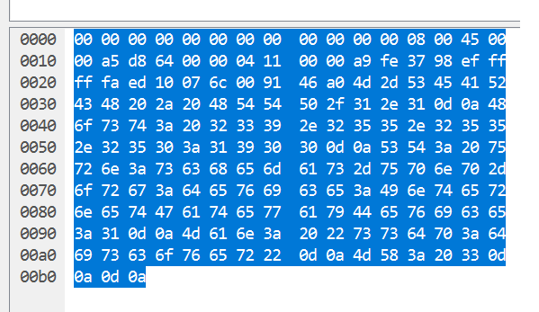Source MAC:

00:00:00:00:00:00

Destination MAC:

00:00:00:00:00:00

Type: 08 00 = IPV4

Version: 4

IHL: 5

Total length: 00a5 = 165 Bytes

ID: D864 = 55396

Flags: 0

Offset: 000

TTL: 04 = 4 seconds

Protocol = 11 in hex = 17 for UDP

Header checksum: 0000

Source IP: a9.fe.37.98 = 169.254.55.152

Destination IP: ef.ff.ff.fa = 239.255.255.250

Options: Not used, IHL = 5 lines

Data:

ed 10 07 6c 00 91 46 a0 4d 2d 53 45 41 52 43 48 20 2a 20 48 54 54 50 2f 31 2e 31 0d 0a 48 6f 73 74 3a 20 23 33 39 2e 32 35 35 2e 32 35 35 2e 32 35 30 3a 31 39 30 30 0d 0a 53 54 3a 20 75 72 6e 3a 73 63 68 65 6d 61 73 2d 75 70 6e 70 2d 6f 72 67 3a 64 65 76 69 63 65 3a 49 6e 74 65 72 6e 65 74 47 61 74 65 77 61 79 44 65 76 69 63 65 3a 31 0d 0a 4d 61 6e 3a 20 22 73 73 64 70 3a 64 69 73 63 6f 76 65 72 22 0d 0a 4d 58 3a 20 33 0d 0a 0d 0a

[237][16][7]l[0][145]F[160]M-SEARCH \* HTTP/1.1[13][10]Host: #39.255.255.250:1900[13][10]ST: urn:schemas-upnp-org:device:InternetGatewayDevice:1[13][10]Man: "ssdp:discover"[13][10]MX: 3[13][10][13][10]