Ryan Carey

Ruc230

3/22/19

Assignment 5

1. List all Order IDs and the associated Customer Full Names for orders  
(Hint: Customer Table and Order Table are connected by Customer ID, use that condition in your JOIN)

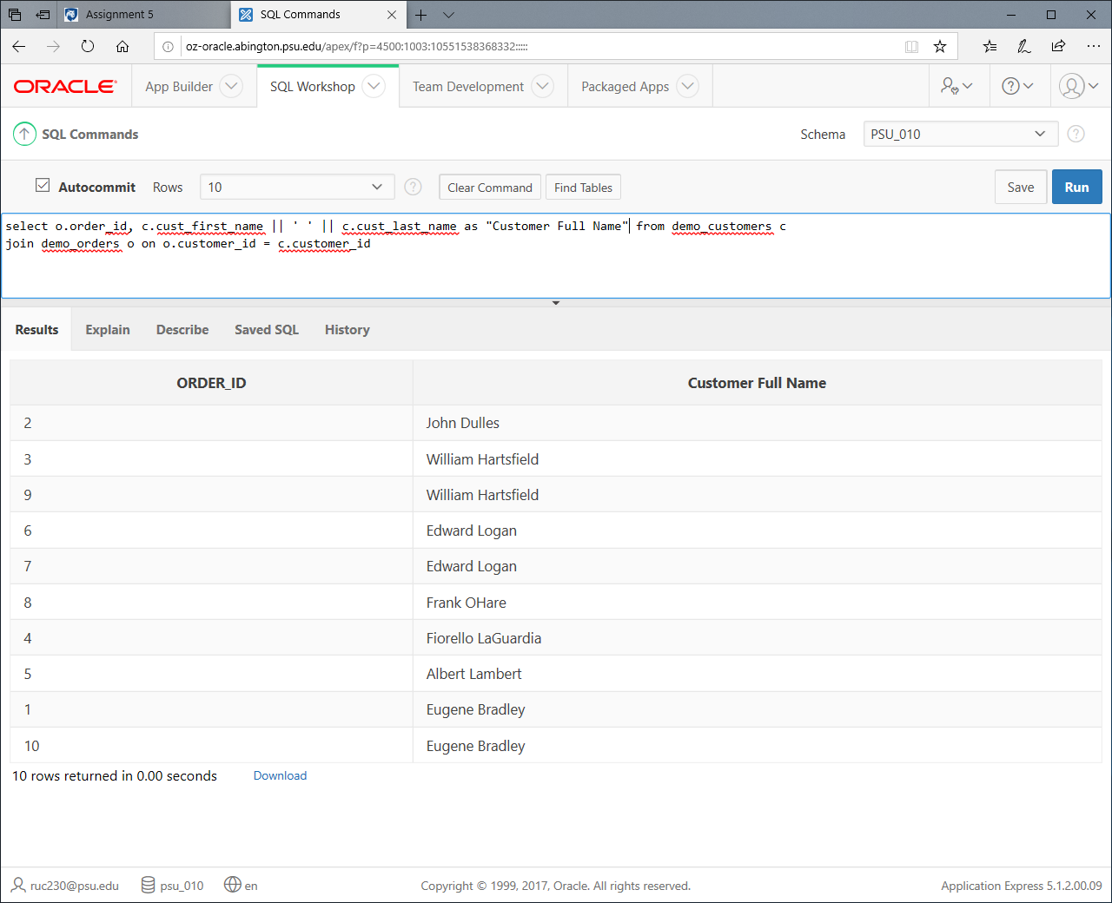

Very simple join of two tables, nothing exciting here. Not even a where clause.

2. List Customers from 'VIRGINIA'. I want you to use STATES table.  
(Hint: Customer Table and State Table can be connected by CUST_STATE and ST, use that condition in your JOIN)

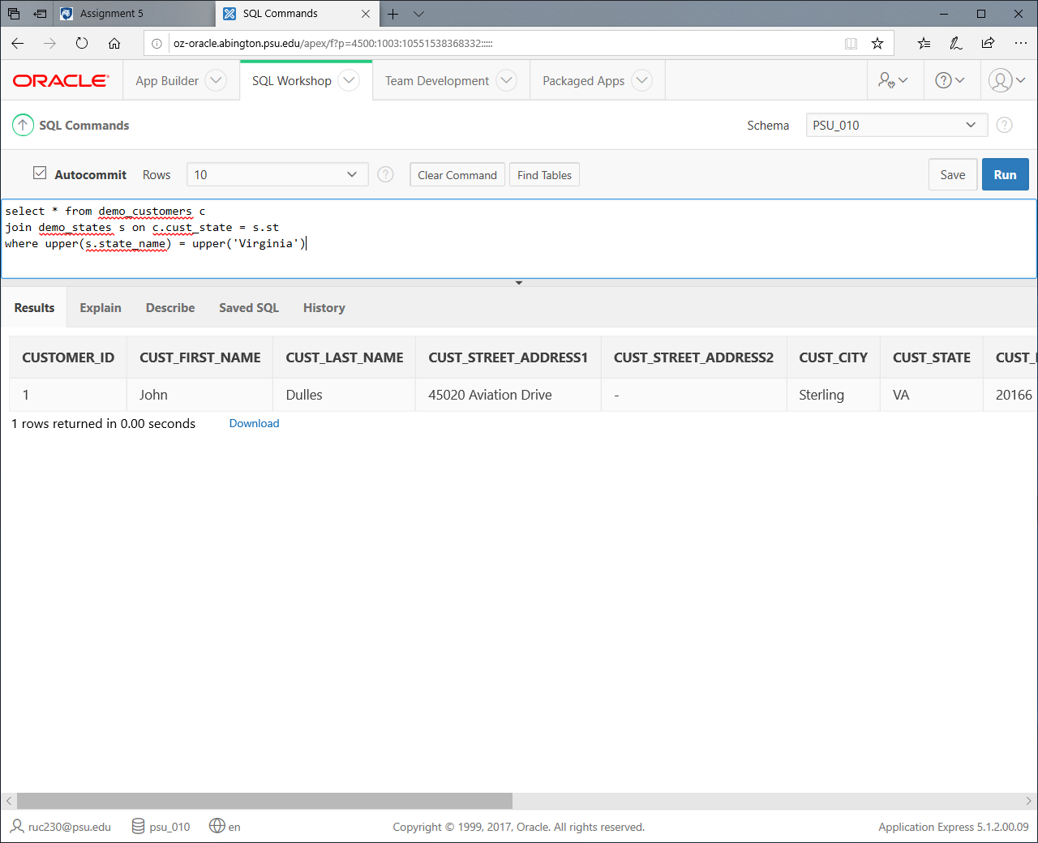

I used upper just in case of format differences. Other than that it’s a simple join you even gave us the join condition. Used * since you didn’t ask for any specific information, I gave it all.

3. List Order IDs and the associated Customer Full Names for orders that are ordered from either 'VIRGINIA' or 'NEW YORK'. I want you to connect three tables with SQL JOINS and use WHERE clause to filter certain customers.  
(Hint: Customer Table and Order Table are connected by Customer ID and Customer Table and State Table can be connected by CUST_STATE and ST, use those conditions in your JOINs)

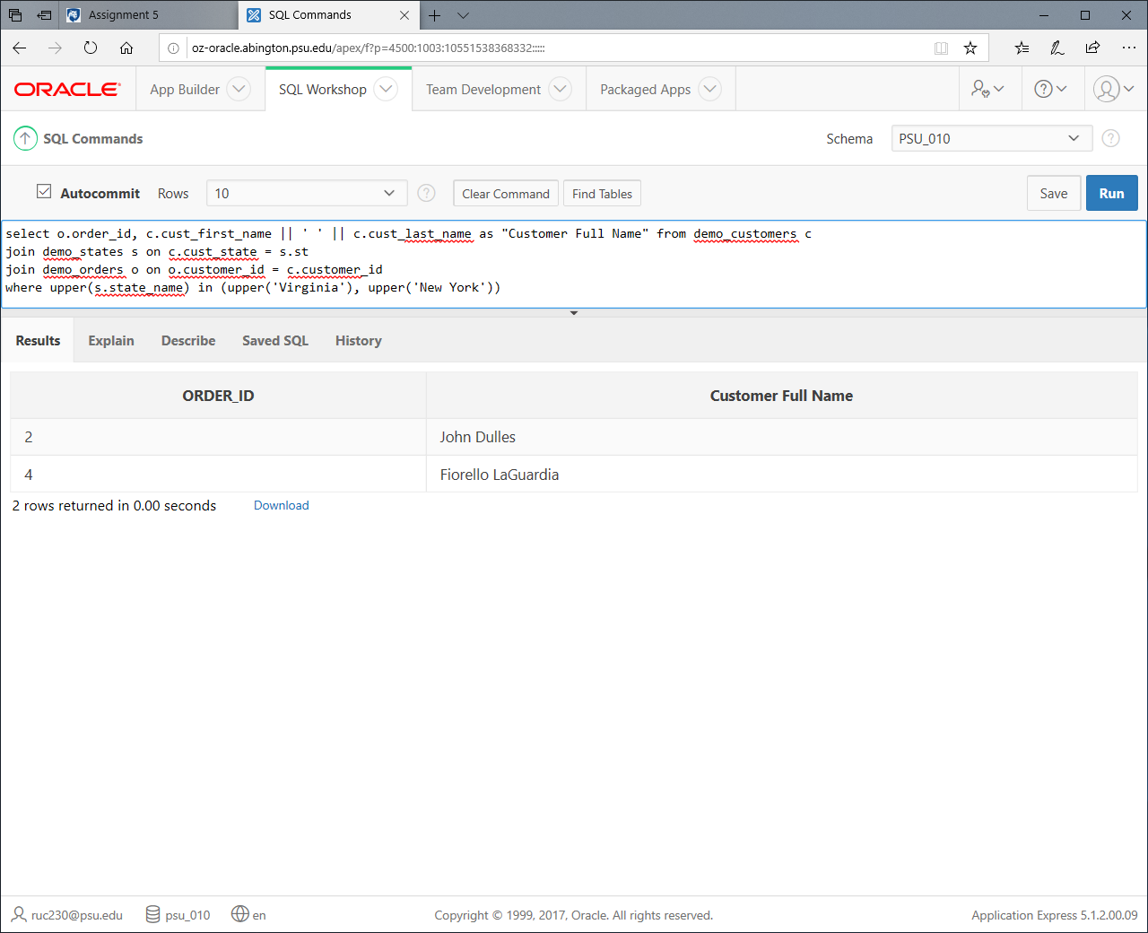

Just the order_id and full names are selected. I used IN for the where clause because it’s better than = connected by AND.

4. Find me the Full Name of the Customer for Order ID = 1. I want you to use JOINs to connect Customer and Orders table. I only want the Full Name (nothing else).  
(Hint: Customer Table and Order Table are connected by Customer ID, use that condition in your JOIN, use additional filters to filter Order_ID = 1)

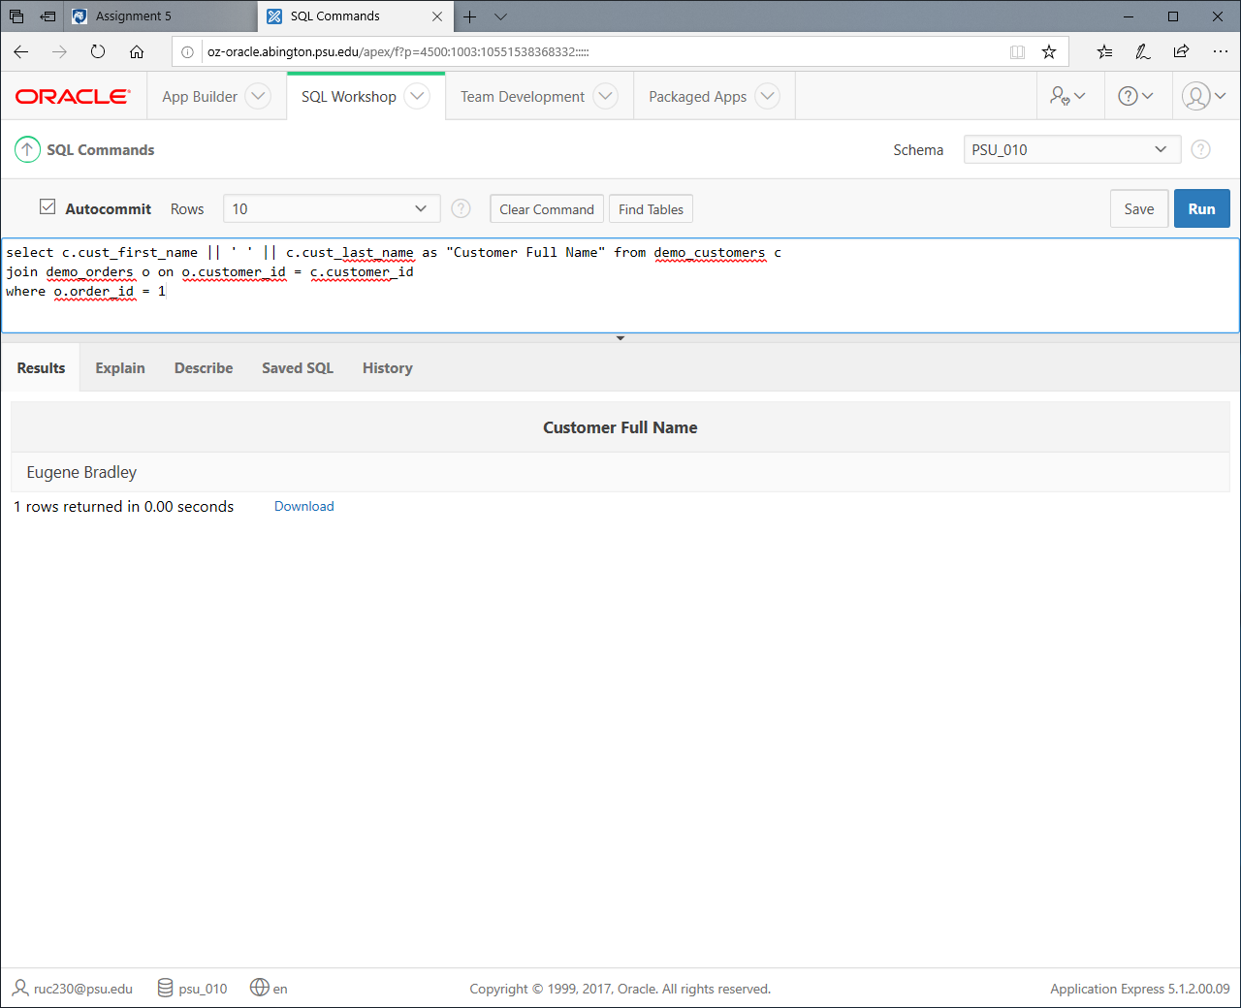

Again a simple join, you gave us a lot of the join conditions. Just the full name, as requested, is selected.

5. Find me the Product Names from the Orders of John Dulles. You need to connect multiple tables with SQL joins and use WHERE clause to filter certain customers. I want you to list only Product Names (nothing else).

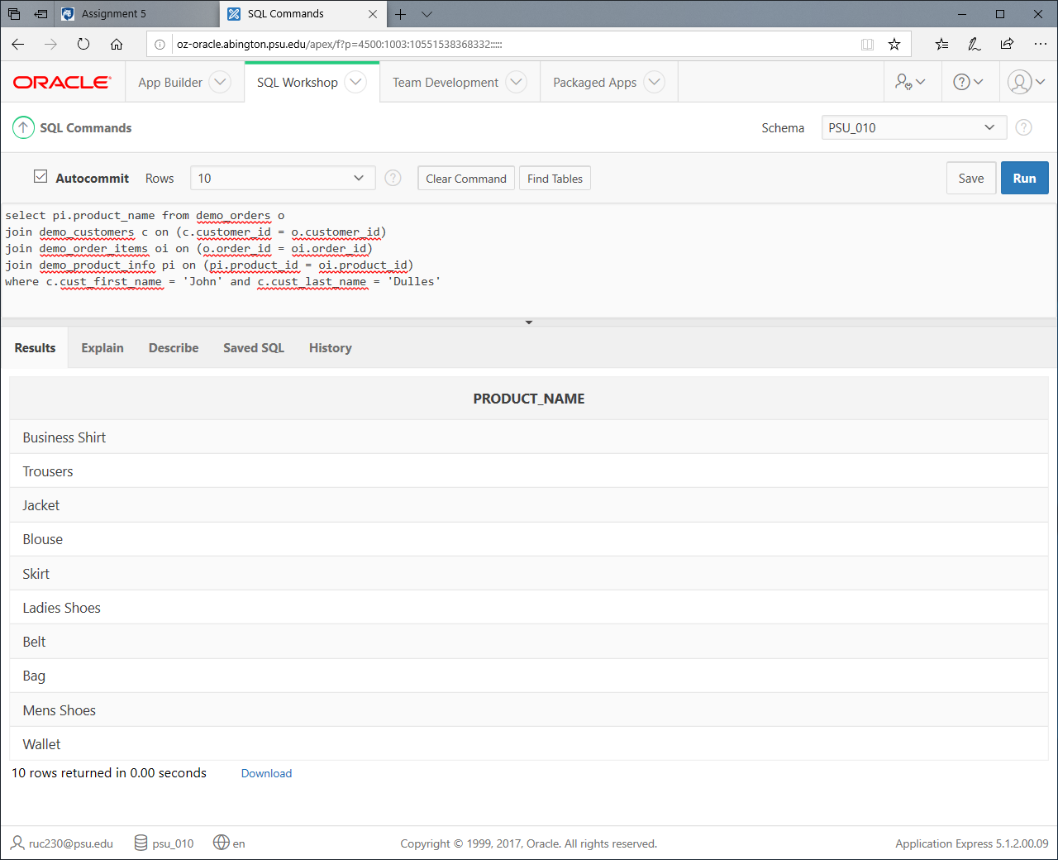

This is very similar or identical to an example we did in class so I was able to search my SQL query history to answer this very quickly.

6. Find me the Customer Full Names who ordered Products in 'Womens' category. You need to connect multiple tables with SQL joins and use WHERE clause to filter certain category. I want you to list only Customer Full Names (nothing else).

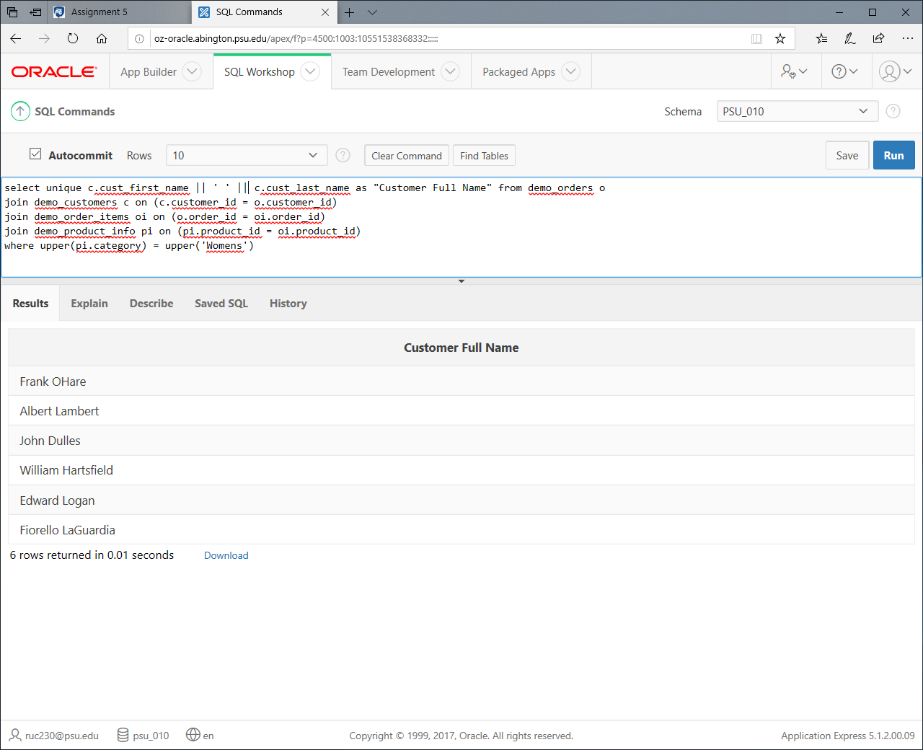

This was the most involved so far. Just the full names are returned. I used upper to get rid of any case issues. Had to be typed up fresh.

7. Find me the Customer Full Names who ordered 'Leather' products. You need to connect multiple tables with SQL joins and use WHERE and LIKE clauses to filter product descriptions that has leather in it. I want you to list only Customer Full Names (nothing else). Don't forget the case sensitivity in LIKE clause. Try to use UPPER function (go to WEEK 2 to learn).

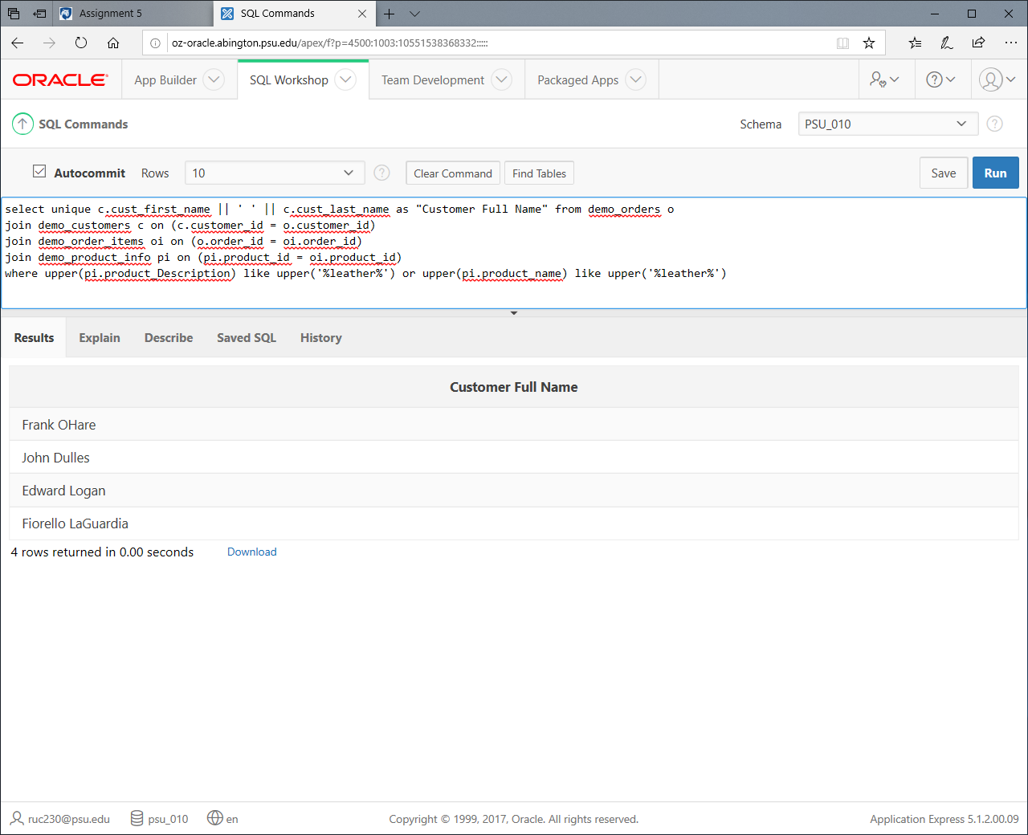

I used an OR to connect two clauses involving the name and description in case a description was incorrect. I also performed the joins in a logical order and used LIKE. This was probably one of the tougher questions, relatively speaking.

8. Find me the Product Names for ORDER ID = 1. You need to connect PRODUCT_INFO, ORDER_ITEMS, and ORDERS tables. I want you to list only Product Names.

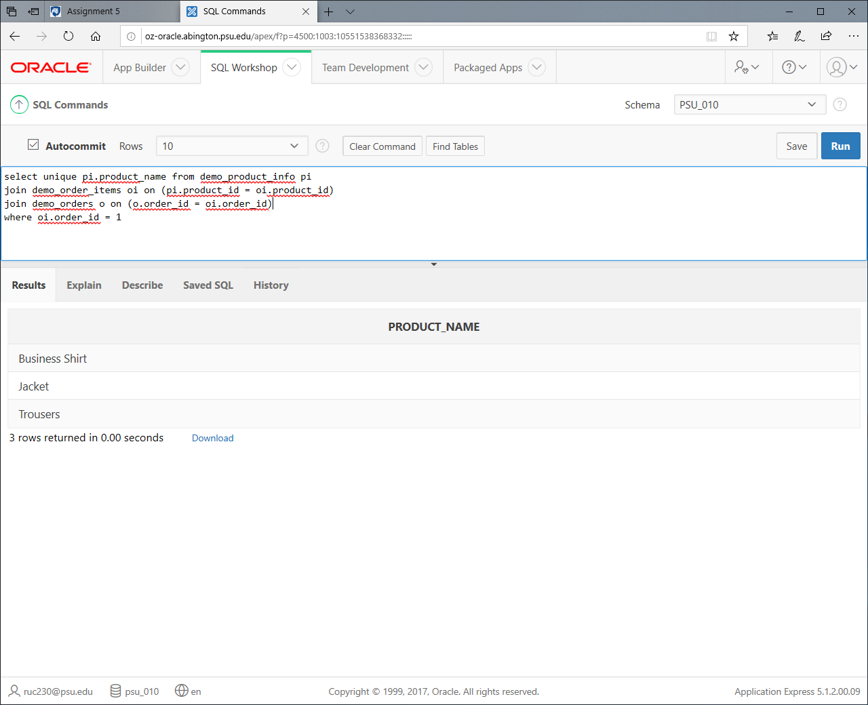

Again I performed the joins in a logical order, and gave only the requested information. I chose to use UNIQUE because it didn’t say you intended to count the occurrences of each product name, that would be a different question.

9. List the name of the products that are ordered in large quantities (greater than 5 per order). You need to connect PRODUCT_INFO and ORDER_ITEMS tables. You need to filter them based on ORDER_ITEMS.Quantity. I want you to list only Product Names.

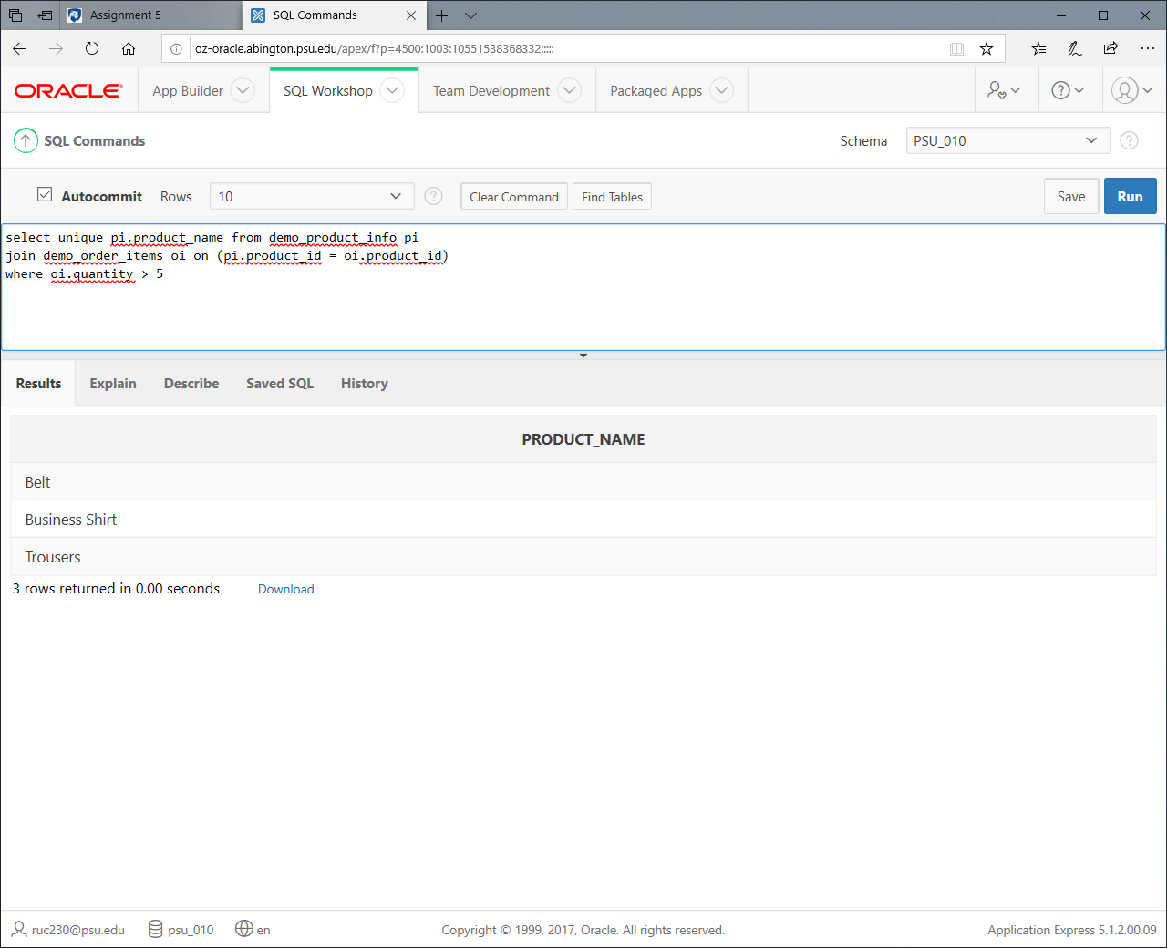

This was another simple one, everything we needed was given in the question. Don’t even know what to say about this one, anyone who gets this wrong should change majors probably.

10. List the Full name of the states of the customers who ordered a 'Wallet'. You need to connect multiple tables. I want you to list only the State Full Name (not abbreviation from Customer table).  
(Hint: Connect state, customer, orders, order_items, and product_info tables).

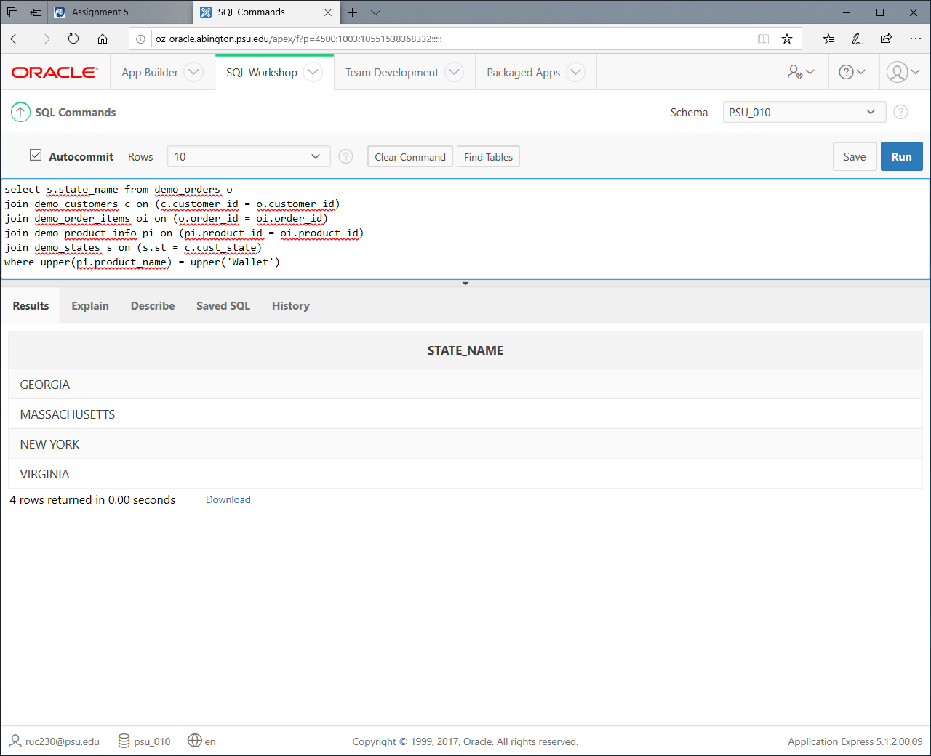

This required the most joins despite being a pretty simple request. I used UPPER again just in case. Once again I performed the joins in a logical order so everything can be more easily traced.