Ryan Carey

Ruc230

4/16/2019

Organization of Data

Assignment 6

1. Create a VIEW named vCustomerOrders and submit your SQL query for creating this view. (10 points)

create or replace view vCustomerOrders

(Customer, OrderDate, OrderID)

as

select c.cust_first_name || ' ' || c.cust_last_name as "Customer Name", o.order_timestamp as "OrderDate", o.order_id as "OrderID"

from demo_orders o

join demo_customers c on (c.customer_id = o.customer_id)

Select all Orders and their Customers. Include OrderID, OrderDate, CustomerName (Customer First and Last Name as a single attribute).

Run SQL query below and paste screenshot of your result. (10 points)

SELECT * FROM vCustomerOrders WHERE OrderID = 1

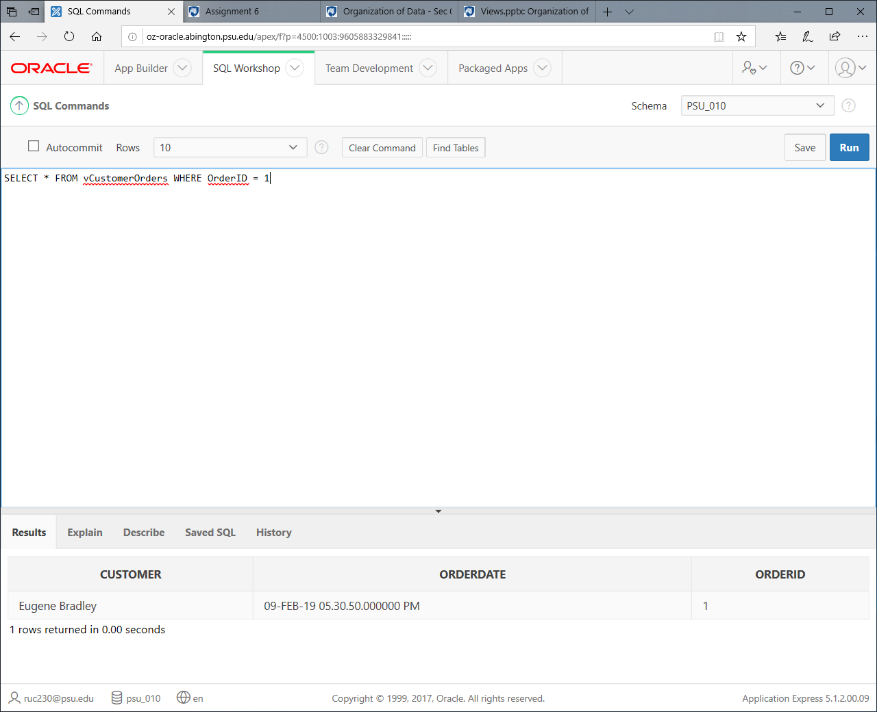

2. Create a View named vTotalQuantitiesOrderedByProduct and submit your SQL query for creating this view. (10 points)

create view vTotalQuantitiesOrderedByProduct (TotalQuantity, Product_Name)

as

select sum(quantity), pi.product_name

from demo_order_items oi

join demo_product_info pi on (oi.product_id = pi.product_id)

group by pi.product_name

This view should perform the following query:

Select count of all products grouped by product name. Include SUM(Quantity) as TotalQuantity and Product Name. (Perform INNER JOIN on DEMO_PRODUCT_INFO and DEMO_ORDER_ITEMS and group it by ProductName)

Run SQL query below and paste screenshot of your result. (10 points)

SELECT * FROM vTotalQuantitiesOrderedByProduct

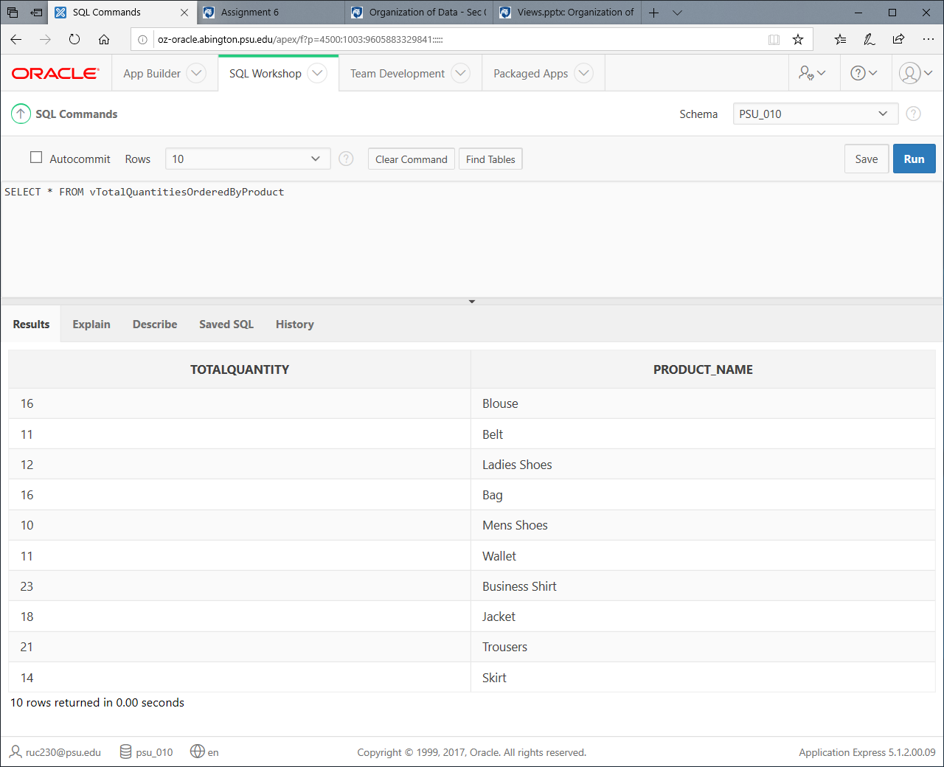

3. Create a Stored Procedure Named spGetCustomerNameforOrder and submit your SQL query for creating this SP. (10 points)

create or replace procedure spGetCustomerNameforOrder(OID in demo_ORDERS.order_ID%TYPE)

IS

l_cursor SYS_REFCURSOR;

thisCustomer demo_customers.cust_first_name%TYPE;

begin

OPEN l_cursor FOR

select Customer

FROM vCustomerOrders

WHERE OrderID = OID;

fetch l_cursor

INTO thisCustomer;

DBMS_OUTPUT.PUT_LINE(thisCustomer);

CLOSE l_cursor;

end;

This SP should accept OrderID as a parameter and print the name of the customer on screen (Full Name). The procedure MUST make use of the view created in Question 1 and SELECT MUST be done on this View.

Run SQL query below and paste screenshot of your result. (10 points)

BEGIN

sp_GetCustomerNameforOrder(1);

END;

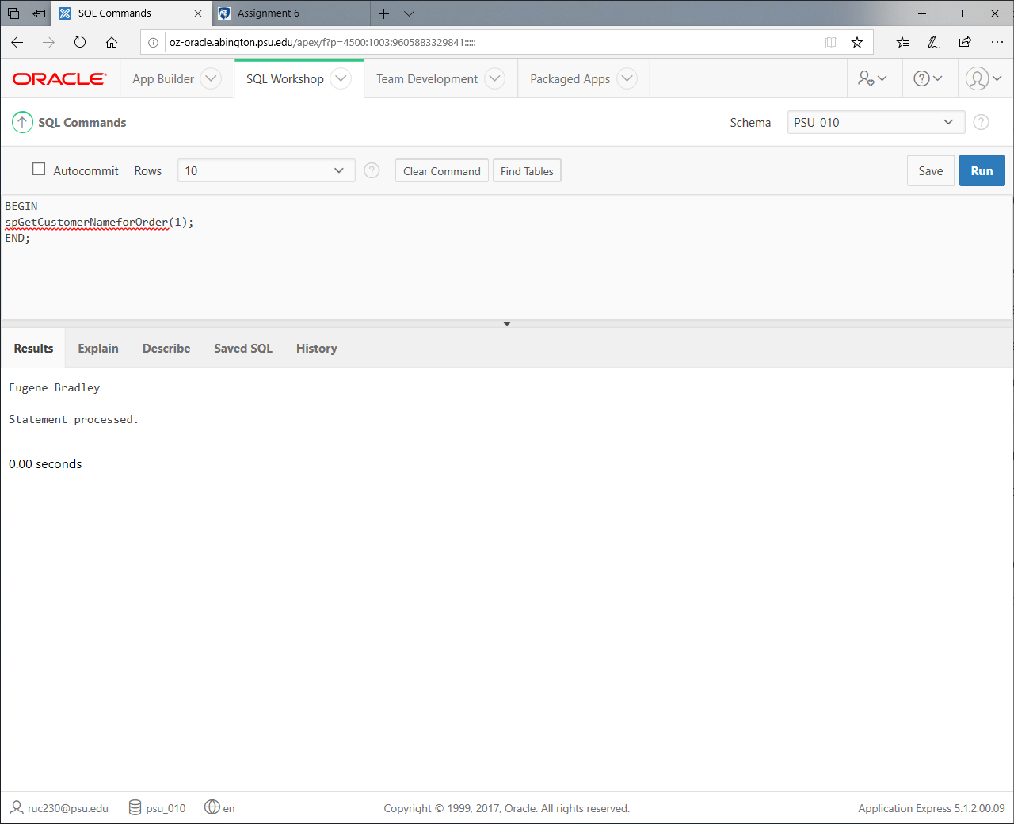

4. Create a Stored Procedure Named sp_CreateNewCustomer and submit your SQL query for creating this SP. (10 points)

create or replace procedure spCreateNewCustomer(firstn in demo_customers.cust_first_name%TYPE, lastn in demo_customers.cust_last_name%type)

IS

begin

insert into demo_customers (cust_first_name, cust_last_name)

values (firstn, lastn);

end;

This SP should accept required Customer attributes (Customer First Name, Customer Last Name).

In this stored procedure you will be expected to do an INSERT into DEMO_CUSTOMERS table.

Run these two SQL queries below and paste screenshots of your results (two screenshots one for each). (10 points)

BEGIN

sp_CreateNewCustomer('Gokhan', 'Ozden');

END;

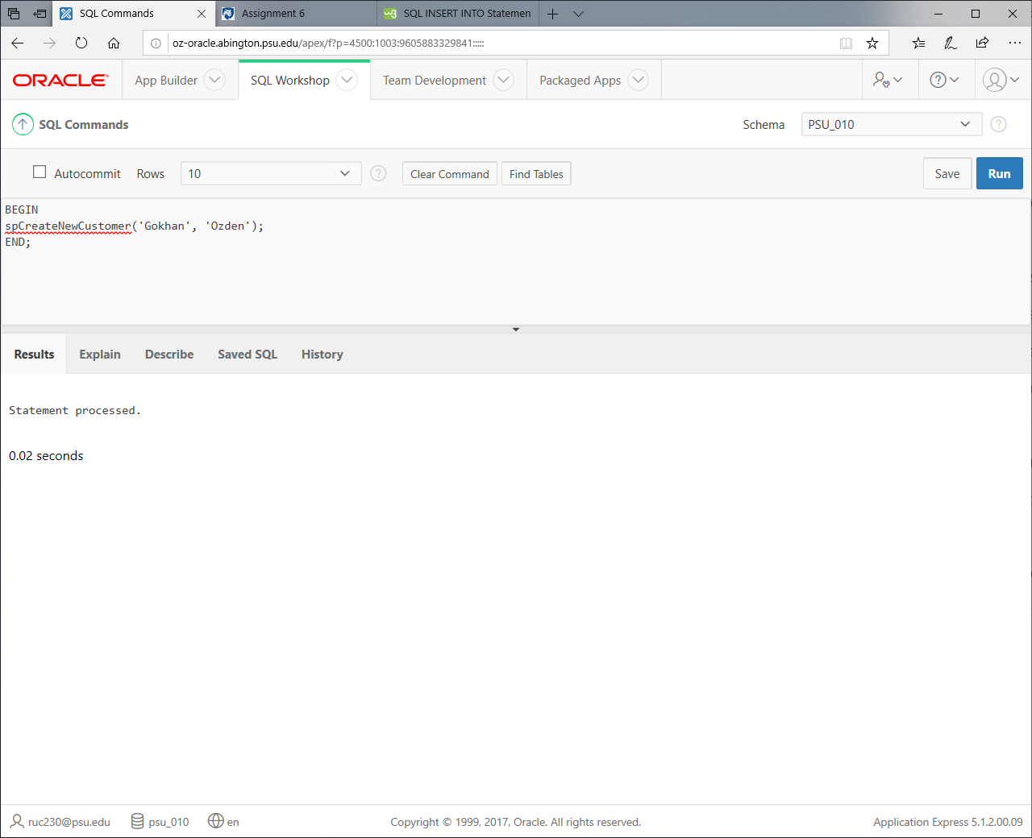

SELECT * FROM DEMO_CUSTOMERS WHERE CUST_LAST_NAME = 'Ozden';

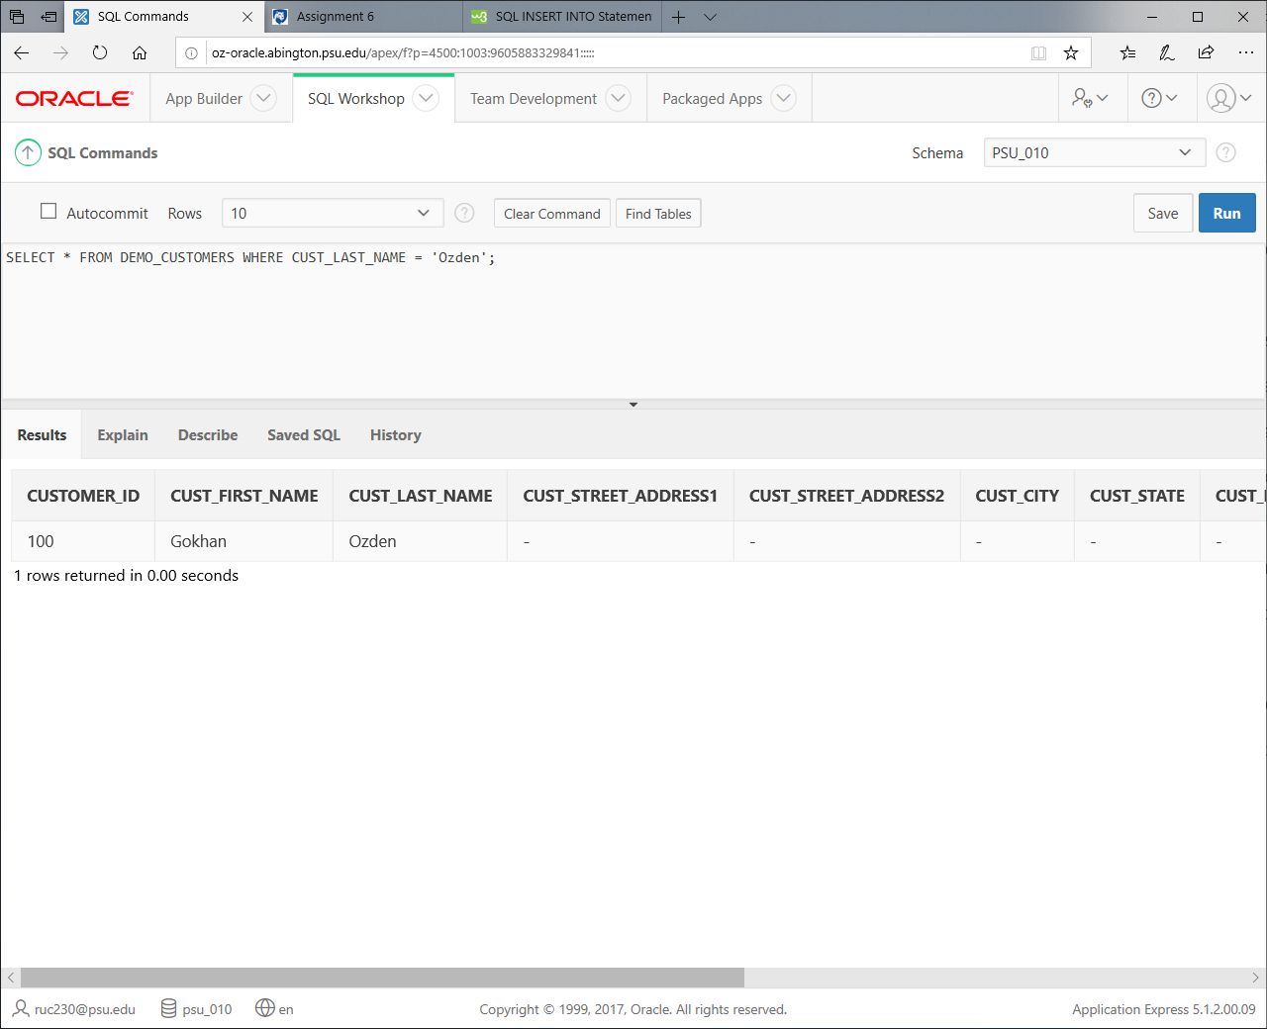

5. Write a function named "F_StateName" that takes the CUST_STATE as an input and returns the state full name from the DEMO_STATES table. (10 points) Show me the results of the below query: (10 points

create or replace function FStateName

(

cst in varchar2

)

return varchar2

is

retstate varchar2(50);

begin

SELECT demo_states.state_name

INTO retstate

FROM demo_states

WHERE demo_states.st = cst;

return retstate;

end;

SELECT Cust_First_Name, Cust_Last_Name, F_StateName(Cust_State) FROM Demo_Customers

