Final Report
Introduction
The following case study highlights an insider threat scenario involving a disgruntled employee who is suspected of attempting to leak sensitive information. The following report applies CAINE to a realistic scenario in which a company must investigate possible data theft, USB activity, malware, deleted files, and suspicious network traffic.
The company, Keystone Business Solutions, had a recent conflict after an employee, Jason Miller, did not obtain a promotion due to poor workplace conduct. A couple weeks after this event, the IT department noticed unusual traffic from Jason’s personal workstation. Internal logs showed that sensitive files may have been accessed outside of normal business hours, and network monitoring showed a connection to an unfamiliar IP address. Keystone Business Solutions handled payroll records, client contracts, internal business documents, and other sensitive information, any possibility of corporate data being leaked results in serious and swift action.
The company security team immediately decided to move forward with a digital forensic investigation. The goals included preserving evidence, determining whether confidential files were copied anywhere, identifying any external device connections, analyzing any possible deleted files, reviewing memory and network activity, and producing a standard report in case of any disciplinary or legal action. The forensic team chose to use CAINE due to its ability to support the many parts of digital forensic workflow.
Background of CAINE
Computer aided investigative environment (CAINE) is a computer forensics tool that has several tools that support database, memory, forensic and network analysis. Some specific tools it uses are The Sleuth Kit (disk & file analysis), Autopsy (GUI of Sleuth Kit), RegRipper (extracts keys and data), Tinfoleak (collects Twitter intelligence), Wireshark (collects network traffic), PhotoRec (collects lost files from disk and cameras), Fsstat(displays file information). CAINE is deployed in Read-Only mode by default, so it doesn’t tamper with any existing evidence. It is built around a complete investigative environment that is organized to integrate existing software tools. It can be booted from removable media like a flash drive or from an optical disk to run in the memory. We chose CAINE because of the vast number of different tools it can use. Since it's not specific to one type of forensic investigation, it can be used for many different investigations. In a specific LIVE mode, CAINE can operate on data storage objects without having to boot up the operating system.
This made CAINE a useful tool for the investigation, due to the case involving many forms of possible evidence. Investigators did not know whether Jason had copied the files to an external USB drive, deleted evidence, used malware, or sent information over the network. CAINE includes tools for disk imaging, file recovery, registry analysis, memory analysis, and network analysis. This allows the investigation to proceed in one organized forensic environment.
Forensic Integrity and Evidence Preservation
Forensic analysts use specially designed forensic environments to examine and preserve digital evidence in a way that ensures integrity and admissibility. CAINE is one of the most popular tools in the digital forensics field, since it offers a complete set of forensic tools in one operating system. Predominantly CAINE is used by law enforcement agencies, cybersecurity experts, and researchers, due to its flexibility, reliability, and focus on forensic integrity.
The forensic team needed a tool that would allow them to examine Jason’s workstation while preserving the evidence, with no possibility of changing or damaging it. This was especially important since the company needed the findings to be credible, in case of any post investigation actions needed. If Jason did attempt to leak corporate secrets, the evidence would need to be clearly documented and preserved.
One of the more important advantages of CAINE is the focus on preserving evidence. The fact that CAINE comes in read-only by default ensures that investigators do not inadvertently destroy or tamper with any evidence. This is important in all legal and law enforcement settings, where even the slightest bit of evidence contamination can ruin a whole case.
With consideration of the issue extending past the workplace, and into the court room, the forensic team would need to prove what happened using evidence that could be repeated exactly and verified by another investigator.
An important consideration in carrying out digital forensic investigations using CAINE is the issue of ensuring the forensic integrity of the process and the legal admissibility of all the evidence collected. The issue of forensic integrity entails ensuring that the digital evidence collected and presented in court has not been altered in any way from the time it was collected to the time it is presented in court. This is achieved by adhering to guidelines such as write-blocking, which ensure that the original storage media is not altered in any way. The investigator must also ensure that the data collected is not tampered with in any way. If at any point the integrity of the evidence is compromised, it may not be allowed in court even if it is relevant to the case. The investigator must guarantee that all the steps taken in the process of carrying out the digital forensic investigation using CAINE are verifiable so that another investigator could obtain the exact same results under the same conditions. The investigator must make sure that all steps taken in the process of carrying out the digital forensic investigation using CAINE are documented in detail. This will verify that the evidence collected has been handled in a secure manner throughout the process. The issue of making sure forensic integrity stays intact is not only a technical requirement, but a legal one.
Incident Description
The full incident began when the company’s IT department noticed that Jason’s workstation was generating unusual traffic after normal working hours. The traffic included repeated connections to an external IP address that was not associated with any approved business services. Around the same time, a manager reported to IT that Jason was also seen using a personal USB drive at his desk, company policy prohibited employees from using any unapproved removable storage devices.
Jason’s role was in the company’s operations department, so his workstation did have access to sensitive internal documents. His account had permission to view payroll spreadsheets, internal business documents, and personal client information. Once the suspicious activity had been noticed Jason’s account was frozen and his workstation was secured. A forensic investigator was assigned to image the system, examining any possible file access, determining whether external USB devices were used, and analyzing whether data was transmitted outside of the organization.
Several major questions had to be focused on throughout the investigation. First, investigators needed to know if Jason had accessed any sensitive files. Second, if those files were accessed, investigators need to determine whether Jason copied them onto removable media. Third, they had to check for any deleted files or damaged partitions, and if they contained any relevant evidence. Fourth, they needed to examine any memory or network activity for possible malware or exfiltration attempts. Once these questions are answered, a clear and reliable report would need to be documented.
Evidence Sources and Recovery Plan
Because of the possibility of insider data theft, investigators identified many possible sources of digital evidence. These include Jason’s desktop, his internal hard drive, disk images, external USB devices, network traffic captures, RAM data, registry files, and deleted files. CAINE was especially useful because it can analyze these evidence sources.
There are lots of different devices that CAINE can recover data from and use in an investigation. Common sources of data are desktop computers, servers, network storage devices, and laptops. Their internal drives accept optical media like CDs and DVDs and many different ports, for example USB (Universal Serial Bus) ports, firewire ports, PCMCIA (Personal Computer Memory Card International Association) where devices and other external storage media can be attached. Computers also have volatile data that can be recovered if the system hasn’t been shut down or rebooted at all. Any other devices around the computer, such as digital cameras, digital recorders, cell phones, etc., can also be a source of data in any investigation that CAINE would have to get data from as long as the investigator gets the right permits if necessary.
The most important evidence in this case was Jason’s workstation and any removable storage devices he had connected to it. Since the system may have contained deleted files, accessed documents, USB artifacts, possible malware, or browser history, the team had to follow a structured process to continue with recovery.
To use CAINE to recover data from a device, the right tool must be used in the right process. Each recovery has the same general process: Develop a plan, Acquire the data, Verify the data’s integrity. The specifics of each process depends on the type of data being recovered. The factors that can change a plan are the relative likely value of the data from the device, the volatility of the data on the device, and the amount of effort that would go into recovering the data. Acquiring data is where it varies the most between formats and tools used. After getting the data, the last thing to do is verify the integrity of the data where the original data is compared to the copied data to make sure it's all the same.
Following the process of identifying the evidence, the investigators planned the order for evidence collection. Since volatile memory can be lost when a system is powered off, memory evidence was considered high importance. However, the disk image and USB evidence were also highly important because they could show whether Jason just accessed or if he copied the files as well. Once the plan is established, investigators use CAINE to acquire and verify the evidence.
Evidence Acquisition
First steps include creating a forensic image of Jason’s workstation. Investigators need a bit-by-bit copy of the storage media so they can analyze the copy instead of the original device. This helps preserve the original evidence and reduces any risk of contamination.
One of the more important parts of CAINE is the evidence acquisition tools, which are employed to create the forensic images of the digital storage media. The tools that are commonly employed in the process include the use of the Guymager or the use of the dd or the dc3dd command-line tools, which are employed in the bit-streaming imaging process. This ensures that all the sectors of the digital storage media are perfectly duplicated, including the data that is not accessible or that is deleted. This makes it so all the evidence is not overlooked. The tools employed in the process can create images in various formats, including the RAW format or the dd format and the Expert Witness format, commonly referred to as the E01 format. An important aspect of the process is the employment of the write-blocking mechanisms, which ensure that the original evidence is not altered in any way. Moreover, hashing techniques such as the MD5 or SHA-1 are employed to create the digital fingerprint of the original evidence and the acquired evidence. The hash values are employed to confirm that the created image is an exact duplicate of the original evidence.
In the investigation, Guymager was used to create a forensic image of the disk. This step created the foundation for the rest of the analysis because all later examinations would be performed on the copied image rather than Jason’s original workstation. The hash verification helped confirm that the copy and the original match.
Some very important tools apart of Caine, used for forensic acquisitions, are Guymager and dcfldd. Guymager has a graphical user interface while dccfldd is a command line tool. Guymanger simplifies imaging processes of different types of image formats like raw and EWF. Dcflld is a better version of the traditional dd tool. These tools both have hashing to ensure the data is the same. Another aspect is file system analysis.
Guymager Generated Report:
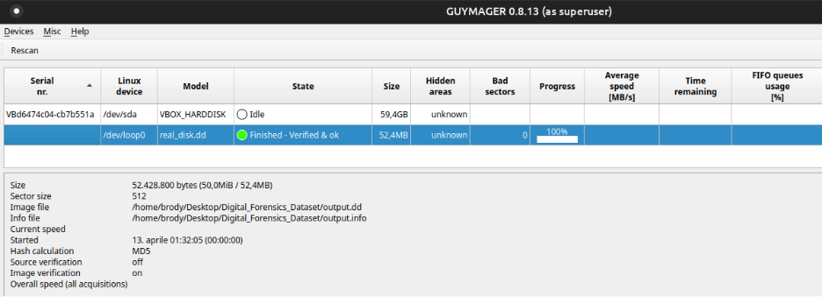
Guymager was used to create a forensic image of the disk. The imaging process completed successfully and verified the image. This ensures data integrity during forensic analysis.
File System Analysis
After the disk image was created and verified, investigators moved into file system analysis. The goal was to identify whether Jason accessed confidential files, deleted evidence, or attempted to hide any data on the system.
After acquiring the data, CAINE offers powerful capabilities in terms of file system analysis, allowing users to analyze the data containing the acquired image in detail. Tools like Autopsy, developed using the Sleuth Kit, allow users to analyze popular file systems like NTFS, FAT, and EXT. These tools allow users to recover deleted data, identify hidden data, and reconstruct file structures that may have been intentionally modified or damaged. One of the most powerful features of the file system analysis tools is the ability to reconstruct timelines using data contained in file systems, including creation data/time, modification data/time, and access data/time stamps. This feature is extremely powerful in terms of understanding user behavior and establishing a timeline of events. Other powerful utilities like PhotoRec and TestDisk are also included in CAINE and are extremely powerful in terms of recovering lost data even in cases where the file system is damaged. This allows users to identify data that may not be immediately apparent using standard file system browsing techniques.
This part of the investigation showed if Jason may have tried to delete files after copying them or hide evidence in damaged or less obvious parts of the file system. Investigators used The Sleuth Kit and Autopsy to examine the disk image, looking for any activity related to confidential documents.
Two tools that recover data in CAINE are Autopsy and The Sleuth Kit. They can recover data on desktop computers, laptops, external drives, internal drives, and disk images. Data types that are recovered are deleted files, images, documents, videos, email data, browser history, metadata and timeline data. Specifically, disk image files can be analyzed if they are a(n) RAW/DD (.dd, .img), E01 (.E01), AFF (.aff), and ISO (.iso) data type. The different files systems that are supported are NTFS, FAT, FAT32, exFAT, EXT2, EXT3, EXT4, HFS, HFS+, and some versions of APFS.
Another aspect is file system analysis. CAINE has tools like The Sleuth Kit and Autopsy that both are really good and powerful for analyzing disk images and file systems like NTFS, EXT, and FAT. The Sleuth Kit is a command line tool while Autopsy is a Graphical user interface that uses The Sleuth Kit as its backbone. These tools are used to reconstruct user actions and identify suspicious file activity.
The file system analysis helped build a timeline of Jason’s activity. The team looked at access times, modified files, deleted documents, and any folders containing copied or staged company data. The Sleuth Kit’s fls command was used to list files within the disk image and identify lost or orphaned entries.
Fls Generated Report:
The fls command from The Sleuth Kit was used to list files within the disk image. The output shows file entries including lost and orphaned files. This tool is commonly used to identify deleted files and file system structure during forensic investigations.
This finding supports the idea that file system artifacts could provide an insight into Jason’s actions even if he attempted to remove any evidence. However, file system analysis alone was not enough. Investigators would also need to examine deleted files and damaged disk structures.
Deleted File and Partition Recovery
Since Jason may have tried to delete files after copying them, the investigators used CAINE’s recovery tools to search for any deleted or lost data. PhotoRec and TestDisk were useful in this stage, since they can recover data from storage media even when normal browsing does not show the files.
PhotoRec and TestDisk are tools in CAINE that recover deleted or lost files from many different storage devices like hard drives, USB drives, memory cards, and disk images. The file systems they work with are NTFS, FAT, FAT32, exFAT, EXT2, EXT3, EXT4, HFS, and HFS+. The file types they can recover are image files, documents, video files, compressed files, and email data. They are typically used together with PhotoRec focuses on recovering individual files and TestDisk recovers partitions and file systems. PhotoRec uses file carving techniques, which searches for file signatures instead of the file system structure. TestDisk restores partition tables, rebuilds boot sectors, and recovers inaccessible disks.
In the investigation, PhotoRec was used to attempt recovery of deleted files from the disk image. No files were recovered in the simulated report, the process still showed the use of the tool and how it can be used in respect to an insider-threat case.
PhotoRec Generated Report:
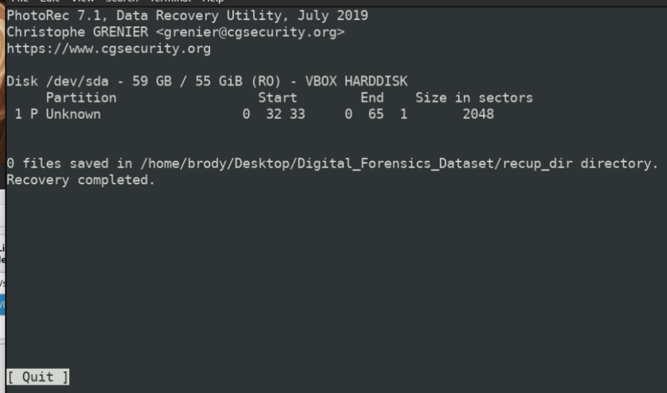
PhotoRec was used to attempt recovery of deleted files from the disk image. The recovery completed successfully, but no files were recovered. This demonstrates PhotoRec’s file carving capabilities.
TestDisk was then used to review the disk structure. This was a way for investigators to determine whether any lost partitions or damaged file systems existed that could contain evidence of the attempted leak.
TestDisk Generated Report:
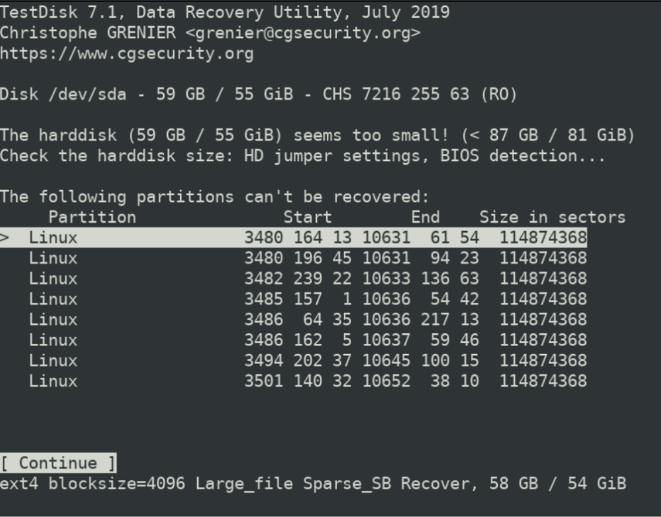
TestDisk was used to analyze the disk structure and identify partitions. The output shows multiple Linux partitions and disk information. This helps investigators recover lost partitions.
Although the recovery stage did not produce deleted confidential files, it helped confirm that the forensic team had checked any areas where hidden or deleted information may have existed. The next step was to examine any system artifacts that could show whether Jason accessed company documents or connected any USB devices.
Registry and USB Evidence
The case involved a possible use of a personal USB drive; registry analysis quickly became one of the most important parts of the whole investigation. Windows registry artifacts can show any files that were recently accessed, any USB devices that have been connected, any programs that have been installed, and specific user activity. This would help prove if Jason interacted with the confidential company documents and whether a removable USB device was connected.
RegRipper is a tool in CAINE that extracts and analyzes registry files. The hive files it works with are SAM, SYSTEM, SOFTWARE, SECURITY, and NTUSER.DAT. The information it can extract is login activity, installed programs, USB device history, system configuration, and recently accessed files. It is typically used on windows systems for their registry-based evidence.
In the investigation, RegRipper provided some of the strongest evidence so far of tying Jason’s actions to the suspected data leak. The registry analysis was able to show recently accessed files and a USB device connection. The files identified in the report were directly relevant to the company’s concern, since they included payroll and confidential documents.
RegRipper Generated Report:
Registry Hive: NTUSER.DAT
OS: Windows
Activity Identified: Recently Accessed Files, USB Device History, System Configuration
Recent Files: payroll.xlsx, confidential.docx
USB Devices Detected: Kingston 16GB
RegRipper was used to analyze the Windows registry hive file NTUSER.DAT. It extracted activity information including recently accessed files and USB device history. It identified that files like payroll.xlsx and confidential.docx were accessed and a 16GB Kingston USB was connected. This shows RegRipper’s ability to extract user activity and system configuration information during an investigation.
This evidence strongly supports the theory that Jason accessed sensitive files and connected a USB device. While this alone did not prove that the files were successfully leaked, it established the fact that Jason’s workstation interacted with confidential files and removable media. The next question was whether any malware or active processes were involved in moving the data outside of the company.
Memory Analysis
Since suspicious network activity had been detected, the forensic team also needed to examine volatile memory. Memory analysis can reveal any active processes, open network connections, and malware that may not appear as normal files on the hard drive. This was especially important since a data leak could involve a running process that sends information to an outside server.
A significant part of CAINE is the support it offers for memory (RAM) analysis, particularly through the Volatility Framework. Unlike information stored on the hard drive, information within the system’s memory is volatile, it is lost once the system is shut down. This means that memory analysis can offer investigators unique information not offered by hard drive analysis. Volatility can, for instance, allow investigators to access information about processes running on the system, network connections, modules, and possible malware information from the memory dump. This is particularly significant where sophisticated cybercrimes or malware are involved, where the only information about the crime is within the system’s memory. By analyzing the system’s memory, investigators can detect suspicious activities that took place during system operation.
In the investigation, Volatility was used to analyze a memory dump from Jason’s system. The results showed suspicious processes and an external network connection. This showed evidence of possible malware-assisted data exfiltration.
Volatility Generated Report:
Memory Image: memory_dump.raw
Operating System: Windows
Processes Identified: explorer.exe, svchost.exe, data_stealer.exe, backdoor.exe
Network Connections: 192.168.1.10 > 185.203.116.45
Loaded Modules: kernel32.dll, user32.dll
Volatility was used to analyze the memory dump file memory_dump.raw. It identified running processes, network connections, and loaded modules in system memory. Suspicious processes like data_stealer.exe and backdoor.exe were identified. This shows volatility’s ability to analyze volatile memory and detect malicious activity in an investigation.
The presence of data_stealer.exe and backdoor.exe made the investigation much more serious. These suspicious process names suggested that Jason’s workstation may have been compromised or intentionally used to move data outside the company. The external connection from 192.168.1.10 to 185.203.116.45 gave investigators another lead to compare with the network traffic analysis.
Network Analysis
The company’s suspicions began with unusual outbound traffic, so network analysis definitely became a major part of the investigation. Investigators needed to determine if Jason’s workstation communicated with external addresses and whether the network traffic had supported the theory of attempted data exfiltration.
Wireshark is a tool in CAINE that analyzes and captures network traffic. It supports different file formats such as PCAP and PCAPNG which are files that store network packets for later analysis. It can analyze the traffic from network interfaces like Ethernet and Wi-Fi to view data like IP addresses, protocols, packet contents, and communication between devices.
Wireshark helped investigators review DNS queries and communication between internal and external IP addresses. The earlier memory analysis had identified a suspicious connection, and the network review confirmed that suspicious communication occurred during the investigation period.
Wireshark Generated Report:
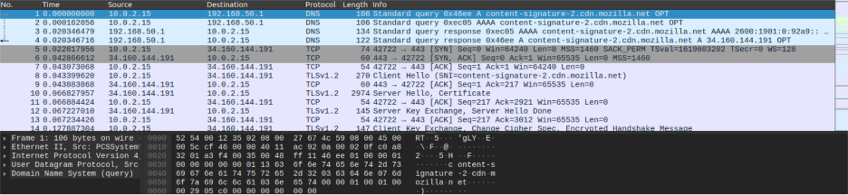
Wireshark was used to capture and analyze network traffic. The output shows DNS queries and communication between multiple IP addresses. This helps investigators detect suspicious network activity.
This supported the possibility that Jason’s workstation had communicated outside the company network, while the sensitive files were being accessed. These results did not stand alone, when combined with registry evidence, memory evidence, and file system analysis, they created a stronger timeline of suspicious behavior.
File System Structure Analysis
To better understand the disk image, investigators used Fsstat to review the file system structure. This lays out the evidence, including metadata, block size, and areas where deleted or hidden data could exist. Fsstat is a tool included in The Sleuth Kit in CAINE that finds information about file systems from storage devices on a system. It supports file systems like NTFS, FAT, EXT2, EXT3, and EXT4, where it can find the details on the structure and layout of a file system. It can display the file system type, block size, metadata structure, and layout of allocated and unallocated space.
Fsstat Generated Report:
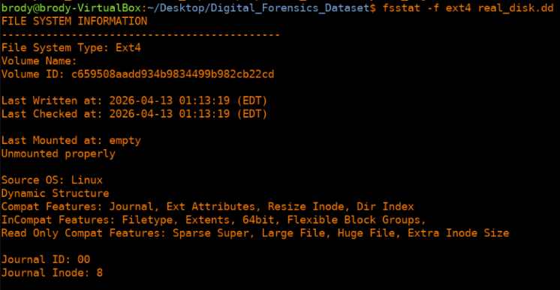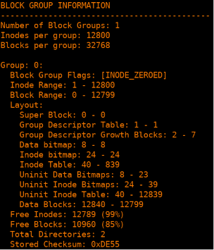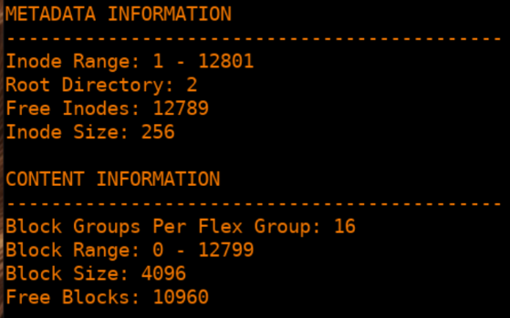
Fsstat was used to analyze the forensic disk image and display file system information. The output shows the file system type as EXT4, block size, inode range, and metadata information. This helps investigators understand the disk structure and locate deleted or hidden data.
This helped confirm that the investigators understood the evidence structure before any conclusions have been drawn. In a forensic investigation, this type of information matters since deleted or hidden data may exist in unallocated space.
Integrated Tool Findings
Another major advantage of using CAINE is the fact that it provides a highly integrated platform that is very effective in the process of digital forensic investigation. CAINE is advantageous over other tools in the fact that it provides a platform where all the necessary tools for the process of digital forensic investigation are available in one piece. This allows for the sense that the chance of error has been reduced. This is because, unlike other tools where the investigator is forced to switch from one system to another, CAINE provides a platform where all the necessary tools are in reach in one place. Using other tools allows for a higher chance of contamination since the investigator would have to switch from one system to another during their investigation. The fact that CAINE provides a highly integrated platform allows for the chance of contamination to be reduced marginally. This permits the tools to be compatible with one another, allowing for the output of one tool to be connected to the input of the next.
This allowed the investigators to connect evidence across different parts of the system. RegRipper showed that payroll.xlsx and confidential.docx were accessed and that a Kingston 16GB USB device was detected. Volatility showed suspicious processes and a connection to an external IP. Wireshark showed network communication between IPs. Together these findings bring a larger picture than a single tool would provide.
Reporting and Findings
Lastly, CAINE has a reporting and documentation feature, which is important in ensuring that results are presented in a legally acceptable format. Many of the included tools, such as Autopsy, have a reporting feature that allows investigators to present their findings in a structured and detailed manner. This includes details such as recovered files, timelines, hash values, and analysis results. Furthermore, a chain of custody is also important in ensuring that evidence has not been tampered with and can be presented in court. This involves tracking how evidence is collected, analyzed, and processed through the investigative process. In the case of this investigation, the final report summarized the evidence between the file system analysis, the registry findings, the memory analysis, and the network activity.
Through forensic analysis, the investigation had produced many important findings. Jason’s workstation was initially successfully imaged and verified, so the evidence was able to be analyzed without altering the original system. Recovery tools were used to check whether deleted or damaged data existed, although no files were recovered through PhotoRec or TestDisk. The strongest findings came from registry, memory, and network analysis. RegRipper showed what files were accessed, as well as the device that had been connected. Volatility identified suspicious processes along with a connection to an unknown IP address. Wireshark was also able to show DNS queries and communication between multiple IP addresses.
When all the evidence is viewed together, it strongly suggests that Jason’s workstation was involved in highly suspicious activity consistent with an attempted data leak. The combined results of the forensic analysis create a strong case that the employee attempted to access, copy, and transmit corporate information.
Conclusion
This simulated insider threat case showed how CAINE could be used to analyze all available information. The final analysis concluded that insider threats often require more than one type of forensic evidence. A USB artifact by itself may not be enough evidence. However when file access, USB history, memory processes, and network activity are combined, investigators can build a stronger and more complete understanding of what occurred. CAINE’s value in this case was its ability to bring tools together in one forensic environment.

Works Cited:
“CAINE Computer Aided Investigative Environment.” CAINE Live, www.caine-live.net/. Accessed 29 Mar. 2026.
National Institute of Standards and Technology. Guide to Integrating Forensic Techniques into Incident Response. NIST, 2006, nvlpubs.nist.gov/nistpubs/Legacy/SP/nistspecialpublication800-86.pdf.
“Digital Forensics and Investigation Techniques.” Journal of Cybersecurity and Business Intelligence, www.jcbi.org/index.php/Main/article/view/614. Accessed 29 Mar. 2026.
Scott, Brody, Ryan Carter, and Tyler Slack. CAINE. Preliminary Research Write-up, Slippery Rock University, 2026.
Scott, Brody, Ryan Carter, and Tyler Slack. CAINE Milestone 2, Slippery Rock University, 2026.
Scott, Brody, Ryan Carter, and Tyler Slack. CAINE Milestone 3, Slippery Rock University, 2026.

