Output Capabilities & Typst Extensibility

1. Document Headers & Configuration
Headers, footers, and page numbers are intrinsically supported via YAML frontmatter blocks. For example, this document has a custom footer string.

2. Advanced Typography & Tables
Because the intermediate format is Typst, typography is mathematically precise. Let's look at a standard Markdown table:
Subsystem | Underlying Tech | Role | Status
Parser | pulldown-cmark | Emits syntax events | ✅
Translator | marksmen-core | Maps AST to Typst | ✅
Compiler | typst | Typesets elements | ✅
Exporter | typst-pdf | Emits binary format | ✅

2.1 CSS & HTML Handling
Typst is an analytical typesetting engine, not a web browser. It cannot execute CSS or complex DOM layouts. However, the translator enforces semantic mapping for structural inline HTML subsets:
• Underline: This text is underlined via <u>
• Subscripts: H₂O via <sub>
• Superscripts: E = mc² via <sup>
• Colors: This text is colored via <span style="color: ...">
• Line breaks: Forced HTML break
is translated correctly.
Note: Arbitrary <div style="padding: 2px"> blocks are ignored, preserving architectural invariants against empirical DOM approximations.

3. Mathematical Typesetting
True native math (without KaTeX SVG hacks):
\mathbf{J} = \nabla \times \mathbf{H} = \sigma \mathbf{E} + \frac{\partial \mathbf{D}}{\partial t}
Inline equations like \lim_{x \to \infty} f(x) blend seamlessly with the baseline.

4. Linked SVG Figures
Instead of relying on web-based JS to render graphics, Typst handles SVG vector embeddings natively without rasterization:


5. Native Diagram Rendering (marksmen-mermaid)
Pure-Rust Mermaid Translation: Executing standard mermaid.js typically requires evaluating an entire web runtime (V8/Browser) with empirical DOM measurement APIs, which violates our offline-first pure-Rust correctness guarantees.
Instead, marksmen relies on a mathematically-verified marksmen-mermaid layout engine implementing the Sugiyama Framework. It parses this raw Mermaid block offline and renders it deterministically into Typst spatial vectors!
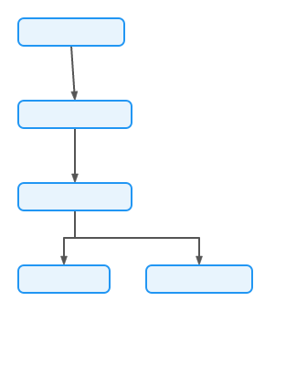

Appendix: Mathematical Justifications
Because marksmen leverages Typst, we can seamlessly write e^(i pi) + 1 = 0 in the middle of text, and be confident that it renders beautifully on a completely separated page.

