LCLS Science, Research and Development
PULSE Institute for ultrafast enery science

Sophia Perry
Purchasing
SLAC National Accelerator Laboratory
2575 Sand Hill Road
Menlo Park, CA 94025
Direct: (650) 926-3605
Email: sophiap@slac.stanford.edu

Dr. Ryan N. Coffee,
Senior Staff Scientist,
The Linac Coherent Light Source,
The PULSE Institute for Ultrafast Energy Science
2575 Sand Hill Road, Mail Stop 20
Menlo Park, California 94025, USA
(650) 387-0981
coffee@slac.stanford.edu

2 May 2019

Dear Sophia,

RE: Abaco Quotation number 20010611

I have reviewed Requisition 299103, “LCLS-II LC-3384” from Abaco Inc. for $85,481.00. I have concluded that this is acceptable since SLAC TID-AIR has already invested many person-months of effort to configure the PC821-HNNNN; FPGA=K085. The upgrade to PC821-HNNNN; FPGA=K115 is only the FPGA chip that provides greater computing resources for the output logic on this Analog to Digtal Converter (ADC). We note that the $4,264.00 difference per part compared to the previous version is significantly lower than the labor cost of developing for the PC821 digitizer board. The additional logic of upgrading the FPGA=K085 to the FPGA=K115 allows for more sophisticated algorithms for the data reduction at the waveform digitizer while incurring no additional infrastructure redesign. I conclude that this is a fair and reasonable additional cost and the best value for SLAC given the expected upgrades needed for the sake of data rates at LCLS-II. Please proceed with Requisition 299103. If you have any questions, please contact me.

Sincerely,
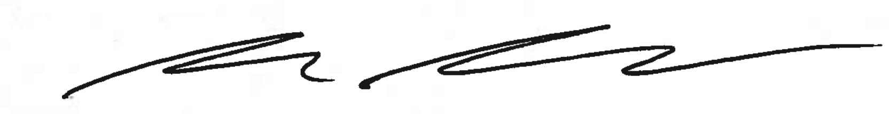

Ryan N. Coffee

