“Fork in the Road” Capstone Planning Document

## Description:

For my Capstone Project, I will be building an interactive story based on the theme of classic fairy tales similar to Little Red Riding Hood

To begin the experience, the player will face in to a path leading into the woods. There is a little girl crying off of the path.

When the player interacts with the girl, she will ask for help delivering a package to Grandma’s house because she’s too scared to go into the woods. The player will choose to help her or not. The player will also choose which path into the woods to take. The Dark and Scary path or the Bright and Cheery.

After selecting Play from the start screen, the choices the player makes will determine the outcome of the results. The experience fades to black, end credits show, and start screen is displayed.

Point system: Reward for bringing the package to Grandma. The girl will tell you that Grandma will like you more if you bring her mushrooms from the forest. If you bring her 5 mushrooms, she will reward you. Point system is displayed in the players field of view at all times.

## Features And Dependencies:

### 3D Models + Animations (Reference Images)

* 1. Little girl

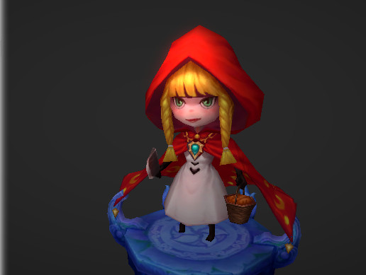

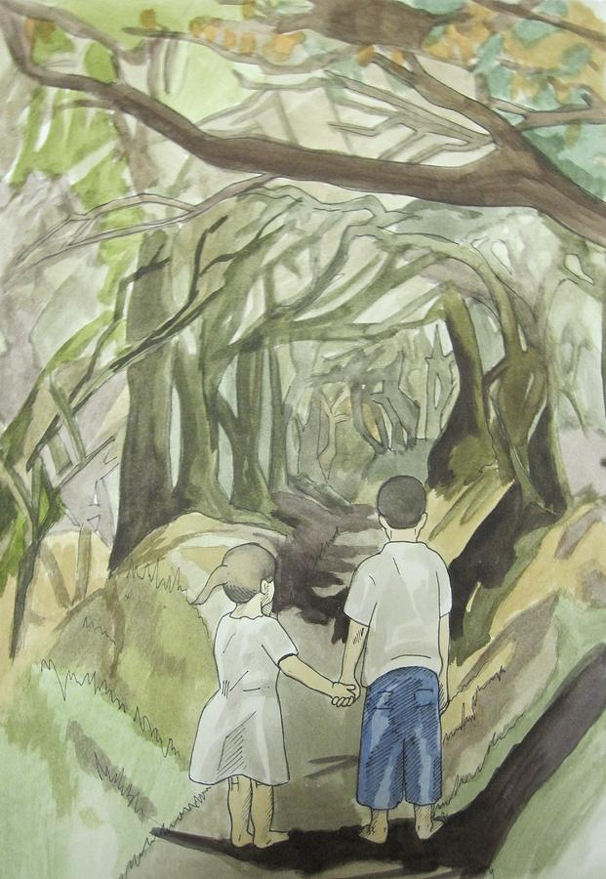

* 1. Creatures in the Dark

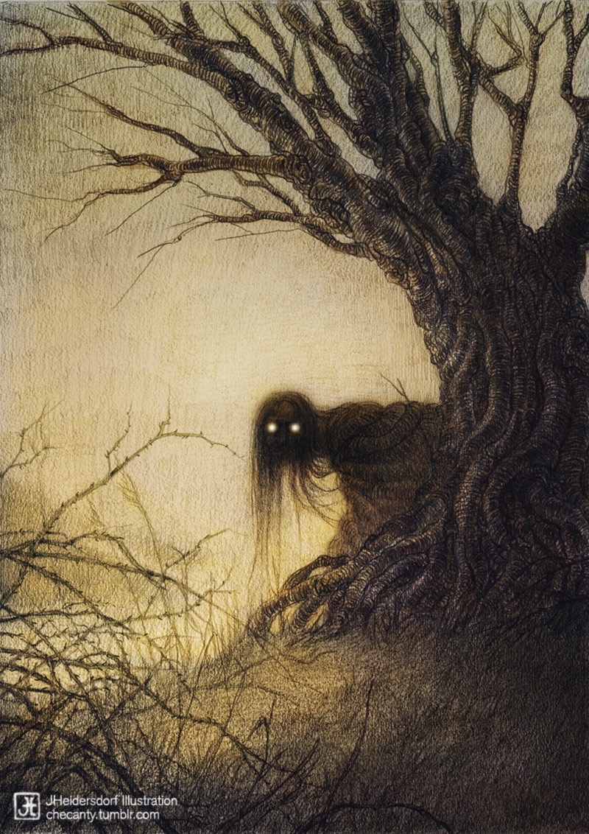

* 1. Fantasy Skybox
     1. 
  2. Greenery
     1. 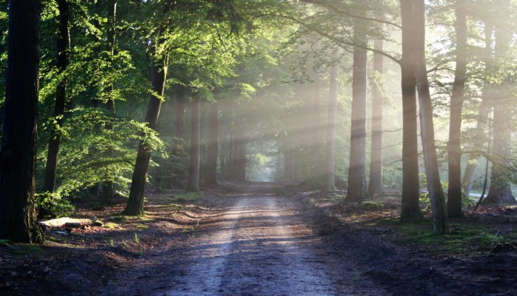

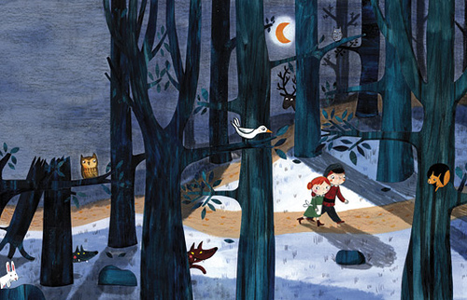

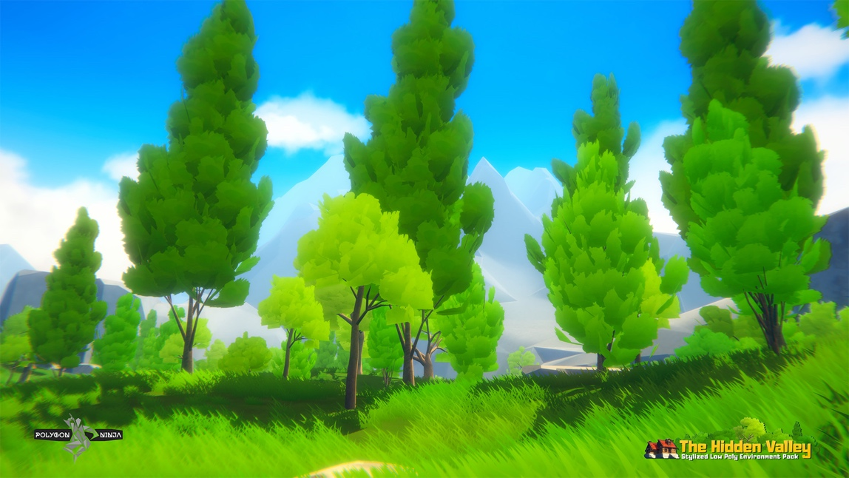

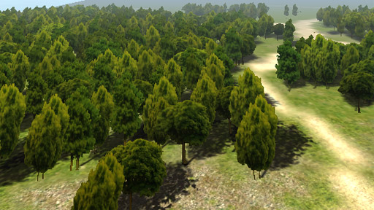

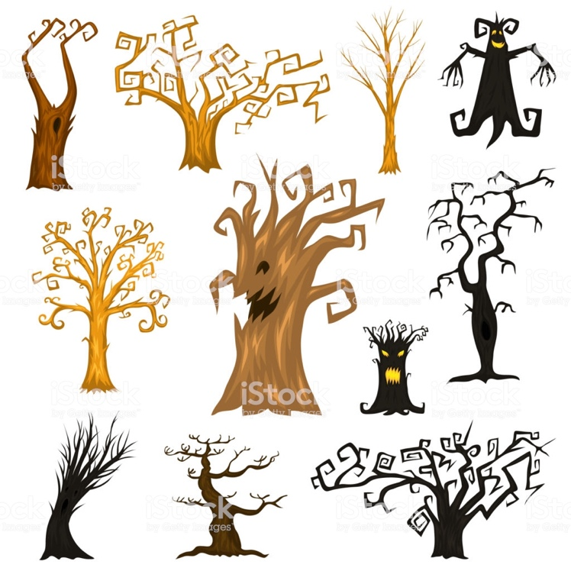

* 1. Cottage

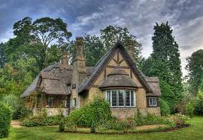

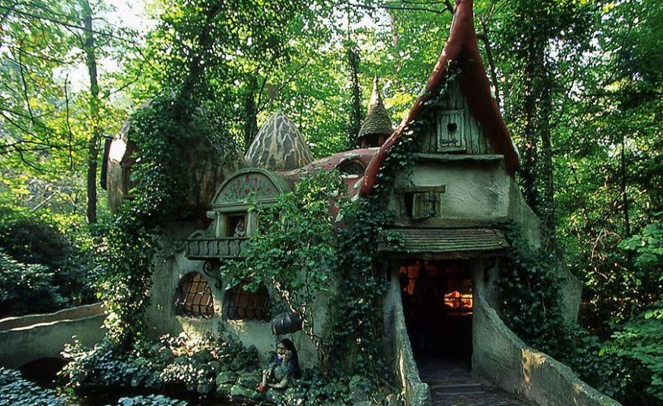

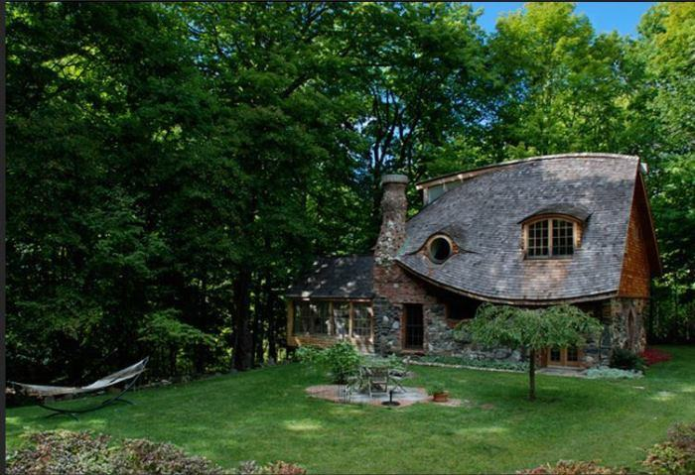

### Game Loop

* 1. Crying girl
  2. Speak Recognition to accept or decline request to help.
  3. Fading to black and restarting
  4. Timer based Hints to guide player towards the right areas

### Other Effects

* 1. Cartoon Lighting to make the experience feel more like Mother Goose
  2. Particle Effects to add dust in the air.
  3. Particle Effects for the items that can be collected.
  4. Spatial Sound effects for girl crying and speaking, forest creatures, ambient sounds and music.
  5. Lighting to give each path an emotional different look and feel.
  6. Physics – Tree branch falling in path.

“Fork in the Road” Capstone Scoping

## ***What worked and what didn’t?***

## Features And Dependencies:

### 3D Models + Animations

* 1. Little Girl model and animation
  2. Forest Creatures
  3. Cottage
  4. Forest Greenery
     1. **Revised: Will use SpeedTree to create the forest and save on performance and creation time.**
  5. Lighting

### Game Loop

### Other Effects