# 

# GEOG208_16S2: Remote Sensing for Geospatial Analysis

# Lab 1 : A quick start to ENVI 5.3, image display, and reflectance

Name: Ryan Cox

Student ID: 64656394

Extend the space as required!

# Part 1:

***Q1. What do the numbers in the brackets stand for?***

The amount of each type of colour

***Q2. By which sensor have the data been acquired?***

***Q3. What is the file size in bytes in the Windows file explorer (click with the right mouse button on the file and ‘properties’) compared to the file size in the Data Manager File Information? How is this calculated? Explain.***

1.46 mb or 1,536,000 bytes, this is calculated by getting the amount of pixels in the image the amount of bands for each pixel and then each pixel has 1 byte of colour for each band, so 640 x 400 X 6 X 256.

***Q4. Which bands are automatically chosen? Why?***

The red, green and blue bands because they show the image in true colour.

***Q5. What are typical NDVI values for very healthy vegetation, and drier vegetation?***

|  |  |  |  |
| --- | --- | --- | --- |
| *Scene 1* | | *Scene 2* | |
| *Moist* | *0.6* | ***Moist*** | *60* |
| *Dry* | *0.3* | ***Dry*** | *30* |

***Q6. Choose your favourite colour table and save the result as a *.jpg file using File->Chip view to-> file. Include the picture in the lab 1 report with a figure caption.***

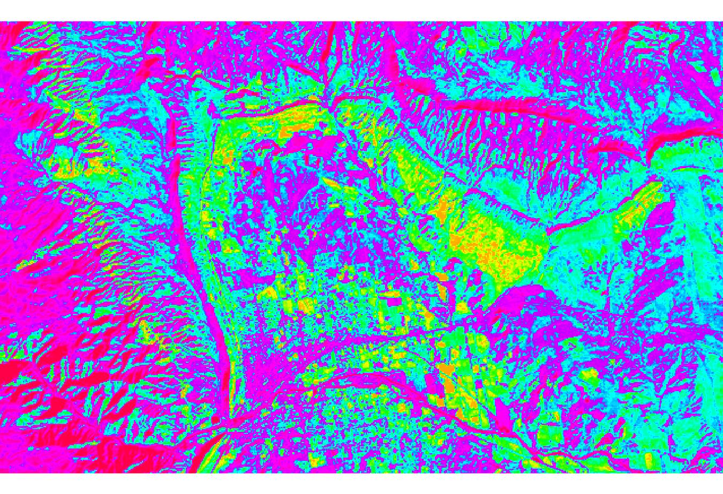

Figure - can_tmr.img with pastels colour table

# Part 2

**Q7. What do the values in the Landsat file naming convention relate to? Fill in the table in your word report.**

|  |  |  |  |  |  |  |  |  |
| --- | --- | --- | --- | --- | --- | --- | --- | --- |
| **L** | **T** | **5** | **074** | **090** | **2010** | **356** | **HOA** | **00** |

|  |  |
| --- | --- |
| *ID* | *Description and value* |
| L | Landsat |
| T | TM data |
| 5 | Landsat satellite number 5 |
| 074 | Starting path |
| 090 | Starting row |
| 2010 | Year image was taken |
| 356 | Julian date |
| HOA | Ground station identifier |
| 00 | Version number |

### *Q8. Include the image into your report with a figure caption.*

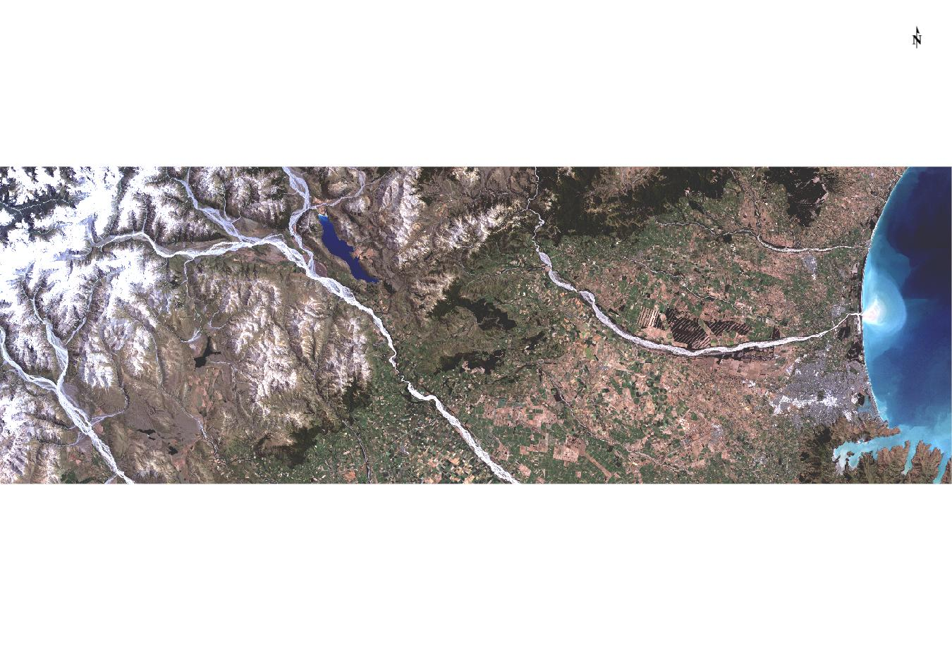

Figure - Landsat radiometric calibration

### *Q9: In which ‘unit’ is the reflectance measured and what does this unit actually mean?*

***Q10: Fill in the table in the word report:***

|  |  |  |  |  |
| --- | --- | --- | --- | --- |
| Canterbury Plains Reflectance Values | | | | |
| *Basic Stats* | *Min* | *Max* | *Mean* | *StdDev* |
| Band 1 | 6.256 | 36.650 | 11.155 | 4.744 |
| Band 2 | 3.958 | 76.503 | 11.206 | 7.752 |
| Band 3 | 2.016 | 64.710 | 9.792 | 7.620 |
| Band 4 | 0.408 | 80.699 | 23.463 | 10.843 |
| Band 5 | 0.000 | 51.526 | 16.890 | 8.508 |
| Band 7 | 0.000 | 74.965 | 9.696 | 5.793 |

**Q11. Save your final figure into an image for the word report file.**

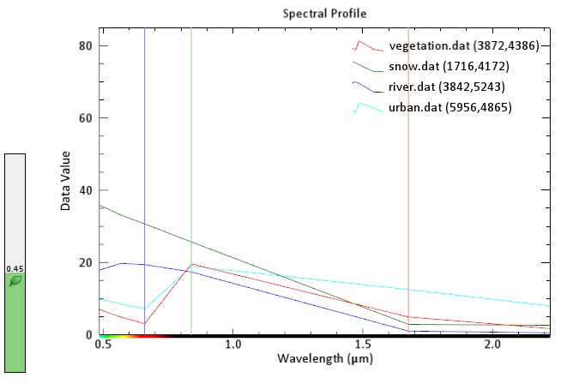

**Q12. For every band combination, chip a view to a *.jpg. Include the four pictures into the report, annotate the band combination, and give an explanation of the colour you see. Clearly mark the four positions from where you have taken the spectral from before using ‘Annotation Symbol’.**

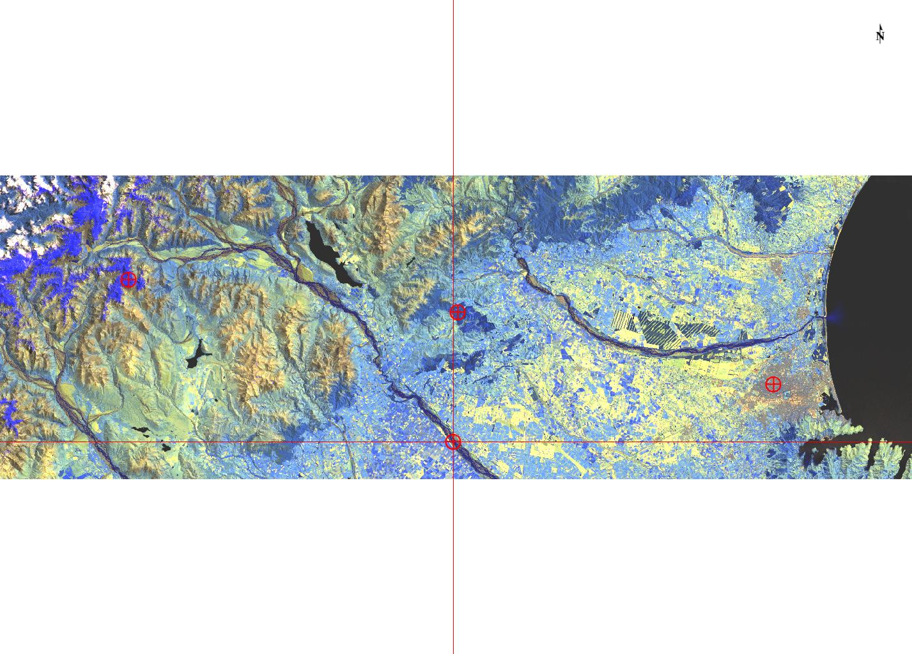

Figure - bands 754

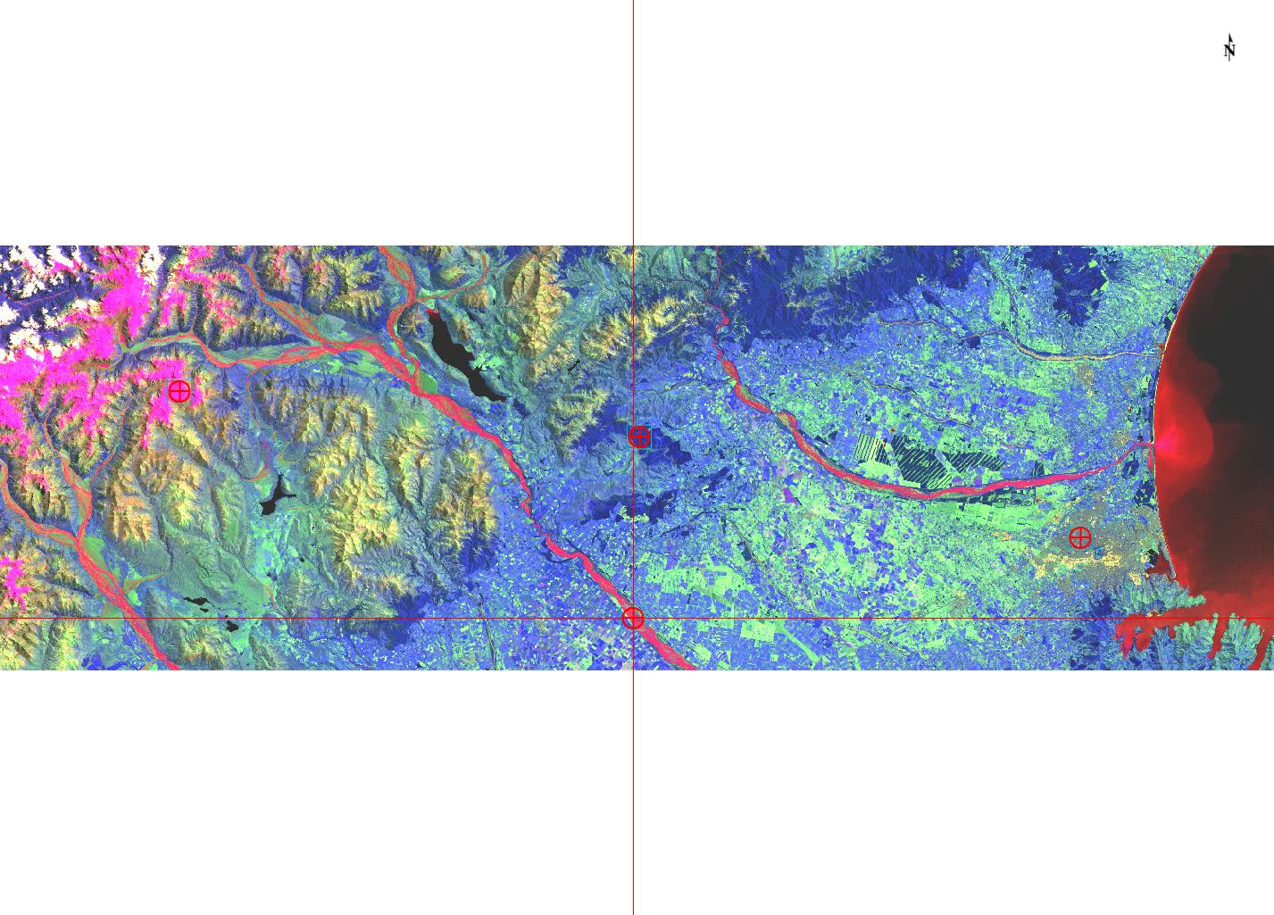

Figure – bands 742

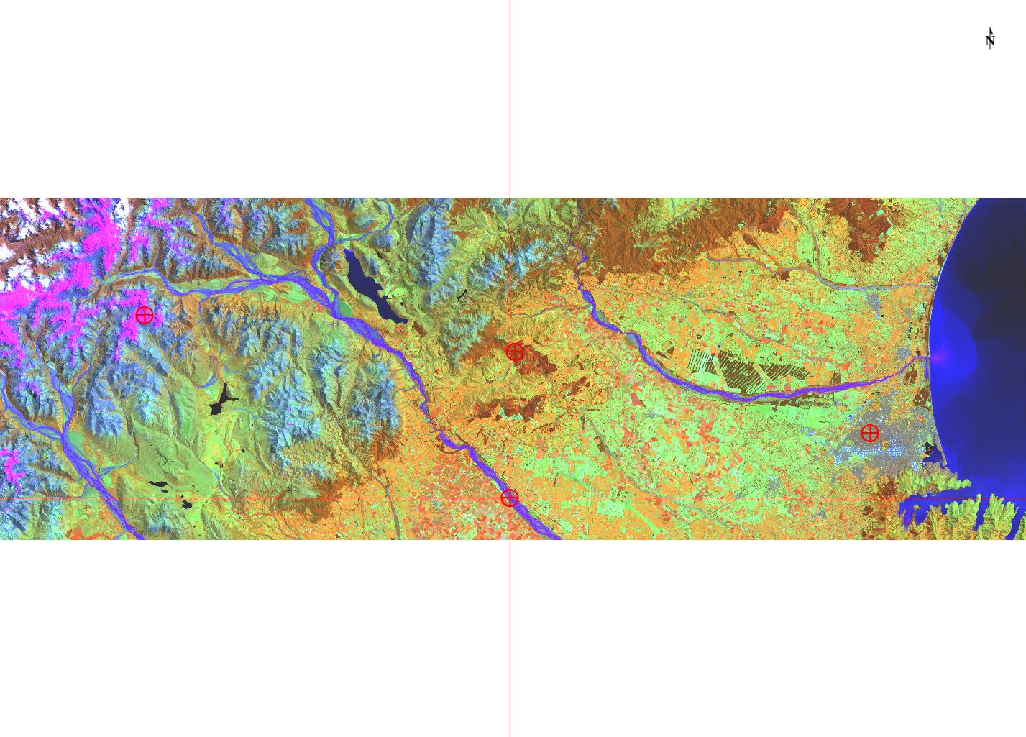

Figure - bands 451

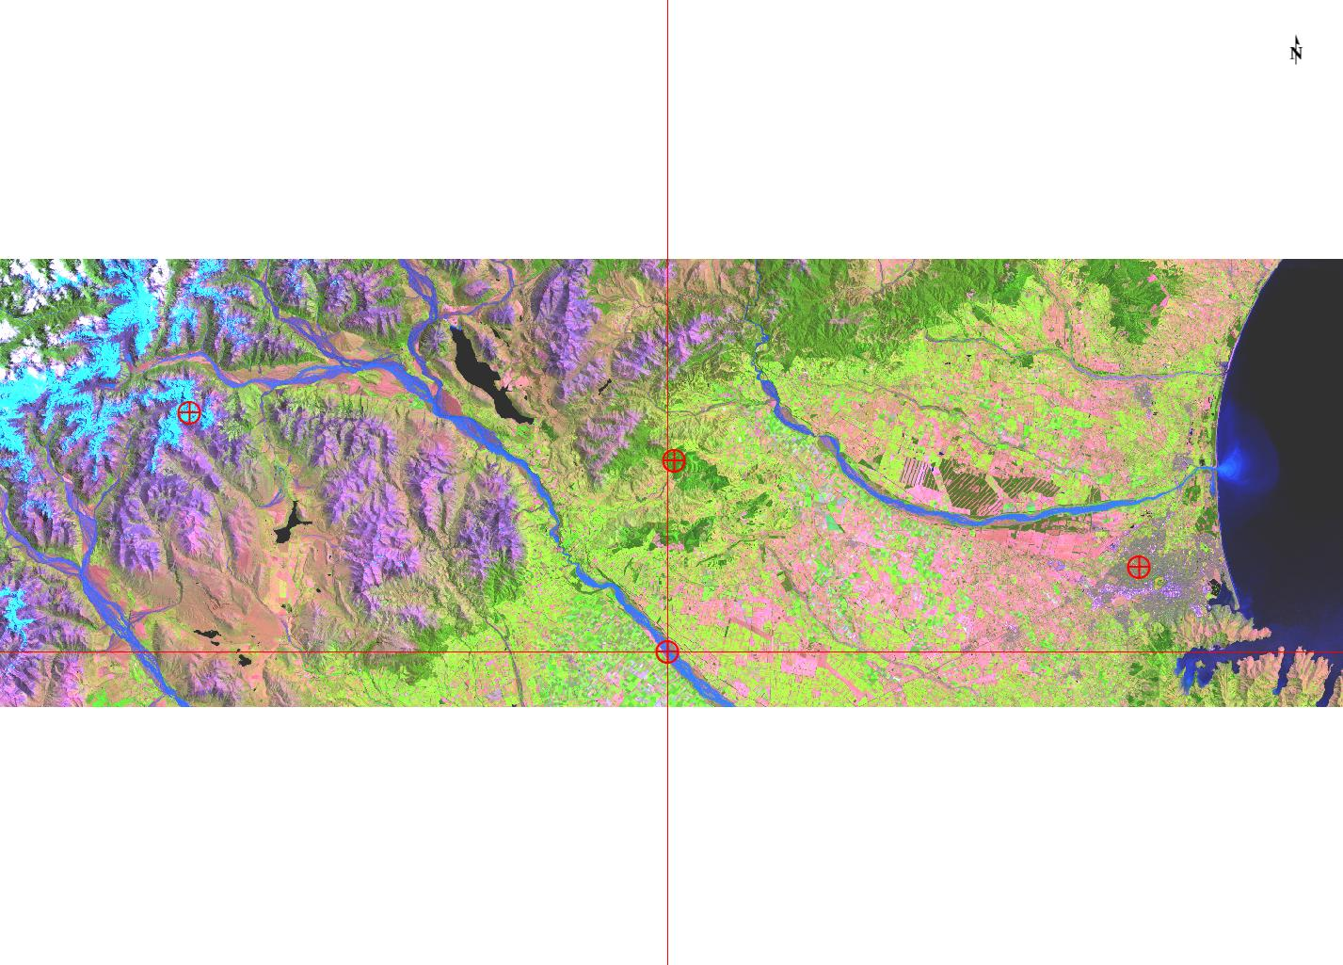

Figure - bands 543