# 

# GEOG208\_17S2: Remote Sensing Data for Geographic Analysis

# Lab 3: Image classification - Answer Sheet (see instructions on lab sheet)

## Name: Ryan Cox Student ID: 64656394

### Exercise 1: Classification workflow (20 points)

*Q1. Import a \*.jpg of your result into the report, describe which classifier you have worked with including one additional interesting detail of that classifier.*

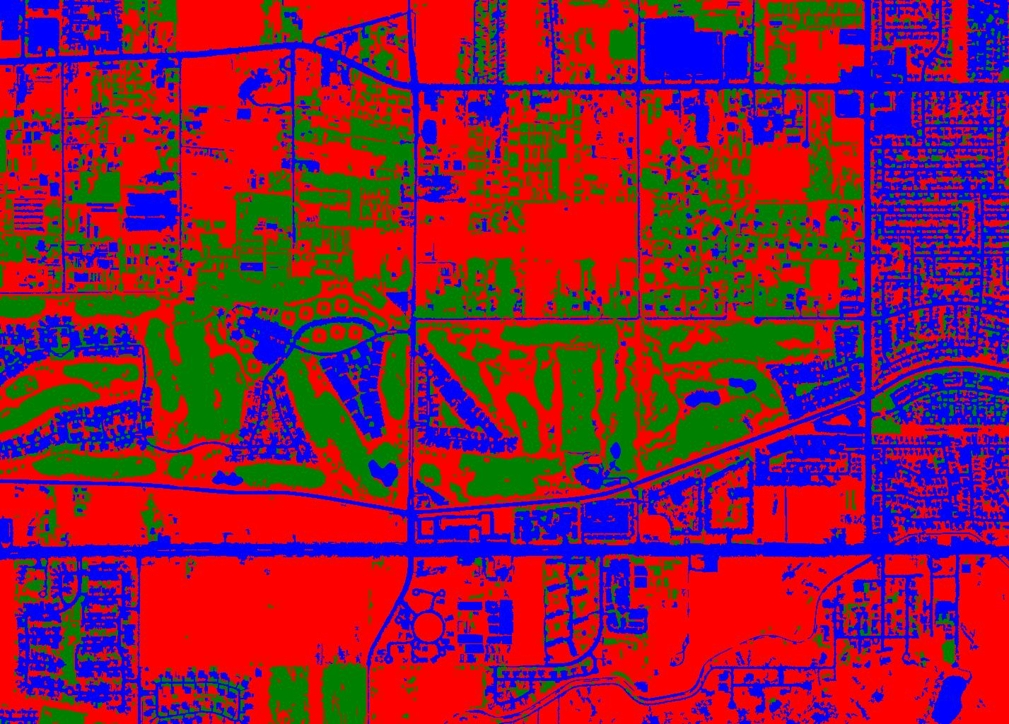

Figure - Phoenix AZ image using the SAM (Spectral Angle Mapper) which uses angles to assign to different classes

*Q2. What is supervised and unsupervised classification (three facts each)? What are the advantages/disadvantages of the two classification types (up to three arguments)? Make use of bullet points for your answers.*

Supervised classification is given training data as areas set by the user, uses algorithms to compute what pixels will be added to what class from the selected pixels and to get the best results select multiple areas all over the image.

* An advantage of this is that the user gets a lot of control over what areas they select and can classify area more accurately using for example false imagery.
* A disadvantage is that it takes more time to select area and have to correctly identify different terrains to classify.

Unsupervised classification automatically assigns different terrains to a class,

* An advantage is that it can be quickly be done as there is no need to select areas of interest and select areas to classify.
* A disadvantage is that the user has less control over what gets classified and can only choose how many classes to have.

### Exercise 2: “Dancing Pixels”. Exploring pixel clusters with 2D scatterplots (15 points) *Q3. Identify the pixel clusters for 3 typical surface types; mark them on the scatterplot, and save the scatterplot and the corresponding image to a \*.jpg for inclusion into the report. Add a caption clearly explaining your findings.*

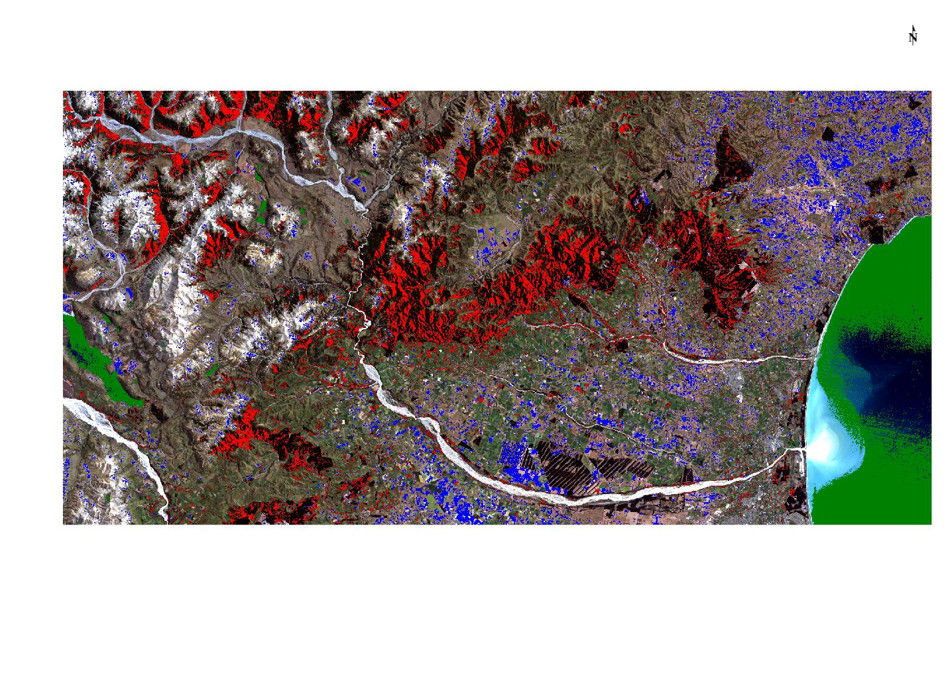

Figure - Landsat 5 spectral subset 2010 showing marked area on the scatter plot in the figure below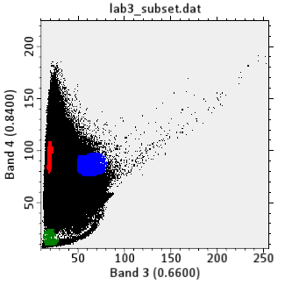

Figure - Scatterplot showing Red and infrared bands for the spectral subset above

We can see that the water has very low red and IR values and so in the scatterplot is most of the values for water are around the origin of the scatter plot. The vegetation which has a high amount of reflected inferred but very little reflected red light and so most of the values for that are around the top part of the y axis. The soil values have a high amount of both red and infrared reflected light and so the pixels on the scatterplot are in the middle of the data.

### Exercise 3: Supervised classification (20 points) *Q4. Export images which show the training sites (maybe you need to zoom in) and the classification to a \*.jpg, import into the report file and describe the classes. How many image bands have you chosen for your classification?*

### P:\My Documents\goeg208\lab3_traingsets.jpg

Figure - Same Spectral subset from before showing the trainging areas chosen which are for water, snow, vegetation, soil and urban

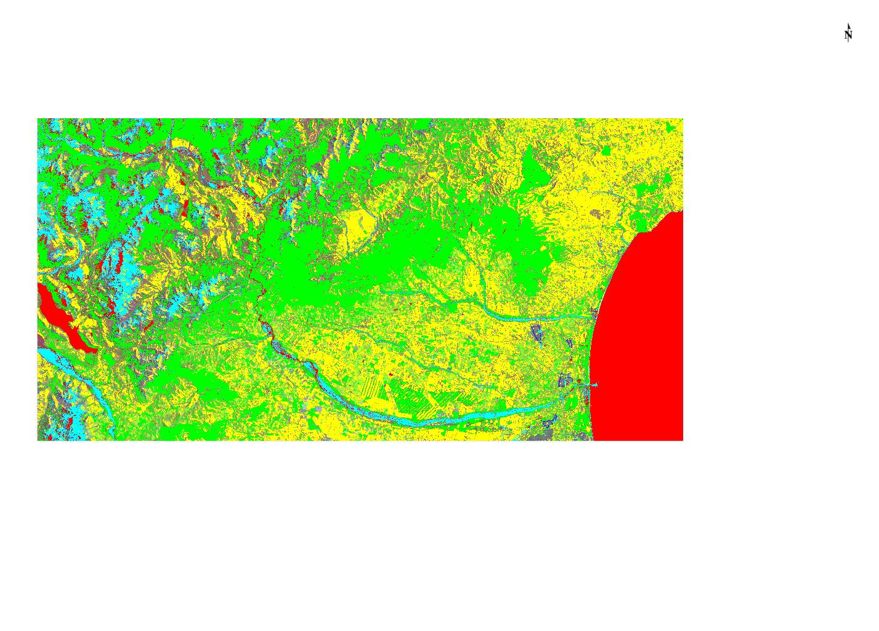

Figure - Classified image showing soil, water, vegetation and snow classes

I didn’t include the urban class because, too many areas were incorrectly classified and looking the scatter plot around the urban areas you can see that the point are spread out and overlap a lot with soil pixels.

*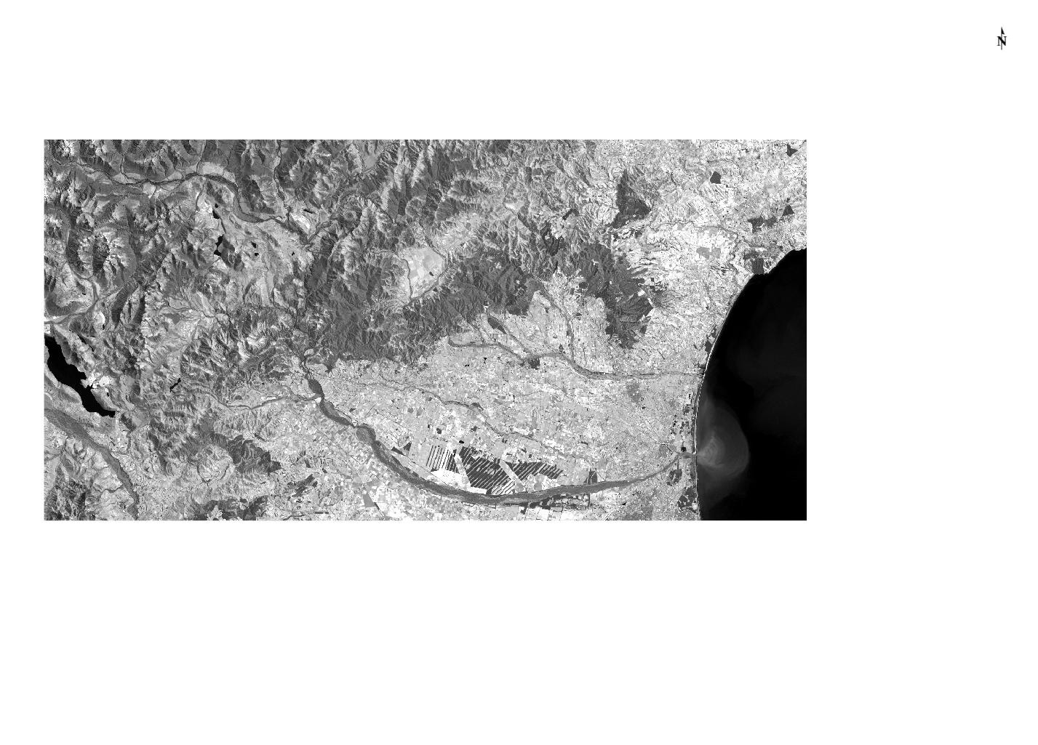*

*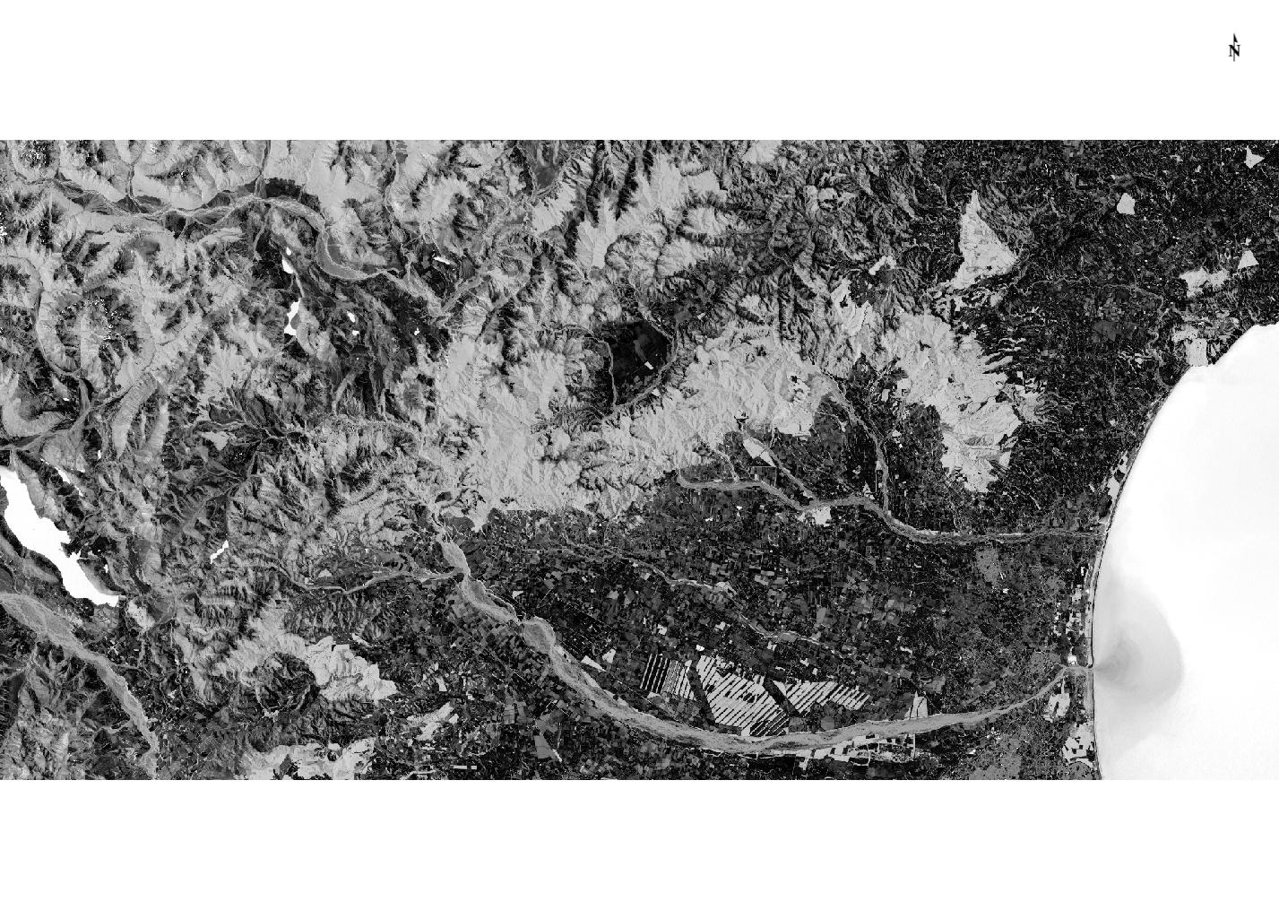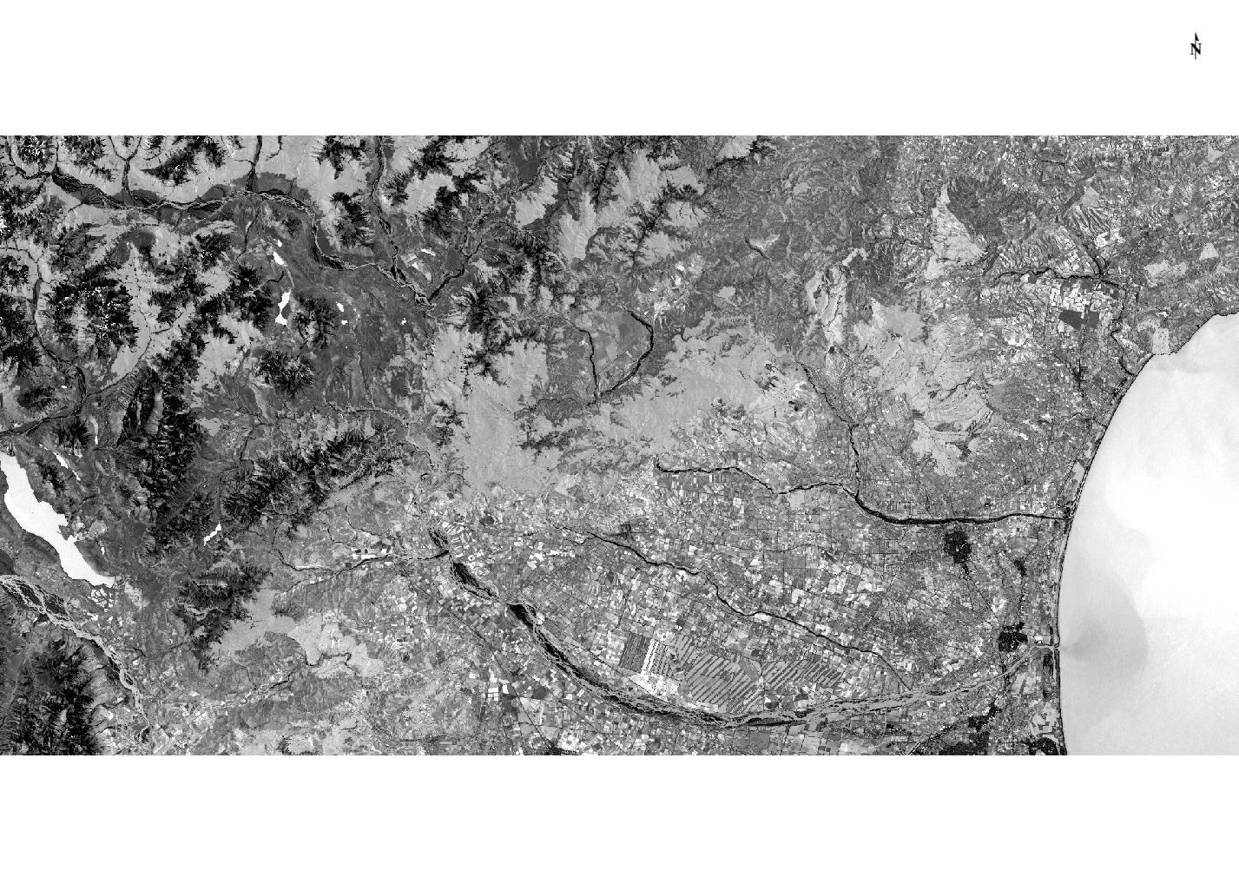*

*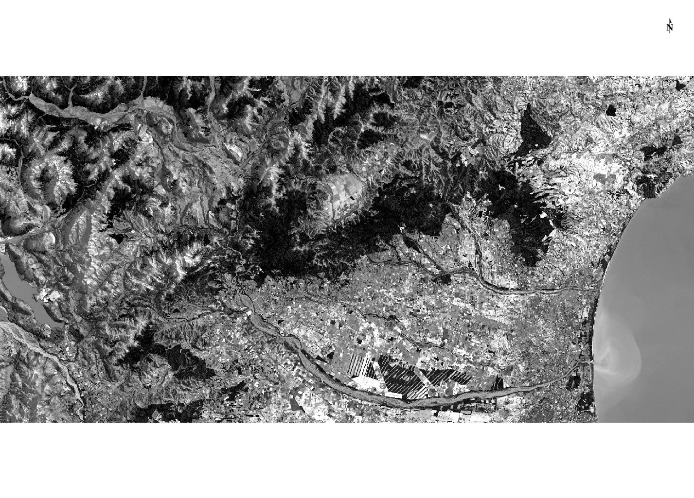*

### Exercise 4: Working with rules images (35 points)

Chip a view of every rule image to a \*.jpg image, and do an interpretation of the grey value images. Where are the rule images dark? Where are they bright? What does this mean in view of the classifier you have chosen? Also show the new classification, and describe how you have used the rule images to get your second version of image classification. Which thresholds have you applied?

### *Q5. Export all your results into a \*.jpg for inclusion into the report, annotate by answering the questions above, and upload to learn.*

### Exercise 5: Confusion matrix (10 points)

*Q6. Try an interpretation of the matrix (in your own words) using the lecture notes, ENVI Help, and the reading (p. 415/416: ‘The Error Matrix’, p. 419: ‘Overall Accuracy’ – first two paragraphs). Think about the accuracies (producer, user, overall accuracy); how are these defined? What are the accuracies for the various users?*

*Include a screenshot of your matrix and identify where you can find the numbers for producer, user, and overall accuracy.*