CPE 464 Lab 1 Worksheet

Name: Ryan Cramer

This lab worksheet needs to be typed. Each student must type in their own answers. You will upload your worksheet to Canvas. This worksheet is due on the Friday after lab at 11:59 pm.

In this lab we are going to look at some basic networking concepts and tools. The steps in this lab are:

- Program #1 questions
- Ping
- Traceroute (tracert on windows)
- Wireshark for packet analysis

This lab assumes you have already installed Wireshark. (https://www.wireshark.org/#download)

- Ping

The ping command allows you to query another computer to see if that computer is correctly connected to a network.

The format for the ping command is: ping <hostname>
You can execute this command in a Linux terminal or in the windows command window. On a Linux/Mac us: ping -c 5 <hostname>. This will limit the ping command to 5 requests/replies.

- ping a University. e.g. ping www.msu.edu. (DO NOT use www.msu.edu... Pick some other university in the US and try them. If the entire class goes to the same university, they may lock us out. Keep trying until you get all successful pings for a site.)

What is the average time it takes for this ping to be successful? (note – a ping is measured by sending and then receiving a ping packet – so it’s a round trip. We can refer to this time as RTT or round trip time.)

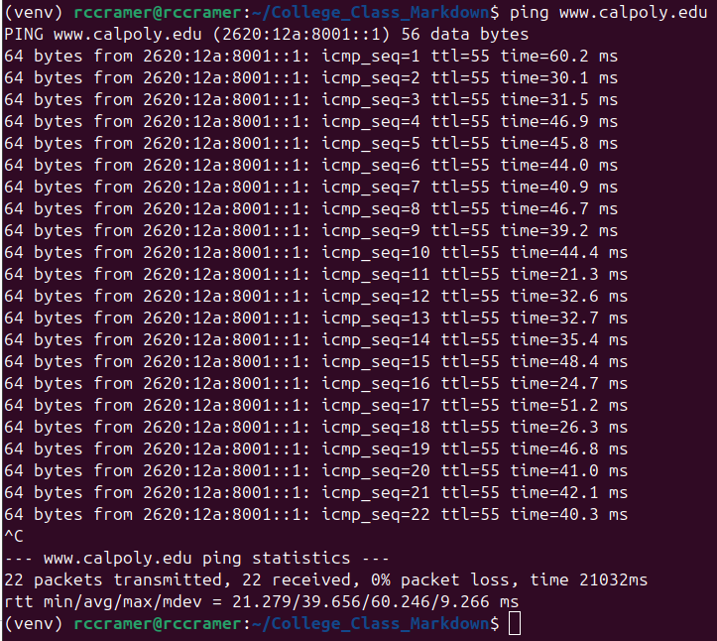

The average RTT is 39.656 milliseconds.

- ping www.imperial.ac.uk. What is the average time (RTT) it takes for this ping to be successful?

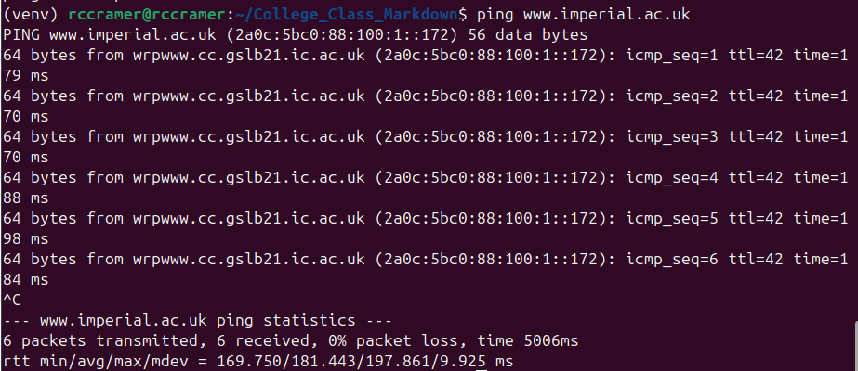
The average RTT is 181.443 milliseconds

- We talked about latency (RTT or round trip time) in lecture. Can you speculate why it takes longer to ping www.imperial.ac.uk than the US based university?

It likely takes www.imperial.ac.uk longer than www.calpoly.edu because of the physical distance, and the delay of fiber/Ethernet cabling as well as the wireless transmission.

We will look at the ping command again as part of our use of wireshark later in this lab.

- Traceroute (on windows its tracert or tracepath on newer Linux boxes)

The traceroute (tracert, tracepath) command allows you to see the path taken across the Internet. It returns the IP address or name of the routers that the packet traverses. Let’s look at the path between your location and some other locations.

- In a terminal/command window type: traceroute www.imperial.ac.uk (or on windows: tracert www.imperial.ac.uk or on some Linux boxes: tracepath www.imperial.ac.uk)

- How many hops (routers) are between you and www.imperial.ac.uk?

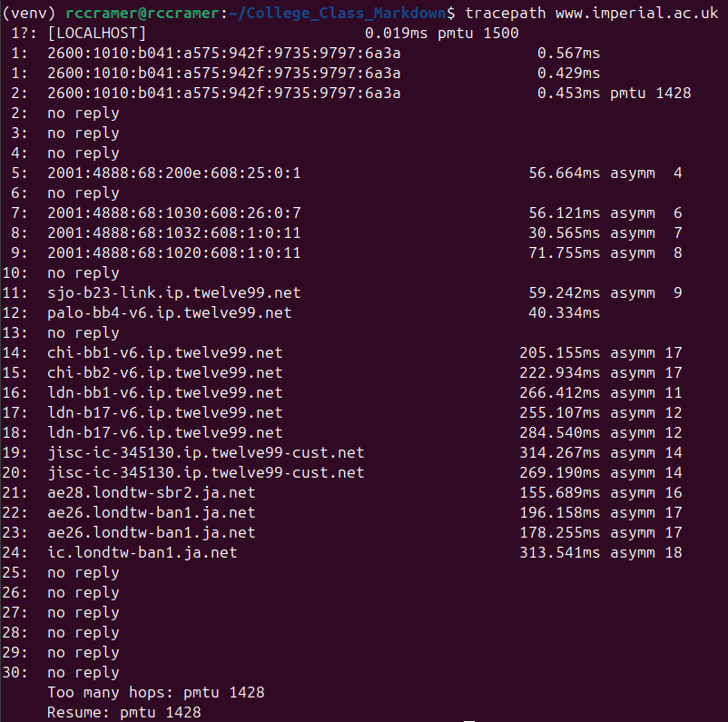
There are at least 24 known hops between myself and www.imperial.ac.uk but there could be more.

- Speculate which hop takes you from the US to England, which hop is it?

It appears that the hop that takes me from the US to England could be chi-bb1-v6.ip.twelve99.net
because the next hop is ldn-bb1. The prefix of “chi” and “ldn” leads me to believe we are hopping
from Chicago to London.

- About the first router in England:

From the traceroute, what is the name of the first router you think is in England:

Let’s look up information on that router by its name. Go to Google and search for the name of the router. (For me the router is JANET.ear3.London2.Level3.net, so I typed ‘who has JANET.ear3.London2.Level3.net’ in Google. Note, you could also look it up by IP address.)

In what country (and city) is this router located?

- Traceroute to www.umich.edu (traceroute www.umich.edu)

- How may hops are between you and www.umich.edu?

- How many routers are the same in the traceroute results for www.imperial.ac.uk and www.umich.edu?

- Wireshark.

In this part of the lab you need Wireshark (www.wireshark.org) on your computer. Wireshark allows you to analyze packet traces. These packets may be captured on a live network (this is called packet sniffing) or wireshark can analyze packet traces previously captures and stored in a file with the extension ‘.pcap’ or ‘.pcapng.’ In this lab (and in program 1) you will analyze packet trace files that I captured on my network.

Note…Your first program, called trace, is to write a simple version of a packet analyzer. You will be given packet trace files (.pcap) and are required to output information on each packet.

- Download and install wireshark (www.wireshark.org) on your computer
- Download the ping.pcap file from canvas
- Open the ping.pcap file in wireshark

First, you are going to look at to look at the headers for ping packets. For the first part of the lab, there are three headers that we are interested in. These are the Ethernet header, IP header and ICMP (ping) header.

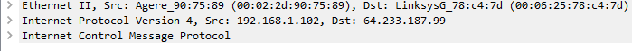

Using Wireshark, you will expand each of these headers and look at the values in these headers.

- Ethernet Overview (using the ping.pcap file)

  - Based on the lecture, draw (or list the fields in) a standard ethernet header, include the length of each field. (If you don’t remember google ethernet header).

Looking at the Ethernet header in 4th packet in the ping.pcap file via wireshark. Expand the Ethernet PDU so you can see all of the fields.

  - What is the source Ethernet MAC address in the colon notation (e.g. 05:03:…)?
  - What is the destination Ethernet MAC address?
  - This Ethernet frame caries an IP payload, what is the Ethernet Type value that specifies the this?

What is the hex value for the type field for the following payloads that may be carried by Ethernet (see https://en.wikipedia.org/wiki/EtherType):

  - Type field value for Internet Protocol version 4 (IPv4)?
  - Type field value for Internet Protocol version 6 (IPv6)?
  - Type field value for Address Resolution Protocol (ARP)?

  - Explain how you could determine that an Ethernet Frame carries a TCP segment (talk about it with your group)?

- Internet Protocol Overview (using the ping.pcap file)

Go to the 1st packet in the file. The ping protocol is called ICMP. Expand the packet in the middle window (right click then “Expand All”).

- What is the source IP address for the 1st ping request
- What is the destination IP address for the 1st ping request packet?

Compare the packet in the ping.pcap file and the IP header figure from Wikipedia:

https://en.wikipedia.org/wiki/IPv4#/media/File:IPv4_Packet-en.svg

- What Version of IP is this in binary and decimal?
- What is the header length (IHL) value in binary and decimal?
- What is the total length value?
- What is the Time to Live (TTL) value?
- What is the Protocol value?

Go to Wikipedia for a list of protocol numbers: https://en.wikipedia.org/wiki/List_of_IP_protocol_numbers

- What is the protocol number for TCP?
- What is the protocol number for UDP?
- What is the protocol number for ICMP?

- Ping – officially called Internet Control Message Protocol (ICMP)

Looking at the “Internet Control Message Protocol” section of packet #1.

    - What is the ICMP type value for the ICMP Echo request packet (packet 1)?
    - Look at packet 2, what is the type value for the ICMP Echo reply packet?
    - Back to packet 1, what is the data that was sent in the ping request packets (in ASCII – select the data in the middle window and look at what is highlighted in the bottom window)?

    - When you turn in this lab, include a screenshot of wireshark running on your computer with the ping.pcap packets.

- DHCP (still using wireshark)

Now we are going to study one of the network protocols we use every day. This protocol is called DHCP. Using Google answer the questions below.

  - What does DHCP stand for?

  - What is the purpose of DHCP?

  - Name and explain the four basic packets used in DHCP

  - Draw a packet flow diagram of the packets that flow between your computer and the DHCP server.

  - Looking at the DHCP packet trace file (found on canvas, dhcp_trace.pcapng) using wireshark, answer the following questions:

                - Looking at the first packet, expand the Ethernet II header:

  - what is the source (src) MAC address?

  - In the same packet, what is the destination (dst) MAC Address?

  - The destination MAC address is a broadcast address, explain why.

                - Looking at the DHCP Offer packet (expand this header) answer the following questions:

- What is the IP address of the DHCP server?

- How long is the lease for this DHCP offer?

- What is the client offered (your) IP Address?

- What is the Router’s IP address (this is also called a default gateway)?

  - Describe two different types of DHCP Vulnerabilities. (google DHCP security issues)

- Question Deleted.

When you are done, I recommend you begin working on program #1 called trace.

Because we are using live networks with real sites, sometimes those sites are not available or think Cal Poly is sending them too much weird traffic and stop responding. If this happens just pick another university (or really any site).
The IP version is in the first 4 bits of the first byte of the IP Header. The IHL field is the last four bits of the first byte of the IP header.

