Central Asia Barometer Data Analysis
Ryan Womack
2026-03-31
Copyright Ryan Womack, 2026. This work is licensed under CC BY-NC-SA 4.0
Central Asia Barometer Data Analysis
data wrangling, exploratory data analysis and data visualization of Central Asia Barometer Data
first developed for presentation at American University of Central Asia, Spring 2026

1. Overview
This workshop illustrates working with data, starting from the basics of importing and setting up data, and moving on to descriptive statistics, basic analysis, and data visualization. Coding is primarily in R, but also with some Python examples. Both R and Python are excellent tools for data analysis, so to some extent your choice is a matter of preference and familiarity. The R language emerged from statistics and added computing functionality, whereas Python is a general purpose computing language to which heavy doses of statistical capabilities have been added.

1.1 Definitions
Statistics is the broad field that provides rigorous tools for data analysis through mathematics. Although we may think of machine learning as a computer science topic, the fundamental theory behind machine learning is mostly statistics. Machine learning (ML) refers to many possible methods of using computing on a foundation of mathematical models, in order to understand and make predictions from data. Artificial intelligence is also part of machine learning, and until the rise in popularity of Generative AI, AI/ML usually referred to a broad suite of analytical techniques. Generative AI (GenAI) refers more narrowly to the AI that makes probabilistic guesses on the basis of massive training data, typically using Large Language Models (LLMs). Since GenAI does not provide reproducible, replicable results, it is not as useful for reliable research results. Vibe coding, or using GenAI to develop computer code and syntax, may have some applications, but is difficult to use without basic understanding of the programming languages in question. For ongoing projects that require steady modifications to an expanding codebase, GenAI is weaker at creating code that does not alter the structure of the project.

2. Installation
This workshop does not cover the installation of R and RStudio, but assumes that you have a working copy available.
R is open source software for statistical analysis, available at R-project.org. It is recommended to install R first. R commands can be executed by many editors and IDEs, directly in the terminal, or via script files. However, one of the most powerful and common methods, which we will use here, is to use the RStudio IDE.
RStudio, available from Posit as an open source download, is a tool for creating and running R code (and Python and a few other languages), with many helpful features and templates for working with the other formats and tools in the R ecosystem. RStudio will make use of your installed version of R, running as a layer on top. Posit is also developing Positron as a newer IDE with more flexibility to work with R, Python, and other possible languages. This workshop does not use Positron, although the code should also work there.
Both RStudio and Positron are introducing AI suggestion tools built into their interfaces that claim to work with and understand the specific code of your project. These should be preferred to using external services like ChatGPT.
For immediate use without installation, try the following:
- The Posit Cloud is also a free service that allows you to use RStudio (with some limitations on time and memory) with the creation of an account.
Please see the Getting Started with R video for more details (or other web tutorials and guides).
Python is also open-source, and can be used with various editors and tools, which are not detailed here.

2.1 R help
The R help system is easy to access. Use a question mark before the name of a specific function to pull up its manual page ( ?sample or ?rnorm). Use two question marks to search The help tab in the lower right quadrant of RStudio also allows full access to the built in help, including manuals and searching.
Searching the internet for R help can be useful, since there are a wealth of tutorials, blog posts, and other material on general methods and specific R packages. It is helpful to add something like “R statistics” or “R software” or “R package” to your search to distinguish from all other uses of the letter R!

3. Setup and preparing data

3.1 R packages required
We will use the pak package for installation as a more complete approach to package management. Replace the pkg commands with install.packages() versions if you prefer.
This session relies on the tidyverse suite of packages for data manipulation as a preference, although the same tasks could be accomplished in base R using other functions. Install pak and tidyverse if you don’t already have them on your system. We will also need reticulate to run Python code chunks.
install.packages("pak", dependencies=TRUE)
library(pak)
pkg_install("tidyverse")
pkg_install("readxl")
pkg_install("reticulate")
devtools::session_info()
Note that the update.packages() command can be run periodically to check for newer versions of any packages installed.
Load the packages so that we can work with them.
library(readxl)
library(tidyverse)
── Attaching core tidyverse packages ──────────────────────── tidyverse 2.0.0 ──
✔ dplyr 1.2.0 ✔ readr 2.2.0
✔ forcats 1.0.1 ✔ stringr 1.6.0
✔ ggplot2 4.0.2 ✔ tibble 3.3.1
✔ lubridate 1.9.5 ✔ tidyr 1.3.2
✔ purrr 1.2.1
── Conflicts ────────────────────────────────────────── tidyverse_conflicts() ──
✖ dplyr::filter() masks stats::filter()
✖ dplyr::lag() masks stats::lag()
ℹ Use the conflicted package (<http://conflicted.r-lib.org/>) to force all conflicts to become errors

3.2 Versions
The links to the right provide alternate modes of accessing this content. You can choose Light or Dark mode HTML, a downloadable PDF, or a Word Docx format file all representing the same content. Code files with R (.R) or Python (.py) are also available, if you’d like to isolate the code from the description.

3.3 Kyrgyz and Russian language
Also, machine-translated versions of this content in Russian and Kyrgyz are linked on the right.

3.4 Python support
Now let’s load reticulate (for Python support only). We must set the correct location of python corresponding to our system.
A Python file is provided for those who want to try out the same data steps in Python. Note that the Python file was machine-translated from R.
# Sys.setenv(RETICULATE_PYTHON = "/usr/bin/python3")
library(reticulate)
use_python("/usr/bin/python3")

4. Central Asia Barometer
As you are probably aware, the Central Asia Barometer project conducts polls and surveys across the countries of Central Asia (Kazakhstan, Kyrgyzstan, Tajikistan, Turkmenistan, and Uzbekistan) and releases the results on a regular basis. Except for the latest wave of data, the CA Barometer data is freely downloadable from their website after providing a contact e-mail. These surveys examine contemporary political and social attitudes, and allow for longitudinal comparisons over time and cross-country comparisons.
For this initial workshop, we will get familiar with the CA Barometer by looking at recent data (2022) for one country (Kyrgyzstan). The second workshop will extend and deepen our understanding by adding additional years and countries to our analysis, and explore more complex data manipulation and analysis.

4.1 Understanding the data
Before worrying about coding or statistical analysis, the first step in working with real-world data is to develop an understanding of its structure and meaning. We want to know what data has been collected, how it has been organized, and think about what kinds of questions it can answer. Only then can we know how to properly proceed with analyzing it.
For CA Barometer, this means looking at the Questionnaire (for the 2022 wave) and the Methods Report for that year.

5. Download and import data
We download data from Central Asia Barometer at https://ca-barometer.org/assets/files/projects/cab-survey-wave-12-excel-kyrgyzstan-kyrgyzstan-2022-autumn.xlsx
download.file("https://ca-barometer.org/assets/files/projects/cab-survey-wave-12-excel-kyrgyzstan-kyrgyzstan-2022-autumn.xlsx", "CAB_2022.csv")
mydata <- read_excel("CAB_2022.csv")
mydata
# A tibble: 1,518 × 158
MM1 MM2b MM3a MM3b MM4 MM5 MM6 MM7 MM8
<dbl> <dbl> <dbl> <chr> <chr> <dbl> <chr> <dbl> <dttm>
1 100017 778 6 CATI Kyrgyzstan 329 Female 1 2022-11-01 00:00:00
2 100028 771 6 CATI Kyrgyzstan 163 Female 1 2022-11-01 00:00:00
3 100035 505 6 CATI Kyrgyzstan 329 Female 1 2022-11-01 00:00:00
4 100036 509 6 CATI Kyrgyzstan 311 Female 1 2022-11-01 00:00:00
5 100048 706 6 CATI Kyrgyzstan 329 Female 1 2022-11-01 00:00:00
6 100054 504 6 CATI Kyrgyzstan 329 Female 1 2022-11-01 00:00:00
7 100085 502 6 CATI Kyrgyzstan 210 Female 1 2022-11-01 00:00:00
8 100086 708 6 CATI Kyrgyzstan 251 Female 1 2022-11-01 00:00:00
9 100087 500 6 CATI Kyrgyzstan 329 Female 1 2022-11-01 00:00:00
10 100099 553 6 CATI Kyrgyzstan 329 Female 1 2022-11-01 00:00:00
# ℹ 1,508 more rows
# ℹ 149 more variables: MM9 <dttm>, MM10 <chr>, MM11 <chr>, MM12 <dttm>,
# MM13 <dttm>, MM14 <chr>, A1a <chr>, A1b <chr>, A2 <chr>, A3a <chr>,
# A3b <chr>, A4a <chr>, A4b <chr>, A4c <chr>, A4d <chr>, A4e <chr>,
# A4f <chr>, A5a <chr>, A5b <chr>, A5c <chr>, A5d <chr>, A6 <chr>, A7 <chr>,
# B1 <chr>, B2 <chr>, B3 <chr>, B4a <chr>, B4b <chr>, B5a <chr>, B5b <chr>,
# B6a <chr>, B6b <chr>, B6c <chr>, B6d <chr>, B6e <chr>, B7 <chr>, …
attach(mydata)

6. Data Wrangling

6.1 Selection and naming
We select interesting variables from the questionnaire to analyze. We’ll also change their names to something more memorable.
We want to study across several dimensions:
- language, region, income, sex
and relate this to opinions. We can spend some time looking at the questionnaire to see how these variables are labeled.
Note that MM4 is the country code, but we have already loaded the Kyrgyz file, so we don’t need to explicitly select this. Also note that ethnic group is already labeled ‘EthnicGrp’. Other variables we will make more intuitive to access by renaming them.
names(mydata)
[1] "MM1" "MM2b" "MM3a" "MM3b" "MM4" "MM5"
[7] "MM6" "MM7" "MM8" "MM9" "MM10" "MM11"
[13] "MM12" "MM13" "MM14" "A1a" "A1b" "A2"
[19] "A3a" "A3b" "A4a" "A4b" "A4c" "A4d"
[25] "A4e" "A4f" "A5a" "A5b" "A5c" "A5d"
[31] "A6" "A7" "B1" "B2" "B3" "B4a"
[37] "B4b" "B5a" "B5b" "B6a" "B6b" "B6c"
[43] "B6d" "B6e" "B7" "B8" "B9a" "B9b"
[49] "B9c" "B9d" "B10" "B11a" "B11b" "B12"
[55] "B13" "B14" "B15a" "B15b" "B15c" "B15d"
[61] "B16" "D1" "D2a" "D2b" "E1a" "E1b"
[67] "E1c" "E1d" "E1e" "E2a" "E2b" "E2c"
[73] "E2d" "E2e" "E3" "E4a" "E4b" "E5a"
[79] "E5b" "E5c" "E6a" "E6b" "E7a" "E7b"
[85] "E7c" "E8a" "E8b" "E8c" "E8d" "E8e"
[91] "E9a" "E9b" "E10" "E11" "E12" "E13"
[97] "E14" "E15a" "E15b" "E15c" "E16" "E17"
[103] "E19a" "E19b" "E19c" "E20a" "E20b" "E20c"
[109] "E21" "G1a" "G1b" "G2" "G3a" "G3b"
[115] "G4" "G5" "G6" "G7" "G8" "G9"
[121] "H1" "H2" "H3" "H4" "H5a" "H5b"
[127] "DD1" "DD2" "DD3" "DD4" "DD5" "DD6a"
[133] "DD6b" "DD6c" "DD7a" "DD7b" "DD7c" "DD8"
[139] "DD9a" "DD9b" "DD9c" "DD9d" "DD10" "DD11"
[145] "DD12" "DD13" "DD14" "DD15" "DD16" "DD17"
[151] "DD18a" "DD18b" "DD19" "DD20" "EthnicGrp" "AgeGrp"
[157] "FinalWgt1" "FinalWgt2"
mydata <- mydata |> rename('Sex'='DD1', 'Region'='MM10', 'Language'='DD11','Income'='DD8')
attach(mydata)
The following objects are masked from mydata (pos = 3):
A1a, A1b, A2, A3a, A3b, A4a, A4b, A4c, A4d, A4e, A4f, A5a, A5b,
A5c, A5d, A6, A7, AgeGrp, B1, B10, B11a, B11b, B12, B13, B14, B15a,
B15b, B15c, B15d, B16, B2, B3, B4a, B4b, B5a, B5b, B6a, B6b, B6c,
B6d, B6e, B7, B8, B9a, B9b, B9c, B9d, D1, D2a, D2b, DD10, DD12,
DD13, DD14, DD15, DD16, DD17, DD18a, DD18b, DD19, DD2, DD20, DD3,
DD4, DD5, DD6a, DD6b, DD6c, DD7a, DD7b, DD7c, DD9a, DD9b, DD9c,
DD9d, E10, E11, E12, E13, E14, E15a, E15b, E15c, E16, E17, E19a,
E19b, E19c, E1a, E1b, E1c, E1d, E1e, E20a, E20b, E20c, E21, E2a,
E2b, E2c, E2d, E2e, E3, E4a, E4b, E5a, E5b, E5c, E6a, E6b, E7a,
E7b, E7c, E8a, E8b, E8c, E8d, E8e, E9a, E9b, EthnicGrp, FinalWgt1,
FinalWgt2, G1a, G1b, G2, G3a, G3b, G4, G5, G6, G7, G8, G9, H1, H2,
H3, H4, H5a, H5b, MM1, MM11, MM12, MM13, MM14, MM2b, MM3a, MM3b,
MM4, MM5, MM6, MM7, MM8, MM9

6.2 Descriptive statistics
Let’s take a look at several of these variables and see how they’re distributed. A simple table command will do the trick for getting initial familiarity with the data. While some large datasets are difficult to gain intuitive understanding of, for this kind of social science data, nothing beats spending time looking over the data before getting into more complex analysis. We may also discover outliers or issues to remedy before moving forward.
table(Sex)
Sex
Female Male
750 768
table(Region)
Region
Batkenskaja Bishkek Chujskaja Dzhalal-Abadskaja
105 399 228 222
Issyk-Kul'skaja Narynskaja Osh City Oshskaja
142 83 65 214
Talaskaja
60
table(Language)
Language
Don't Know (vol.) Kazakh Kyrgyz Other (vol.)
2 1 1280 14
Refused (vol.) Russian Tajik Turkmen
1 154 1 2
Uzbek
63
table(Income)
Income
10,001 - 12,000 som 12,001 - 16,000 som 16,001 - 20,000 som
71 136 160
2,801 - 4,100 som 20,001 - 28,000 som 4,101 - 6,000 som
33 185 46
6,001 - 8,000 som 8,001 - 10,000 som Don't Know (vol.)
36 96 84
Less than 2,801 som More than 28,000 som Refused (vol.)
40 570 61
table(EthnicGrp)
EthnicGrp
Kyrgyz Other Russian Uzbek
1315 62 63 78
table(Sex,Language)
Language
Sex Don't Know (vol.) Kazakh Kyrgyz Other (vol.) Refused (vol.) Russian
Female 1 0 627 5 1 92
Male 1 1 653 9 0 62
Language
Sex Tajik Turkmen Uzbek
Female 1 1 22
Male 0 1 41
table(Income, Sex)
Sex
Income Female Male
10,001 - 12,000 som 36 35
12,001 - 16,000 som 71 65
16,001 - 20,000 som 84 76
2,801 - 4,100 som 17 16
20,001 - 28,000 som 95 90
4,101 - 6,000 som 30 16
6,001 - 8,000 som 21 15
8,001 - 10,000 som 56 40
Don't Know (vol.) 49 35
Less than 2,801 som 17 23
More than 28,000 som 251 319
Refused (vol.) 23 38
table(E17)
E17
A few more months A few more weeks About another week Another month
333 21 27 65
Another year Don't know (vol.) More than a year Refused (vol.)
279 373 209 16
Several more days Two years or more
32 163

6.3 Recoding data
One issue that we discover is that Income is reported in categories, by range. If we want to treat Income as a number, we will have to recode it. We set each range to its rough midpoint in the code below, using the recode_values command.
mydata$Income_Numeric <- recode_values(
Income,
"Less than 2,801 som" ~ 1400,
"2,801 - 4,100 som" ~ 3400,
"4,101 - 6,000 som" ~ 5000,
"6,001 - 8,000 som" ~ 7000,
"8,001 - 10,000 som" ~ 9000,
"10,001 - 12,000 som" ~ 11000,
"12,001 - 16,000 som" ~ 14000,
"16,001 - 20,000 som" ~ 18000,
"20,001 - 28,000 som" ~ 24000,
"More than 28,000 som" ~ 40000,
c("Don't Know (vol.)", "Refused (vol.)") ~ NA
)
We reattach the data to make sure the new variable, Income_Numeric, is easily available, then check how it turned out.
attach(mydata)
The following objects are masked from mydata (pos = 3):
A1a, A1b, A2, A3a, A3b, A4a, A4b, A4c, A4d, A4e, A4f, A5a, A5b,
A5c, A5d, A6, A7, AgeGrp, B1, B10, B11a, B11b, B12, B13, B14, B15a,
B15b, B15c, B15d, B16, B2, B3, B4a, B4b, B5a, B5b, B6a, B6b, B6c,
B6d, B6e, B7, B8, B9a, B9b, B9c, B9d, D1, D2a, D2b, DD10, DD12,
DD13, DD14, DD15, DD16, DD17, DD18a, DD18b, DD19, DD2, DD20, DD3,
DD4, DD5, DD6a, DD6b, DD6c, DD7a, DD7b, DD7c, DD9a, DD9b, DD9c,
DD9d, E10, E11, E12, E13, E14, E15a, E15b, E15c, E16, E17, E19a,
E19b, E19c, E1a, E1b, E1c, E1d, E1e, E20a, E20b, E20c, E21, E2a,
E2b, E2c, E2d, E2e, E3, E4a, E4b, E5a, E5b, E5c, E6a, E6b, E7a,
E7b, E7c, E8a, E8b, E8c, E8d, E8e, E9a, E9b, EthnicGrp, FinalWgt1,
FinalWgt2, G1a, G1b, G2, G3a, G3b, G4, G5, G6, G7, G8, G9, H1, H2,
H3, H4, H5a, H5b, Income, Language, MM1, MM11, MM12, MM13, MM14,
MM2b, MM3a, MM3b, MM4, MM5, MM6, MM7, MM8, MM9, Region, Sex
The following objects are masked from mydata (pos = 4):
A1a, A1b, A2, A3a, A3b, A4a, A4b, A4c, A4d, A4e, A4f, A5a, A5b,
A5c, A5d, A6, A7, AgeGrp, B1, B10, B11a, B11b, B12, B13, B14, B15a,
B15b, B15c, B15d, B16, B2, B3, B4a, B4b, B5a, B5b, B6a, B6b, B6c,
B6d, B6e, B7, B8, B9a, B9b, B9c, B9d, D1, D2a, D2b, DD10, DD12,
DD13, DD14, DD15, DD16, DD17, DD18a, DD18b, DD19, DD2, DD20, DD3,
DD4, DD5, DD6a, DD6b, DD6c, DD7a, DD7b, DD7c, DD9a, DD9b, DD9c,
DD9d, E10, E11, E12, E13, E14, E15a, E15b, E15c, E16, E17, E19a,
E19b, E19c, E1a, E1b, E1c, E1d, E1e, E20a, E20b, E20c, E21, E2a,
E2b, E2c, E2d, E2e, E3, E4a, E4b, E5a, E5b, E5c, E6a, E6b, E7a,
E7b, E7c, E8a, E8b, E8c, E8d, E8e, E9a, E9b, EthnicGrp, FinalWgt1,
FinalWgt2, G1a, G1b, G2, G3a, G3b, G4, G5, G6, G7, G8, G9, H1, H2,
H3, H4, H5a, H5b, MM1, MM11, MM12, MM13, MM14, MM2b, MM3a, MM3b,
MM4, MM5, MM6, MM7, MM8, MM9
mean(Income_Numeric, na.rm=TRUE)
[1] 24995.78
hist(Income_Numeric)
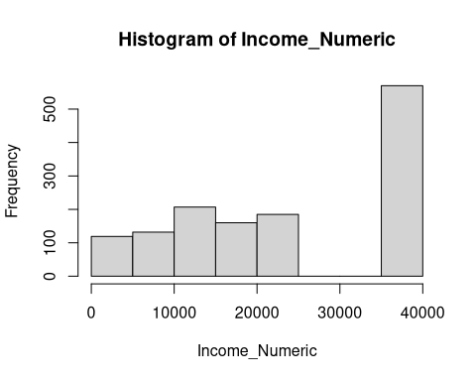
mydata |>
group_by(Sex) |>
summarize(Inc = mean(Income_Numeric, na.rm=TRUE))
# A tibble: 2 × 2
Sex Inc
<chr> <dbl>
1 Female 23753.
2 Male 26208.
# t-tests or chi-sq for significance
# try a t-test
# is income significantly different by sex - yes
t.test(Income_Numeric~Sex)
Welch Two Sample t-test
data: Income_Numeric by Sex
t = -3.3228, df = 1370.6, p-value = 0.0009147
alternative hypothesis: true difference in means between group Female and group Male is not equal to 0
95 percent confidence interval:
-3904.313 -1005.607
sample estimates:
mean in group Female mean in group Male
23753.10 26208.06

7. Plots - Data Visualization
We can pick any general issue to focus on, such as which messenger app people use. Actually, in Kyrgyzstan everyone uses WhatsApp, so perhaps not so interesting! Let’s pick something more general, like whether the country is going in the right or wrong direction.
table(Sex,A3a)
A3a
Sex Do not use chat rooms or messengers Don't Know (vol.) Other (vol.)
Female 16 2 1
Male 22 1 7
A3a
Sex Telegram Viber WhatsApp
Female 41 0 690
Male 52 1 685
table(D1)
D1
Don't Know (vol.) Refused (vol.) Right direction Wrong direction
138 16 1157 207
table(D1, Sex)
Sex
D1 Female Male
Don't Know (vol.) 72 66
Refused (vol.) 9 7
Right direction 579 578
Wrong direction 90 117
table(D1, Region)
Region
D1 Batkenskaja Bishkek Chujskaja Dzhalal-Abadskaja
Don't Know (vol.) 5 40 22 19
Refused (vol.) 1 2 5 3
Right direction 90 266 162 181
Wrong direction 9 91 39 19
Region
D1 Issyk-Kul'skaja Narynskaja Osh City Oshskaja Talaskaja
Don't Know (vol.) 6 8 8 18 12
Refused (vol.) 3 0 0 2 0
Right direction 125 69 53 173 38
Wrong direction 8 6 4 21 10
table(D1, Language)
Language
D1 Don't Know (vol.) Kazakh Kyrgyz Other (vol.) Refused (vol.)
Don't Know (vol.) 1 0 112 1 0
Refused (vol.) 0 0 10 0 1
Right direction 1 1 1009 11 0
Wrong direction 0 0 149 2 0
Language
D1 Russian Tajik Turkmen Uzbek
Don't Know (vol.) 20 0 0 4
Refused (vol.) 4 0 0 1
Right direction 79 1 2 53
Wrong direction 51 0 0 5
table(D1, Income_Numeric)
Income_Numeric
D1 1400 3400 5000 7000 9000 11000 14000 18000 24000 40000
Don't Know (vol.) 3 1 3 2 11 6 7 17 15 50
Refused (vol.) 0 2 0 0 1 1 2 0 1 7
Right direction 31 26 38 30 78 56 115 125 147 414
Wrong direction 6 4 5 4 6 8 12 18 22 99
Recode to drop ‘Don’t Know’ and ‘Refused’
mydata$D1_recode <- recode_values(
D1,
"Right direction" ~ "Right",
"Wrong direction" ~ "Wrong",
c("Don't Know (vol.)", "Refused (vol.)") ~ NA
)
mydata$D1_recode <- as.factor(mydata$D1_recode)
attach(mydata)
The following objects are masked from mydata (pos = 3):
A1a, A1b, A2, A3a, A3b, A4a, A4b, A4c, A4d, A4e, A4f, A5a, A5b,
A5c, A5d, A6, A7, AgeGrp, B1, B10, B11a, B11b, B12, B13, B14, B15a,
B15b, B15c, B15d, B16, B2, B3, B4a, B4b, B5a, B5b, B6a, B6b, B6c,
B6d, B6e, B7, B8, B9a, B9b, B9c, B9d, D1, D2a, D2b, DD10, DD12,
DD13, DD14, DD15, DD16, DD17, DD18a, DD18b, DD19, DD2, DD20, DD3,
DD4, DD5, DD6a, DD6b, DD6c, DD7a, DD7b, DD7c, DD9a, DD9b, DD9c,
DD9d, E10, E11, E12, E13, E14, E15a, E15b, E15c, E16, E17, E19a,
E19b, E19c, E1a, E1b, E1c, E1d, E1e, E20a, E20b, E20c, E21, E2a,
E2b, E2c, E2d, E2e, E3, E4a, E4b, E5a, E5b, E5c, E6a, E6b, E7a,
E7b, E7c, E8a, E8b, E8c, E8d, E8e, E9a, E9b, EthnicGrp, FinalWgt1,
FinalWgt2, G1a, G1b, G2, G3a, G3b, G4, G5, G6, G7, G8, G9, H1, H2,
H3, H4, H5a, H5b, Income, Income_Numeric, Language, MM1, MM11,
MM12, MM13, MM14, MM2b, MM3a, MM3b, MM4, MM5, MM6, MM7, MM8, MM9,
Region, Sex
The following objects are masked from mydata (pos = 4):
A1a, A1b, A2, A3a, A3b, A4a, A4b, A4c, A4d, A4e, A4f, A5a, A5b,
A5c, A5d, A6, A7, AgeGrp, B1, B10, B11a, B11b, B12, B13, B14, B15a,
B15b, B15c, B15d, B16, B2, B3, B4a, B4b, B5a, B5b, B6a, B6b, B6c,
B6d, B6e, B7, B8, B9a, B9b, B9c, B9d, D1, D2a, D2b, DD10, DD12,
DD13, DD14, DD15, DD16, DD17, DD18a, DD18b, DD19, DD2, DD20, DD3,
DD4, DD5, DD6a, DD6b, DD6c, DD7a, DD7b, DD7c, DD9a, DD9b, DD9c,
DD9d, E10, E11, E12, E13, E14, E15a, E15b, E15c, E16, E17, E19a,
E19b, E19c, E1a, E1b, E1c, E1d, E1e, E20a, E20b, E20c, E21, E2a,
E2b, E2c, E2d, E2e, E3, E4a, E4b, E5a, E5b, E5c, E6a, E6b, E7a,
E7b, E7c, E8a, E8b, E8c, E8d, E8e, E9a, E9b, EthnicGrp, FinalWgt1,
FinalWgt2, G1a, G1b, G2, G3a, G3b, G4, G5, G6, G7, G8, G9, H1, H2,
H3, H4, H5a, H5b, Income, Language, MM1, MM11, MM12, MM13, MM14,
MM2b, MM3a, MM3b, MM4, MM5, MM6, MM7, MM8, MM9, Region, Sex
The following objects are masked from mydata (pos = 5):
A1a, A1b, A2, A3a, A3b, A4a, A4b, A4c, A4d, A4e, A4f, A5a, A5b,
A5c, A5d, A6, A7, AgeGrp, B1, B10, B11a, B11b, B12, B13, B14, B15a,
B15b, B15c, B15d, B16, B2, B3, B4a, B4b, B5a, B5b, B6a, B6b, B6c,
B6d, B6e, B7, B8, B9a, B9b, B9c, B9d, D1, D2a, D2b, DD10, DD12,
DD13, DD14, DD15, DD16, DD17, DD18a, DD18b, DD19, DD2, DD20, DD3,
DD4, DD5, DD6a, DD6b, DD6c, DD7a, DD7b, DD7c, DD9a, DD9b, DD9c,
DD9d, E10, E11, E12, E13, E14, E15a, E15b, E15c, E16, E17, E19a,
E19b, E19c, E1a, E1b, E1c, E1d, E1e, E20a, E20b, E20c, E21, E2a,
E2b, E2c, E2d, E2e, E3, E4a, E4b, E5a, E5b, E5c, E6a, E6b, E7a,
E7b, E7c, E8a, E8b, E8c, E8d, E8e, E9a, E9b, EthnicGrp, FinalWgt1,
FinalWgt2, G1a, G1b, G2, G3a, G3b, G4, G5, G6, G7, G8, G9, H1, H2,
H3, H4, H5a, H5b, MM1, MM11, MM12, MM13, MM14, MM2b, MM3a, MM3b,
MM4, MM5, MM6, MM7, MM8, MM9

7.1 Illustrative plots
Here are a few illustrative plots. We’re not trying to make them pretty at this point, just trying to quickly understand our data.
# Some illustrative plots
ggplot(data=mydata, aes(x=Income_Numeric, y=Region))+geom_point()
Warning: Removed 145 rows containing missing values or values outside the scale range
(`geom_point()`).
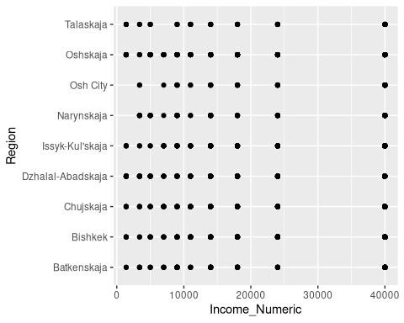
ggplot(data=mydata, aes(x=Region, y=Income_Numeric))+geom_jitter()
Warning: Removed 145 rows containing missing values or values outside the scale range
(`geom_point()`).
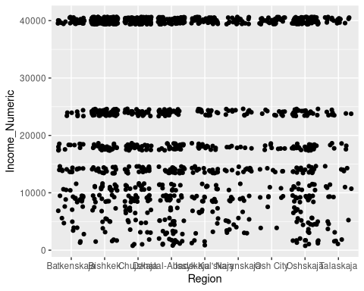
boxplot(Income_Numeric~D1)
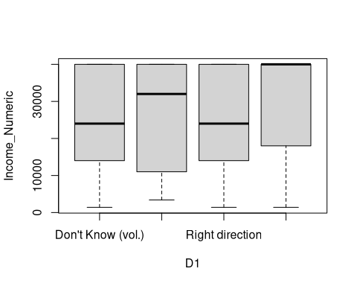
boxplot(Income_Numeric~D1_recode)
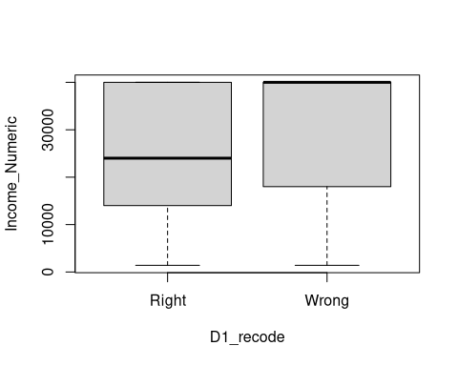
ggplot(mydata, aes(x=D1_recode))+facet_grid(~Sex)+geom_bar()
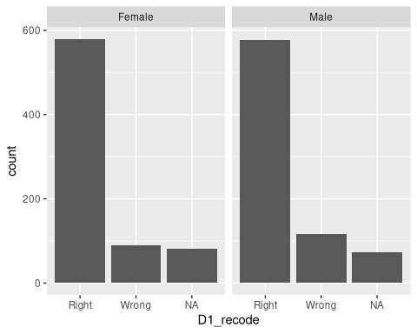

8. Further statistical analysis

8.1 Logistic regresssion
As an example of statistical analysis, we can try a logistic regression to predict the answer to the right direction question. Logistic regression is the suitable method for when the outcome is a binary choice (yes/no, true/false, right/wrong).
logistic_output <- glm(D1_recode ~ Sex + Language + Income_Numeric, family=binomial, data=mydata)
summary(logistic_output)
Call:
glm(formula = D1_recode ~ Sex + Language + Income_Numeric, family = binomial,
data = mydata)
Coefficients:
Estimate Std. Error z value Pr(>|z|)
(Intercept) -1.504e+01 8.827e+02 -0.017 0.98641
SexMale 3.881e-01 1.688e-01 2.298 0.02154 *
LanguageKazakh -2.200e-01 1.248e+03 0.000 0.99986
LanguageKyrgyz 1.246e+01 8.827e+02 0.014 0.98874
LanguageOther (vol.) 1.258e+01 8.827e+02 0.014 0.98863
LanguageRussian 1.390e+01 8.827e+02 0.016 0.98744
LanguageTajik 6.654e-02 1.248e+03 0.000 0.99996
LanguageTurkmen -4.101e-01 1.080e+03 0.000 0.99970
LanguageUzbek 1.178e+01 8.827e+02 0.013 0.98935
Income_Numeric 1.692e-05 6.179e-06 2.739 0.00617 **
---
Signif. codes: 0 '***' 0.001 '**' 0.01 '*' 0.05 '.' 0.1 ' ' 1
(Dispersion parameter for binomial family taken to be 1)
Null deviance: 1042.64 on 1243 degrees of freedom
Residual deviance: 983.01 on 1234 degrees of freedom
(274 observations deleted due to missingness)
AIC: 1003
Number of Fisher Scoring iterations: 13

9. Other possibilities
These are some notes on additional interesting variables in the data, although feel free to pick your own and explore.
Question B13 - “Have Russians been emigrating to your area?” could be analyzed by region
Question E17 - “How long will conflict with Ukraine last?” asked in 2022
Question G3b - “Attitude toward President Japarov?” what breakdowns would be interesting here?

10. Conclusion
There is no one stopping point for data analysis. Keep going until you have a full understanding of the data and its interaction with the questions you seek to answer. The second part of this workshop series will illustrate more advanced methods and combinations of data.
See Data Analysis 1 and Data Analysis 2 for further discussion of data analysis techniques.

10.1 R for Data Science
Consult the R for Data Science book to learn more about data wrangling. Also check out tidymodels a collection of packages for modeling and machine learning using tidyverse principles.

