atom 10000 bucket 500 GPU

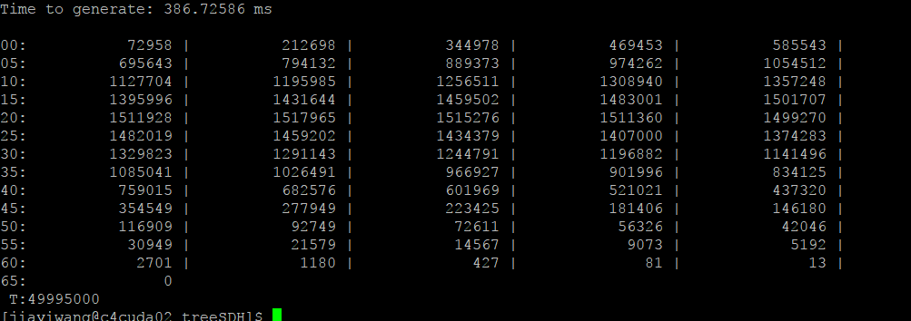

atom 10000 bucket 500 CPU

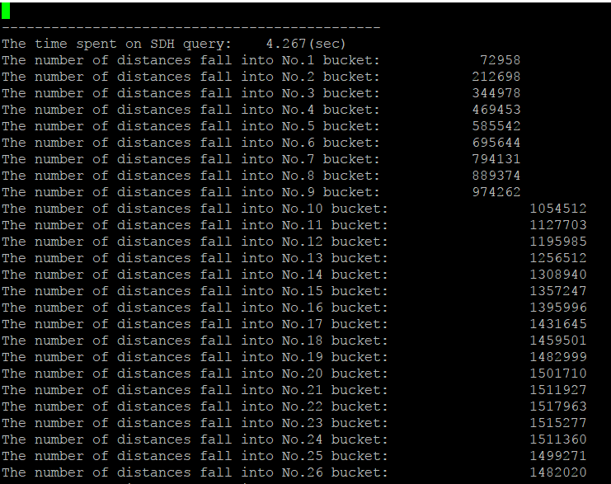

atom 100000 bucket 1000 CPU

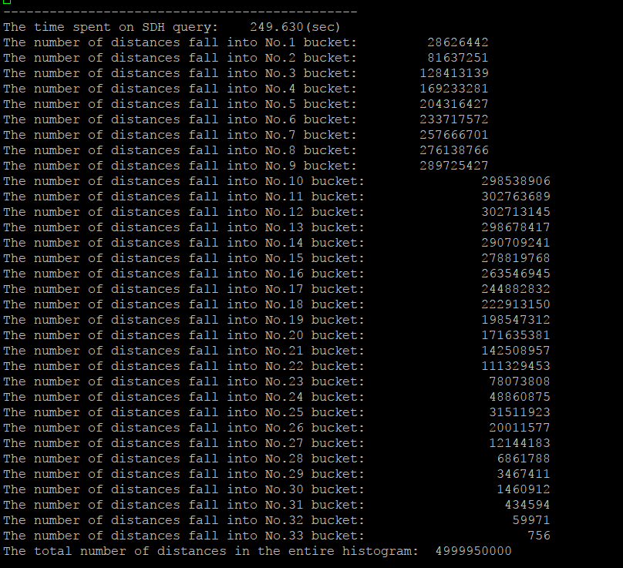

atom 100000 bucket 1000 GPU

