# CS 255 System Design Document Template

This template lays out all the different sections that you need to complete for Project Two. Each section has guidance to prompt your thinking. You will need to continually reference the interview transcript as you work to make sure that you are addressing your client’s needs. There is no required length for the final document. Instead the goal is to complete each section based on what your client’s needs are. Remove this note when you are finished, and replace all bracketed text with the relevant information.

## UML Diagrams

### UML Use Case Diagram

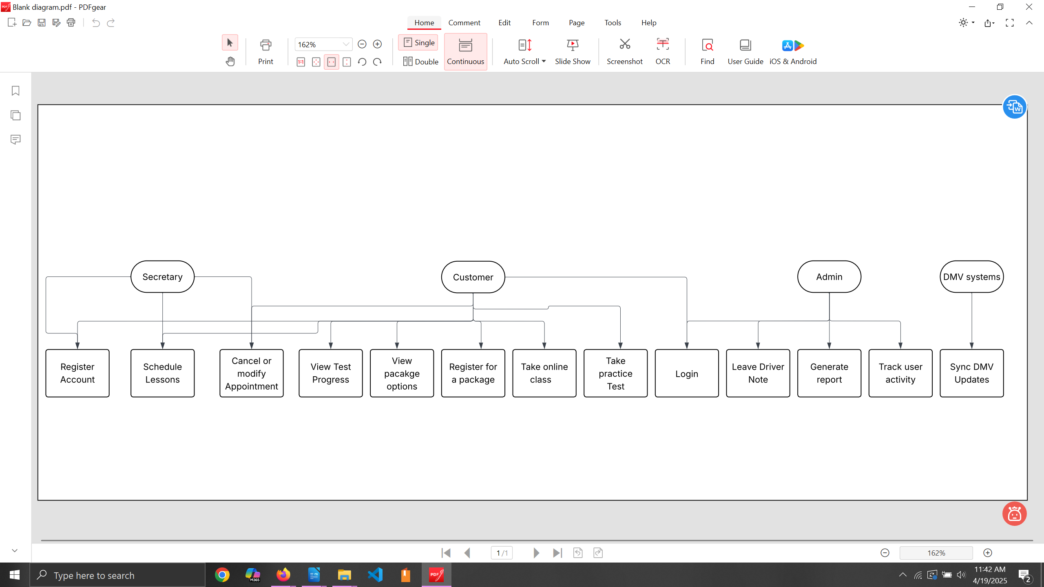

### UML Activity Diagrams

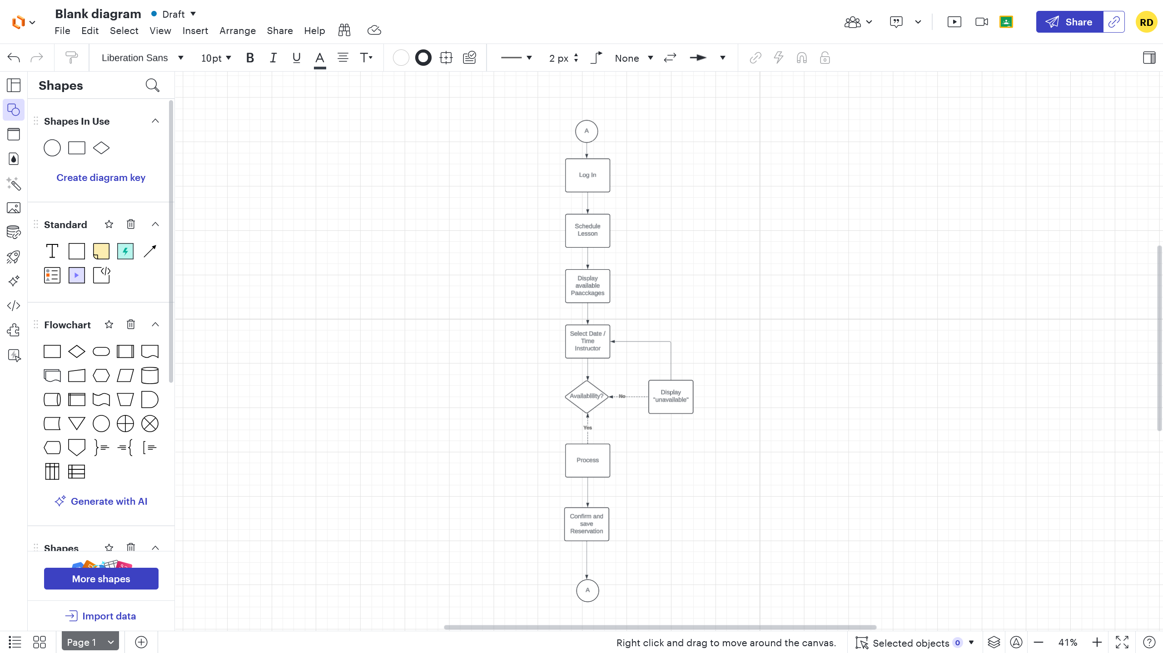

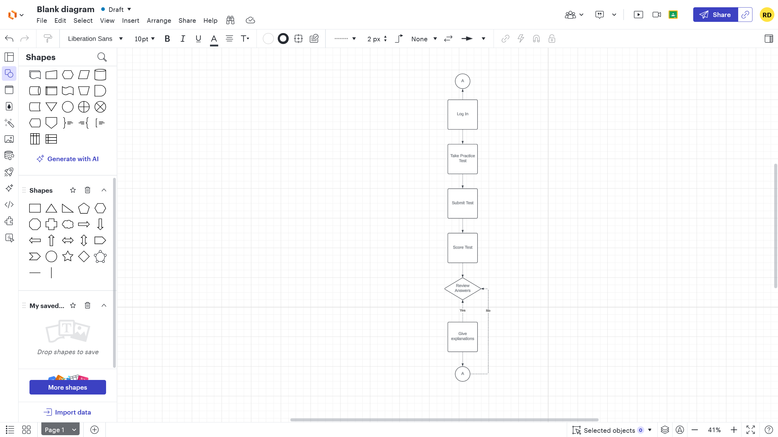

### UML Sequence Diagram

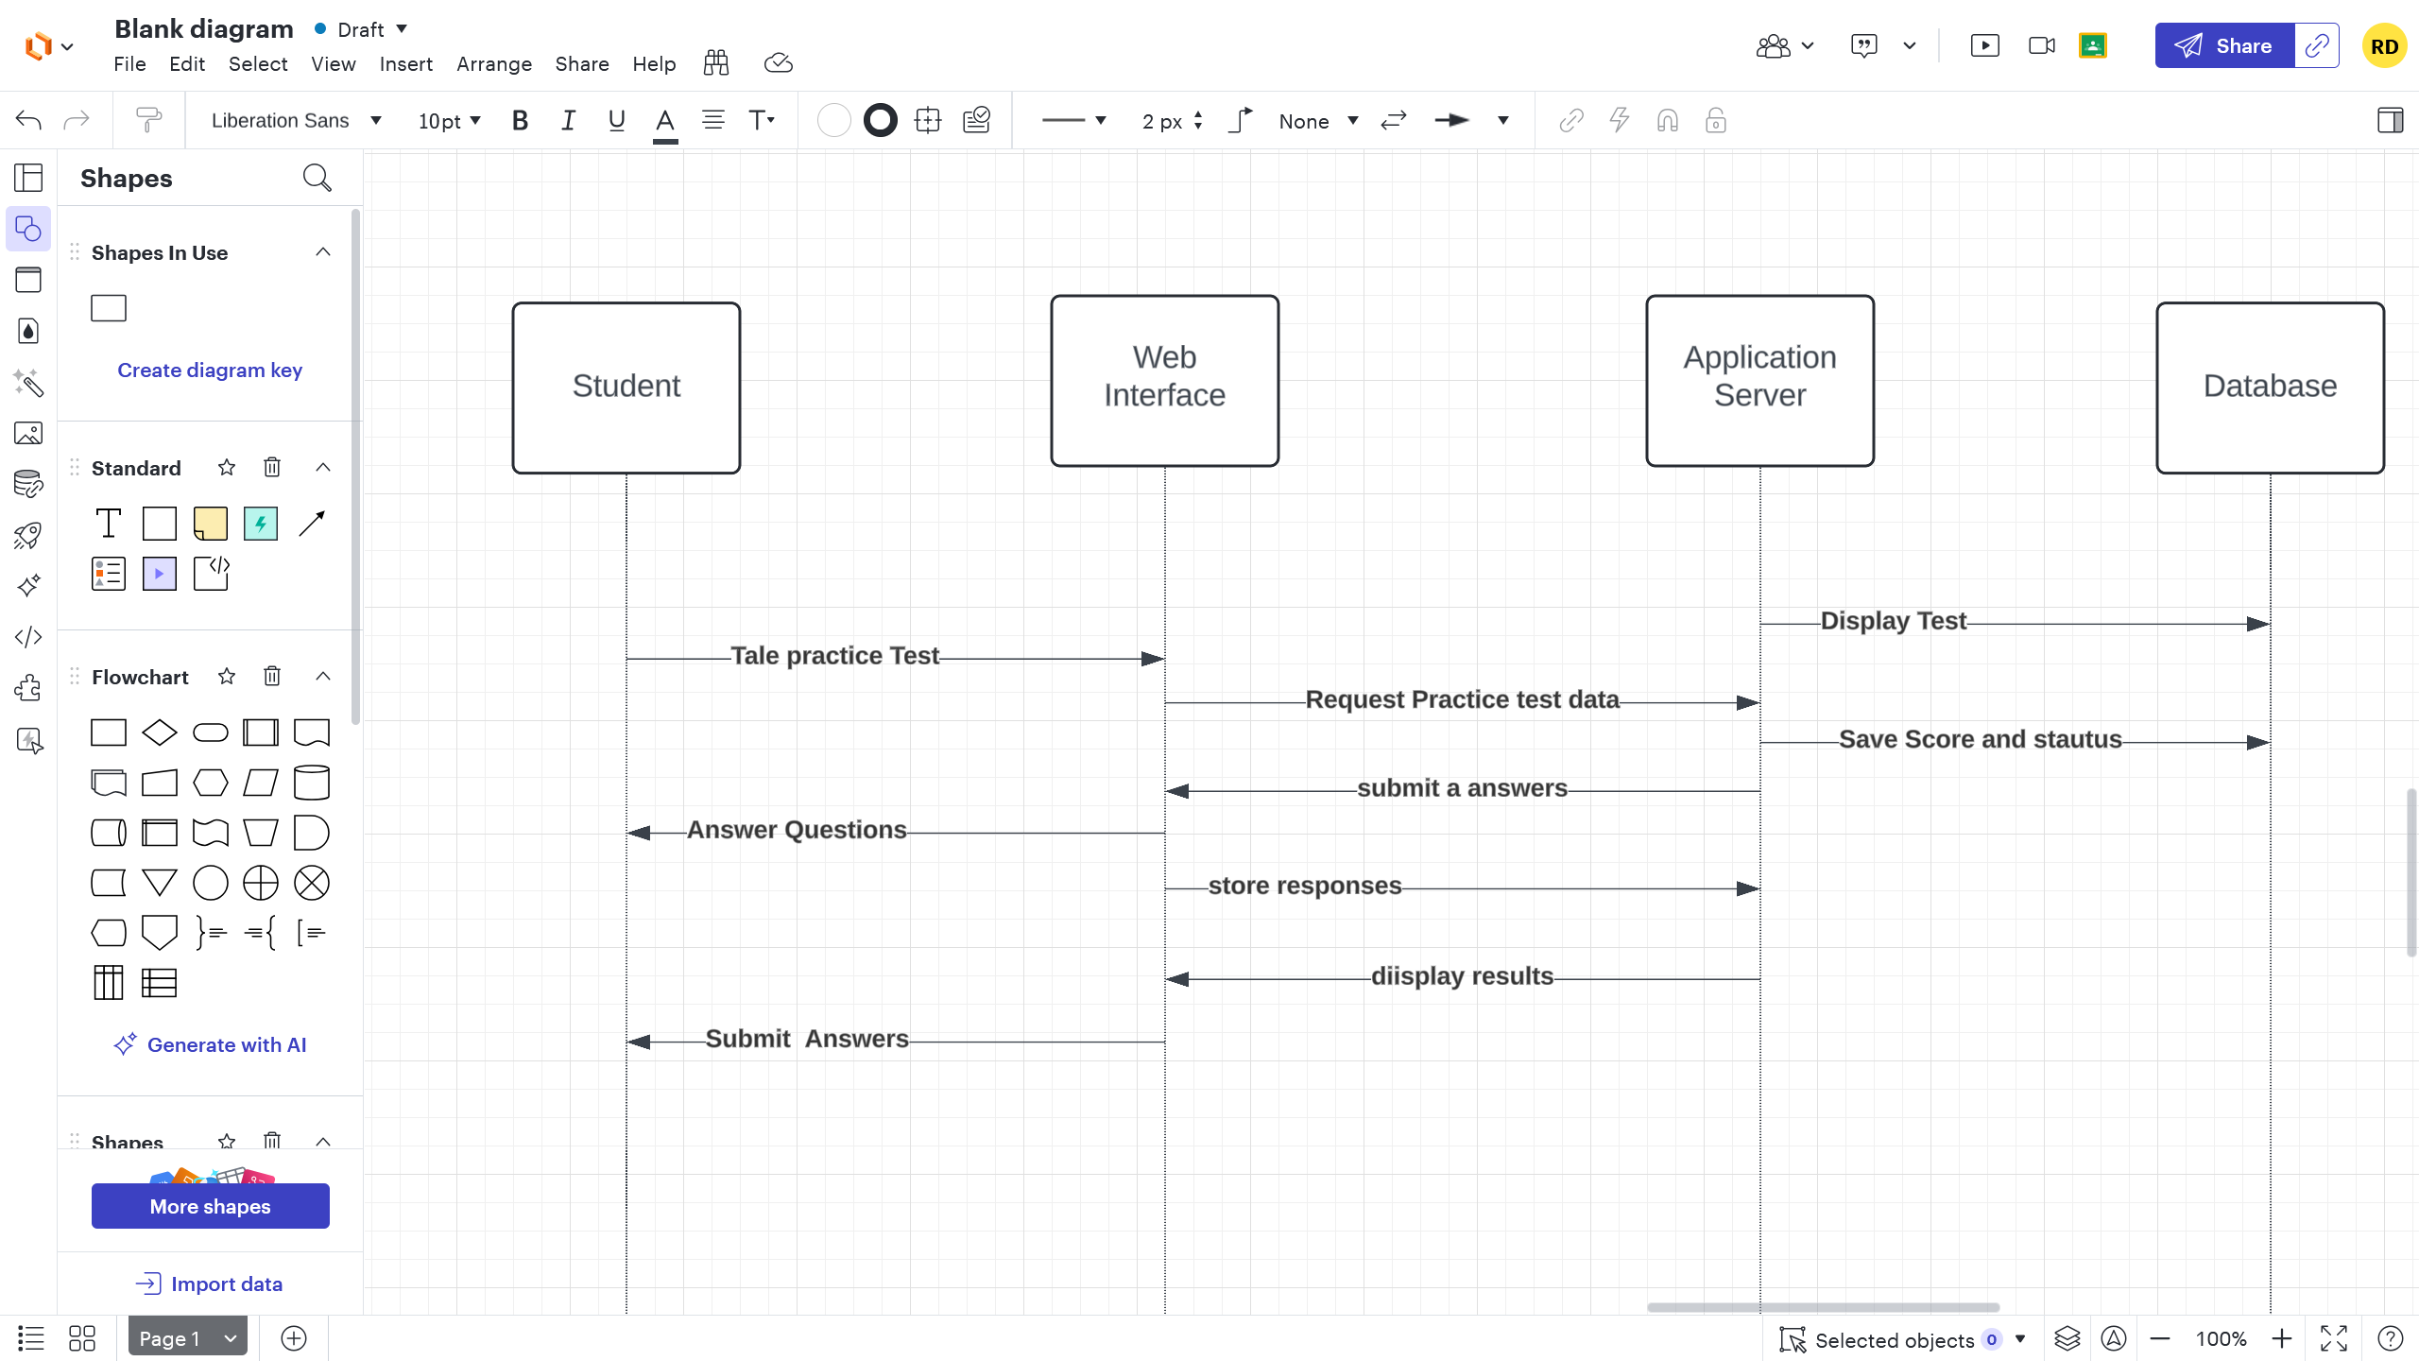

### UML Class Diagram

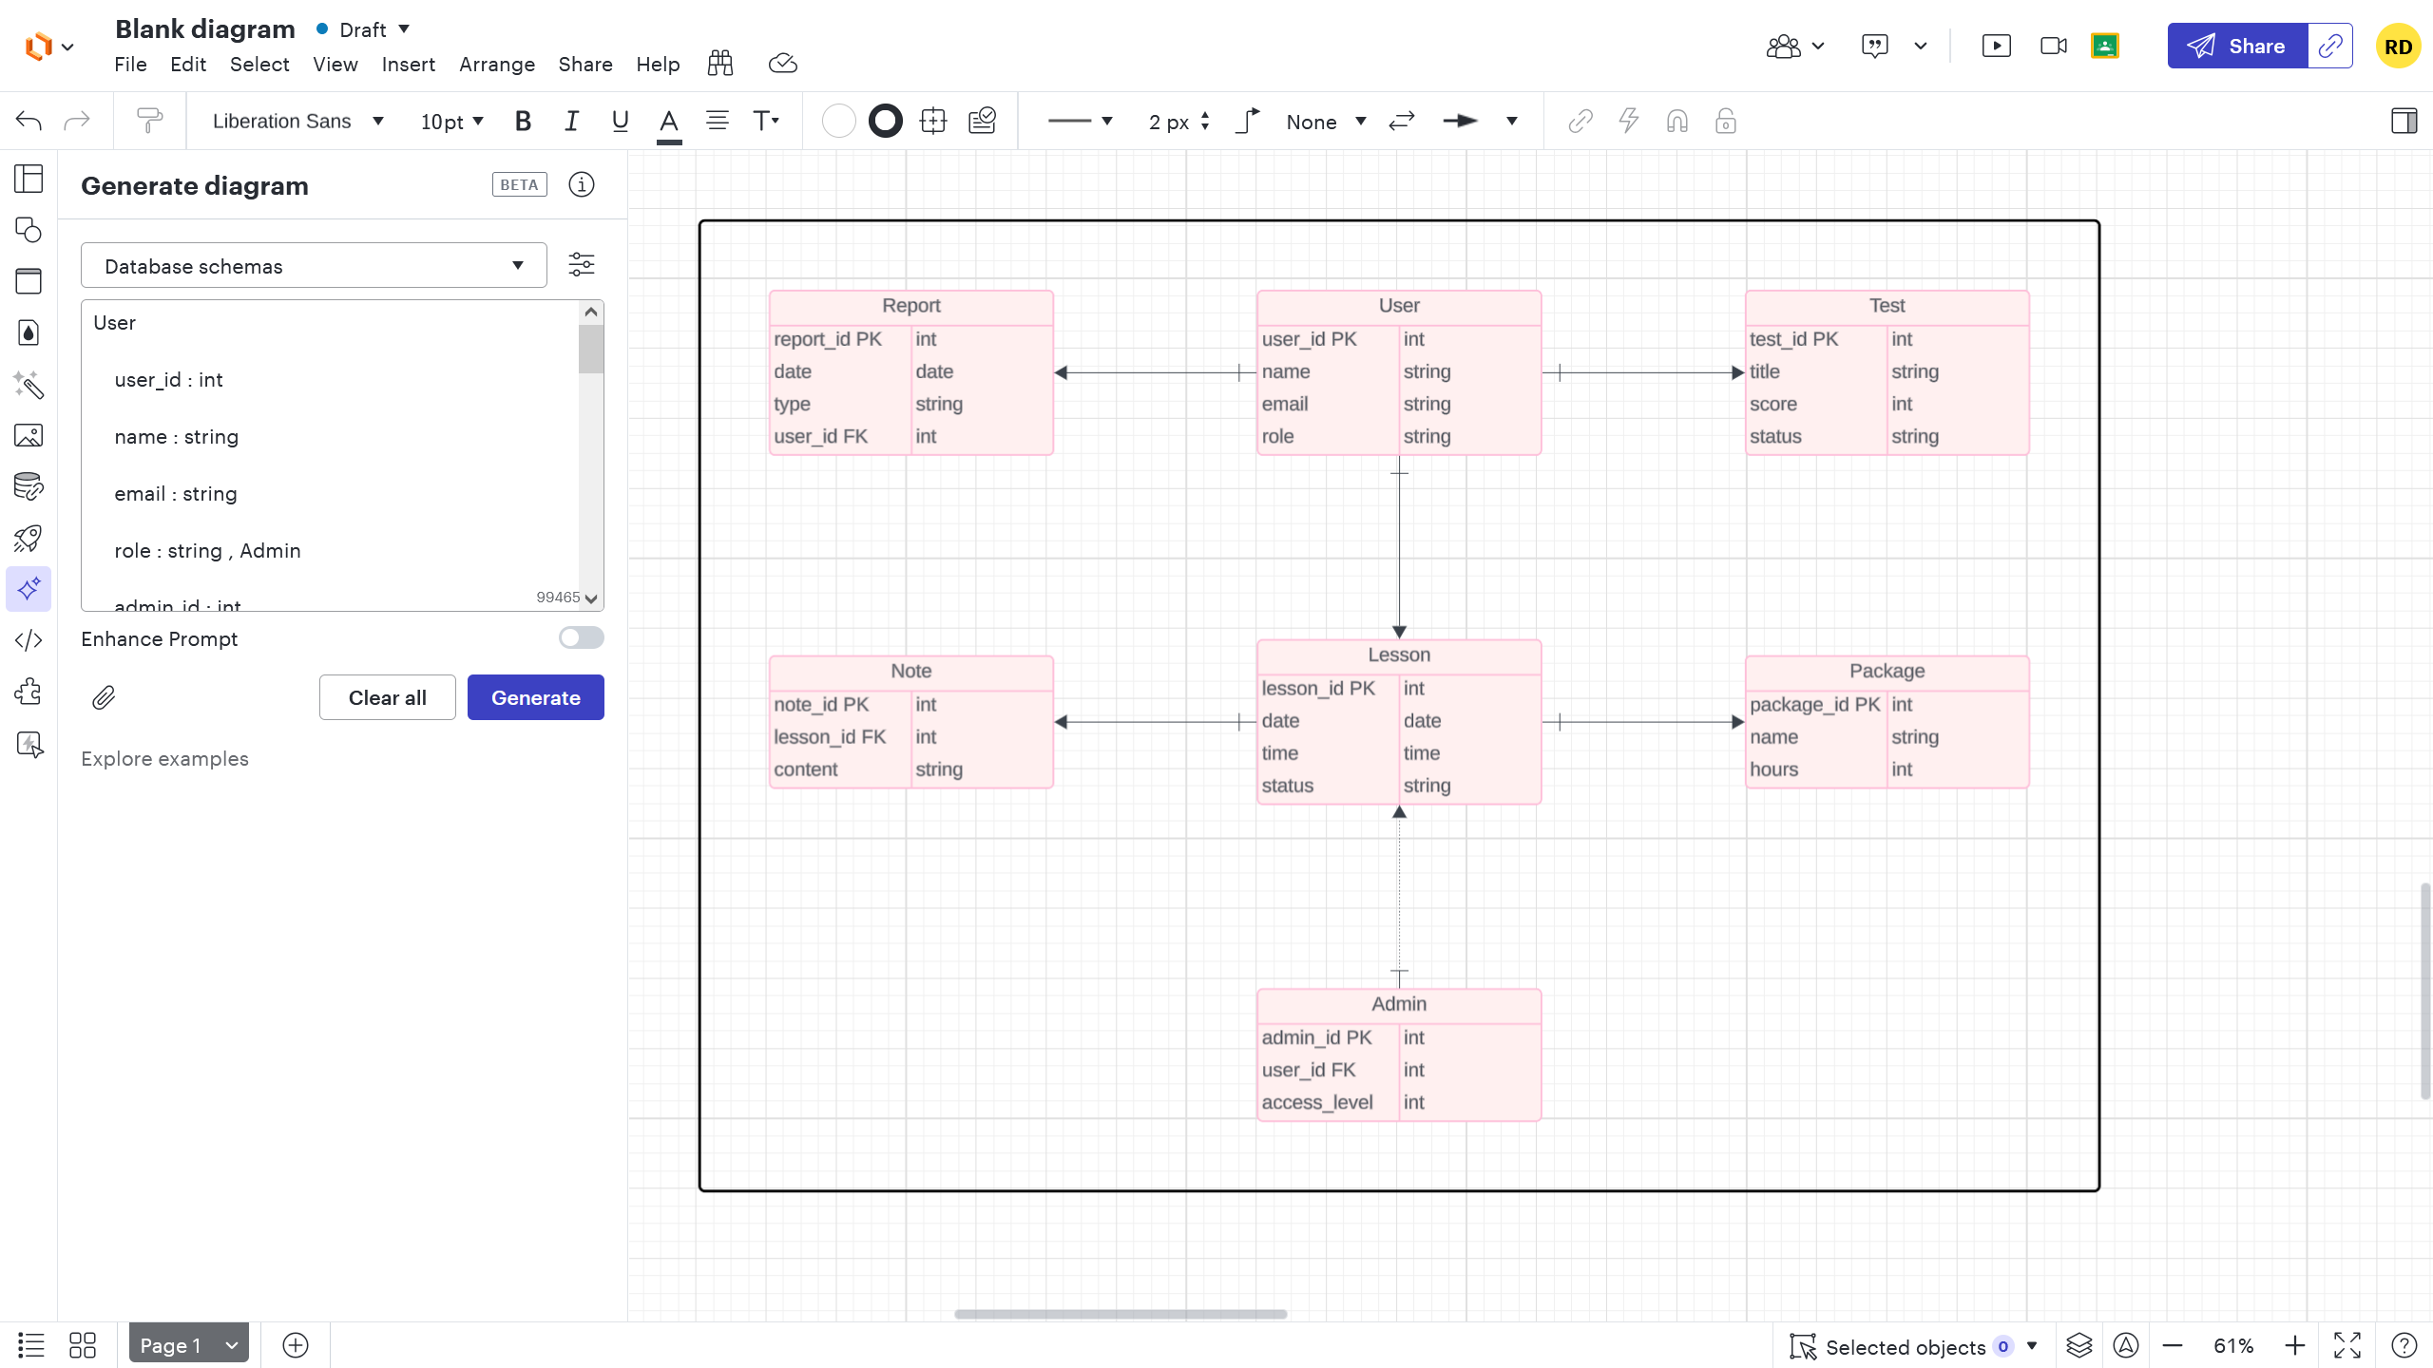

## Technical Requirements

***Hardware Requirements:***

* Web server with at least 8 GB RAM and quad-core CPU
* Cloud-based storage for secure and scalable data handling
* Reliable internet connection for all users and staff devices

**Software Requirements:**

* Web browser (Chrome, Firefox, Safari) for end-user access
* Server-side framework ( Node.js, Django, or Java Spring)
* Database system ( PostgreSQL or MySQL)
* Frontend framework ( React or Vue.js)
* Cloud platform (AWS, Azure, or Google Cloud)

**Tools:**

* Lucidchart for UML modeling
* Version control using Git and GitHub
* IDE such as Visual Studio Code
* Excel or reporting tools for exported data reviews

**Infrastructure:**

* Web-based deployment over HTTPS with encryption
* Role-based access control for students, secretaries, admins, and IT
* Cloud-hosted backend services to enable data availability from any device
* Backup system with automatic daily data copies
* Scalable environment to handle increasing users and lesson reservations