2-2 Activity: SQL Injection Coding

Ryan DeBraal

CS-405-X6389 Secure Coding 21EW6

**Summary**  
  
In order to complete this assignment I utilized a regular expression to detect when a specific series of characters within a string were a part of the SQL query.

I used a website called RegexStorm.net to develop my regular expression and then implemented the code once I had a generic enough solution that would match each of the test cases.

**RegEx Development**  
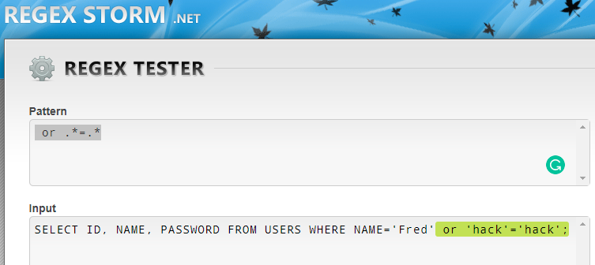  
  
**Program Output**

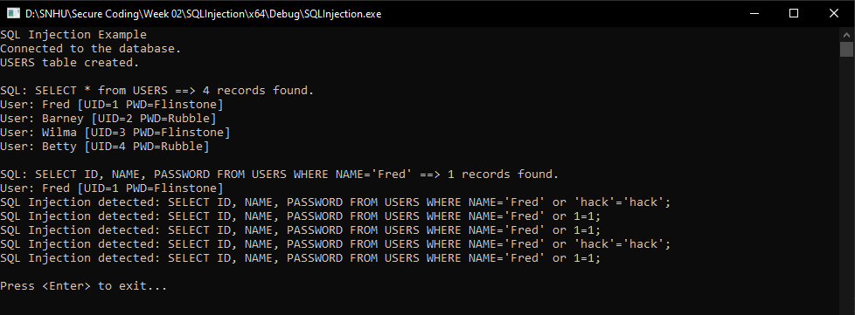

**Resources**

<http://regexstorm.net/tester>

<http://www.cplusplus.com/reference/regex/regex_search/>