2-2 Activity: SQL Injection Coding

Ryan DeBraal

CS-405-X6389 Secure Coding 21EW6

**Summary**  
  
In order to complete this assignment I utilized the getline() function which allows you to specify a maximum amount of characters to feed into the std::cin stream buffer, this guarantees there cannot be a buffer overflow caused by user input.

**Program Output**

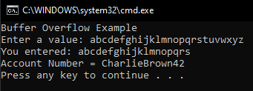

**Resources**

<https://en.cppreference.com/w/cpp/io/cin>

<https://en.cppreference.com/w/cpp/io/basic_istream/getline>