**Visual Studio errors and warnings**

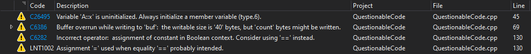

|  |  |  |
| --- | --- | --- |
| **Error** | **Analysis** | **Line** |
| Variable 'A::x' is uninitialized. Always initialize a member variable (type.6). | **NOT RISK** Variable initialization issue but doesn’t pose significant security risk. | 45 |
| Buffer overrun while writing to 'buf': the writable size is '40' bytes, but 'count' bytes might be written. | **RISK** Buffer overflow vulnerability | 69 |
| Incorrect operator: assignment of constant in Boolean context. Consider using '==' instead. | **NOT RISK** Variable assignment issue but doesn’t pose significant security risk. | 130 |
| Assignment '=' used when equality '==' probably intended. | **NOT RISK** Variable assignment issue but doesn’t pose significant security risk. | 130 |

**CppCheck errors and warnings**

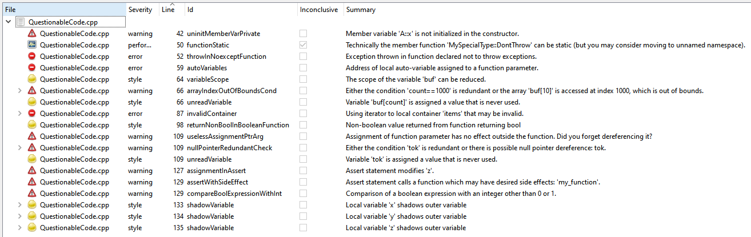

|  |  |  |
| --- | --- | --- |
| **Error** | **Analysis** | **Line** |
| Member variable 'A::x' is not initialized in the constructor. | **NOT RISK** Variable initialization issue but doesn’t pose significant security risk. | 42 |
| The member function 'MySpecialType::DontThrow' can be made a static function. Making a function static can bring a performance benefit since no 'this' instance is passed to the function. | **NOT RISK** Performance issue but doesn’t pose significant security risk. | 50 |
| Exception thrown in function declared not to throw exceptions. | **NOT RISK** Possible bug but doesn’t pose significant security risk. | 52 |
| Dangerous assignment - the function parameter is assigned the address of a local auto-variable. Local auto-variables are reserved from the stack which is freed when the function ends. So the pointer to a local variable is invalid after the function ends. | **RISK** Possible manipulation of pointer memory address | 59 |
| The scope of the variable 'buf' can be reduced. Warning: Be careful when fixing this message, especially when there are inner loops | **NOT RISK** Stylistic choice but doesn’t pose significant security risk. | 64 |
| Either the condition 'count==1000' is redundant or the array 'buf[10]' is accessed at index 1000, which is out of bounds. | **NOT RISK** Possible bug but doesn’t pose significant security risk. | 66 |
| Variable 'buf[count]' is assigned a value that is never used. | **NOT RISK** Code doesn’t interact. | 66 |
| Using iterator to local container 'items' that may be invalid. | **NOT RISK** Possible bug but doesn’t pose significant security risk. | 87 |
| Non-boolean value returned from function returning bool | **NOT RISK** Possible bug but doesn’t pose significant security risk. | 98 |
| Assignment of function parameter has no effect outside the function. Did you forget dereferencing it? | **NOT RISK** Garbage collector issue but doesn’t pose significant security risk. | 109 |
| Either the condition 'tok' is redundant or there is possible null pointer dereference: tok. | **NOT RISK** Possible null reference but doesn’t pose significant security risk. | 109 |
| Variable 'tok' is assigned a value that is never used. | **NOT RISK** Code doesn’t interact. | 109 |
| Variable 'z' is modified inside assert statement. Assert statements are removed from release builds so the code inside assert statement is not executed. If the code is needed also in release builds, this is a bug. | **NOT RISK** Code doesn’t interact. | 127 |
| Non-pure function: 'my_function' is called inside assert statement. Assert statements are removed from release builds so the code inside assert statement is not executed. If the code is needed also in release builds, this is a bug. | **NOT RISK** Code doesn’t interact. | 129 |
| Comparison of a boolean expression with an integer other than 0 or 1. | **NOT RISK** Possible comparison issue but doesn’t pose significant security risk. | 129 |
| Local variable 'x' shadows outer variable | **NOT RISK** Stylistic choice but doesn’t pose significant security risk. | 133 |
| Local variable 'y' shadows outer variable | **NOT RISK** Stylistic choice but doesn’t pose significant security risk. | 134 |
| Local variable 'z' shadows outer variable | **NOT RISK** Stylistic choice but doesn’t pose significant security risk. | 135 |