### Ryan Eisma

### BAN 592 - Course Project Work

### Due 7/2/2023

## Minnesota Timberwolves Four Factors Analysis Against External Factors

library(tidyverse)  
library(ggcorrplot)  
library(gridExtra)

game <- read_csv("game.csv")  
# str(game)

# Season after the bubble  
# recent <- game %>% filter(game_date > "2020/12/21")  
recent <- game %>% filter(game_date > "2021/10/21")

2022/23: 42-40

2021/22: 46-36

2020/21: 23-49 - Excluded due to difference in the record.

wolves = recent %>% filter(team_abbreviation_home == 'MIN' | team_abbreviation_away == 'MIN')  
  
wolves = wolves %>% mutate(outcome = ifelse(team_abbreviation_home == 'MIN', ifelse(wl_home == 'W','W', 'L' ), ifelse(wl_away == 'W','W', 'L' )))  
  
wolves = wolves %>% mutate(dest_outcome = ifelse(team_abbreviation_home == 'MIN', ifelse(wl_home == 'W','Home Win', 'Home Loss' ), ifelse(wl_away == 'W','Away Win', 'Away Loss' )))  
  
wolves = wolves %>% mutate(plus_minus = ifelse(team_abbreviation_home == 'MIN', plus_minus_home, plus_minus_away))  
  
wolves = wolves %>% mutate(wl_binary = ifelse(outcome == 'W', 1, 0))  
  
wolves$outcome = as_factor(wolves$outcome)  
wolves$dest_outcome = as_factor(wolves$dest_outcome)  
wolves$wl_binary = as.numeric(wolves$wl_binary)  
  
# summary(wolves)

### Create 4 Factors

# OeFGPct = (2pt FGM + 1.5 * 3pt FGM) / FGA  
wolves = wolves %>% mutate(OeFGPct = ifelse(team_abbreviation_home == 'MIN',(((fgm_home-fg3m_home)+(1.5*fg3m_home))/fga_home) ,(((fgm_away-fg3m_away)+(1.5*fg3m_away))/fga_away)))  
  
# OTOVPct  
wolves = wolves %>% mutate(OTOVPct = ifelse(team_abbreviation_home == 'MIN',((100 * tov_home)/(fga_home + 0.44 * ftm_home+ tov_home)) ,((100 * tov_away))/(fga_away + 0.44 * ftm_away + tov_away)))   
  
# Offensive Rebounding Percentage Formula=(Offensive Rebounds)/[(Offensive Rebounds)+(Opponent’s Defensive Rebounds)]  
wolves = wolves %>% mutate(ORBPct = ifelse(team_abbreviation_home == 'MIN', (oreb_home)/(oreb_home + dreb_away), (oreb_away)/(oreb_away + dreb_home)))  
  
# OFT = FT/FGA  
wolves = wolves %>% mutate(OFT = ifelse(team_abbreviation_home == 'MIN', (fta_home)/(fga_home), (fta_away)/(fga_away)))  
  
# DeFGPct = (2pt FGM + 1.5 * 3pt FGM) / FGA  
wolves = wolves %>% mutate(DeFGPct = ifelse(team_abbreviation_home == 'MIN',(((fgm_away-fg3m_away)+(1.5*fg3m_away))/fga_away) ,(((fgm_home-fg3m_home)+(1.5*fg3m_home))/fga_home)))  
  
# Defensive Rebounding Percentage   
wolves = wolves %>% mutate(DRBPct = ifelse(team_abbreviation_home == 'MIN', (dreb_home)/(oreb_away + dreb_home), (dreb_away)/(oreb_home + dreb_away)))  
  
# DTOVPct  
wolves = wolves %>% mutate(DTOVPct = ifelse(team_abbreviation_home == 'MIN',((100 * tov_away)/(fga_away + 0.44 * ftm_away+ tov_away)) ,((100 * tov_home))/(fga_home + 0.44 * ftm_home + tov_home)))   
  
# DFT = FT/FGA  
wolves = wolves %>% mutate(DFT = ifelse(team_abbreviation_home == 'MIN', (fta_away)/(fga_away), (fta_home)/(fga_home)))

### Create Rest and Back To Back Sets

wolves <- wolves %>%  
 mutate(game_date = as.Date(game_date))  
wolves <- wolves %>%  
 arrange(game_date)  
  
consecutive_games <- wolves %>%  
 filter(game_date - lag(game_date) == 1)  
rest_games <- wolves %>%   
 filter(game_date - lag(game_date) > 2)  
home_games <- wolves %>%   
 filter(team_abbreviation_home == 'MIN')  
road_games <- wolves %>%   
 filter(team_abbreviation_away == 'MIN')

#summary(consecutive_games)  
#summary(rest_games)  
#summary(home_games)  
#summary(road_games)  
  
#mean(wolves$OeFGPct) 0.5494323  
#mean(wolves$ORBPct) 0.2279773  
#mean(wolves$OTOVPct) 13.27211  
#mean(wolves$OFT) 0.2622303  
#mean(wolves$DeFGPct) 0.5395748  
#mean(wolves$DRBPct) 0.7475091  
#mean(wolves$DTOVPct) # 14.24  
#mean(wolves$DFT) # 0.296

### Home Court Advantage

(Note: Before removal of the low year)

Home Win:59

Home Loss:54

Away Win:44

Home Win:59

# wolves %>%  
# filter(dest_outcome %in% c("Home Win", "Home Loss")) %>%  
# ggplot() +  
# aes(x = dest_outcome) +  
# geom_bar(fill = "#112446") +  
# theme_minimal()

four_fact = wolves %>% select(wl_binary, plus_minus, OeFGPct, OTOVPct, OFT,ORBPct, DeFGPct, DTOVPct, DFT,DRBPct)  
str(four_fact)

## tibble [149 × 10] (S3: tbl_df/tbl/data.frame)  
## $ wl_binary : num [1:149] 1 0 1 0 0 0 0 0 0 1 ...  
## $ plus_minus: num [1:149] 7 -9 5 -2 -18 -11 -20 -7 -13 24 ...  
## $ OeFGPct : num [1:149] 0.469 0.428 0.544 0.466 0.443 ...  
## $ OTOVPct : num [1:149] 16.86 9.98 14.89 17.77 12.09 ...  
## $ OFT : num [1:149] 0.104 0.3 0.187 0.101 0.196 ...  
## $ ORBPct : num [1:149] 0.245 0.196 0.25 0.306 0.291 ...  
## $ DeFGPct : num [1:149] 0.399 0.506 0.484 0.46 0.555 ...  
## $ DTOVPct : num [1:149] 23.64 17.34 8.11 16.18 14.74 ...  
## $ DFT : num [1:149] 0.258 0.264 0.221 0.182 0.366 ...  
## $ DRBPct : num [1:149] 0.618 0.667 0.75 0.689 0.721 ...

p1 <- ggplot(data=wolves, aes(x=outcome, y=OeFGPct, color=OeFGPct))+geom_point(show.legend = FALSE) + theme_bw()  
p2 <- ggplot(data=wolves, aes(x=outcome, y=OFT, color=OFT))+geom_point(show.legend = FALSE) + theme_bw()  
p3 <- ggplot(data=wolves, aes(x=outcome, y=ORBPct, color=ORBPct))+geom_point(show.legend = FALSE) + theme_bw()  
p4 <- ggplot(data=wolves, aes(x=outcome, y=OTOVPct, color=OTOVPct))+geom_point(show.legend = FALSE) + theme_bw()  
p5 <- ggplot(data=wolves, aes(x=outcome, y=DeFGPct, color=DeFGPct))+geom_point(show.legend = FALSE)   
p6 <- ggplot(data=wolves, aes(x=outcome, y=DFT, color=DFT))+geom_point(show.legend = FALSE) + theme_bw()  
p7 <- ggplot(data=wolves, aes(x=outcome, y=DRBPct, color=DRBPct))+geom_point(show.legend = FALSE) + theme_bw()  
p8 <- ggplot(data=wolves, aes(x=outcome, y=DTOVPct, color=DTOVPct ))+geom_point(show.legend = FALSE) + theme_bw()

### Offensive

grid.arrange(p1, p2, p3, p4, ncol = 2)

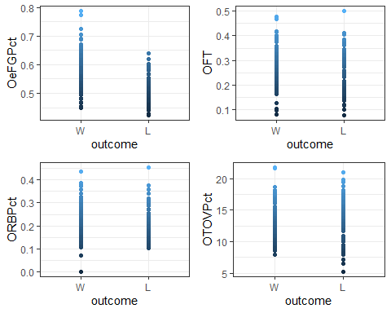

grid.arrange(p5, p6, p7, p8, ncol = 2)

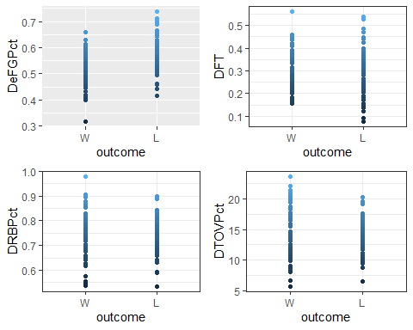

p1 <- ggplot(home_games) +  
 aes(x = outcome, y = OeFGPct) +  
 geom_boxplot(fill = "#2EF818") +  
 theme_minimal() + xlab("")  
p2 <- ggplot(home_games) +  
 aes(x = outcome, y = ORBPct) +  
 geom_boxplot(fill = "#2EF818") +  
 theme_minimal() + xlab("")  
p3 <- ggplot(home_games) +  
 aes(x = outcome, y = OTOVPct) +  
 geom_boxplot(fill = "#2EF818") +  
 theme_minimal() + xlab("")  
p4 <- ggplot(home_games) +  
 aes(x = outcome, y = OFT) +  
 geom_boxplot(fill = "#2EF818") +  
 theme_minimal()+ xlab("")  
  
p5 <- ggplot(home_games) +  
 aes(x = outcome, y = DeFGPct) +  
 geom_boxplot(fill = "#2EF818") +  
 theme_minimal() + xlab("")  
p6 <- ggplot(home_games) +  
 aes(x = outcome, y = DRBPct) +  
 geom_boxplot(fill = "#2EF818") +  
 theme_minimal() + xlab("")  
p7 <- ggplot(home_games) +  
 aes(x = outcome, y = DTOVPct) +  
 geom_boxplot(fill = "#2EF818") +  
 theme_minimal() + xlab("")  
p8 <- ggplot(home_games) +  
 aes(x = outcome, y = DFT) +  
 geom_boxplot(fill = "#2EF818") +  
 theme_minimal() + xlab("")

grid.arrange(p1, p2, p3, p4, ncol = 2)

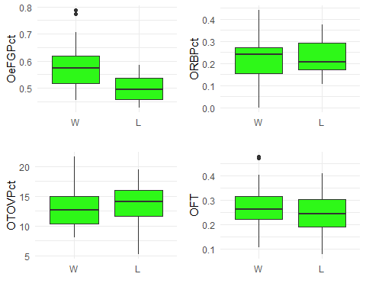

grid.arrange(p5, p6, p7, p8, ncol = 2)

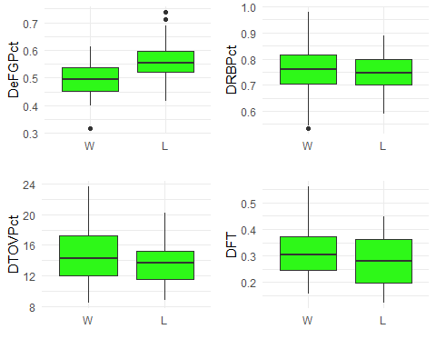

p1 <- ggplot(road_games) +  
 aes(x = outcome, y = OeFGPct) +  
 geom_boxplot(fill = "#2EF818") +  
 theme_minimal() + xlab("")  
p2 <- ggplot(road_games) +  
 aes(x = outcome, y = ORBPct) +  
 geom_boxplot(fill = "#2EF818") +  
 theme_minimal() + xlab("")  
p3 <- ggplot(road_games) +  
 aes(x = outcome, y = OTOVPct) +  
 geom_boxplot(fill = "#2EF818") +  
 theme_minimal() + xlab("")  
p4 <- ggplot(road_games) +  
 aes(x = outcome, y = OFT) +  
 geom_boxplot(fill = "#2EF818") +  
 theme_minimal()+ xlab("")  
  
p5 <- ggplot(road_games) +  
 aes(x = outcome, y = DeFGPct) +  
 geom_boxplot(fill = "#2EF818") +  
 theme_minimal() + xlab("")  
p6 <- ggplot(road_games) +  
 aes(x = outcome, y = DRBPct) +  
 geom_boxplot(fill = "#2EF818") +  
 theme_minimal() + xlab("")  
p7 <- ggplot(road_games) +  
 aes(x = outcome, y = DTOVPct) +  
 geom_boxplot(fill = "#2EF818") +  
 theme_minimal() + xlab("")  
p8 <- ggplot(road_games) +  
 aes(x = outcome, y = DFT) +  
 geom_boxplot(fill = "#2EF818") +  
 theme_minimal() + xlab("")

grid.arrange(p1, p2, p3, p4, ncol = 2)

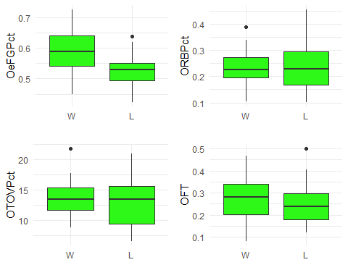

grid.arrange(p5, p6, p7, p8, ncol = 2)

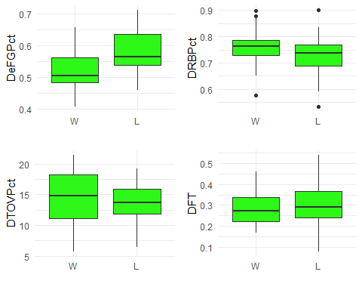

p1 <- ggplot(consecutive_games) +  
 aes(x = outcome, y = OeFGPct) +  
 geom_boxplot(fill = "#2EF818") +  
 theme_minimal() + xlab("")  
p2 <- ggplot(consecutive_games) +  
 aes(x = outcome, y = ORBPct) +  
 geom_boxplot(fill = "#2EF818") +  
 theme_minimal() + xlab("")  
p3 <- ggplot(consecutive_games) +  
 aes(x = outcome, y = OTOVPct) +  
 geom_boxplot(fill = "#2EF818") +  
 theme_minimal() + xlab("")  
p4 <- ggplot(consecutive_games) +  
 aes(x = outcome, y = OFT) +  
 geom_boxplot(fill = "#2EF818") +  
 theme_minimal()+ xlab("")  
  
p5 <- ggplot(consecutive_games) +  
 aes(x = outcome, y = DeFGPct) +  
 geom_boxplot(fill = "#2EF818") +  
 theme_minimal() + xlab("")  
p6 <- ggplot(consecutive_games) +  
 aes(x = outcome, y = DRBPct) +  
 geom_boxplot(fill = "#2EF818") +  
 theme_minimal() + xlab("")  
p7 <- ggplot(consecutive_games) +  
 aes(x = outcome, y = DTOVPct) +  
 geom_boxplot(fill = "#2EF818") +  
 theme_minimal() + xlab("")  
p8 <- ggplot(consecutive_games) +  
 aes(x = outcome, y = DFT) +  
 geom_boxplot(fill = "#2EF818") +  
 theme_minimal() + xlab("")

grid.arrange(p1, p2, p3, p4, ncol = 2)

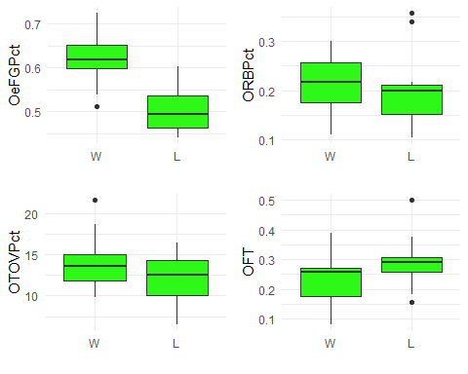

grid.arrange(p5, p6, p7, p8, ncol = 2)

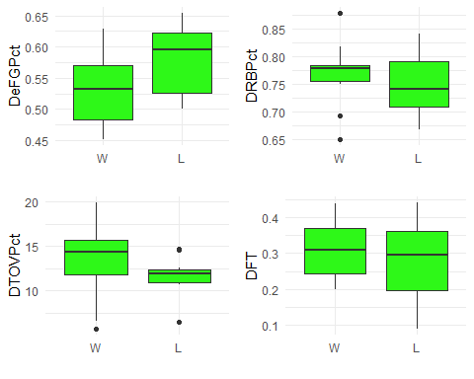

p1 <- ggplot(rest_games) +  
 aes(x = outcome, y = OeFGPct) +  
 geom_boxplot(fill = "#2EF818") +  
 theme_minimal() + xlab("")  
p2 <- ggplot(rest_games) +  
 aes(x = outcome, y = ORBPct) +  
 geom_boxplot(fill = "#2EF818") +  
 theme_minimal() + xlab("")  
p3 <- ggplot(rest_games) +  
 aes(x = outcome, y = OTOVPct) +  
 geom_boxplot(fill = "#2EF818") +  
 theme_minimal() + xlab("")  
p4 <- ggplot(rest_games) +  
 aes(x = outcome, y = OFT) +  
 geom_boxplot(fill = "#2EF818") +  
 theme_minimal()+ xlab("")  
  
p5 <- ggplot(rest_games) +  
 aes(x = outcome, y = DeFGPct) +  
 geom_boxplot(fill = "#2EF818") +  
 theme_minimal() + xlab("")  
p6 <- ggplot(rest_games) +  
 aes(x = outcome, y = DRBPct) +  
 geom_boxplot(fill = "#2EF818") +  
 theme_minimal() + xlab("")  
p7 <- ggplot(rest_games) +  
 aes(x = outcome, y = DTOVPct) +  
 geom_boxplot(fill = "#2EF818") +  
 theme_minimal() + xlab("")  
p8 <- ggplot(rest_games) +  
 aes(x = outcome, y = DFT) +  
 geom_boxplot(fill = "#2EF818") +  
 theme_minimal() + xlab("")

grid.arrange(p1, p2, p3, p4, ncol = 2)

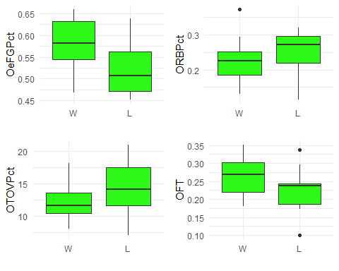

grid.arrange(p5, p6, p7, p8, ncol = 2)

