Week 5 Activities (Correlation in R)

Table of contents

In this weeks workshop, we are going to learn how to perform correlations (simple and multiple) which you covered in last weeks lecture, along with checking the relevant assumptions etc.

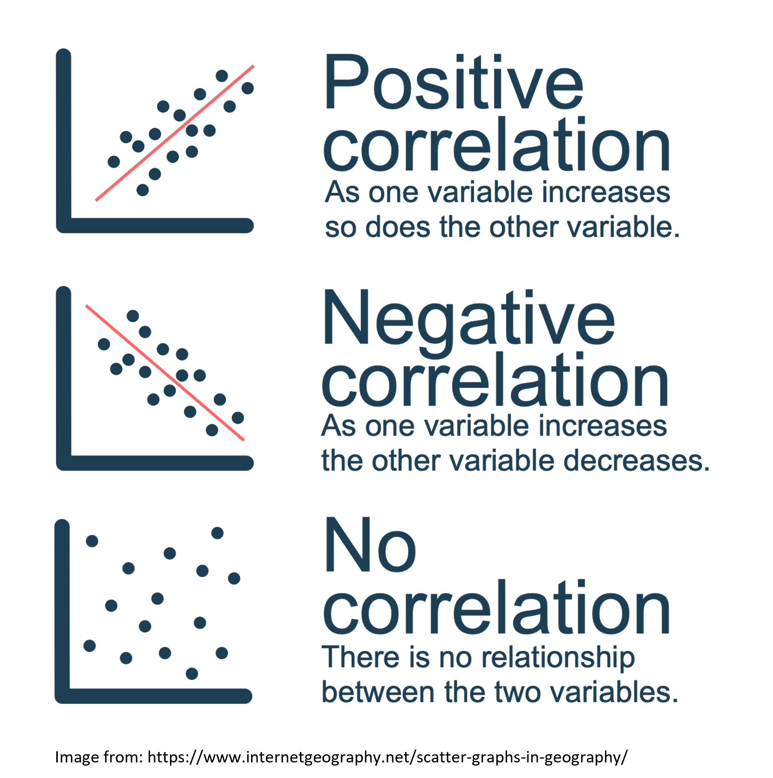

- Use the jmv package to run descriptive statistics and check assumptions.

- Conduct a simple correlation in R.

- Conduct a multiple correlation R.

- Learn how to make pretty correlation graphs.

- Conduct an apriori power analysis in R for correlations.

## Let’s Get Set Up

Let’s begin by ensuring your working environment is ready for today’s session. Open RStudio or Posit Cloud and complete the following tasks to set everything up.

## Activity 1: Set Up Your Working Directory & R Script for this week

One of the first steps in each of these workshops is setting up your *working directory*. The working directory is the default folder where R will look to import files or save any files you export.

If you don’t set the working directory, R might not be able to locate the files you need (e.g., when importing a dataset) or you might not know where your exported files have been saved. Setting the working directory beforehand ensures that everything is in the right place and avoids these issues.

|  |
| --- |
| Reminder on Steps to Set Up Your Working Directory |
| 1. Click: **Session → Set Working Directory → Choose Directory** 2. Navigate to the folder you created for this course (this should be the same folder you used for previous workshops). 3. Create a new folder called week5 inside this directory. 4. Select the week5 folder and click **Open**.   Don’t forget to verify your working directory before we get started  You can always check your current working directory by typing in the following command in the console:  getwd()  [1] "/Users/ryandonovan 1/Desktop/rintro/activities/week5" |

As in previous weeks we will create an **R script** that we can use for today’s activities. This week we can call our script 05-correlations

|  |
| --- |
| Reminder on creating an R script |
| 1. Go to the menu bar and select: **File → New File → R Script**  * This will open an untitled R script.  1. To save and name your script, select:  * **File→ Save As**, then enter the name: * 05-correlations * Click **Save** |

At the top of your R script type in and run the following code (this turns off scientific notation from your output:

options(scipen = 999)

## Activity 2: Installing / Loading R Packages

We’ll be using several **R packages** to make our analysis easier. The jmv package is particularly helpful for running descriptive statistics, while pwr helps us calculate power for our tests. The car package will allow us to check additional assumptions. We will be using a new package this week also: correlation, this package will be used for running our correlations.

**REMEMBER**: If you encounter an error message like “Error in library(package name): there is no packaged calledpackage name”, you’ll need to install the package first by editing the following for your console:

install.packages("package name") #replace "package name" with the actual package name

Here are the packages we will be using today:

library(jmv) # this will help us run descriptive statistics

Warning: package 'jmv' was built under R version 4.3.3

library(pwr) # this will enable us to conduct power analysis   
library(car) # this is for checking assumptions

Loading required package: carData

library(correlation) #this runs our correlation

Warning: package 'correlation' was built under R version 4.3.3

library(performance) # this helps with our assumption checks

Warning: package 'performance' was built under R version 4.3.3

library(psych) # this will be helpful for our multiple correlation graph

Attaching package: 'psych'

The following object is masked from 'package:car':  
  
 logit

The following objects are masked from 'package:jmv':  
  
 pca, reliability

library(ggplot2) # we will be useful for making lots of pretty graphs

Attaching package: 'ggplot2'

The following objects are masked from 'package:psych':  
  
 %+%, alpha

library(ggcorrplot) # we will be useful for making lots of pretty graphs

## Activity 3: Download and load in your dataset

Today we are going to analyse data from a study on sleep quality, personality factors, and psychological wellbeing which you will find it on Canvas under the Module **Week 5**

- **SleepQuality.csv** **→** our dataset

### Download this file onto your computer and move it to your week5 folder.

Once this is done load the dataset into R and save it as a dataframe called “df_sleep”:

|  |
| --- |
| Tip |
| df_sleep <- read.csv("SleepQuality.csv") |

## Correlations

Todays data was collected from a cross-sectional study examining the relationship between sleep difficulty, anxiety, and depression.

After loading the datasets, it’s always good practice to inspect it before doing any analyses. You can use the head() function to get an overview of the sleep quality dataset.

head(df_sleep)

Participant SleepDifficulty Optimism Depression Anxiety  
1 1 12.32332 6.895218 25.73838 50.14666  
2 2 12.03404 12.593687 26.36019 50.59385  
3 3 12.05411 5.389429 27.75646 50.47726  
4 4 13.47842 9.192558 25.01543 53.32908  
5 5 16.32334 5.869162 32.23879 70.42495  
6 6 18.55490 5.819719 36.75899 73.08169

Now that our environment is set up and our dataset is loaded, we are ready to dive into descriptive statistics & check our assumptions.

Last week we learned how to use descriptives function to do both of these things.

## Activity 4: Get descriptive statistics & check assumptions

Let’s imagine we’re interested in investigating the relationship between **depression** and **anxiety**. Specifically we predict that higher levels of depression (as shown by higher scores) will be associated with higher anxiety levels (as shown by higher scores).

In this case:

Our **variables** are 1) depression and 2) anxiety

We could specify our hypothesis as such:

**H1:** We predict that higher depression will be positively correlated with higher anxiety scores.

**H0 (Null hypothesis):** There will not be a significant correlation between depression scores and anxiety scores

Note that as we do specify the direction of the association / correlation that this is a **directional hypothesis**

As we are interested in the relationship between two continuous variables, this would be best addressed via a **simple correlation**. Before we can do this, there are a couple of preliminary steps we need to take. First, we need to check the assumptions required for a correlation.

### Checking our assumptions

There are two main types of correlation you might use: **Pearsons** and **Spearmans** , for an overview of both check the associated textbook chapter on correlations. For the purposes of this workshop, you would typically use **Pearsons** correlation, unless the below assumptions are not met.

There are several key assumptions for conducting Pearsons simple correlation:

a. The data are continuous, and are either interval or ratio.

|  |
| --- |
| Tip |
| **Interval data** = Data that is measured on a numeric scale with equal distance between adjacent values, that does **not** have a true zero. This is a very common data type in research (e.g. Test scores, IQ etc).  **Ratio data** = Data that is measured on a numeric scale with equal distance between adjacent values, that has a true zero (e.g. Height, Weight etc).  Here we know our two variables are outcomes on a wellbeing test, as such they are interval data and this assumption has been met |

b. There is a data point for each participant for both variables.

|  |
| --- |
| Note |
| A quick way to check this assumption is to see if there is any missing data. If there isn’t then this assumption is met. Note that number of missing data points is one of the values you automatically get when using the descriptives function. |

c. The data are normally distributed for your two variables.

d. The relationship between the two variables is linear.

e. The assumption of homoscedasticity.

**Assumptions (c-d): Normality & linearity**

For correlations we can check these assumptions via visualization. Please refer to the associated textbook chapter for detailed guidance on checking these assumptions via visualization.

Normality can be assessed using a histogram and qqplot (both of with we can get using the descriptives function), and also **Shapiro-Wilks test** which we learned last week. We can also take this opportunity to get some of our descriptive statistics for our write-up, we need **mean** and **standard deviation** for both variables.

Remember if you type ?descriptives into your console it will give you an overview of the arguments you can use.

|  |
| --- |
| Code in case you get stuck / to double check your work |
| descriptives(df_sleep, # our data  vars = c("Depression", "Anxiety"), # our two variables  hist = TRUE, # this generates a histogram  sw = TRUE, # this runs shapiro-wilks test  qq=TRUE) # this generates a qq plot  DESCRIPTIVES   Descriptives   ─────────────────────────────────────────────────   Depression Anxiety   ─────────────────────────────────────────────────   N 150 150   Missing 0 0   Mean 25.05236 50.30168   Median 25.14149 50.21348   Standard deviation 6.173965 12.34318   Minimum 8.203621 16.32001   Maximum 40.04161 78.15740   Shapiro-Wilk W 0.9942665 0.9914144   Shapiro-Wilk p 0.8206004 0.5009269   ───────────────────────────────────────────────── |

To check for linearity can use a scatterplot. The below code will generate a simple scatterplot for this purpose of checking normality (later on we’ll learn to generate prettier graphs that you can use in your reports).

plot(x=df_sleep$Depression,y=df_sleep$Anxiety)

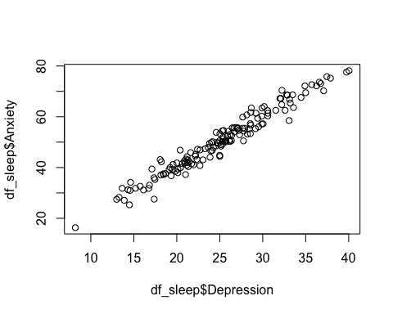

**e.** **Homoscedasticity**

There are a number of ways to check this assumption: visually via plotting of the residuals (which we will cover in Week 7 for Regression), or via a test. Here we will use a Breusch-Pagan test (1979) for heteroscedasticity.

To do this we will create a linear model, and then use the function check_heteroscasticity from the performance package.

If we get a non-significant p-value then the data is homoscedastic and our assumption has been met.

model <- lm(Depression ~ Anxiety, data = df_sleep) # here we are creating an object "model" which contatins a linear model of our DV ~ IV   
check_heteroscedasticity(model) # this function performs a Breusch-Pagan test for our model

OK: Error variance appears to be homoscedastic (p = 0.771).

Based on the above we can ascertain that:

* the variables are normally distributed
* the relationship between the two variables is linear
* the assumption of homoscedasticity is met

As such we can use a **Pearson** correlation to test our hypotheses.

## Activity 5: Running the Simple Correlation

We use the correlation function to perform the correlation. The syntax is:

# Remember you need to edit the specific names/variables below to make it work for our data and needs  
  
cor.test(DataframeName$Variable1, DataframeName$Variable2, method = "pearson" OR "spearman", alternative = "two.sided" or "less" or "greater")  
  
# alternative specifies whether it's a one or two-sided test, or one-sided. "greater" corresponds to positive association, "less" to negative association

As we have a **directional hypothesis** where we expect a **positive** correlation we will run a one-sided correlation. Let’s run this correlation for depression and anxiety on our df_sleep dataset:

|  |
| --- |
| Our simple correlation code |
| cor.test(df_sleep$Depression, df_sleep$Anxiety, method = "pearson", alternative = "greater")  Pearson's product-moment correlation  data: df_sleep$Depression and df_sleep$Anxiety t = 56.595, df = 148, p-value < 0.00000000000000022 alternative hypothesis: true correlation is greater than 0 95 percent confidence interval:  0.9708085 1.0000000 sample estimates:  cor  0.977668 |

The correlation results show a significant correlation between the depression and anxiety scores.

**Here’s how we might write up the results in APA style:**

A Pearsons correlation was conducted to assess the relationship between depression (*M*= 25.05, *SD*= 6.17) and anxiety scores (*M*= 50.3, *SD*= 12.34). The test showed that there was a significant positive correlation between the two variables *r*(148) = 0.98, *p* < 0.01. As such we reject the null hypothesis.

## Multiple Correlations

Sometimes we’re interested in the associations between multiple variables. In todays dataset we have sleep difficulty, optimism, depression, and anxiety. As such we might be interested in the relationship between all four variables.

In addition to our earlier prediction regarding depression and anxiety we could also predict:

1) that greater sleep difficulty (as shown by higher values) will be associated with higher anxiety and depression levels (as shown by higher scores).

2) that greater optimism (as shown by higher values) will be associated with lower anxiety and depression levels (as shown by lower scores).

In this case:

Our **variables** are 1) depression, 2) anxiety, 3) sleep difficulty, and 4) optimism.

As we are interested in the relationship between four continuous variables, this would be best addressed via a **multiple correlation**. Before we can do this, there are a couple of preliminary steps we need to take.

A lot of the steps are very similar to a simple correlation. So we can refer to the above sections for help if we get unsure.

## Activity 6: Descriptive statistics and assumption checking

We already checked that depression and anxiety meet the assumptions for a Pearsons correlation but now we need to do the same for **sleep difficulty** and **optimism**. Double-check **Activity 4** for a reminder on the steps to check the below.

a. The data are continuous, and are either interval or ratio.

b. There is a data point for each participant for both variables.

c. The data are normally distributed for your two variables.

d. The relationship between the two variables is linear.

e. The assumption of homoscedasticity.

|  |
| --- |
| Code to double-check your work when you’re done |
| descriptives(df_sleep, # our data  vars = c("Depression", "Anxiety", "SleepDifficulty", "Optimism"), # our four variables  hist = TRUE, # this generates a histogram  sw = TRUE, # this runs shapiro-wilks test  qq=TRUE) # this generates a qq plot  DESCRIPTIVES   Descriptives   ─────────────────────────────────────────────────────────────────────────────────   Depression Anxiety SleepDifficulty Optimism   ─────────────────────────────────────────────────────────────────────────────────   N 150 150 150 150   Missing 0 0 0 0   Mean 25.05236 50.30168 12.37026 10.57763   Median 25.14149 50.21348 12.37819 10.76353   Standard deviation 6.173965 12.34318 2.736946 3.284548   Minimum 8.203621 16.32001 6.599527 0.4951533   Maximum 40.04161 78.15740 18.73516 18.83997   Shapiro-Wilk W 0.9942665 0.9914144 0.9846297 0.9912025   Shapiro-Wilk p 0.8206004 0.5009269 0.0937667 0.4788844   ───────────────────────────────────────────────────────────────────────────────── |

|  |
| --- |
| Tip |
| If you want to try the pairs.panel function it enables you to check the visual assumptions for all the variables at once.  pairs.panels(df_sleep) |

## Activity 7: Running the multiple correlation

To run our multiple correlation we need to use slightly different syntax than before:

# Remember you need to edit the specific names/variables below to make it work for our data and needs  
  
correlation(DataframeName, # our data  
 select = c("Variable1", "Variable2", "Variable3", "Variable4"), # our variables  
 method = "pearson" OR "spearman",  
 p_adjust = "bonferroni") # our bonferroni adjustment for multiple comparisons - see the associated textbook chapter for a discussion of this  
  
# Note that we do not specify the direction of our predicted correlation here as some may be positive and others may be negative

|  |
| --- |
| Code to double-check your work when you’re done |
| # we are saving the results of our correlation as an object called "mcor" mcor <- correlation(df_sleep, # our data  select = c("Depression", "Anxiety", "SleepDifficulty", "Optimism"), # our variables  method = "pearson",  p_adjust = "bonferroni") # our bonferroni adjustment for multiple comparisons mcor  # Correlation Matrix (pearson-method)  Parameter1 | Parameter2 | r | 95% CI | t(148) | p ------------------------------------------------------------------------------- Depression | Anxiety | 0.98 | [ 0.97, 0.98] | 56.60 | < .001*** Depression | SleepDifficulty | 0.90 | [ 0.87, 0.93] | 25.65 | < .001*** Depression | Optimism | -0.16 | [-0.31, 0.00] | -1.98 | 0.298  Anxiety | SleepDifficulty | 0.88 | [ 0.84, 0.91] | 22.47 | < .001*** Anxiety | Optimism | -0.14 | [-0.29, 0.02] | -1.73 | 0.515  SleepDifficulty | Optimism | -0.10 | [-0.25, 0.06] | -1.18 | > .999   p-value adjustment method: Bonferroni Observations: 150 |

**How we might write up the results in APA style?**

A Pearsons multiple correlation with bonferroni correction was conducted to assess the relationship between depression (*M*= 24.26, *SD*= 5.89), anxiety scores (*M*= 48.62, *SD*= 12.48), sleep difficulty (*M*= **?**, *SD*= **?**), and optimism (*M*= **?**, *SD*= **?**). The test showed that there was a significant positive correlation between depression and anxiety *r*(148) = 0.97, *p* < 0.01, and depression and sleep difficulty *r*(148) = 0.9, *p* < 0.01, but no significant correlation between depression and optimism *r*(148) = -0.16, *p* = 0.29**.** There was also a significant positive correlation between anxiety and sleep difficulty *r*(148) = 0.88, *p* < 0.01, but no significant correlation between optimism and anxiety *r*(148) = -0.14, *p* = 0.52 or optimism and sleep difficulty *r*(148) = -0.1, *p* = >.99.

## Activity 8: Graphs

We need to visualize our data not only to check our assumptions but also to include in our write-up / results / dissertations. As you may see above the write-up for a multiple correlation can be lengthy/confusing, and a good graphic can help your reader (and you) understand the results more easily.

Today we’ll be using the ggcorrplot function. We will learn a lot more about making visualizations in week 9, but for today we will learn how to clearly visualize our correlation results. The code below makes a correlation matrix for the multiple correlation we just ran.

ggcorrplot(mcor)

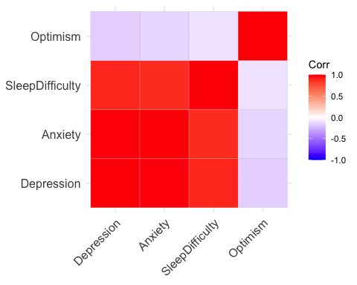

If you type in ?ggcorrplot to your console you can see there are many optional arguments you can use to customize your graph. Using this try to do the following:

1. Give your graph a meaningful title (e.g. “Super cool correlation matrix”)
2. Try changing the display type lower and upper, see what looks best.
3. Display the correlation values on the graph
4. Try changing method to “circle”
5. Try some of the arguments, see what you think looks best

|  |
| --- |
| Ciara’s attempt at “super cool correlation matrix” code |
| ggcorrplot(mcor, type = "lower", method = "circle", title = "Super cool correlation matrix",  lab = TRUE) |

You may also want to save your graphs outside of R (e.g. to use in a report or paper). There are a few ways to do this.

1. To simply export from the “Plots” panel in R (as below).



1. To export via code as below:

png("myplot.png") #specify you want a png file, and your file name  
myplot <- ggcorrplot(mcor) # create an object with that same name that is your plot  
print(myplot) # print the plot  
dev.off() # #this tells R that we are done with adding stuff to our png

quartz_off_screen   
 2

## Activity 9: Power analyses!

Here we are going to learn about how to conduct a power analysis for a correlation.

As you may recall there are some key pieces of information we need for a power analysis, and some specifics that we need for a correlation:

1. Alpha level (typically 0.05 in Psychology and the social sciences)
2. The minimum correlation size of interest
3. Our desired power
4. If our test is one or two-tailed (i.e. do we have a directional or nondirectional hypothesis)

Reminder that this [interactive visualization](https://rpsychologist.com/d3/nhst/) can be helpful in understanding how these things interact.

|  |
| --- |
| How do I know what the minimum correlation size of interest is? |
| This is a good question! Correlation (r) values can be split into arbitrary bands as shown below (Cohen, 1988):   * Small Effect (r = ~ 0.1) * Medium Effect (r = ~ 0.3) * Large Effect (r = ~ 0.5)   As we are aware it is easier to detect large effects. As such, if we really have no idea what effect size we should expect then we should power for small effects.  If however we are conducting a replication, or a very similar study to one that has been already done, then we can power for the correlation they report.  Again I refer to: [A useful paper if you’re interested in learning more](https://online.ucpress.edu/collabra/article/8/1/33267/120491/Sample-Size-Justification) |

## Power analysis for a simple correlation

The syntax for conducting an apriori statistical power analysis for a simple correlation is the following:

# Conduct power analysis for a simple correlation  
pwr.r.test(r = 0.2, # your expected correlation value  
 sig.level = 0.05, # Significance level  
 power = 0.80, # Desired power level  
alternative = "two.sided") # Indicates a two-tailed test, #can be changed to less or greater

approximate correlation power calculation (arctangh transformation)   
  
 n = 193.0867  
 r = 0.2  
 sig.level = 0.05  
 power = 0.8  
 alternative = two.sided

1. Try running the above power-analyses again but for a one sided (directional) test. What does this do to our required sample size?
2. What happens if we increase the correlation value we expect to find?