Week 8 Activities (Anova in R)

Table of contents

In this week’s workshop, we will learn how to run a between-subjects **one-way ANOVA** and a between-subjects **factorial ANOVA** in R.

# Setting Up R

Before we begin, let’s ensure your working environment is ready for today’s session. Open **RStudio** or **Posit Cloud**, and follow the steps below.

## Activity 1: Set Up Your Working Directory & R Script

Each time we work in R, it’s important to set up our **working directory**. This is the folder where R looks for files when importing data and where it saves any files you export.

If you don’t set the working directory, R may not be able to locate your dataset, or you might not know where your exported files have been saved. Setting the working directory beforehand helps keep everything organised and prevents these issues.

|  |
| --- |
| Reminder on Steps to Set Up Your Working Directory |
| 1. Click: **Session → Set Working Directory → Choose Directory** 2. Navigate to the folder you created for this course (this should be the same folder you used for previous workshops). 3. Create a new folder called week8 inside this directory. 4. Select the week8 folder and click **Open**.   Don’t forget to verify your working directory before we get started  You can always check your current working directory by typing in the following command in the console:  getwd()  [1] "C:/Users/0131045s/Desktop/Programming/R/Workshops/rintro/activities/week8" |

As in previous weeks we will create an **R script** that we can use for today’s activities. This week we’ll name the script as 08-anova

|  |
| --- |
| Reminder on creating an R script |
| 1. Go to the menu bar and select: **File → New File → R Script**  * This will open an untitled R script.  1. To save and name your script, select:  * **File→ Save As**, then enter the name: * 08-anova * Click **Save** |

At the top of your R script type in and run the following code (this turns off scientific notation from your output):

options(scipen = 999)

## Activity 2: Installing / Loading R Packages

We will use several R packages to simplify our analysis. Ensure you have them installed and loaded.

**REMEMBER**: If you encounter an error message like “Error in library(package name): there is no packaged calledpackage name”, you’ll need to install the package first by editing the following for your console:

install.packages("package name") #replace "package name" with the actual package name

Here are the packages we will be using today. Make sure that you have loaded in each of these packages by running the following lines of code.

library(patchwork) #helps build useful plots  
library(car) #for checking assumptions  
library(afex) #For running our ANOVA models  
library(tidyverse) #Data manipulation  
library(pwr) #power analysis  
library(lsr) #effect size calculations  
library(emmeans) #Computes post-hoc tests  
library(performance) #Assesses models performances and assumptions  
library(jmv) #Descriptive statistics

## Activity 3: Load Your Datasets

This week, we will work with **four separate datasets**. You can find these datasets on **Canvas**.

* **psycho.csv** → Dataset for the **One-Way ANOVA Example**
* **caffeine_mood.csv** → Dataset for the **One-Way ANOVA Exercise**
* **anxiety_treatment.csv** → Dataset for the **Factorial ANOVA Example**
* **diet_exercise.csv** → Dataset for the **Factorial ANOVA Exercise**

***Download these files onto your computer and move them to your week8 folder.***

# One Way ANOVA - Example & Exercise

## Activity 4: One-Way Between Subjects ANOVA Example

In recent years, there has been a growing interest in exploring the therapeutic potential of psychoactive treatments for mental health. This dataset examines the effects of Psilocybin and DMT on Neuroticism, a personality trait associated with various psychological disorders. The researchers investigated whether the administration of Psilocybin and DMT had a significant effect on participants’ Neuroticism levels.

***Research Question***: Is there an effect of psychoactive treatment on Neuroticism?

**Hypotheses**:

*H₀ (Null Hypothesis)***:** There is no effect of psychoactive treatment on Neuroticism.

*H₁ (Alternative Hypothesis):* There is an effect of psychoactive treatment on Neuroticism.

***Method***: 60 participants were recruited and randomly assigned to one of three groups: Psilocybin, DMT, or Placebo. One-day after taking the substance, participants completed a Neuroticism Measure.

***Our task***: Run a One-Way ANOVA to see if there is an effect of Psychoactive treatment on Neuroticism.

### Step 1: Load in and Check your Dataset

First, we need to load the dataset into R using the read.csv() function:

df_psycho <- read.csv("psycho.csv")

Once a dataset is loaded, it’s important to always verify that:

1. It has been loaded correctly.
2. It contains the expected data.

We can use the head() function to quickly check this by displaying the first 6 rows of the dataset.

head(df_psycho)

Participant_ID Treatment Neuroticism  
1 1 Placebo 39.39524  
2 2 Placebo 42.69823  
3 3 Placebo 60.58708  
4 4 Placebo 45.70508  
5 5 Placebo 46.29288  
6 6 Placebo 62.15065

Another way you can quickly sanity check your dataset is by checking the last few rows with the tail() function. The tail() function works like the head() function, the only difference being it prints the last 6 rows of the dataset.

tail(df_psycho)

Participant_ID Treatment Neuroticism  
55 55 Psilocybin 52.74229  
56 56 Psilocybin 70.16471  
57 57 Psilocybin 39.51247  
58 58 Psilocybin 60.84614  
59 59 Psilocybin 56.23854  
60 60 Psilocybin 57.15942

|  |
| --- |
| What if I want to view the entire dataset? |
| You can click on the dataset in the Environment page to view it  You can click on the dataset in the Environment page to view it |

Either way, everything looks in order, so let’s get cracking with the analysis.

### Step 2: Conduct Descriptive Statistical Analysis

Now, let’s run some descriptive statistics using the descriptives() function. This will help us understand the distribution of **Neuroticism** scores across the different treatment groups.

We will first calculate the mean, standard deviation, and other key statistics for Neuroticism, grouped by Treatment:

descriptives(data = df_psycho,   
 vars = "Neuroticism",  
 splitBy = "Treatment"  
)

DESCRIPTIVES  
  
 Descriptives   
 ───────────────────────────────────────────────────   
 Treatment Neuroticism   
 ───────────────────────────────────────────────────   
 N DMT 20   
 Placebo 20   
 Psilocybin 20   
 Missing DMT 0   
 Placebo 0   
 Psilocybin 0   
 Mean DMT 44.48743   
 Placebo 46.41624   
 Psilocybin 56.06485   
 Median DMT 43.60057   
 Placebo 46.19985   
 Psilocybin 54.64291   
 Standard deviation DMT 8.299387   
 Placebo 9.726653   
 Psilocybin 9.573406   
 Minimum DMT 28.13307   
 Placebo 25.33383   
 Psilocybin 39.51247   
 Maximum DMT 57.53815   
 Placebo 62.86913   
 Psilocybin 76.68956   
 ───────────────────────────────────────────────────

This gives us a first look at the data, but we can refine it further.

If you remember from week 4, we can adjust the descriptives() function to remove unnecessary details and add visualisations.

In the code below, we will:

* Remove the minimum (min = FALSE) and maximum (max = FALSE) values. I am removing both just to remove some clutter from our Descriptives output table.
* Generate visualisations:
  + A histogram (hist = TRUE) with a density overlay (dens = TRUE).
  + A bar plot (bar = TRUE).
  + A boxplot (box = TRUE) to examine distribution and possible outliers.

descriptives(data = df_psycho,   
 vars = "Neuroticism",  
 splitBy = "Treatment",  
 min = FALSE,  
 max = FALSE,  
 hist = TRUE,   
 dens = TRUE,  
 bar = TRUE,  
 box = TRUE  
)

Warning in FUN(X[[i]], ...): no non-missing arguments to max; returning -Inf

DESCRIPTIVES  
  
 Descriptives   
 ───────────────────────────────────────────────────   
 Treatment Neuroticism   
 ───────────────────────────────────────────────────   
 N DMT 20   
 Placebo 20   
 Psilocybin 20   
 Missing DMT 0   
 Placebo 0   
 Psilocybin 0   
 Mean DMT 44.48743   
 Placebo 46.41624   
 Psilocybin 56.06485   
 Median DMT 43.60057   
 Placebo 46.19985   
 Psilocybin 54.64291   
 Standard deviation DMT 8.299387   
 Placebo 9.726653   
 Psilocybin 9.573406   
 ───────────────────────────────────────────────────

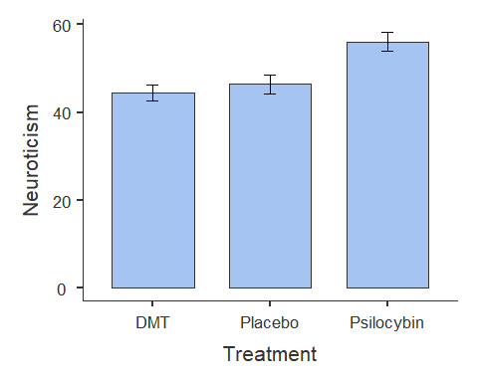

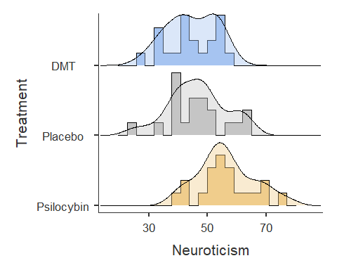

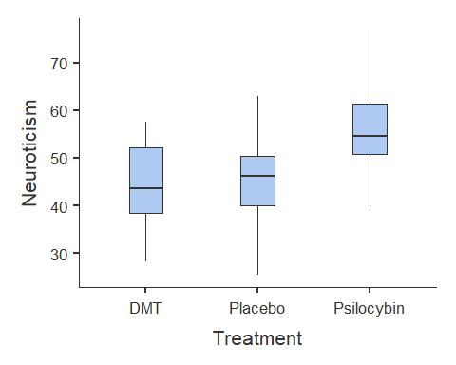

From the results, we can observe the following:

* Participants in the *Psilocybin* group tend to score higher on Neuroticism than those in the *DMT* or *Placebo* groups.
* The *DMT* and *Placebo* groups have similar Neuroticism scores.

Now let’s investigate whether there is a significant effect of Treatment on Neuroticism.

### Step 3: Run our One-Way ANOVA

To run a **one-way ANOVA**, we use the aov_ez() function. Below is the general syntax (you will need to replace certain placeholders with the appropriate column names from your dataset):

anova_example_syntax <- aov_ez(id = "The name of the Participant ID column",   
 dv = "The name of the dependent variable",   
 between = "The name of the independent variable",   
 es = "pes",   
 type = 3,   
 include_aov = TRUE,  
 data = yourdataset)   
  
anova(anova_example_syntax)

|  |
| --- |
| Code Explanation |
| Code Explanation Let’s unpack what is going on here code wise:   1. **anova_example_syntax <- aov_ez(...)**: This line of code is creating a new R variable called **anova_example_syntax**. This variable will store the results of the one-way ANOVA analysis. 2. **id = "the name of your participant ID column"**: This part specifies the column in your dataset that contains the participant IDs. It helps identify which data points belong to each participant. 3. **dv = "the name of your your dependent variable column"**: Here, you specify the dependent variable 4. **between = "the name of your your independent variable column"**: Here, you specify the independent variable 5. **es = "pes"**: This argument specifies that you want to compute the effect size in terms of partial eta-squared (pes). 6. **type = 3**: The **type** argument specifies the type of sum of squares used in the ANOVA. Type 3 is often used for balanced designs. 7. **include_aov = TRUE**: This indicates that you want to include the standard ANOVA table as part of the output. It provides additional information about the analysis. 8. **data = yourdataset**: Finally, you specify the dataset on which you want to perform the ANOVA analysis.  **Understanding the Output**  * Running **anova_example_syntax** will display the ANOVA results, including the *F-statistic*, *degrees of freedom*, and *p-value*. * Running **anova(anova_example_syntax)** provides a more detailed table with additional information such as *sum of squares* and *mean squares*. * The p-value will help us determine whether the treatment groups significantly differ in Neuroticism scores. |

#### Running Our One-Way ANOVA

Now, let’s apply the syntax to our actual dataset, df_psycho. We will store the results into the variable anova_one:

anova_one <- aov_ez(id = "Participant_ID",   
 dv = "Neuroticism",   
 between = "Treatment",   
 es = "pes",   
 type = 3,   
 include_aov = TRUE,  
 data = df_psycho)

Converting to factor: Treatment

Contrasts set to contr.sum for the following variables: Treatment

anova(anova_one)

Anova Table (Type 3 tests)  
  
Response: Neuroticism  
 num Df den Df MSE F ges Pr(>F)   
Treatment 2 57 85.046 9.0482 0.24097 0.0003866 ***  
---  
Signif. codes: 0 '***' 0.001 '**' 0.01 '*' 0.05 '.' 0.1 ' ' 1

We can see that the main effect of Treatment on Neuroticism scores was statistically significant (F(2, 57) = 9.05, p < 0.001). This indicates that there are significant differences in Neuroticism scores among the treatment groups. The effect size (partial eta-squared - under the ges column) is 0.241, which suggests that approximately 24.1% of the variance in Neuroticism scores can be attributed to the differences in treatment groups.

|  |
| --- |
| Why does it say `Converting to factor: Treatment’? |
| Factors are a special data type in R. They enable R to identify categorical variables like:   * Nationality (levels: Irish, English, Indian, American, French, German, Brazilian) * Handiness (e.g. right-handed, left-handed, ambi-dextrous) * Experimental Group (e.g. intervention, control) * Education Status (e.g. first-year, second-year, third-year, fourth-year, masters, PhD).   In this case, the aov_ez function is just converting our Treatment variable into a factor/categorical variable, which is what we want!  Factors are really useful when it comes to data manipulation or data wrangling. But we’ll get to that in the last week of the semester. |

|  |
| --- |
| Effect size cut-off points |
| η² = 0.01 represents a small effect  η² = 0.06 represents a medium effect  η² = 0.14 represents a large effect (Richardson, 2011) |

### Step 4: Check Parametric Assumptions

Before interpreting our ANOVA results, we need to check whether the test’s assumptions are met. Since these assumptions relate to how well the ANOVA models the data, we *evaluate them after running the test* rather than before.

**Assumptions of a One-Way Between-Subjects ANOVA**

1. The dependent variable (DV) is measured on an *interval* or *ratio* scale.
2. Observations are *independent* (i.e., no repeated measures).
3. The *residuals* should be **normally distributed**.
4. There should be *homogeneity of variance* between groups.

We have already confirmed **Assumption 1** (Neuroticism is ratio data) and **Assumption 2** (each participant is in only one group, ensuring independence).

Now, let’s check the remaining assumptions.

**Checking Normality of Residuals**

To verify normality, we will:  
- **Visualise** residuals with a Q-Q plot.  
- **Run the Shapiro-Wilk test** (p > .05 indicates normality).

qqPlot(residuals(anova_one))

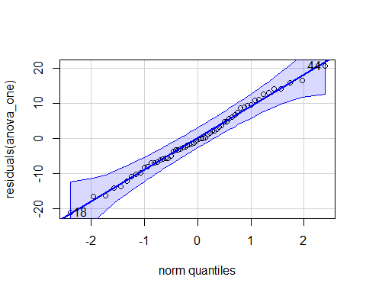

[1] 18 44

shapiro.test(residuals(anova_one))

Shapiro-Wilk normality test  
  
data: residuals(anova_one)  
W = 0.99284, p-value = 0.9791

#### **Interpreting the Results**

* In the **Q-Q plot**, the dots should closely follow the diagonal line.
* In the **Shapiro-Wilk test**, a *p-value greater than .05* suggests that residuals are **normally distributed**.

Since our p-value is **greater than .05 (p > .05)**, normality is **not violated**.

**Checking Homoegeneity of Variance**

We test whether all groups have similar variance using **Levene’s Test**:

test_levene(anova_one)

Warning: Functionality has moved to the 'performance' package.  
Calling 'performance::check_homogeneity()'.

OK: There is not clear evidence for different variances across groups (Levene's Test, p = 0.965).

#### **Interpreting the Results**

* If the *p-value is greater than .05*, it means **variance is equal across groups**, satisfying the assumption.
* We have met this assumption!

### Step 5: Running post-hoc tests

An ANOVA tells us **whether** there is a significant difference between three or more groups, but it does not tell us **where** those differences lie.

If we find a significant result, the next step is to run a *post-hoc test*, which compares each group to every other group to identify the specific differences.

#### **Post-Hoc Test Syntax**

To perform pairwise comparisons, we use the emmeans() function:

emmeans(our_anova_model,   
 pairwise ~ IV,   
 adjust = "Tukey")

**Breaking Down the Code**

1. **emmeans(...)**: Computes pairwise comparisons between groups.
2. **our_anova_model** The variable containing the results of the one-way ANOVA.
3. **pairwise ~ IV** Specifies that we want to compare the levels/groups of the independent variable.
4. **adjust = "Tukey"** Applies the Tukey correction to adjust p-values for multiple comparisons.

**Why Use the Tukey Correction?**

When conducting multiple comparisons, the risk of making a Type I error (false positive) increases. The Tukey correction reduces this risk by adjusting p-values to be more conservative. There are other types of corrections we can apply, but for this class we will stick with Tukey.

#### Running the Post-Hoc Test on Our Data

We now apply this test to our dataset:

AOV1_pairwise <-emmeans(anova_one,   
 pairwise ~ Treatment,   
 adjust = "Tukey")  
  
AOV1_pairwise

$emmeans  
 Treatment emmean SE df lower.CL upper.CL  
 DMT 44.5 2.06 57 40.4 48.6  
 Placebo 46.4 2.06 57 42.3 50.5  
 Psilocybin 56.1 2.06 57 51.9 60.2  
  
Confidence level used: 0.95   
  
$contrasts  
 contrast estimate SE df t.ratio p.value  
 DMT - Placebo -1.93 2.92 57 -0.661 0.7867  
 DMT - Psilocybin -11.58 2.92 57 -3.970 0.0006  
 Placebo - Psilocybin -9.65 2.92 57 -3.309 0.0046  
  
P value adjustment: tukey method for comparing a family of 3 estimates

**Interpreting the Results**

The output shows the **p-values** for pairwise comparisons between treatment groups:

* **DMT vs. Psilocybin:** *p < .001* (significant difference)
* **Placebo vs. Psilocybin:** *p = .005* (significant difference)
* **DMT vs. Placebo:** *p = .787* (no significant difference)

This means that *participants who took Psilocybin had significantly higher Neuroticism scores* than those in the **Placebo** or **DMT** groups. However, there was *no significant difference* between the **DMT and Placebo** groups.

### Step 6: Writing our results in APA style

A one-way between-subjects ANOVA was conducted to examine the effect of treatment condition (*Placebo*, *Psilocybin*, *DMT*) on Neuroticism scores. This test was selected as the dependent variable was continuous, there was independence of observations, there was homogeneity of variance, and normality of residuals was displayed.

The analysis revealed a significant effect of treatment on Neuroticism, *F*(2, 57) = 9.05, *p* < .001, *η²* = .241. This suggests that approximately 24.1% of the variance in Neuroticism scores can be attributed to differences between treatment groups. Based on this result, one can reject the null hypothesis.

Post-hoc pairwise comparisons, using the Tukey correction, revealed that:

The *Psilocybin* group had significantly higher Neuroticism scores than the *DMT* group (*t* = -3.97, *p* = .0006).

The *Psilocybin* group also had significantly higher Neuroticism scores than the *Placebo* group (*t* = -3.31, *p* = .0046).

No significant difference was found between the *DMT* and *Placebo* groups (*t* = -0.66, *p* = .787).

These results suggest that *Psilocybin* led to significantly higher Neuroticism scores compared to *DMT* and *Placebo*, while *DMT* and *Placebo* did not differ significantly. Based on these results, one can reject the null hypothesis.

### Step 7: Power Analysis

A **power analysis** helps determine whether our sample size is sufficient to detect an effect. There are **two types of power analysis**:

1. **Apriori power analysis** – Performed *before* data collection to determine the required sample size.
2. **Post-hoc power analysis** – Performed *after* an analysis to check how much power the study had given the sample size used.

#### **Apriori Power Analysis**

This test helps us determine the **minimum sample size** needed to achieve **80% power** (*power = 0.8*), assuming a **moderate effect size** (*f = 0.25*).

pwr.anova.test(k = 3, # Number of groups   
 f = .25, # Expected effect size  
 sig.level = .05,   
 power = .8)

Balanced one-way analysis of variance power calculation   
  
 k = 3  
 n = 52.3966  
 f = 0.25  
 sig.level = 0.05  
 power = 0.8  
  
NOTE: n is number in each group

This function calculates the required sample size per group to detect an effect. If the calculated sample size is larger than what we collected, it suggests that our study may be underpowered.

#### Post-Hoc Power Analysis

This test calculates how much power we had given our actual sample size (n = 20 per group).

pwr.anova.test(k = 3, #number of groups   
 n = 20,  
 f = .25, #observed effect size  
 sig.level = .05)

Balanced one-way analysis of variance power calculation   
  
 k = 3  
 n = 20  
 f = 0.25  
 sig.level = 0.05  
 power = 0.3744311  
  
NOTE: n is number in each group

If the resulting power is above 0.8, the study had sufficient power to detect the expected effect. If it is below 0.8, there is a higher risk of a Type II error (failing to detect a real effect).

We can see that our power is 0.35 (35%), which suggests it is substantially underpowered (we want it to be 80% or higher). Therefore we need to be extra cautious when interpreting these results.

### Step 8: Create a Nice Visualisation (Violin Plot)

Next week we will go into more detail on how to create nice visualisations in R. But here is code that you can use in the meantime to create a violin plot.

ggplot(df_psycho, aes(x = Treatment,   
 y = Neuroticism,   
 fill = Treatment)) +   
 labs(title = "Effect of Psychoactive Treatment on Neuroticism") +  
 geom_violin(trim = FALSE) +  
 geom_boxplot(width = .2, colour = "black") +   
 theme_classic() +  
 theme(legend.position = "none")

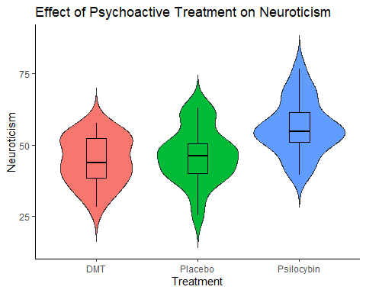

The main thing, is that when you are adapting this code for your own work (e.g. in the exercise later), make sure to replace wherever you see Treatment with your Independent Variable, and where ever you see Neuroticism with your Dependent Variable. Don’t forgot to change the title as well! E

We will visualise the results of a Factorial ANOVA in a different way, but more on that later.

## Activity 5: One-Way ANOVA Exercise

Researchers investigated the effects of caffeine consumption on mood.

**Research Question**: Is there an effect of Caffeine on Mood?

**Hypotheses**:

*H₀ (Null Hypothesis):* There is no effect of Caffeine on Mood?

*H₁ (Alternative Hypothesis)*: There is an effect of Caffeine on Mood.

**Method**: 200 participants were randomly assigned to one of four groups for one week: No Caffeine (Control), 100mg of Caffeine (Low Caffeine), 250mg of Caffeine (High Caffeine), or 400mg of Caffeine (High Caffeine). Their mood was collected each day and an average of their mood scores for the week was computed.

***Our task***: Run a One-Way ANOVA to see if there is an effect of Caffeine on Mood.

Follow the same **seven steps** from the worked example to analyse this dataset.

1. **Load and Inspect the Dataset**
   * Load the dataset (caffeine_mood.csv) into R.
   * Check the first few rows using head().
2. **Explore the Data**
   * Calculate descriptive statistics for mood split by by group.
   * Create visualisations: histograms with density plots, barplots, and a boxplot.
3. **Run the One-Way ANOVA**
   * Use aov_ez() to perform the ANOVA.
4. **Check ANOVA Assumptions**
   * Test normality of residuals with a **Q-Q plot** and **Shapiro-Wilk test**.
   * Check homogeneity of variance using **Levene’s test**.
   * If there are violations, just make a note of them.
5. **Conduct Post-Hoc Comparisons**
   * Use emmeans() with Tukey correction to determine which specifc groups are significantly different.
6. **Report Results in APA Format**
   * Write a short APA-style interpretation of the results.
7. **Conduct a Power Analysis**
   * Use pwr.anova.test() to check ***post-hoc*** statistical power.

# Factorial ANOVA

## Activity 6: Factorial ANOVA Example

One-Way ANOVAS are a good test when you are investigating the effect of one independent variable with three or more levels on some dependent variable. However, you will often want to investigate the effect of more than one independent variable on a dependent variable. In those situations, Factorial ANOVAS can be an excellent statistical test to use.

In this example, we will walk through the steps involved in conducting a Factorial ANOVA.

### Research Introduction

In recent years, psychological interventions such as Cognitive Behavioral Therapy (CBT), Dialectical Behavioural Therapy (DBT) and Mindfulness-Based Therapy have gained widespread recognition for their effectiveness in treating anxiety. While both therapies have been shown to reduce anxiety, their relative effectiveness and their effectiveness over different durations of interventions are still of interest. This study aimed to investigate the effect of therapy type (CBT, Mindfulness, or no intervention) on anxiety reduction over different durations of time.

**Research Question:** Is there an effect of therapy type and duration of treatment on anxiety?

**Hypotheses:**

*Null Hypothesis (H₀)***:** Therapy type and treatment duration have no effect on anxiety levels after the intervention.

*Alternative Hypothesis (H₁)***:** Therapy type and treatment duration influence anxiety levels, with CBT and DBT leading to lower anxiety scores compared to Mindfulness, and longer durations (12 weeks) resulting in greater anxiety reduction than shorter durations (6 weeks).

**Method**: A total of 180 participants were randomly assigned to one of three therapy groups: CBT (n = 60), DBT (n = 60), or Mindfulness (n = 60). They were also randomly assigned to receive therapy for either 6 weeks (n = 90) or 12 weeks (n = 90). After completing the assigned intervention, their anxiety levels were measured.

**Analysis Plan:** A *3×2 Factorial ANOVA* will be conducted to examine:

1. The **main effect of therapy type** (whether different therapies lead to different anxiety levels).
2. The **main effect of duration** (whether 6-week vs. 12-week treatment impacts anxiety levels differently).
3. The **interaction effect** between therapy type and duration (whether the effectiveness of a therapy depends on the length of treatment).

This approach allows us to understand both the individual and combined effects of therapy type and duration on anxiety reduction.

|  |
| --- |
| Why is it a 3X2 Factorial ANOVA? |
| I used to often get confused about the numbers for a factorial design. For example, why is this called a 3x2 Factorial ANOVA?  Well the reason is that this examines the effects of two independent variables, each with multiple levels:   1. **Therapy Type** (Independent Variable 1) – This variable has **three levels**:    * Cognitive Behavioral Therapy (CBT)    * Mindfulness-Based Therapy    * Dialectical Behavioural Therapy (DBT) 2. **Duration** (Independent Variable 2) – This variable has **two levels**:    * 6 weeks of treatment    * 12 weeks of treatment   Since the first independent variable (**Therapy Type**) has **3 levels** and the second independent variable (**Duration**) has **2 levels**, the appropriate notation for this design is **3×2**. |

### Step 1: Load in and Check Your Data

First, we need to load the dataset into R using the read.csv() function. Let’s call it df_anxiety. We can then check the first six rows using the head() function.

df_anxiety <- read.csv("anxiety_treatment.csv")  
  
head(df_anxiety)

ID Anxiety Therapy Duration  
1 1 54.63603 Mindfulness 6 Weeks  
2 2 76.04019 Mindfulness 6 Weeks  
3 3 58.30279 Mindfulness 6 Weeks  
4 4 58.55996 Mindfulness 6 Weeks  
5 5 51.01651 Mindfulness 6 Weeks  
6 6 63.09393 Mindfulness 6 Weeks

One step we are going to do extra here is turn the

### Step 2: Conduct Descriptive Statistical Analysis

Now, let’s run some descriptive statistics using the descriptives() function. This will help us understand the distribution of **Anxiety** scores across the different Treatment and Duration groups.

We will first calculate the mean, standard deviation, and other key statistics for Anxiety , grouped by Treatment. We will also generate

* A histogram (hist = TRUE) with a density overlay (dens = TRUE).
* A bar plot (bar = TRUE).
* A boxplot (box = TRUE) to examine distribution and possible outliers.

We are also going to convert the **Duration** variable into a factor. You do not need to include this code in the exercise, as we have not covered factors yet. However, I am doing it here to ensure that any plots display 6 weeks first and then 12 weeks afterwards.

df_anxiety$Duration <- factor(df_anxiety$Duration,   
 levels = c("6 Weeks", "12 Weeks"))  
  
descriptives(data = df_anxiety,  
 vars = Anxiety,  
 splitBy = c("Therapy", "Duration"),  
 min = F,  
 max = F,  
 box = T,  
 hist = T,  
 bar = T,  
 dens = T)

Warning in FUN(X[[i]], ...): no non-missing arguments to max; returning -Inf

DESCRIPTIVES  
  
 Descriptives   
 ─────────────────────────────────────────────────────────────   
 Therapy Duration Anxiety   
 ─────────────────────────────────────────────────────────────   
 N CBT 6 Weeks 30   
 12 Weeks 30   
 DBT 6 Weeks 30   
 12 Weeks 30   
 Mindfulness 6 Weeks 30   
 12 Weeks 30   
 Missing CBT 6 Weeks 0   
 12 Weeks 0   
 DBT 6 Weeks 0   
 12 Weeks 0   
 Mindfulness 6 Weeks 0   
 12 Weeks 0   
 Mean CBT 6 Weeks 50.72652   
 12 Weeks 40.61220   
 DBT 6 Weeks 47.76104   
 12 Weeks 38.54935   
 Mindfulness 6 Weeks 63.94147   
 12 Weeks 59.69312   
 Median CBT 6 Weeks 49.93308   
 12 Weeks 40.43544   
 DBT 6 Weeks 47.70946   
 12 Weeks 38.58374   
 Mindfulness 6 Weeks 63.36728   
 12 Weeks 59.45626   
 Standard deviation CBT 6 Weeks 6.241643   
 12 Weeks 6.144259   
 DBT 6 Weeks 7.812456   
 12 Weeks 6.536182   
 Mindfulness 6 Weeks 6.140044   
 12 Weeks 6.217064   
 ─────────────────────────────────────────────────────────────

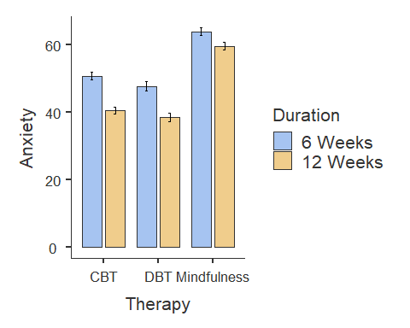

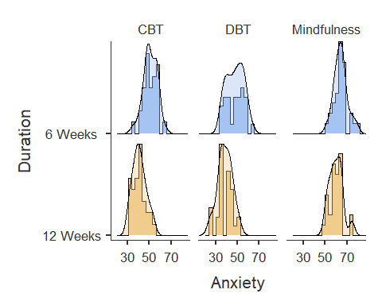

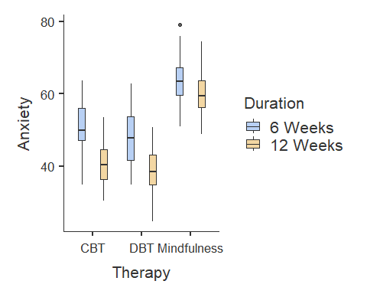

From the results, we can observe the following:

* Participants who completed CBT and DBT therapy had lower Anxiety scores than participants who completed Mindfulness therapy.
* Participants who completed 12-weeks of therapy had lower Anxiety scores than participants who completed six-weeks of therapy.
* There does not seem to much difference between participants who completed DBT and CBT, although it seems like participants who completed DBT had slightly smaller Anxiety scores.
* The bar plot identifies one outlier in the Mindfulness - Six Weeks group. The ANOVA is generally robust to single outliers, so we can ignore this for now.

Now let’s investigate whether there is a significant effect of Therapy on Anxiety over Length.

### Step 3: Run Your Factorial ANOVA

#### The Syntax

To run a **factorial ANOVA**, we also use the aov_ez() function. The syntax is nearly identical to the One-Way ANOVA.

Below is the general syntax (remember you will need to replace certain placeholders with the appropriate column names from your dataset):

anova_example_syntax <- aov_ez(id = "The name of the Participant ID column",  
 dv = "The name of the dependent variable",   
 between = "The name(s) of the between-subjects independent variable",   
 es = "pes",   
 type = 3,   
 include_aov = TRUE,  
 data = yourdataset)   
  
anova(anova_example_syntax)

#### Running it on our Dataset

For our dataset, we have two between subjects independent variables: Therapy and Duration, so our code will be the following:

fact_anova <- aov_ez(id = "ID",  
 between = c("Therapy", "Duration"),   
 dv = "Anxiety",   
 type = 3,  
 es = "pes",  
 include_aov = TRUE,  
 data = df_anxiety)

Converting to factor: Therapy

Contrasts set to contr.sum for the following variables: Therapy, Duration

fact_output <- summary(fact_anova)  
  
fact_output

Anova Table (Type 3 tests)  
  
Response: Anxiety  
 num Df den Df MSE F ges Pr(>F)  
Therapy 2 174 42.803 143.7634 0.62299 < 0.00000000000000022  
Duration 1 174 42.803 64.9195 0.27172 0.0000000000001195  
Therapy:Duration 2 174 42.803 3.4962 0.03863 0.03246  
   
Therapy ***  
Duration ***  
Therapy:Duration *   
---  
Signif. codes: 0 '***' 0.001 '**' 0.01 '*' 0.05 '.' 0.1 ' ' 1

We can see that the main effect of Therapy type on Anxiety scores was statistically significant, F(2, 174) = 143.76, p < 0.001. This indicates that different therapy types led to significantly different anxiety levels after the intervention. The effect size (generalised eta squared) is 0.623, suggesting that approximately 62.3% of the variance in anxiety scores can be attributed to differences in therapy type.

The main effect of Duration was also statistically significant, F(1, 174) = 64.92, p < 0.001, indicating that treatment length (6 weeks vs. 12 weeks) had a significant impact on anxiety levels. The effect size is 0.272, meaning that 27.2% of the variance in anxiety scores is explained by treatment duration.

Additionally, there was a significant interaction effect between Therapy type and Duration, F(2, 174) = 3.50, p = 0.032. The effect size is 0.039, indicating that the interaction accounts for 3.9% of the variance in anxiety scores. This suggests that the effectiveness of therapy types may depend on the duration of treatment.

### Step 4: Check Your Parametric Assumptions

Before interpreting our ANOVA results, we need to check whether the test’s assumptions are met. Since these assumptions relate to how well the ANOVA models the data, we evaluate them after running the test rather than before.

**Assumptions of a Factorial ANOVA**

The assumptions are the same as one the one-way ANOVA, namely:

1. The dependent variable (DV) is measured on an *interval* or *ratio* scale.
2. Observations are *independent* (i.e., no repeated measures).
3. The *residuals* should be **normally distributed**.
4. There should be *homogeneity of variance* between groups.

A basic glance at the data already confirms **Assumption 1** (Anxiety is interval data) and **Assumption 2** (each participant is in only one group, ensuring independence).

We can use the same method as before to check normality of residuals and homogeneity of variance.

# Check Normality Assumption  
qqPlot(residuals(fact_anova)) # Q-Q Plot of residuals

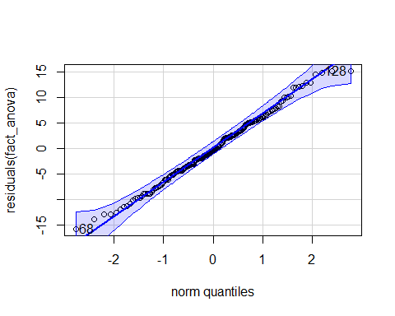

[1] 68 128

shapiro.test(residuals(fact_anova)) # Shapiro-Wilk test for normality

Shapiro-Wilk normality test  
  
data: residuals(fact_anova)  
W = 0.99368, p-value = 0.6344

# Check Homogeneity of Variance  
test_levene(fact_anova)

Warning: Functionality has moved to the 'performance' package.  
Calling 'performance::check_homogeneity()'.

OK: There is not clear evidence for different variances across groups (Levene's Test, p = 0.352).

We can see that the dots are mostly on the line. The Shapiro-Wilk’s value is greater than .05, as is the Levene’s Test p-value. Based on these results, we can say we have met our assumptions.

Now let’s determine where the differences lie!

### Step 5: Run Your Post-Hoc Comparisons

Like the One-Way ANOVA, a factorial ANOVA tells us whether there is a significant difference between three or more groups, but it does not tell us where those differences lie.

If we find a significant result, the next step is to run a post-hoc test, which compares each group to every other group to identify the specific differences.

The syntax is slightly different for the Factorial ANOVA. The reason for this is that we are comparing differences in groups across more than one independent variables. So we will need post-hoc tests across both Therapy Type and Duration of Therapy.

Luckily, it is easy to do this in R using the | symbol.

posthoc_factorial <- emmeans(fact_anova,   
 pairwise ~ Therapy | Duration,   
 adjust = "Tukey")  
  
posthoc_factorial

$emmeans  
Duration = 6 Weeks:  
 Therapy emmean SE df lower.CL upper.CL  
 CBT 50.7 1.19 174 48.4 53.1  
 DBT 47.8 1.19 174 45.4 50.1  
 Mindfulness 63.9 1.19 174 61.6 66.3  
  
Duration = 12 Weeks:  
 Therapy emmean SE df lower.CL upper.CL  
 CBT 40.6 1.19 174 38.3 43.0  
 DBT 38.5 1.19 174 36.2 40.9  
 Mindfulness 59.7 1.19 174 57.3 62.1  
  
Confidence level used: 0.95   
  
$contrasts  
Duration = 6 Weeks:  
 contrast estimate SE df t.ratio p.value  
 CBT - DBT 2.97 1.69 174 1.756 0.1878  
 CBT - Mindfulness -13.21 1.69 174 -7.823 <.0001  
 DBT - Mindfulness -16.18 1.69 174 -9.579 <.0001  
  
Duration = 12 Weeks:  
 contrast estimate SE df t.ratio p.value  
 CBT - DBT 2.06 1.69 174 1.221 0.4423  
 CBT - Mindfulness -19.08 1.69 174 -11.296 <.0001  
 DBT - Mindfulness -21.14 1.69 174 -12.517 <.0001  
  
P value adjustment: tukey method for comparing a family of 3 estimates

***Interpreting the Results***

#### **Main Findings**

1. **12-Week Duration**:
   * CBT (M = 40.6) and DBT (M = 38.5) resulted in lower anxiety scores than Mindfulness (M = 59.7).
   * The difference between CBT and DBT was small and not statistically significant (p = 0.671).
   * Mindfulness had significantly higher anxiety scores compared to both CBT (p < .0001) and DBT (p < .0001), suggesting that CBT and DBT were more effective in reducing anxiety over 12 weeks.
2. **6-Week Duration**:
   * CBT (M = 50.7) and DBT (M = 47.8) again showed lower anxiety scores than Mindfulness (M = 63.9).
   * The difference between CBT and DBT was not significant (p = 0.2428).
   * Mindfulness resulted in significantly higher anxiety scores compared to CBT (p < .0001) and DBT (p < .0001), indicating that it was the least effective therapy type over 6 weeks.

#### **Summary**

* CBT and DBT both significantly reduced anxiety compared to Mindfulness at both 6-week and 12-week durations.
* There was no significant difference between CBT and DBT in reducing anxiety.
* The 12-week duration was more effective than 6 weeks, as anxiety scores were lower across all therapy types after 12 weeks.
* The interaction effect suggests that Mindfulness was particularly ineffective over shorter durations, as its scores were much higher than CBT and DBT, especially at 6 weeks.

Overall, the findings indicate that CBT and DBT are both effective therapies for reducing anxiety, especially over 12 weeks, whereas Mindfulness is less effective in comparison.

### Step 6: Visualise your Model

The following code will enable us to plot the interaction between Duration and Therapy.

afex_plot(fact_anova,   
 x = "Duration", #what goes on the x-axis  
 trace = "Therapy", #to make sure it tracks the other independent variable as well  
 error = "between",  
 mapping = c("color", "linetype")) + # Automatically maps color & line type to Therapy  
 theme_classic() # Clean and simple theme

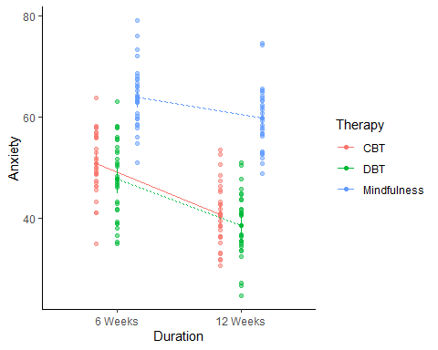

When adapting this code to your own work, make sure to replace Duration and Therapy with your own Independent Variables.

In terms of deciding what goes on the x-axis, it does not really matter too much. You could swap Duration and Therapy in the above code, and it will still produce a plot (feel free to try). Usually, the final decision is what plot looks more informative about the results.

### Step 7: Write up your results in APA style

A 3 × 2 factorial ANOVA was conducted to examine the effects of therapy type (*CBT*, *DBT*, *Mindfulness*) and treatment duration (6 weeks vs. 12 weeks) on post-treatment anxiety scores.

There was a significant main effect of therapy type, *F*(2, 174) = 143.76, *p* < .001, *η²ₚ* = 0.623, indicating that anxiety scores differed significantly across therapy conditions.

There was also a significant main effect of treatment duration, *F*(1, 174) = 64.92, *p* < .001, *η²ₚ* = 0.272, suggesting that participants who received 12 weeks of treatment (*M* = 46.3, *SE* = 1.19) had significantly lower anxiety scores than those who received 6 weeks of treatment (*M* = 54.1, *SE* = 1.19).

The therapy type by treatment duration interaction was also statistically significant, *F*(2, 174) = 3.50, *p* = .032, *η²ₚ* = 0.039, indicating that the effectiveness of therapy type depended on treatment duration.

Post-hoc comparisons with Tukey correction showed that *CBT* (*M* = 50.7, *SE* = 1.19) and *DBT* (*M* = 47.8, *SE* = 1.19) were significantly more effective than *Mindfulness* (*M* = 63.9, *SE* = 1.19) at reducing anxiety after 6 weeks (*p* < .0001). Similarly, after 12 weeks, *CBT* (*M* = 40.6, *SE* = 1.19) and *DBT* (*M* = 38.5, *SE* = 1.19) remained significantly more effective than *Mindfulness* (*M* = 59.7, *SE* = 1.19) (*p* < .0001). However, there was no significant difference between *CBT* and *DBT* at either time point (*p* = .671 for 12 weeks; *p* = .243 for 6 weeks).

Based on these results, one can reject the null hypothesis.

## Activity 7: Factorial ANOVA Exercise

### **Research Introduction**

Obesity is a growing health concern, and many people try different exercise and diet strategies to lose weight. However, it is unclear how different types of exercise and diets affect weight loss. This study aims to investigate the impact of **exercise type** (Three Levels: *None, Cardio, Strength Training*) and **diet type** (Two Levels: *Standard, High-Protein*) on weight loss.

### **Research Question**

Is there an effect of exercise type and diet type on weight loss?

### **Hypotheses**

*H₀ (Null Hypothesis):* There is no effect of exercise and diet type on weight loss.

*H₁ (Alternative Hypothesis):* There is an effect of exercise and diet type on weight loss.

### **Method**

A total of **180 participants** were randomly assigned to one exercise type and one diet type in a **3 × 2 design**:

1. **Exercise Type:**
   * None (n = 60)
   * Cardio (n = 60_
   * Strength Training (n = 60)
2. **Diet Type:**
   * Standard Diet (n = 90)
   * High-Protein Diet (n = 90)

The study lasted 12 weeks, with participants in the exercise groups attending three supervised sessions per week. Participants followed dietary guidelines based on their assigned diet type. Weight loss (kg) was recorded at the end of the study.

### **Our Task**

Conduct a **factorial ANOVA** to test whether exercise type and diet type effect weight loss and if there is an interaction between them. Use the diet_exercise.csv dataset. Run through the same exact steps as the example.