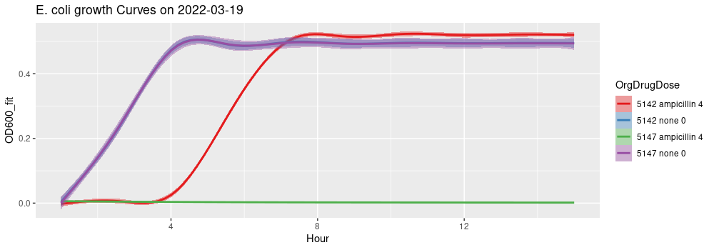

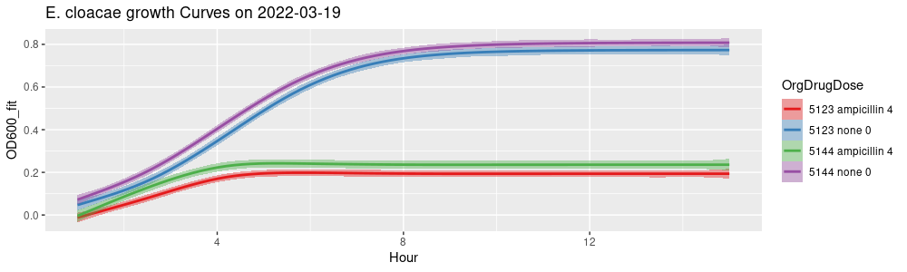

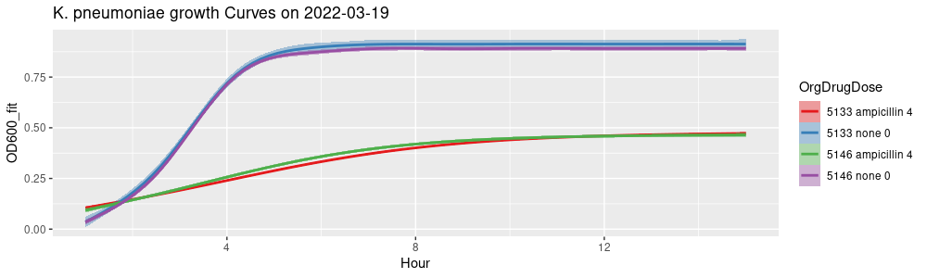

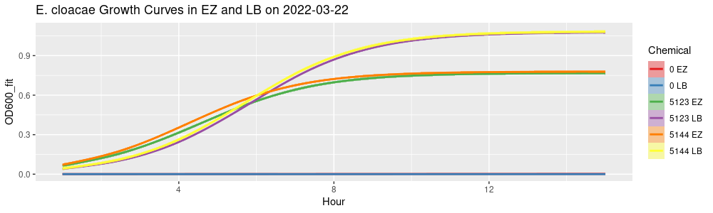

this.Fitted_Plot <-
ggplot(
Fitted_Experiments[
Date == "2022-03-22",
.(OD600_fit, Chemical = paste(Organism, Chemical)), by = .(Hour, Organism, Induced)],
aes(
x = Hour,
y = OD600_fit,
color = Chemical,
fill = Chemical)) +
geom_smooth(
method = "gam") +
scale_colour_brewer(palette = "Set1") +
scale_fill_brewer(palette = "Set1") +
ggtitle(paste("E. cloacae Growth Curves in EZ and LB on", i))

plot(this.Fitted_Plot)

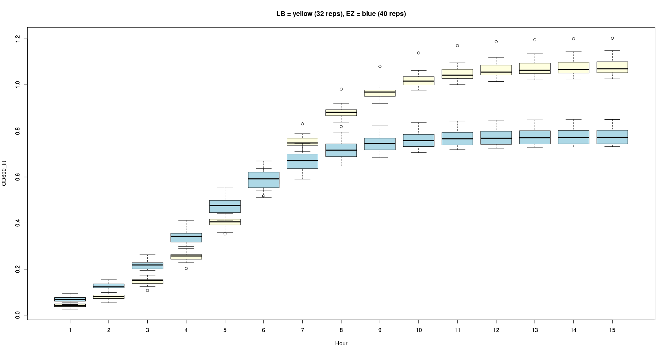
boxplot(OD600_fit ~ Hour, data = Fitted_Experiments[Date == c("2022-03-22") & Chemical == "LB" & Organism %in% c(5123, 5144)],
col = "light yellow",
main = "LB = yellow (32 reps), EZ = blue (40 reps)")

boxplot(OD600_fit ~ Hour, data = Fitted_Experiments[Date %in% c("2022-03-19", "2022-03-22") & Chemical %in% c("EZ", "none") & Organism %in% c(5123, 5144)], col = "light blue", add = T)

