Pairs Game Component

<http://app.mymaths.co.uk/1782-homework/special-angles>

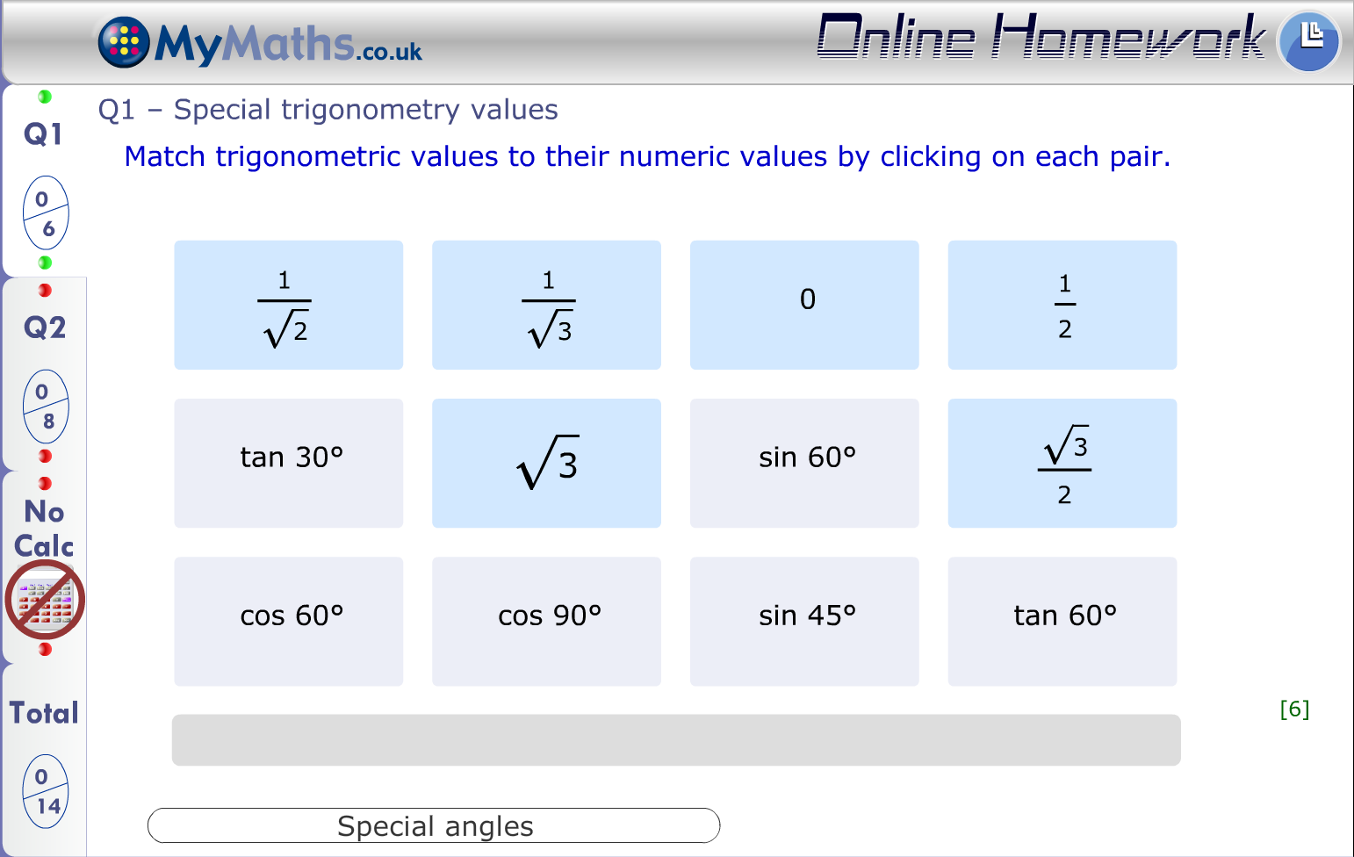

This is a component that lets you play a “matching” game. You can list pairs of tiles that will be randomly placed in a grid. The user then has to click on a pair to match them. If it is a correct match those tiles are removed from the grid. If they click on an incorrect pair, those tiles stay. The game is finished when all pairs have been matched and the grid is empty.

The tiles are organised into two sets. Each pair of tiles has a tile from set A and set B. For example, pair 1 would consist of Tile 1A and Tile 1B. The two sets of tiles can be styled differently. The tiles can contain a wide variety of content including text, maths, graphs and images. The content in the pairs can be randomised.

You can decide whether the tiles are face up or face down (i.e. whether the player can see the values on all the tiles throughout the game.

## Required information:

**Layout**: Choose the number and layout of the tiles in the grid from: 4x2, 5x2, 4x3, 4x4, 5x4.

**Briefs:** For text, maths, graphs, images and randomisation for each pair of tiles.

**Instructional Text:** Custom text at the top of the activity e.g. “Match … to their … by clicking on each pair”

**Orientation**: Whether or not the tiles are faced up (default) or faced down (for a memory game) before they are selected.

## Optional information:

**Colours:** The tiles change colour if they’ve been selected or matched incorrectly. These can, if necessary be changed. Both sets of tiles are defaulted to the same colours.

**Editorial note***: it is possible to change various paddings, see tech documentation*

The text displayed during the game can be customised. “Match!”, “Not a Match!”, “Number of tries:” and “You’ve got them all!”.

## Marking

**Lesson:** behaviour is automatic

**Homework:** behaviour is automatic.

The marks are not assigned in an automatic way, so that means that we can change this if we want to. The marking should be for N pairs:

2N- tries if 2N- tries>0 else 0

They must do N tries to finish so the max marks is N if they do it perfectly and effectively get docked one mark for every extra try until they get to 0.

## Specification Template

|  |  |  |  |  |  |  |
| --- | --- | --- | --- | --- | --- | --- |
| **Pairs Game** – All details in required information | | | | | | |
| Layout **delete as appropriate** | | | 4x2/ 5x2/ 4x3/ 4x4 / 5x4 | | | |
| Show pairs here. Briefs for pairs if not sufficiently detailed in storyboard – Details of text, maths, graphs, images and randomisation for pairs  Number of pairs must correspond to layout. | | | | | | |
| No. | Set A | | | | Set B | |
| 1 | Brief for tile 1A | | | | Brief for tile 1B | |
| 2 |  | | | |  | |
| 3 |  | | | |  | |
| 4 |  | | | |  | |
| 5 |  | | | |  | |
| 6 |  | | | |  | |
| 7 |  | | | |  | |
| 8 |  | | | |  | |
| 9 |  | | | |  | |
| 10 |  | | | |  | |
| Instructional Text – Custom text at the top of the activity | | | | | | |
| e.g. “Match … to their … by clicking on the pair” | | | | | | |
| Marking - is not automatic on the component. The default suggested is below. | | | | | | |
| Default scheme  Max{2**N**-**tries**,0}, where **N** = number of pairs and **tries** = number of pairs clicked before completing. | | | | | | |
| Notes | | | | | | |
|  | | | | | | |
| **Randomisation** – list variables by name. These should appear in orange in the storyboard. | | | | | | |
| **Variable** | | **Type – string, num, int** | | **Range/Options** | | **Notes/restrictions** |
|  | |  | |  | |  |
|  | |  | |  | |  |