L&R MASTER
Watch Cleaning Machine

WORKSHOP MANUAL
Model: Master · Serial No. 13505

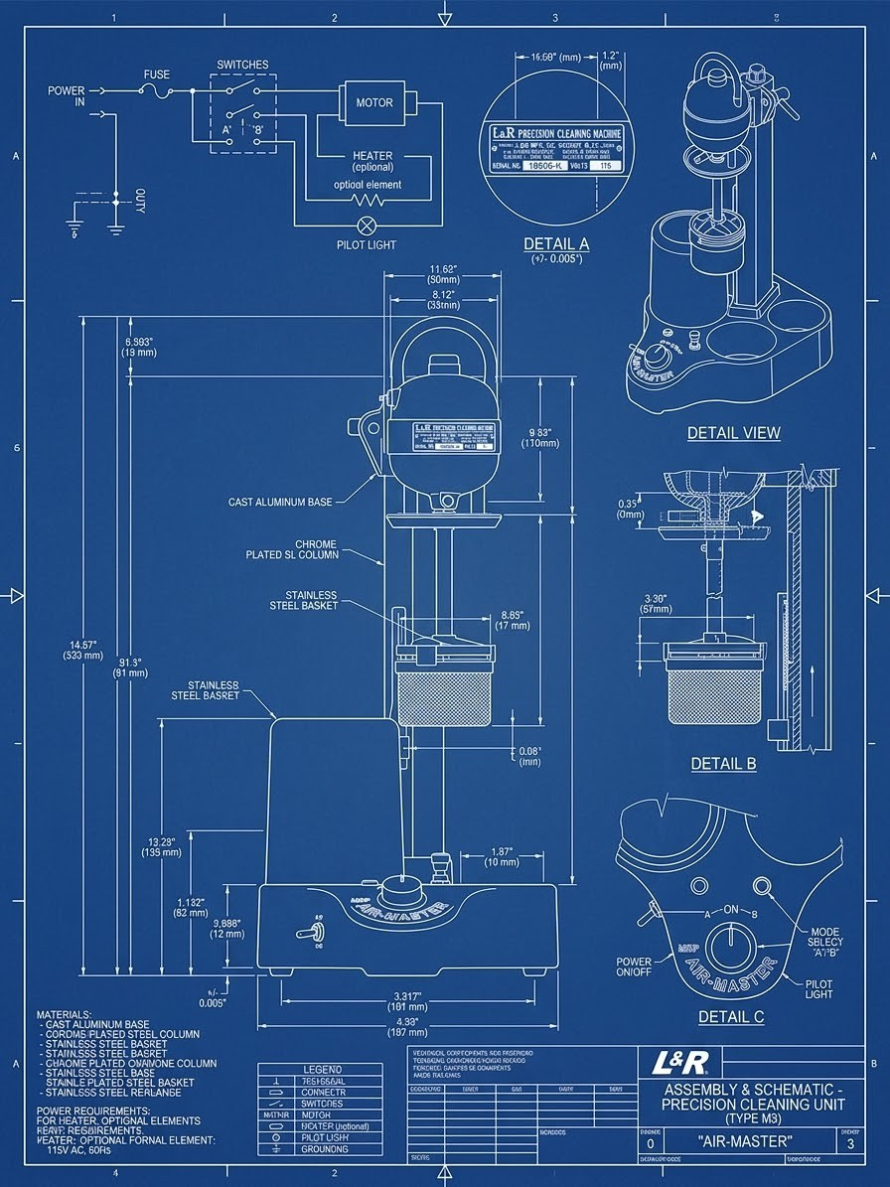
Artistic blueprint rendering — stylized illustration, not a technical drawing.

L&R MFG. CO. (reproduction)
Curated by Hobbs R.E.
June 12, 2026

REPRODUCTION DOCUMENT — reverse-engineered from specimen S/N 13505. For reference only.

Contents
Open in Word, then right-click here and choose "Update Field" to build the table of contents.

About This Manual
L&R Precision Cleaning Machine — Master — Serial No. 13505
Manufacturer: L&R MFG. CO. · Engineer: Hobbs R.E. · Date: June 12, 2026
REPRODUCTION DOCUMENT — Not an original L&R Mfg. Co. technical publication. Reverse-engineered from direct physical restoration of specimen S/N 13505. For reference only.
This workshop manual has three parts:
- Part I — Operating Instructions: how to run the machine.
- Part II — Maintenance & Service: routine care, electrical service, and troubleshooting.
- Part III — Restoration: the full teardown, reconditioning, reassembly, and modern grounded rewire.
Every physical component carries a canonical Part ID (e.g. UH-001, ARM-006, BAS-006) defined in the project Parts Dictionary; drawings and photos are referenced by their file paths in the source repository. Dimensions carry a confidence label — (CONFIRMED) direct measurement, (EST.) estimated, (SYN) synthesized, (REF) reference.
⚠️ Best-judgment note. No original L&R operating or service sheet was obtained for this machine. The procedures in Parts I and II are reconstructed from the machine's mechanism and general practice — sound guidance, but not factory-verified.

Part I — Operating Instructions

L&R Master Watch Cleaning Machine · Master · S/N 13505
REPRODUCTION DOCUMENT — Not an original L&R Mfg. Co. technical publication. Reverse-engineered from specimen S/N 13505 by Hobbs R.E., 2026. For reference only.
Title block: Date June 12, 2026 · L&R Precision Cleaning Machine · Master · S/N 13505 · L&R MFG. CO. · Engineer Hobbs R.E.
⚠️ Best-judgment procedure. No original L&R Master operating sheet was available for this specimen. The operating sequence below is reconstructed from the machine's mechanism, its controls, and general watch-cleaning practice — it is not factory-verified. Treat it as a sound starting point, not gospel.

I.0 — What the machine does
The L&R Master is a spinning-basket parts cleaner for watch and clock movements. A motor drives a mesh basket (BSK-002) that holds the disassembled parts. The basket is lowered into a jar of cleaning or rinsing solution and spun (in both directions) so the fluid scrubs the parts; it is then moved to the next jar, and finally to a heated drying chamber. The motor head rides on a swiveling carrier so the operator can index the basket over each station in turn.
Stations (4 wells, 2×2 grid):
- 3 solution jar bays (BAS-003) — glass jars of cleaning fluid, then rinse(s).
- 1 heater well (BAS-002) — a tall tube that acts as a warm-air drying chamber (the heating element R1 sits below; the basket parks above it, never touching it).

I.1 — Controls
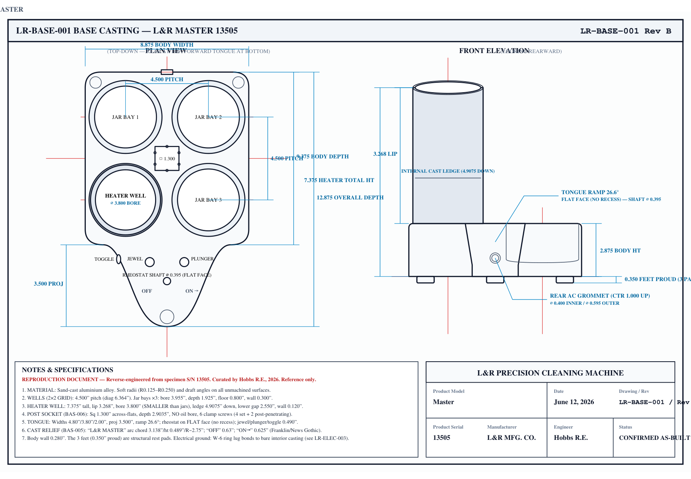
Figure I-1. Base-casting plan view — control layout and well stations (drawing LR-BASE-001).
Control | Part | Function
Speed knob (front, center of tongue) | Rheostat CTL-001 | Motor speed and ON/OFF. Full counter-clockwise = OFF. There is no separate power switch.
Plunger button (top of tongue) | Plunger switch CTL-003 | Momentary REVERSE. Released (out) = forward; press and hold = reverse.
Toggle (left side face) | Toggle switch CTL-004 | Heater ON/OFF (also lights the pilot).
Red jewel (upper-left of tongue) | Pilot lamp CTL-005/006 | Lights when the heater is on.
Speed carrier (rides the post) | Carrier NCK-002 | Swivels/locks to position the basket over each well; the clamp handle (NCK-003) raises/holds the motor.

I.2 — Setup
- Place the machine on a GFCI-protected outlet on a stable, ventilated bench. (See Safety, I.4.)
- Fill the jars: put your cleaning solution in the first jar bay and rinse solution(s) in the others, per your chosen watch-cleaning fluids. Seat each glass jar in a bay. The tapered rubber seal (PLT-002) on the platform deck wedges into the jar mouth to contain splashing.
⚠️ Use non-flammable / water-based solutions — the motor sparks at the commutator (see I.4).
- Load the basket: place the disassembled parts in the mesh basket (BSK-002); use the multi-movement holder inserts if cleaning several movements. Close the lid. Mount the basket on the drive spindle (SPN-002).
- Check the speed knob is at OFF before plugging in.

I.3 — Cleaning cycle (typical)
- Index over the first jar. Swivel the carrier so the basket is centered over the cleaning jar, and lower it in.
- Start slow. Plug in, then sweep the speed knob up from OFF to start the motor and set a moderate speed. (Starting from OFF is a soft-start — see I.4.)
- Agitate both directions. Let it run forward, and press-and-hold the plunger periodically to reverse — alternating directions helps the fluid work through the parts. Run for your preferred cleaning time.
- Return to OFF, raise, and move to the next jar (rinse). Repeat the spin/reverse agitation.
- Repeat through the remaining rinse jar(s).
- Dry. Index the basket over the heater well, switch the toggle ON (the red jewel lights), and spin the basket in the warm chamber to dry the parts. Give it enough time to dry fully, then switch the heater OFF.
- Shut down. Return the speed knob to OFF, then unplug. Remove the basket and retrieve the parts.

I.4 — Operating safety (read before use)
- Non-flammable solutions only. The motor is a brushed universal motor and sparks at the commutator — a normal ignition source. Never run it with volatile/flammable solvent vapor around it. Use water-based or non-flammable cleaning fluids and keep the area ventilated.
- Keep it on a GFCI. Liquids next to a mains motor is exactly the shock scenario a GFCI protects against. The machine is earth-grounded (restoration upgrade), which makes the GFCI fully effective.
- Soft-start habit: always have the speed knob at OFF when you plug in and unplug, and start the motor by sweeping the knob up. This avoids an inrush surge/spark and is gentler on the motor and brushes.
- Don't force a seized basket or carrier — free gently.
- Hot chamber: the heater well and dried parts are warm — handle accordingly.
- The machine is live whenever plugged in (the speed knob is the only on/off) — unplug it when not in use.
Figures: control layout — `drawings/` base-casting plan (LR-BASE-001) + `photos/control-unit/`. Wiring — `drawings/electrical/LR-ELEC-003`.

Part II — Maintenance & Service

L&R Master Watch Cleaning Machine · Master · S/N 13505
REPRODUCTION DOCUMENT — Not an original L&R Mfg. Co. technical publication. Reverse-engineered from specimen S/N 13505 by Hobbs R.E., 2026. For reference only.
Title block: Date June 12, 2026 · L&R Precision Cleaning Machine · Master · S/N 13505 · L&R MFG. CO. · Engineer Hobbs R.E.
⚠️ Best-judgment procedures. No original L&R service sheet was available; maintenance below is reconstructed from this machine's design and general practice. Intervals are guidance, not factory spec.

II.0 — Safety before servicing
- Unplug the machine before any service — it is live whenever plugged in (the speed knob is the only on/off).
- Treat the neck loom's green wire as LIVE (it is a motor branch, not a ground).
- After electrical work, run the Stage-0 cold-checks (II.4) before powering up.

II.1 — Lubrication (the oiling system)
This is the early oiled-bearing generation — the sleeve bearings (BRG-001/002) are fed by a wool-yarn/felt wick system from an oil reservoir, not sealed-for-life. They need periodic oil.
- Upper bearing: lift the silver "OIL" cap (UH-011) on top of the motor dome and put a few drops of light machine oil (Bramec Zoom Spout or equivalent) onto the felt pad beneath it. Oil wicks down the internal yarn to the shaft. Replace the cap.
- Lower bearing: oil is fed through the wick/felt reservoir at the lower housing; add a few drops at the oil-wick port.
- Frequency: a few drops before extended use, or periodically with regular use. Do not over-oil — excess migrates onto the commutator/brushes.
- Oil type: light machine/turbine oil only. Never oil the rubber jar seal — condition rubber with silicone (Part III, III.2.2), never petroleum.
The felt/yarn wicks must stay oil-saturated for the capillary feed to work. If a bearing runs dry or noisy, re-service the wick pack (Part III, III.3).

II.2 — Brushes & commutator
The motor is a brushed universal motor — the carbon brushes are a wear item.
- Access: the two brush caps (UH-004) on the sides of the upper housing unscrew to withdraw each brush.
- Inspect for length (replace when worn short), free movement in the holder, and good spring tension. Keep spare carbon brushes on hand.
- Commutator: should be smooth and light-brown. Normal operation shows a small spark at the brushes, especially on start-up. Heavy, continuous sparking or a ring of fire at steady speed means service is due: clean the commutator (fine abrasive / commutator stick, clear the mica grooves between segments) and check brush seating.
- After a rebuild, new brushes spark more until they bed in to the commutator's curve — this settles with run time.
⚠️ Brush sparking is an ignition source — another reason for non-flammable solutions + ventilation (Part I, I.4).

II.3 — Cleaning & finish care
- Wrinkle finish (body + housings): wipe with a soft cloth; blow dust from the texture. A light coat of micro-crystalline wax (e.g. Renaissance Wax), buffed, protects and deepens the black without gloss. Do not use WD-40 or oily dressings on the finish — they go blotchy and attract dust.
- Chrome (post/hardware): wipe clean; wax lightly to protect. No abrasive polish on the plating.
- Jewel/glass: microfiber + a little glass cleaner; do not wax the lens face.
- Jars & seal: rinse jars between fluid changes; keep the rubber seal (PLT-002) pliable (silicone).

II.4 — Electrical service & cold-checks
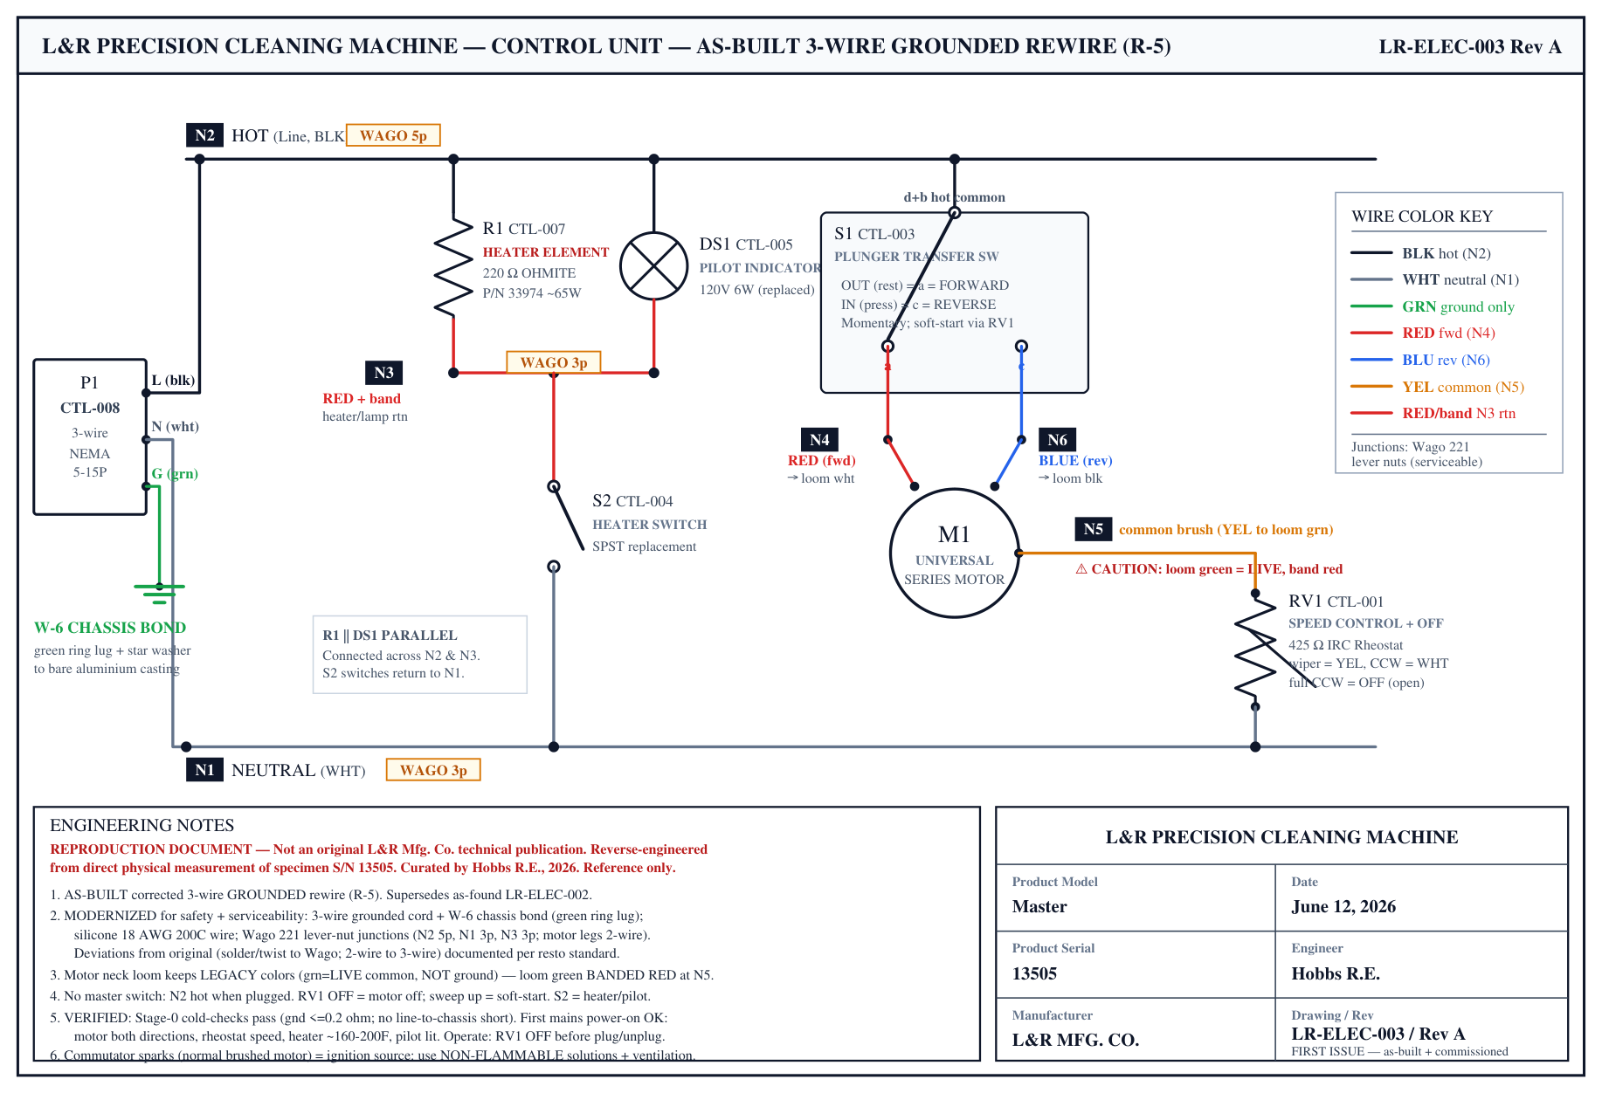
Figure II-1. As-built control-unit wiring schematic, 3-wire grounded (drawing LR-ELEC-003).
The control unit was rewired to a modern grounded standard — see the as-built schematic `drawings/electrical/LR-ELEC-003` (and the as-found LR-ELEC-002 for the original circuit).
- Junctions are serviceable: the distribution nodes use Wago 221 lever connectors — open a lever to probe or re-land a wire without cutting. The rheostat's two lugs are the only soldered joints.
- Color code: BLACK hot · WHITE neutral · GREEN ground only · RED motor forward · BLUE motor reverse · YELLOW motor speed/common · RED-with-band heater/lamp return. (The motor loom keeps legacy colors; its green lead is a live common, banded red at its junction — not a ground.)
- Pilot bulb: a 120 V / 6 W lamp in parallel with the heater; if it fails the heater still works (independent pilot, not a fuse). Replace like-for-like.
Stage-0 cold-checks (cord UNPLUGGED, DMM) — run after any electrical service, before power-on:
- Ground pin ↔ bare chassis: ≤ 0.2 Ω.
- Hot ↔ chassis · Neutral ↔ chassis · Ground ↔ hot · Ground ↔ neutral: all O.L. (open).
- All-off: hot ↔ neutral O.L.; rheostat on = motor winding + rheostat (drops as knob advances); toggle on = ≈ 220 Ω (heater ∥ pilot).
First power-up after service: rheostat at OFF, ideally through a dim-bulb tester + GFCI; sweep the speed up as a soft-start.

II.5 — Troubleshooting
Symptom | Likely cause | Action
Motor won't start | Speed knob at OFF; no power; GFCI tripped; dry/stiff bearing | Sweep knob up from OFF; check outlet/GFCI; oil bearings; check brushes
Motor hums but won't turn | Only one field lead energized / a broken motor-leg connection | Check the motor-leg Wago joins (a Wago open removes a leg); verify with the schematic
Runs one direction only | Reverse (plunger) leg open | Check the plunger switch + its Wago/loom junction
Heavy sparking / ring of fire at commutator | Worn brushes, dirty/rough commutator | Service brushes + commutator (II.2)
No heat / drying chamber cold | Toggle off; heater branch open; R1 or connection fault | Toggle on (jewel should light); cold-check the heater branch (~220 Ω); re-seat the return Wago
Pilot lamp dark but heater works | Bulb burned out (independent pilot) | Replace the 120 V/6 W bulb
Bearing noisy / shaft binds | Reservoir wick dry; contamination | Oil the wick (II.1); if persistent, re-service the wick pack (Part III)
Fluid splashing out of the jar | Jar seal (PLT-002) hardened or mis-seated | Recondition/reseat the rubber seal (silicone)
GFCI trips on power-up | Ground fault in the wiring | Stop; re-run Stage-0 cold-checks; find the fault before retrying

II.6 — Reference
- Wiring: drawings/electrical/LR-ELEC-003 (as-built) · LR-ELEC-002 (as-found).
- Mechanical drawings: drawings/components/ + drawings/exploded/ (full motor + base package).
- Parts: Parts Dictionary + dimension CSVs in docs/dimensions/.
- Full restoration detail: restoration-log.md, teardown-log.md, and Part III of this manual.
Maintenance intervals are guidance; adjust to use. Confidence labels per the Document Production Standards.

Part III — Restoration

L&R Master Watch Cleaning Machine · Master · S/N 13505
REPRODUCTION DOCUMENT — Not an original L&R Mfg. Co. technical publication. Reverse-engineered and restored by Hobbs R.E., 2026, from direct physical work on specimen S/N 13505. For restoration reference only.
Title block: Date June 12, 2026 · L&R Precision Cleaning Machine · Master · S/N 13505 · L&R MFG. CO. · Engineer Hobbs R.E.
About this part. The original L&R manuals covered only operation and maintenance. This part documents what they never did — how to restore a seized, decades-old machine: assess it, take it apart without damage, recondition the parts, reassemble it, rewire it to modern safety standards, and bring it back to life. Procedures use canonical Part IDs (e.g. ARM-010, FLG-002) from the Parts Dictionary; dimensions carry their confidence label. Figures reference the project's bench photos (photos/) and engineering drawings (drawings/). Full as-performed detail — every product, tool, and caution — lives in the source logs (restoration-log.md, teardown-log.md); this chapter is the curated, readable version.
Restoration philosophy. Mechanical and visible parts were restored toward original appearance and function. The electrical system was deliberately modernized for safety and serviceability — the original was a 2-wire ungrounded design with a live "green" wire and no earth ground, and this specimen had prior amateur rework. Every deviation from original is documented so the record stays honest.

III.0 — Assessment (as-found)
Document the machine's condition before touching it — it drives every later decision.
Mechanical. The motor housings (UH-001 / LH-001) carried decades of baked-on factory enamel, oil varnish, and grease crosslinked into the porous aluminum. The self-aligning spherical sleeve bearings (BRG-001 / BRG-002) were mechanically sound and reusable, but their consumables were spent — the wool-felt washers were brittle and broke apart on disassembly, and the reservoir yarn was bone-dry. The tapered rubber jar seal (PLT-002) was dried and near-degraded. Several parts had seized from age and required gentle freeing (never force).
Electrical — the critical hazard. The neck loom carries three wires (black / white / green). The green wire is NOT a safety ground — it is a live, current-carrying motor branch. Treat all three neck conductors as hot. The machine had no earth ground, and inspection showed prior amateur rework (nasty solder blobs, one switch contact failed on a bad joint, a non-original bulb). This confirmed the electrical system should be rebuilt rather than preserved.
Previously modified / non-original. Gasket-to-disk rivets (PLT-005) had to be drilled out to service the seal; the pilot bulb was a later replacement; the AC cord grommet had disintegrated.
Fig. III-0: machine as-received — `photos/` (overall) + reference S/N 13645.

III.1 — Disassembly
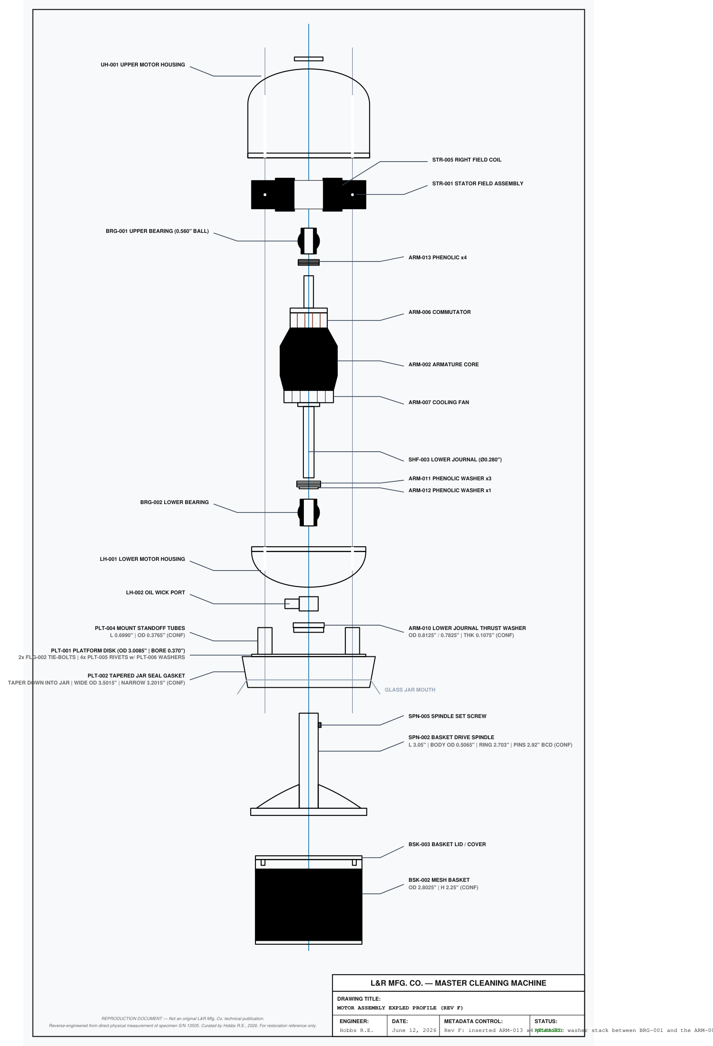
Figure III-1. Motor exploded assembly — disassembly/reassembly reference (drawing EXP-001).
Performed in the order below; reassembly (III.3) is essentially this in reverse. Terminology note: where a prior bench recording said "stator/stator shaft" it meant the armature/rotor; "field coil" meant the stator (STR-001). This text uses the canonical terms.

III.1.1 — Remove the basket and drive spindle
The basket and its drive spindle come off the motor as one "outer column." A single set screw (SPN-005, ¼-20, slotted) locks the basket drive spindle (SPN-002) to the armature's lower journal (SHF-003). Back the set screw out with a flat blade, then draw the spindle/basket assembly off the shaft. If seized from age, free it with very light, deliberate taps of a rubber mallet — gentle pressure only, never a hard strike.
Fig. III-1: `drawings/components/SPN-002…`, `BSK-002…`.

III.1.2 — Understand the platform deck (before the housing bolts)
Beneath the motor is the jar-seal deck: a flat metal platform disk (PLT-001) carrying the tapered rubber jar seal (PLT-002). The gasket is fixed to the disk by four rivets (PLT-005); the remaining two holes pass the long housing bolts (FLG-002) — through standoff tubes (PLT-004) — which clamp the two motor-housing halves together. Knowing this prevents surprise when the next step releases several parts at once.
Fig. III-2: `drawings/components/PLT-001…` + `photos/gasket/`.

III.1.3 — Separate the housings
Unscrew the two long housing bolts (FLG-002). The lower housing (LH-001) drops away, and the armature (ARM-001) comes down with it (the rotor stays seated in the lower bearing, BRG-002). Support the dropping assembly so the commutator and windings are not knocked.
Fig. III-3: bolt circle 2.300" — `drawings/exploded/EXP-001…`.

III.1.4 — Remove the lower thrust ring (ARM-010)
A stepped brass slinger/thrust washer (ARM-010) remains on the lower journal, just outside the housing face; it must come off before the armature will withdraw. Do not pry it — the ring is brass and bends easily. Instead, clamp the housing in a vise raised on blocks so the shaft hangs clear, tap the top of the shaft squarely with a rubber mallet to walk the ring a short way down the journal, then seat a small gear/bearing puller behind it and draw it off evenly.
CAUTION — keep all force axial. Uneven pull or prying will distort the brass ring.
Fig. III-4: `photos/bearings/`.

III.1.5 — Disconnect the electrical
A three-wire loom (black/white/green) runs from the control unit into the motor and lands on the stator field coil (STR-001). Cut these leads at the coil to free the motor. On reassembly they are replaced, not re-spliced.
CAUTION — the GREEN wire is LIVE, not ground. Treat all three as hot.
Fig. III-5: `photos/stator-wiring/`.

III.1.6 — Remove the stator (field coil)
Remove the two stator mount screws (STR-008) and lift the field coil (STR-001) out of the upper housing. (The yoke's other two holes were the FLG-002 pass-throughs, already out.)
Fig. III-6: `drawings/components/STR-001…`.

III.1.7 — Remove the sleeve bearings and springs
Each housing retains a self-aligning spherical sleeve bearing (BRG-001 upper / BRG-002 lower) held by a conical spring (BRG-012). As performed: face-down on a rubber/wood block, the bearing was tapped out of the spring, then the spring removed. This worked but may not be ideal — a better technique is an open question for this design.
Recommended candidates (untested here): (1) release the conical spring first — it captures the ball; (2) warm the aluminum housing (~80–120 °C) to open the fit; (3) press (not hammer) with a drift on an open-bore fixture; (4) soft drift / blind-hole puller. Keep force axial; never pry the spherical socket.
Fig. III-7: `drawings/components/BRG-001…`.
End state: motor fully disassembled, all internals out, ready for cleaning and refinishing.

III.2 — Component restoration

III.2.1 — General cleaning & degrease (R-3)
As each sub-assembly came apart, small hardware (bearings, fasteners, collars, washers, the oil feed tube LH-006, small brackets) was degreased in an ultrasonic tank with a diluted mild-soap solution, then rinsed and dried. Mild/neutral chemistry was chosen deliberately — safe across the mixed materials (steel, brass, aluminum, phenolic). Oversized parts (housings, base casting, neck/pillar) were cleaned by hand. Some mesh basket pieces (BSK-002) carried baked-on chemical sludge and got a stronger Citranox clean.
CAUTIONS: ultrasonic degreasing strips all lubrication — bearings must be re-oiled before/at reassembly (III.3); dry parts promptly (bare steel/aluminum flash-rusts); keep the chemistry mild.

III.2.2 — Jar-seal gasket reconditioning (R-1)
The tapered rubber jar seal (PLT-002, molded with the maker's mark U.S. PATENT 1,872,812) was dried, stiff, and brittle. Restore it by: (1) a warm Citranox clean to remove the orange-brown chemical film; (2) a 16+ hour immersion soak in 100% silicone oil (SEKODAY, a non-cracking silicone sold as treadmill-belt lubricant) to fully re-saturate the rubber; (3) a microfiber buff to a satin-black finish. Result: pliability fully restored, structurally sound again.
CAUTION — silicone only on rubber. WD-40 / petroleum distillates are ruled out — they swell and degrade vintage elastomers.

III.2.3 — Platform-deck refastening (R-6)
The gasket (PLT-002) was originally riveted to the platform disk (PLT-001) by four rivets (PLT-005), which had to be drilled out to service it. Restoration substitutes a serviceable screw set: per hole (×4), a stainless M4-0.7 × 10 mm flat-head Phillips screw + hex nut, reusing the original flat washers (PLT-006). The countersunk head sits flush. The gasket is now removable for future service.
Drawings show the original rivet as the design of record, with a note citing this restoration substitution.

III.2.4 — Bearing-system materials (R-4)
The bearings themselves (BRG-001/002) and the conical springs (BRG-012) were sound and reused (cleaned per III.2.1). Only the spent consumables were replaced, mirroring the original wick/felt oiling scheme:
- Reservoir yarn (BRG-008): Estako Wool 98 — 100% Superwash Merino, un-dyed (won't leach dye or mat when oil-saturated).
- Felt washers (BRG-009 large / BRG-010 small): SAE F3 hard wool felt (dust block + oil containment).
- Oil wick: GE 1/8" vintage-fan wick (~1¼"), tied to the yarn.
- Oil: Bramec Zoom Spout turbine oil.
(The Century Spring TA-2226CS was identified as the dimensional equivalent for BRG-012 if a spring is ever needed, but the originals were reused.)

III.2.5 — Motor-housing cosmetic refinishing (R-2)
Both housing halves (UH-001 / LH-001) carried crosslinked baked-on factory finish. Refinish sequence:
- Chemical strip: coat with Citristrip gel (citrus-based, safe on aluminum), dwell, and work the softened finish out of the deep fins, chambers, and notches with brushes/picks. Remove all residue and dry immediately (bare aluminum flash-rusts).
- Prep & mask: lightly scuff the exterior for primer tooth; precision-mask every running face, bore, and mating flange (FLG-001) with razor-trimmed high-temp tape.
- Final wipe + etch primer: wipe with 99.9% IPA, then Rust-Oleum 249322 self-etching primer in ultra-thin coats (matte olive-grey = proper anchor).
- VHT Wrinkle Plus topcoat: 3 heavy crosshatched coats — horizontal → vertical (5-min flash) → diagonal (5-min flash) — a wrinkle finish needs a thick film with tight flash times to ripple.
- Thermal cure: draw the texture with controlled heat (~350 °F heat gun and/or oven after the level window). Pull the masking while the film is still warm to preserve internal dimensions.
Result: tight, uniform heavy wrinkle grain matching the vintage L&R aesthetic, tolerances preserved.

III.2.6 — Control-unit / base-casting refinishing
The cast-aluminum base body was stripped (Citristrip), and worn cast lettering ("OFF" on the tongue, the "L&R MASTER" relief) was rebuilt with J-B Weld High Heat epoxy on abraded bare metal (it survives the ~350 °F wrinkle bake, unlike polyester filler), then block-sanded flush and the lettering re-cut with a Dremel. The same etch primer → VHT Wrinkle Plus system as the housings was applied, inside and out, for a matching texture.
- Cast lettering was left monochrome (shot with the wrinkle, no color fill) — factory-correct, the relief reads by shadow.
- Cure without an oven: heat-gun draw to form the wrinkle, then a multi-hour cure in direct sun + a warm garage (48–72 hr undisturbed). Confirmed workable.
- Chrome parts (post NCK-001, clamp screw NCK-003) were cleaned and sent out for professional re-chrome.
CAUTION — bake-proof masking. Ordinary painter's tape (~250 °F) scorches at the wrinkle bake; swap to high-temp masks (silicone plugs / stainless bolts / Kapton) before the topcoat. Keep fit surfaces (the BAS-006 post socket, screw holes) masked so wrinkle texture doesn't spoil the fit.

III.3 — Reassembly

III.3.1 — Bearings & lubrication, lower housing (R-7)
No public instructions exist for this — the method reconstructs the original wick/felt capillary oiling.
- Cut ~1 ft of wool yarn (BRG-008) and ~1¼" of GE wick; tie them together.
- Route the yarn through the oil-wick port — stiffen the floppy lead with a wrap of Scotch tape and pull it through with tweezers.
- Place the small felt (BRG-010) flush at the bottom of the bearing (it contacts the incoming wick = how the lower felt gets oiled); route the yarn up the side, wrapping the large felt (BRG-009) at the top neck (oil wicks up to the upper felt).
- Seat the bearing (BRG-002) — mind the bottom notch (one orientation only).
- Pre-oil the felts + yarn with Zoom Spout; let it soak.
- Insert the conical spring (BRG-012).
- Install the retaining ring (BRG-011) at the bottom (friction fit) — tap flush with a brass punch + light rubber-mallet taps, working evenly around.
- Clean the bore (alcohol pads); test-fit the armature (good).
CAUTION — no steel tools under pressure. Use brass punches; light, even, axial force only.

III.3.2 — Bearings & lubrication, upper housing (R-8)
The harder of the two (15+ attempts). Key differences: the upper bearing (BRG-001) has an internal slit and the yarn rides inside it; the upper "small felt" is a solid tab/pad (pin-hole only) that sits at the very top under the oil cap (UH-011); and there is no bottom retaining ring.
- Working method: tie the yarn around a small ~0.400" wood peg with a hitch knot, slip that over the bearing's inner end, route the other end through the internal slit, wrap it tight at the top, and anchor the terminal end with a dab of super glue (the pliable felt detaches during seating otherwise). Thread the lead up through a poked hole in the top felt pad; seat the bearing; add the large felt; pre-oil; insert the spring; test-fit (spins fine); cap the oil port.
Open item (VERIFY): the super-glue anchor's effect on long-term wicking is unknown — watch oil feed over time. It was a last resort with no manual to reference.

III.3.3 — Armature + slinger, mechanical assembly (R-9 → R-11)
- Phenolic end-float washers: stack the 4 washers on the lower journal — ARM-012 (small) against the bearing, then ARM-011 ×3. (These set the rotor's axial position so the fan clears the housing floor. A matching set, ARM-013 ×4, goes on the upper journal at final join.)
- Set the lower housing onto the armature so the journal passes through BRG-002; invert into a press.
- Press the slinger (ARM-010) onto the journal with slow incremental axial pressure — do NOT bottom it out. Leave a running gap ≈ 0.0255" (a knife-blade width); gauge with a feeler as you go.
- Tool: a bench arbor press with a tubular driver / deep socket / fender washer whose bore clears the shaft and whose face bears on the slinger. Never hammer. (The restorer improvised with a reloading press + a 3/8"×1¼" fender washer; the principle is the same.)
- Join the housings: install the stator (STR-001, two STR-008 screws), drop the armature in from the top, fit the ARM-013 ×4 upper washers against BRG-001, and torque the two FLG-002 tie-bolts (which also clamp the platform deck via the PLT-004 tubes).
- Deck → spindle → basket: platform deck (PLT-001/002) → basket drive spindle (SPN-002, SPN-005 set screw) → mesh basket (BSK-002) bayonets on + lid → brushes (UH-004 caps) → oil cap → mount to the body.

III.3.4 — Electrical: modern grounded rewire (R-5)
Figure III-2. As-built grounded rewire schematic (drawing LR-ELEC-003).
The control unit was rewired to a modern, safe, serviceable standard per the restoration philosophy. The as-found circuit was meter-verified into a 6-node map (see LR-ELEC-002), and the rebuild follows the corrected grounded schematic `LR-ELEC-003`.
- Wire: 18 AWG silicone (200 °C) throughout; a new 3-conductor grounded cord with NEMA 5-15P plug.
- Color code: BLACK = hot, WHITE = neutral, GREEN = ground only, RED = motor forward, BLUE = motor reverse, YELLOW = motor speed/common, RED-with-band = heater/lamp return.
- Junctions: Wago 221 lever connectors at the distribution nodes (hot 5-port, neutral 3-port, return 3-port); motor legs on serviceable 2-wire joins; component leads on crimp/heat-shrink terminals. The rheostat's two solder lugs are the only soldered joints.
- Ground bond (W-6): green ring lug under a star washer to bright bare aluminum on the casting.
- Switches: the failed plunger (S1) and frayed toggle (S2) were replaced (same node roles).
CAUTION — the motor loom's green lead is a LIVE common, not ground. Band it red at its junction so green never reads as ground in this machine.

III.3.5 — Motor-lead entry: grommet, sheath anchor, strain relief
The four motor leads leave the sealed motor head and drop down the chrome pillar into the casting, where they pass a bare aluminum edge at the housing/base entry. This is a hard-earned lesson, not an optional nicety:
FIELD-FAILURE LESSON (specimen 13505). During routing, the protective sheath over the motor leads slipped back at the housing entry and left a short length of the WHITE lead bare. That bare conductor touched the grounded aluminum base and arced on power-up. The ground system did exactly its job — the fault went line-to-ground and cleared, never energizing the chassis — but the lead had to be rebuilt. Root cause was purely mechanical: an unanchored sheath and no strain relief let the insulation migrate.
Do this at the motor-lead entry, every time:
- Grommet the pass-through. Fit a rubber grommet (or high-temp silicone) in the entry opening so no conductor ever bears on a bare cast edge.
- Anchor the sheath. Fix the protective sleeve so it cannot slide back off the conductors — a cable clamp, tie anchor, or adhesive-lined heat-shrink at the entry. The sheath must stay put under the pillar's routing tension.
- Add strain relief. Secure the loom just inside the entry so any pull is taken by the jacket, not by the solder/crimp joints or the insulation at the edge.
- Re-inspect before closing up. With the leads dressed, confirm no copper is visible anywhere along the run and that flexing the loom does not expose any.

III.4 — Commissioning (cold-check & first power-on)
Never apply mains until the machine passes an unpowered cold-check.
Stage 0 — cold checks (cord unplugged, DMM). All must pass:
- Ground pin ↔ bare chassis: ≤ 0.2 Ω (near-zero over lead resistance).
- Hot ↔ chassis, Neutral ↔ chassis, Ground ↔ hot, Ground ↔ neutral: all O.L. (open).
- Branch continuity: all-off = O.L.; rheostat on = motor winding + rheostat (tens–hundreds Ω, dropping as the knob advances); toggle on = ≈ 220 Ω (heater R1 in parallel with the pilot lamp).
As performed, Stage 0 caught and fixed two real faults — a marginally-seated Wago (added ~60 Ω series resistance) and a dead pilot bulb — which is exactly its purpose.
Stage 1 — first power-on. The safest first power-up is through a current-limiting dim-bulb tester + GFCI; with Stage 0 fully passed and the motor already proven on a low-voltage DC bench supply, a direct power-on is a reasonable low-risk alternative. Always start with the rheostat at OFF (it is the motor's only on/off), plug in, then sweep the speed up (a soft-start that spares the plug, brushes, and commutator); return to OFF before unplugging.
Result (S/N 13505): motor runs and reverses cleanly, rheostat controls speed, heater warms the drying chamber (~160–200 °F), pilot lamp lit. Full function confirmed.
OPERATING SAFETY. (1) The commutator sparks (normal for a brushed motor) — an ignition source — so use non-flammable / water-based cleaning solutions and good ventilation, never volatile solvent near the running motor. (2) Because the machine handles liquids next to a mains motor, keep it on a GFCI for all use.
Figures to be finalized from `photos/` and `drawings/`. Confidence labels per the Document Production Standards. Full as-performed detail (products, provenance, per-photo figure notes) in `restoration-log.md`.

