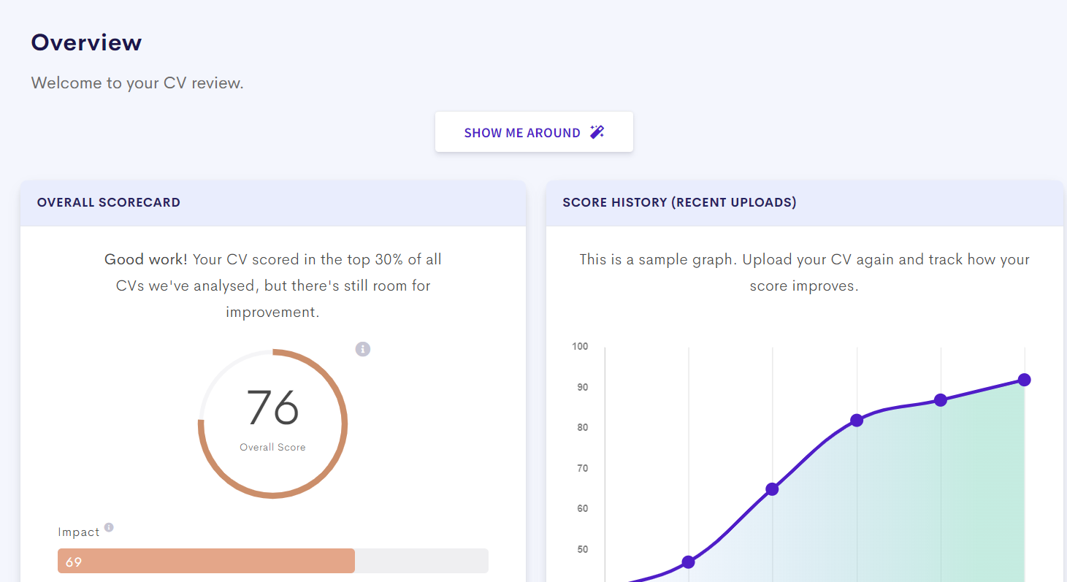






tech Projects
- Level 2 Software Engineering Project
- Recently began group coursework on an informative sustainability board game, involving full development life cycle using Agile Methodology.

- Level 2 Artificial Intelligence and Machine Learning Project
- I will complete an individual piece of coursework demonstrating statistics, feature selection and machine learning in Python.

- Level 1 Data Driven Systems Project
- Created CRUD web application for beach cleaning organisation in a group. My role was to design and implement a normalised relational database using SQL.
- Queried the database, analysed and displayed visualisations and charts of the data on webpages using JavaScript, HTML and CSS.

Education
2025 – 2029 Queen’s University Belfast BSc Computer Science with Professional Experience

- Level 2 Modules
Software Engineering & Systems Development (TBC), Networks and Protocols (TBC), Data Structures & Algorithms (TBC), Professional and Transferable Skills (TBC), Theory of Computation (TBC).

- Level 1 Modules
Introduction to Computer Architecture (87%), Data Driven Systems (82%), Procedural Programming (96%), Fundamentals of Maths for Computing (79%), Introduction to Cyber Security (81%), Object Oriented Programming (84%).

A Levels: Mathematics (A) Computer Science(B) Further Mathematics (B) Biology (B)
11 GCSEs including A* grades in Computer Science, Mathematics, Further Mathematics and English Language
Current Queen’s University BSc Computer Science student with a wide range of technical skills developed from my degree and soft skills of teamwork, adaptability and reliability displayed by my part-time job that I have kept for over 4 years. Currently looking for full time placement year internships.

Proffesional Interests
Member of the Queen’s Computing Society

Daily reader of TLDR Tech Newsletter, keeping up to date with the newest technology and industry developments

Currently completing the Google AI Professional Certificate

Currently completing IBM SkillsBuild Cybersecurity Fundamentals

technical Skills
Operating Systems:
Windows, Linux

Development Languages:
Java, C#, C++, Visual Basic, SQL, JavaScript, HTML, CSS, Assembly

Applications:
Microsoft Office, Eclipse, Visual Studio, Visual Studio Code, Git, Github, MySQL

COntact

RMEIJER9001@GMAIL.COM

07380504500

RYANERINMEIJER

LINKEDIN.COM/IN/RYAN-MEIJER

19 Linen Crescent, Bangor BT19 7JH

Ryan Meijer
  - Computer science student AT Queen’s University Belfast

Ryan Meijer
  - Computer science student AT Queen’s University Belfast

Additional Information
Full UK Driving License

Interests & Achievements
Member of a social running club at Queen’s University Belfast

Currently fundraising for The Oddballs Foundation ahead of the Ballsy 5k run, November 2026

Planning to take part in the Belfast Marathon in May 2027 to raise funds for Cancer Research

UK Senior Maths Challenge — Silver Award

PRacticals
Data Driven Systems
- Modeled and normalised relational databases for real world problems
- Developed web applications using HTML, CSS, JavaScript

Object Orientated Programming
- Implemented and tested searching and sorting algorithms in Java

References
- Mrs. Lynne McKeown, Esplanade Bar and Restaurant, Owner, info@esplanadebangor.com, 07792352366

- Other references available on request

EXperience
February 2022 – Present | Esplanade Bar and Restaurant
Bar & Waiting Staff

- Provide efficient customer service in a busy environment, adapting changing customer demands and maintaining a professional manner under pressure.
- Work across both bar and floor positions, requiring strong communication and teamwork skills to collaborate closely with colleagues in both teams.
- Process cash and card payments accurately while maintaining attention to detail during busy periods.

June 2024 (5 days)|Translink IS Department|Work Experience

- Sat in on stand-ups and a sprint review meeting, giving an insight into the Agile software development workflows
- Upgraded and configured hardware components of desktop systems
- Assisted completion of support tickets on devices on-site and remotely, helping diagnose and resolve technical issues.

- Level 1 Object Orientated Programming Project
- Created Java image management software, using objects to add, retrieve and sort the images in albums.

A Level Project
- Developed a vector-based music recommendation application using cosine similarity algorithm, Visual Basic and SQL to compare user preference profiles and generate personalised song recommendations.
- Completed project documentation including creating full set of requirements, testing and evaluating the project

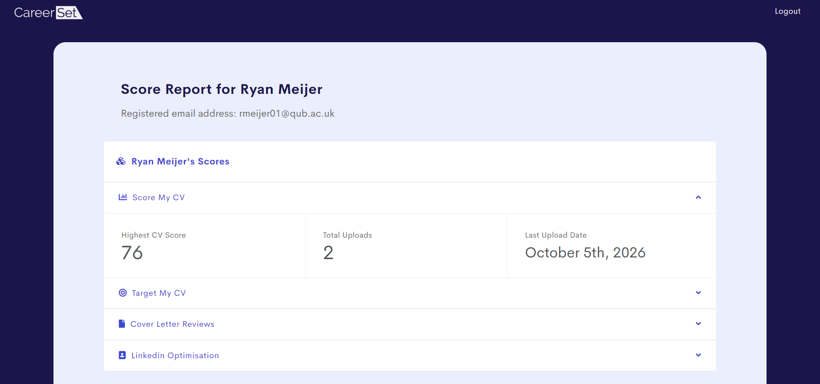

tech Projects
- Level 2 Software Engineering Project
- Recently began group coursework on an informative sustainability board game, involving full development life cycle using Agile Methodology.

- Level 2 Artificial Intelligence and Machine Learning Project
- I will complete an individual piece of coursework demonstrating statistics, feature selection and machine learning in Pytho

- Level 1 Data Driven Systems Project
- Developed a CRUD web application for a beach-cleaning organisation, contributing to the design and implementation of a normalised relational database using SQL
- Developed SQL queries and integrated JavaScript, HTML and CSS to analyse and visualise database data through interactive charts

Current Queen’s University Belfast BSc Computer Science student with a wide range of technical skills developed through my degree, alongside strong teamwork, adaptability and reliability demonstrated through over four years of part-time employment. Currently seeking a full-time placement year internship to apply and further develop my technical skills in a professional environment.

technical Skills
Programming:
Java, C#, C++, Visual Basic, SQL, JavaScript, HTML, CSS, Assembly
Development & Tools:
Git, GitHub, Visual Studio, Visual Studio Code, Eclipse, MySQL
Operating Systems:
Windows, Linux
Other:
Microsoft Office

Education
2025 – 2029 Queen’s University Belfast BSc Computer Science with Professional Experience

- Level 2 Modules
Software Engineering & Systems Development (TBC), Networks and Protocols (TBC), Data Structures & Algorithms (TBC), Professional and Transferable Skills (TBC), Theory of Computation (TBC)

- Level 1 Modules
Introduction to Computer Architecture (87%), Data Driven Systems (82%), Procedural Programming (96%), Fundamentals of Maths for Computing (79%), Introduction to Cyber Security (81%), Object Oriented Programming (84%)

A Levels: Mathematics (A) Computer Science(B) Further Mathematics (B) Biology (B)
11 GCSEs including A* grades in Computer Science, Mathematics, Further Mathematics and English Language

Proffesional Development & Activities
Member of the Queen’s Computing Society

Currently completing the Google AI Professional Certificate

Currently completing IBM SkillsBuild Cybersecurity Fundamentals

Regularly follow technology and industry developments through TLDR Tech Newsletter

COntact

RMEIJER9001@GMAIL.COM

07380504500

RYANERINMEIJER

LINKEDIN.COM/IN/RYAN-MEIJER

19 Linen Crescent, Bangor BT19 7JH

Ryan Meijer
  - Computer science student AT Queen’s University Belfast

Ryan Meijer
  - Computer science student AT Queen’s University Belfast

Additional Information
Full UK Driving License

Interests & Achievements
Member of a social running club at Queen’s University Belfast

Currently fundraising for The Oddballs Foundation ahead of the Ballsy 5k run, November 2026

Planning to take part in the Belfast Marathon in May 2027 to raise funds for Cancer Research

UK Senior Maths Challenge — Silver Award

References
- Mrs. Lynne McKeown, Esplanade Bar and Restaurant, Owner, info@esplanadebangor.com, 07792352366

- Other references available on request

PRacticals
Data Driven Systems
- Modeled and normalised relational databases for real world problems
- Developed web applications using HTML, CSS, JavaScript

Object Orientated Programming
- Implemented and tested searching and sorting algorithms in Java

EXperience
February 2022 – Present | Esplanade Bar and Restaurant
Bar & Waiting Staff

- Provide efficient customer service in a busy environment, adapting to changing customer demands and maintaining a professional manner under pressure
- Work across both bar and floor positions, requiring strong communication and teamwork skills to collaborate closely with colleagues in both teams
- Process cash and card payments accurately while maintaining attention to detail during busy periods

June 2024 (5 days)|Translink IS Department|Work Experience

- Sat in on stand-ups and a sprint review meeting, gaining practical insight into Agile software development workflows
- Upgraded and configured hardware components of desktop systems
- Assisted with IT support tickets for on-site and remote devices, helping diagnose and resolve technical issues.
- Level 1 Object Orientated Programming Project
- Developed an object-oriented Java image management application supporting image storage, retrieval and sorting within albums

A Level Project
- Developed a vector-based music recommendation application using cosine similarity, Visual Basic and SQL to compare user preference profiles and generate personalised song recommendations
- Completed project documentation including creating full set of requirements, testing and evaluating the project

