|  |  |
| --- | --- |
| **Laboratory Activity No. 7** | |
| **Polymorphism** | |
| **Course Code:** CPE103 | **Program:** BSCPE |
| **Course Title:** Object-Oriented Programming | **Date Performed: 02/22/25** |
| **Section: 1 – A** | **Date Submitted:02/22/25** |
| **Name: Eulin, Ryan Bertrand B.** | **Instructor: Ma’am Sayo** |
| **1. Objective(s):** | |
| This activity aims to familiarize students with the concepts of Polymorphism in Object-Oriented Programming | |
| **2. Intended Learning Outcomes (ILOs):** | |
| The students should be able to:   * 1. Identify the use of Polymorphism in Object-Oriented Programming   2. Implement an Object-Oriented Program that applies Polymorphism | |
| **3. Discussion:** | |
| Polymorphism is a core principle of Object-Oriented that is also called “method overriding”. Simply stated the principles says  that a method can be redefined to have a different behavior in different derived classees.  For an example, consider a base file reader/writer class then three derived classes Text file reader/writer, CSV file reader/ writer, and JSON file reader/writer. The base file reader/writer class has the methods: read(filepath=””) , write(filepath=””). The three derived classes (classes that would inherit from the base class) should have behave differently when their read, write methods are invoked.  Operator Overloading:  Operator overloading is an important concept in object oriented programming. It is a type of polymorphism in which a user defined meaning can be given to an operator in addition to the predefined meaning for the operator.  Operator overloading allow us to redefine the way operator works for user-defined types such as objects. It cannot be used for built-in types such as int, float, char etc., For example, '+' operator can be overloaded to perform addition of two objects of distance class.  Python provides some special function or magic function that is automatically invoked when it is associated with that particular operator. For example, when we use + operator on objects, the magic  method add () is automatically invoked in which the meaning/operation for + operator is defined for user defined objects. | |
| **4. Materials and Equipment:** | |
| Windows Operating System Google Colab | |
|  | |

|  |
| --- |
| **5. Procedure:** |
| **Creating the Classes**   1. Create a folder named oopfa1<lastname>_lab8 2. Open your IDE in that folder. 3. Create the base polymorphism_a.ipynb file and Class using the code below:   Coding:  # distance is a class. Distance is measured in terms of feet and inches class distance:  def init (self, f,i):  self.feet=f self.inches=i  # overloading of binary operator > to compare two distances def gt (self,d):  if(self.feet>d.feet):  return(True)  elif((self.feet==d.feet) and (self.inches>d.inches)): return(True)  else:  return(False)  # overloading of binary operator + to add two distances def add (self, d):  i=self.inches + d.inches f=self.feet + d.feet if(i>=12):  i=i-12 f=f+1  return distance(f,i)  # displaying the distance def show(self):  print("Feet= ", self.feet, "Inches= ",self.inches)  a,b= (input("Enter feet and inches of distance1: ")).split() a,b =[int(a),int(b)]  c,d= (input("Enter feet and inches of distance2: ")).split() c,d =[int(c),int(d)]  d1 = distance(a,b) d2 = distance(c,d)  if(d1>d2):  print("Distance1 is greater than Distance2") else:  print("Distance2 is greater or equal to Distance1") d3=d1+d2  print("Sum of the two Distance is:") d3.show() |

4. Screenshot of the program output:

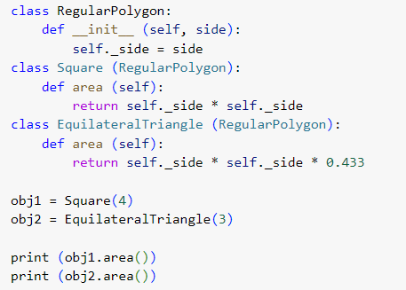

# Testing and Observing Polymorphism

1. Create a code that displays the program below:
2. 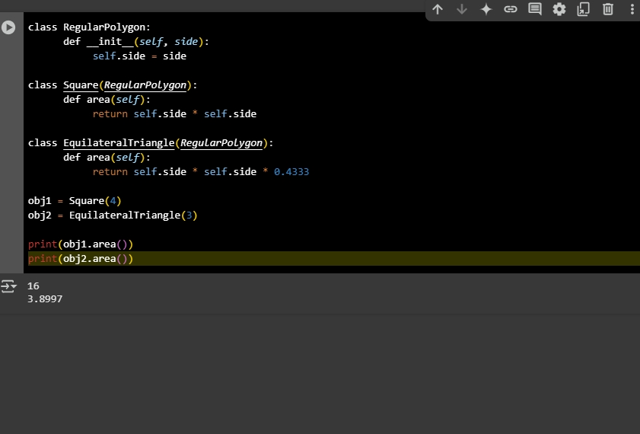Save the program as polymorphism_b.ipynb and paste the screenshot below :
3. Run the program and observe the output.
4. Observation:

# 6. Supplementary Activity:

In the above program of a Regular polygon, add three more shapes and solve for their area using each proper formula. Take a screenshot of each output and describe each by typing your proper labeling.

|  |
| --- |
| **Questions**   1. Why is Polymorphism important? 2. Explain the advantages and disadvantages of using applying Polymorphism in an Object-Oriented Program. 3. What maybe the advantage and disadvantage of the program we wrote to read and write csv and json files? 4. What maybe considered if Polymorphism is to be implemented in an Object-Oriented Program? 5. How do you think Polymorphism is used in an actual programs that we use today? |
| **7. Conclusion:** |
|  |
| **8. Assessment Rubric:** |