Data Structure and Algorithm

Laboratory Activity No. 4

Arrays

|  |  |
| --- | --- |
| *Submitted by:* | *Instructor:* |
| LastName, FirstName MI. | Engr. Maria Rizette H. Sayo |

Month, DD, YYYY

# Objectives

Introduction

Array, in general, refers to an orderly arrangement of data elements. Array is a type of data structure that stores data elements in adjacent locations. Array is considered as linear data structure that stores elements of same data types. Hence, it is also called as a linear homogenous data structure.

This laboratory activity aims to implement the principles and techniques in:

* Writing algorithms using Array data structure
* Solve programming problems using dynamic memory allocation, arrays and pointers

# Methods

Jenna’s Grocery

Jenna wants to buy the following fruits and vegetables for her daily consumption. However, she needs to distinguish between fruit and vegetable, as well as calculate the sum of prices that she has to pay in total.

Problem 1: Create a class for the fruit and the vegetable classes. Each class must have a constructor, deconstructor, copy constructor and copy assignment operator. They must also have all relevant attributes (such as name, price and quantity) and functions (such as calculate sum) as presented in the problem description above.

Problem 2: Create an array GroceryList in the driver code that will contain all items in Jenna’s Grocery List. You must then access each saved instance and display all details about the items.

Problem 3: Create a function TotalSum that will calculate the sum of all objects listed in Jenna’s Grocery List.

Problem 4: Delete the Lettuce from Jenna’s GroceryList list and de-allocate the memory assigned.

# Results

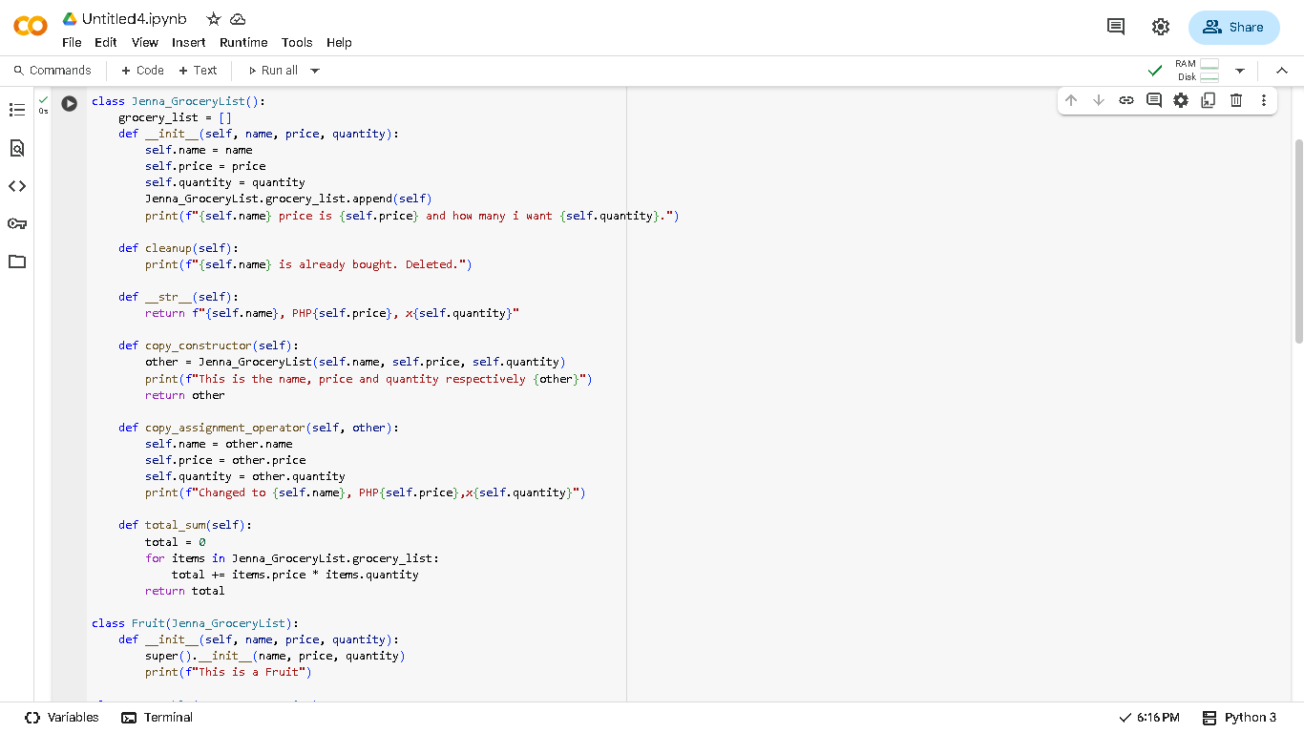

Figure 1

Figure 2

# Conclusion

In summary this laboratory helps the student learn to create constructor, deconstructor, copy constructor and copy assignment operator . To know how this 4 works and also remember some of the C++ functions.