Data Structure and Algorithm

Laboratory Activity No. 6

Singly Linked Lists

|  |  |
| --- | --- |
| *Submitted by:* | *Instructor:* |
| LastName, FirstName MI. | Engr. Maria Rizette H. Sayo |

Month, DD, YYYY

# Objectives

Introduction

A linked list is an organization of a list where each item in the list is in a separate node. Linked lists look like the links in a chain. Each link is attached to the next link by a reference that points to the next link in the chain. When working with a linked list, each link in the chain is called a Node. Each node consists of two pieces of information, an item, which is the data associated with the node, and a link to the next node in the linked list, often called next.

This laboratory activity aims to implement the principles and techniques in:

* Writing algorithms using Linked list
* Writing a python program that will perform the common operations in a singly linked list

# Methods

* Write a Python program to create a singly linked list of prime numbers less than 20. By iterating through the list, display all the prime numbers, the head, and the tail of the list. (using Google Colab)
* Save your source codes to GitHub

# Results

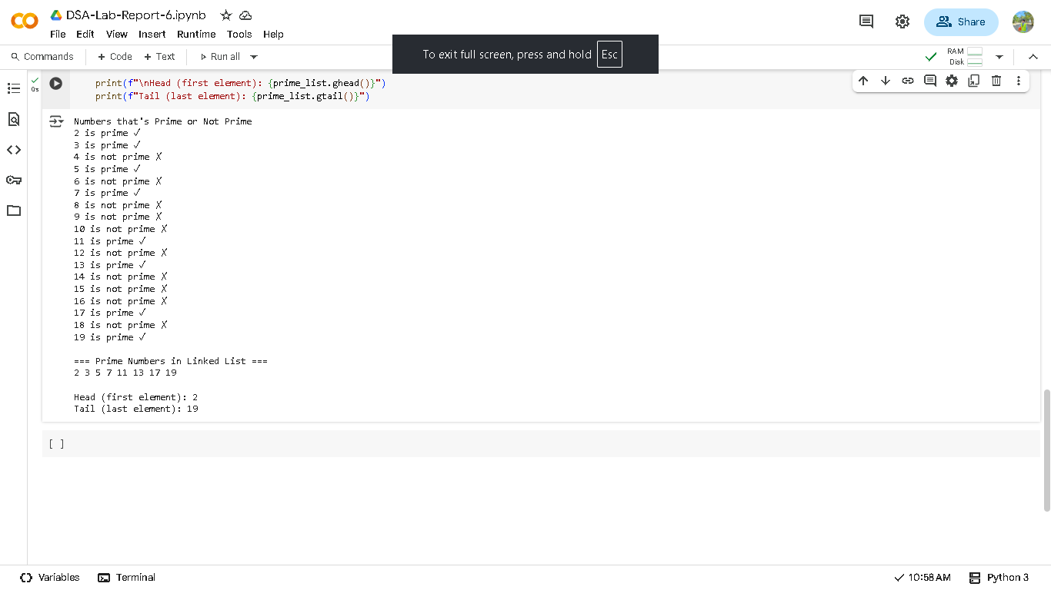

Figure 1

This source code demonstrate how to display and tell what is the head and the tail of a singly linked list, this activity helps the student to dive deeper to data structure of a system where in exploring every types and variants of given data structure it helps the student not only on understanding but also, enhance OOP by doing so. Furthermore, students that engange using website like youtube geekandgeek along with some hel with ai to better the understanding began to learn not just by understanding on how the source code being built also, explore more built in function since, python is the programming language that almost the same to our human language(English).

Proceed here for the Full Source Code:  
<https://colab.research.google.com/drive/1Gwnd_AfIj2UiZkvRAXvbHhPjzKc8tCyY?usp=sharing>

# Conclusion

In summary this activity helps the student to understand how singly linked list works and keep the brain exercise to think, understand and let the brain be curious.

**References**

[1] Co Arthur O.. “University of Caloocan City Computer Engineering Department Honor Code,” UCC-CpE Departmental Policies, 2020.