Data Structure and Algorithm

Laboratory Activity No. 8

Stacks

|  |  |
| --- | --- |
| *Submitted by:* | *Instructor:* |
| LastName, FirstName MI. | Engr. Maria Rizette H. Sayo |

Month, DD, YYYY

# Objectives

Introduction

A stack is a collection of objects that are inserted and removed according to the last-in, first-out (LIFO) principle.

A user may insert objects into a stack at any time, but may only access or remove the most recently inserted object that remains (at the so-called “top” of the stack)

This laboratory activity aims to implement the principles and techniques in:

* Writing Python program using Stack
* Writing a Python program that will implement Stack operations

# Methods

Instruction: Type the python codes below in your Colab. After running your codes, answer the questions below.

# Stack implementation in python

# Creating a stack

def create_stack():

    stack = []

    return stack

# Creating an empty stack

def is_empty(stack):

    return len(stack) == 0

# Adding items into the stack

def push(stack, item):

    stack.append(item)

    print("Pushed Element: " + item)

# Removing an element from the stack

def pop(stack):

    if (is_empty(stack)):

        return "The stack is empty"

    return stack.pop()

stack = create_stack()

push(stack, str(1))

push(stack, str(2))

push(stack, str(3))

push(stack, str(4))

push(stack, str(5))

print("The elements in the stack are:"+ str(stack))

Answer the following questions:

1. Upon typing the codes, what is the name of the abstract data type? How is it implemented
2. What is the output of the codes?
3. If you want to type additional codes, what will be the statement to pop 3 elements from the top of the stack?
4. If you will revise the codes, what will be the statement to determine the length of the stack? (Note: You may add additional methods to count the no. of elements in the stack)

Answers:

1. The abstract data type here is Stack and implemented using python list.

2.

The output is:

Pushed Element: 1

Pushed Element: 2

Pushed Element: 3

Pushed Element: 4

Pushed Element: 5

The elements in the stack are:['1', '2', '3', '4', '5']

3. To pop 3 elements in stack, call pop(stack) 3 times.

4.To determine stack length add a size(stack) and return it with len(stack).

# Results

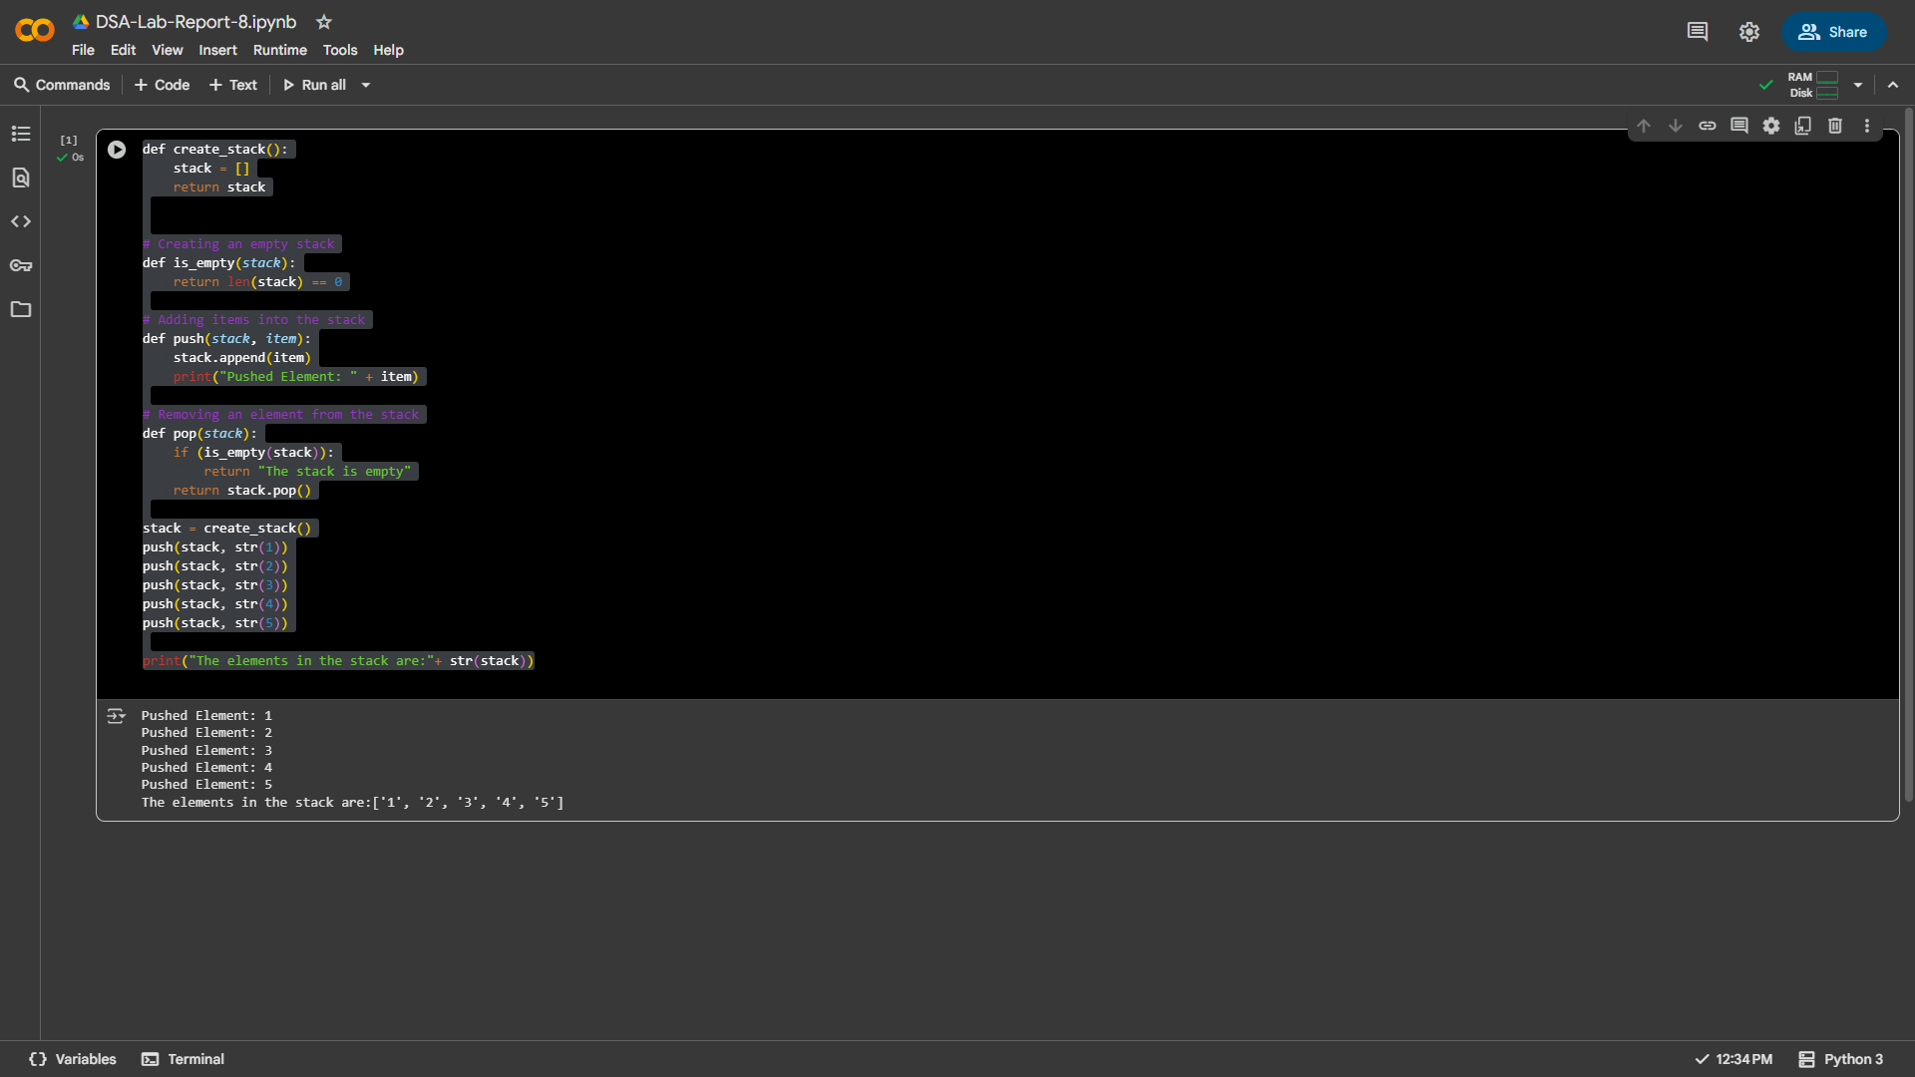

**Output Of This Lab Activity.**

*Figure 1*

# Conclusion

The stack implementation using a Python list successfully demonstrated the Last In, First Out (LIFO) behavior through push and pop operations, validating the fundamental principles of this abstract data type.