Data Structure and Algorithm

Laboratory Activity No. 9

Queues

|  |  |
| --- | --- |
| *Submitted by:* | *Instructor:* |
| LastName, FirstName MI. | Engr. Maria Rizette H. Sayo |

Month, DD, YYYY

# Objectives

Introduction

Another fundamental data structure is the queue. It is a close “the same” of the stack, as a queue is a collection of objects that are inserted and removed according to the first-in, first-out (FIFO) principle. That is, elements can be inserted at any time, but only the element that has been in the queue the longest can be next removed.

The Queue Abstract Data Type

Formally, the queue abstract data type defines a collection that keeps objects in a sequence, where element access and deletion are restricted to the first element in the queue, and element insertion is restricted to the back of the sequence. This restriction enforces the rule that items are inserted and deleted in a queue according to the first-in, first-out (FIFO) principle. The queue abstract data type (ADT) supports the following two fundamental methods for a queue Q:

Q.enqueue(e): Add element e to the back of queue Q.

Q.dequeue( ): Remove and return the first element from queue Q;

an error occurs if the queue is empty.

The queue ADT also includes the following supporting methods (with first being analogous to the stack’s top method):

Q.first(): Return a reference to the element at the front of queue Q, without removing it; an error occurs if the queue is empty.

Q.is empty( ): Return True if queue Q does not contain any elements.

len(Q): Return the number of elements in queue Q; in Python, we implement this with the special method len .

This laboratory activity aims to implement the principles and techniques in:

* Writing Python program using Queues

Writing a Python program that will implement Queues operations

# Methods

Instruction: Type the python codes below in your Colab. Reconstruct them by implementing Queues (FIFO) algorithm. Hint: You may use Array or Linked List

# Stack implementation in python

# Creating a stack

def create_stack():

    stack = []

    return stack

# Creating an empty stack

def is_empty(stack):

    return len(stack) == 0

# Adding items into the stack

def push(stack, item):

    stack.append(item)

    print("Pushed Element: " + item)

# Removing an element from the stack

def pop(stack):

    if (is_empty(stack)):

        return "The stack is empty"

    return stack.pop()

stack = create_stack()

push(stack, str(1))

push(stack, str(2))

push(stack, str(3))

push(stack, str(4))

push(stack, str(5))

print("The elements in the stack are:"+ str(stack))

Answer the following questions:

1. What is the main difference between the stack and queue implementations in terms of element removal?
2. What would happen if we try to dequeue from an empty queue, and how is this handled in the code?
3. If we modify the enqueue operation to add elements at the beginning instead of the end, how would that change the queue behavior?
4. What are the advantages and disadvantages of implementing a queue using linked lists versus arrays?
5. In real-world applications, what are some practical use cases where queues are preferred over stacks?

Answers:  
1. Stack removes last in element first (LIFO) but Queue, removes first element first (FIFO).

2. It returns “NO Data Here!!” message instead of crashing, handled by the is_empty().

3. Adding at beginning would break FIFO behavior, making it function like a stack instead of a Queue.

4. Linked lists dynamic size but more memory, Array on the other hand faster access but fixed size.

5. Print jobs, customer service and other processing where first-come-first serve.

# Results

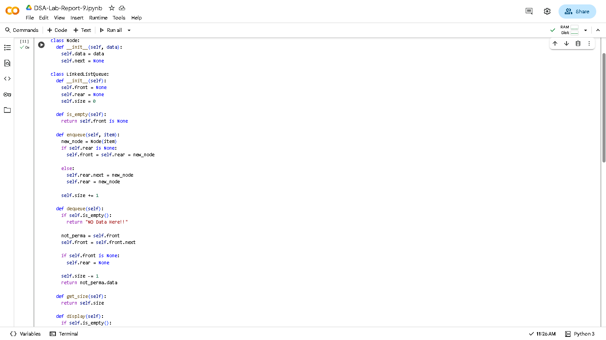

***Figure 1.1 First Part***

***Figure 1.2 Second Part***

# Conclusion

Queues implement FIFO (First-In-First-Out) behavior using linked lists with front/rear pointers, ensuring efficient O(1) insertions and removals while maintaining order integrity—making them ideal for real-world scenarios requiring sequential processing like task scheduling and request handling.

**References**

[1] Co Arthur O.. “University of Caloocan City Computer Engineering Department Honor Code,” UCC-CpE Departmental Policies, 2020.