Data Structure and Algorithm
Laboratory Activity No. 13

Tree Algorithm

Submitted by: | Instructor:
LastName, FirstName MI. | Engr. Maria Rizette H. Sayo

Month, DD, YYYY

Objectives
Introduction
An abstract non-linear data type with a hierarchy-based structure is a tree. It is made up of links connecting nodes (where the data is kept). The root node of a tree data structure is where all other nodes and subtrees are connected to the root.

This laboratory activity aims to implement the principles and techniques in:
- To introduce Tree as Non-linear data structure
- To implement pre-order, in-order, and post-order of a binary tree
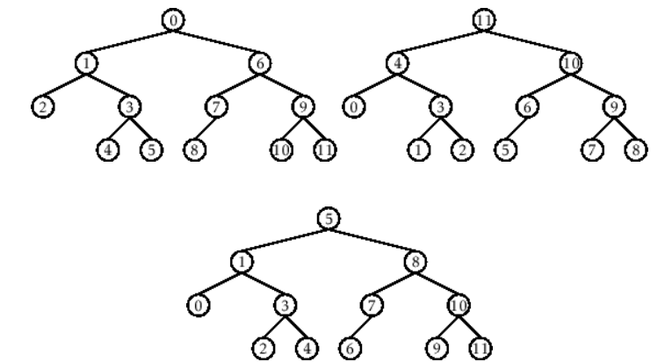

- Figure 1. Pre-order, In-order, and Post-order numberings of a binary tree

Methods
  - Copy and run the Python source codes.
  - If there is an algorithm error/s, debug the source codes.
  - Save these source codes to your GitHub.
  - Show the output

    - Tree Implementation

class TreeNode:
def __init__(self, value):
self.value = value
self.children = []

def add_child(self, child_node):
self.children.append(child_node)

def remove_child(self, child_node):
self.children = [child for child in self.children if child != child_node]

def traverse(self):
nodes = [self]
while nodes:
current_node = nodes.pop()
print(current_node.value)
nodes.extend(current_node.children)

def __str__(self, level=0):
ret = " " * level + str(self.value) + "\n"
for child in self.children:
ret += child.__str__(level + 1)
return ret

# Create a tree
root = TreeNode("Root")
child1 = TreeNode("Child 1")
child2 = TreeNode("Child 2")
grandchild1 = TreeNode("Grandchild 1")
grandchild2 = TreeNode("Grandchild 2")

root.add_child(child1)
root.add_child(child2)
child1.add_child(grandchild1)
child2.add_child(grandchild2)

print("Tree structure:")
print(root)

print("\nTraversal:")
root.traverse()

Questions:
- When would you prefer DFS over BFS and vice versa?
- What is the space complexity difference between DFS and BFS?
- How does the traversal order differ between DFS and BFS?
- When does DFS recursive fail compared to DFS iterative?

Results
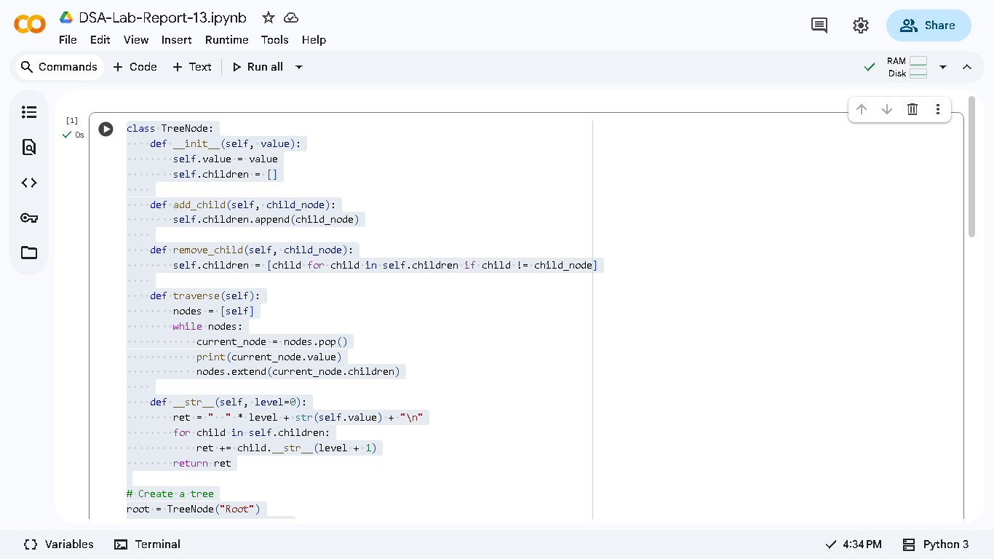
Figure 1.1

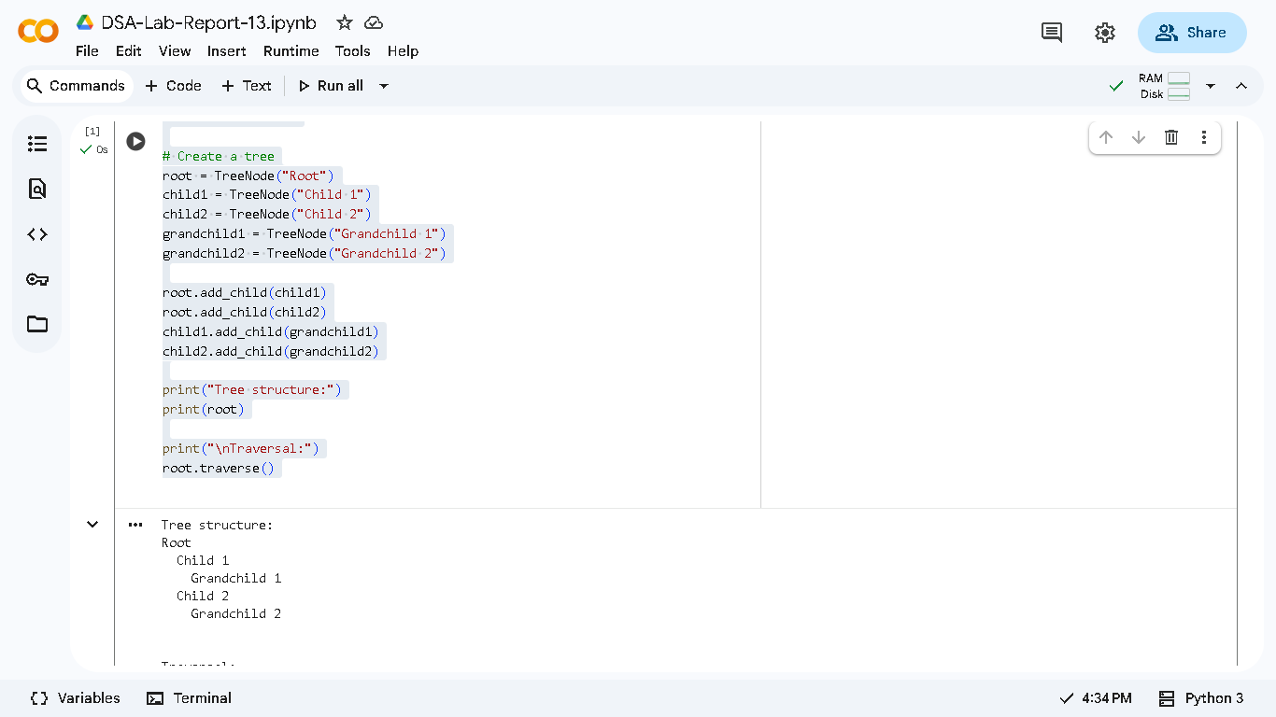
Figure 1.2

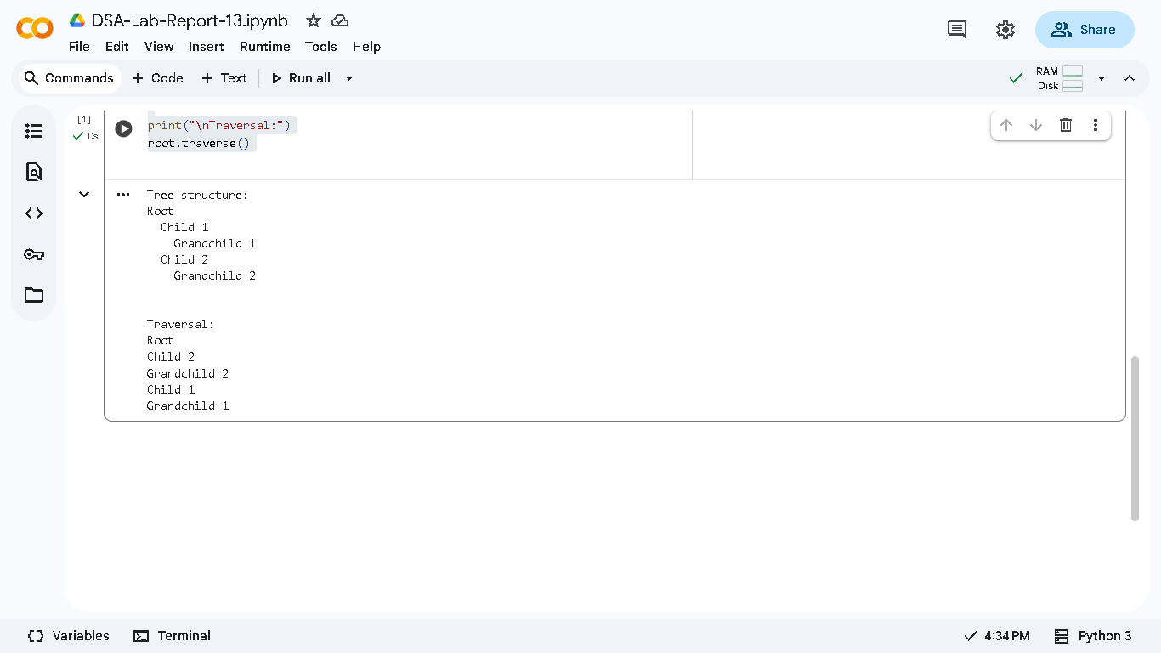
Figure 1.3

Answers:
    - DFS for memory efficiency and path finding while BFS for shortest path and level-order.
    - DFS: O(h) for depth, BFS: O(w) for width.
    - DFS goes deep first (root to child to grandchild) while BFS goes levl by level.
    - DFS recursive falls on deep trees due to stack overflow, iterative handles arbitrary depth.

Conclusion
In conclusion, this activity taught me that both DFS and BFS have important roles in tree traversal with DFS being ideal for deep exploration and memory efficiency and BFS on the other hand works best for level by level processing and shortest path finding. Through hands on coding, I discovered that iterative DFS is more reliable than recursive for large trees since it avoids stack overflow errors that can crash the program.

References
[1] Co Arthur O.. “University of Caloocan City Computer Engineering Department Honor Code,” UCC-CpE Departmental Policies, 2020.

