Data Structure and Algorithm
Laboratory Activity No. 14

Tree Structure Analysis

Submitted by: | Instructor:
LastName, FirstName MI. | Engr. Maria Rizette H. Sayo

Month, DD, YYYY

Objectives
Introduction
An abstract non-linear data type with a hierarchy-based structure is a tree. It is made up of links connecting nodes (where the data is kept). The root node of a tree data structure is where all other nodes and subtrees are connected to the root.

This laboratory activity aims to implement the principles and techniques in:
- To introduce Tree as Non-linear data structure
- To implement pre-order, in-order, and post-order of a binary tree
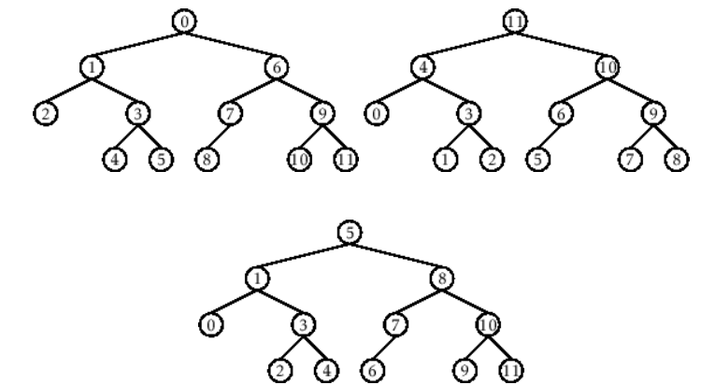

- Figure 1. Pre-order, In-order, and Post-order numberings of a binary tree

Methods
  - Copy and run the Python source codes.
  - If there is an algorithm error/s, debug the source codes.
  - Save these source codes to your GitHub.
  - Show the output

    - Tree Implementation

class TreeNode:
def __init__(self, value):
self.value = value
self.children = []

def add_child(self, child_node):
self.children.append(child_node)

def remove_child(self, child_node):
self.children = [child for child in self.children if child != child_node]

def traverse(self):
nodes = [self]
while nodes:
current_node = nodes.pop()
print(current_node.value)
nodes.extend(current_node.children)

def __str__(self, level=0):
ret = " " * level + str(self.value) + "\n"
for child in self.children:
ret += child.__str__(level + 1)
return ret

# Create a tree
root = TreeNode("Root")
child1 = TreeNode("Child 1")
child2 = TreeNode("Child 2")
grandchild1 = TreeNode("Grandchild 1")
grandchild2 = TreeNode("Grandchild 2")

root.add_child(child1)
root.add_child(child2)
child1.add_child(grandchild1)
child2.add_child(grandchild2)

print("Tree structure:")
print(root)

print("\nTraversal:")
root.traverse()

Questions:
- What is the main difference between a binary tree and a general tree?
- In a Binary Search Tree, where would you find the minimum value? Where would you find the maximum value?
- How does a complete binary tree differ from a full binary tree?
- What tree traversal method would you use to delete a tree properly? Modify the source codes.

Results
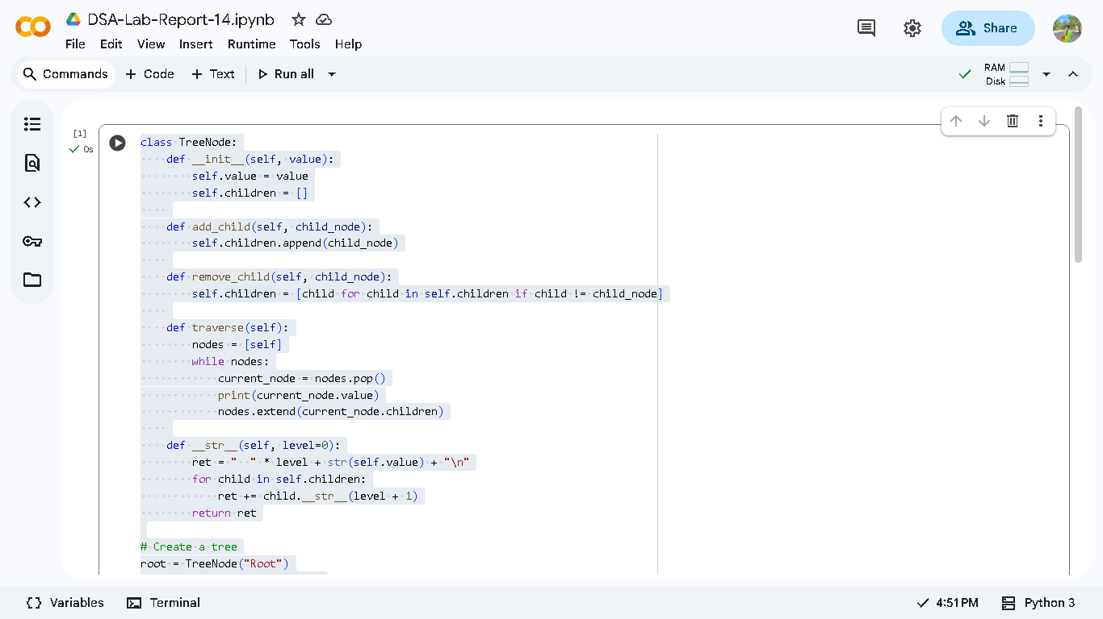
Figure 1.1

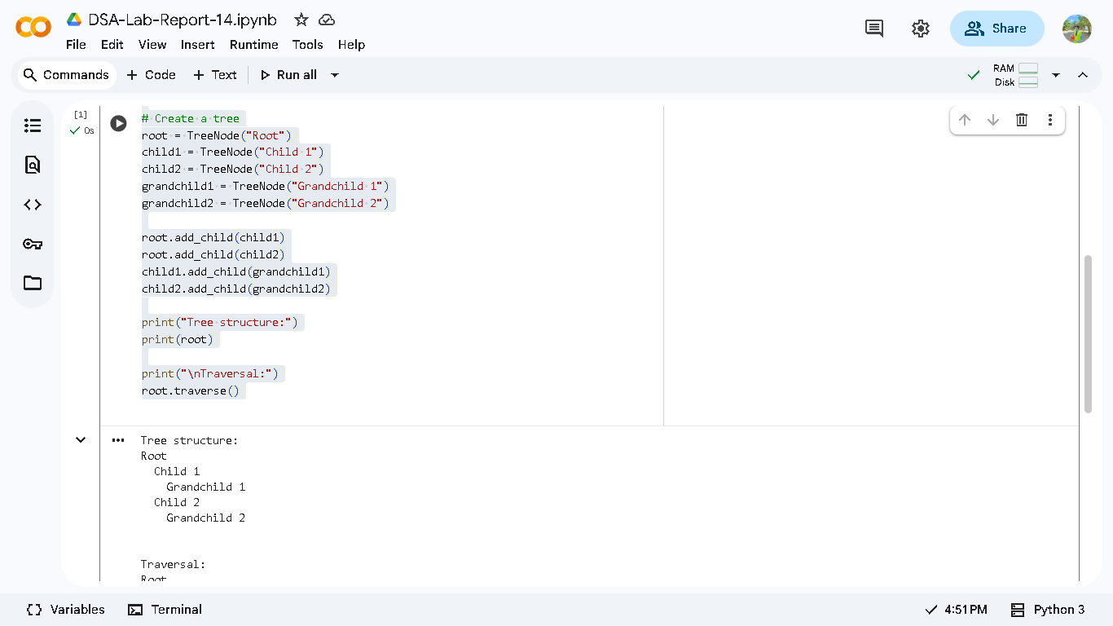
Figure 1.2

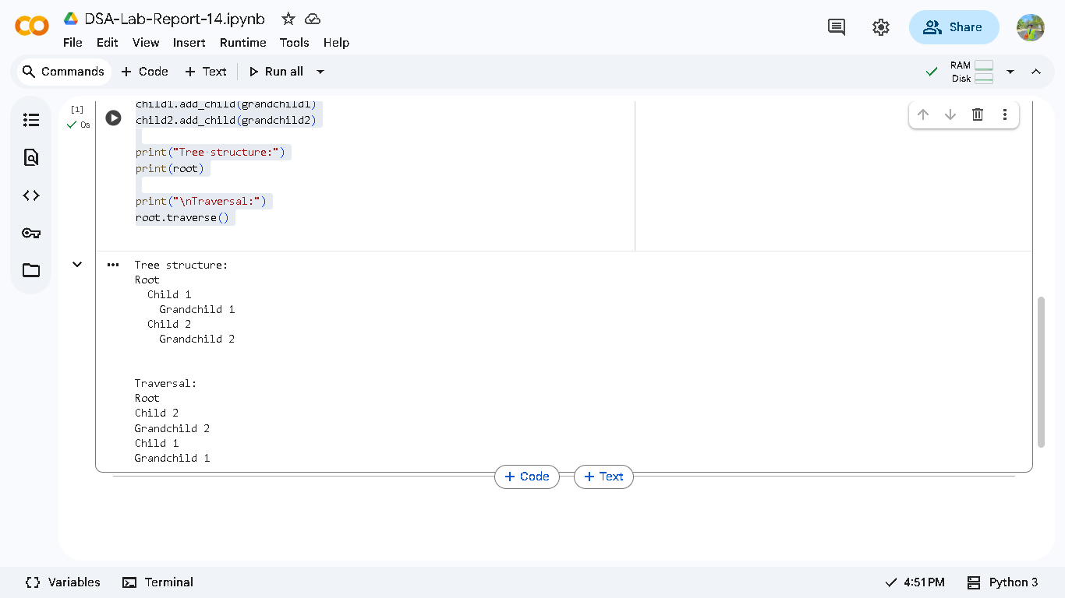
Figure 1.3

Answers:
    - Binary trees restrict nodes to two children while general trees allow unlimited children per node.
    - In BSTs, the minimum value resides in the leftmost node and the maximum in the rightmost node.
    - Complete binary trees fill all levels except the last from left to right, whereas full binary trees require each node to have either zero or two children.
    - Post order traversal ensures proper tree deletion by processing children before their parent node.

Conclusion
In this activity, I learned that binary trees have strict child limits while general trees offer more flexibility and different traversal methods serve specific purposes like postorder for deletion. Understanding these tree properties helps choose the right structure and operations for efficient data management in programming projects.

References
[1] Co Arthur O.. “University of Caloocan City Computer Engineering Department Honor Code,” UCC-CpE Departmental Policies, 2020.

