Ryan Farr – rlf238

October 21st, 2018

CS 5785 – Applied Machine Learning

**Homework 2 – Written Portion**

1. Here we have a prime example of where to apply the Lagrange multiplier with the constraint entered as :

The minimum can be found when the derivative of this function is 0

Which is the standard eigenvalue problem.

1. With features , a two-class response and class sizes coded as , .
   1. We know and and that we will classify as class 2 when
   2. TODO
2. Given M

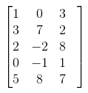

* 1. is given by

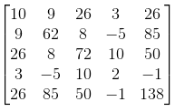

=

And is given by

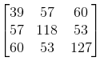

* 1. The eigenvalues for are

The eigenvalues for are

* 1. The eigenvectors for are

*-0.16492942 -0.47164732 -0.33647055 -0.00330585 -0.79820031*

*-0.95539856 -0.03481209 0.27076072 0.04409532 0.10366268* *0.24497323 -0.45330644 0.82943965 0.16974659 -0.13310656*

*-0.54001979 -0.62022234 -0.12704172 0.16015949 0.53095405*

*-0.78501713 0.30294097 0.2856551 0.43709105 -0.13902319*

The eigenvectors for are

*0.42615127 0.61500884 0.66344497*

*0.90453403 -0.30151134 -0.30151134*

*-0.01460404 -0.72859799 0.68478587*