AGRAV - Automated Guided Robotic Armed Vehicle

Overview
AGRAV (Automated Guided Robotic Armed Vehicle) is a mobile robotic system that combines a 6-DOF serial robotic arm with an Automated Guided Vehicle (AGV) to automate material handling and pick-and-place operations.
This prototype was built to explore how mobility and manipulation can be integrated into a single system to improve productivity and reduce manual labor in industrial environments like warehouses and manufacturing plants.
This project was developed as part of our first year capstone (mini) project at NMIMS MPSTME. During our coursework in Industrial Engineering, we studied how material handling and repetitive pick-and-place tasks are still largely performed manually in many warehouses and factories. These tasks are time-consuming, prone to human error, and limited by working hours, which directly impacts overall productivity.
We identified the need for a system that could automate both transport and manipulation of items within industrial settings — something that’s usually handled by separate equipment (like forklifts for transport and robotic arms fixed at one location). Our solution was to combine mobility with manipulation by integrating a robotic arm on top of an AGV, creating a single compact unit capable of performing both tasks. That’s how the idea for AGRAV was born — a modular and scalable solution for next-generation warehouses.

The current version:
- Navigates using line-following sensors
- Can be manually controlled using a custom Android app
- Uses servo motors for arm articulation
- Was modeled in Fusion 360 and analyzed using ANSYS
In future industrial implementations, AGRAV can be scaled with:
- RFID systems to identify and pick specific items
- A Warehouse Management System (WMS) that assigns tasks, tracks inventory, and communicates with multiple AGRAV units for full automation
What is a Warehouse Management System (WMS)?
A WMS is software that manages inventory, tracks item locations, and assigns tasks to robots or workers in a warehouse. In the case of AGRAV, a WMS could direct each vehicle to pick up specific items from shelves, optimize routes, and log completed deliveries — enabling 24/7 automated warehouse operations with minimal human input.

Features
- 6 DOF Robotic Arm with aluminum links
- AGV with Mecanum Wheels for omnidirectional movement
- Arduino-based control
- Bluetooth control via custom Android app
- Line following and obstacle avoidance

Images

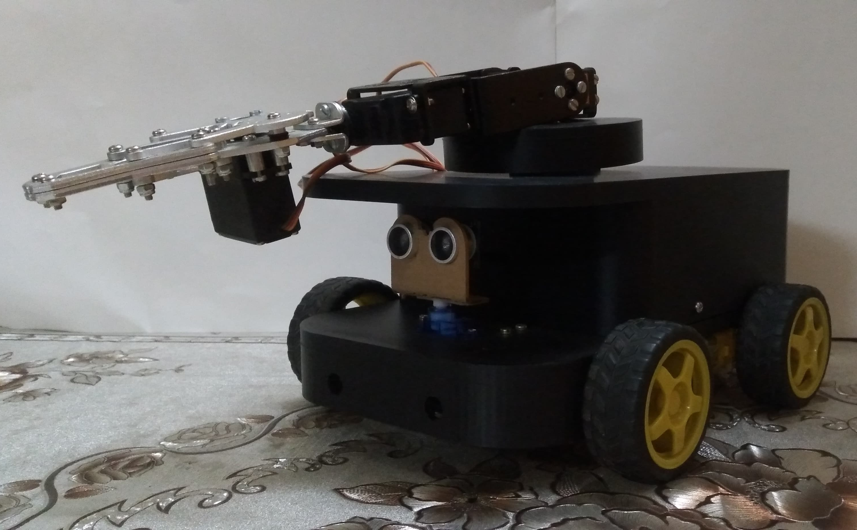
AGRAV Model

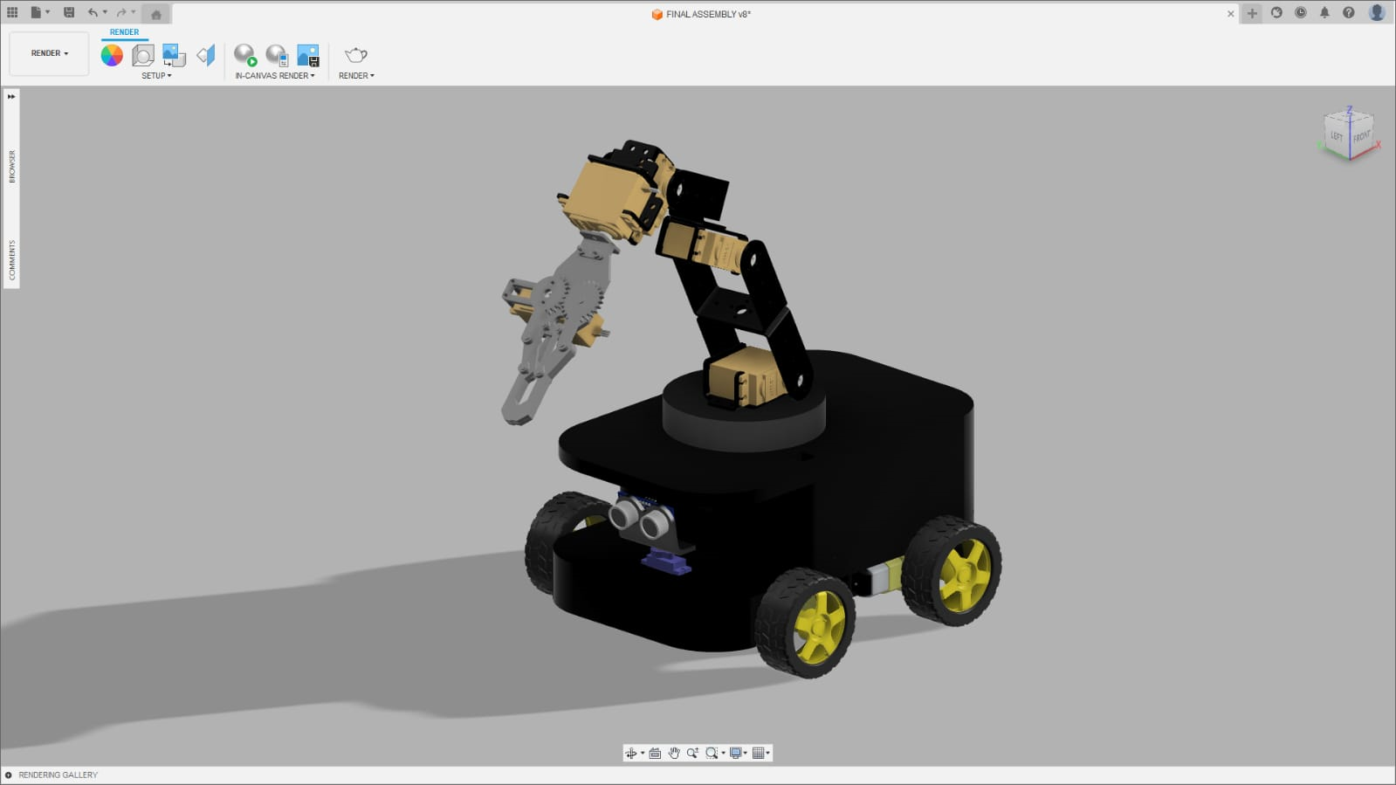
CAD Model

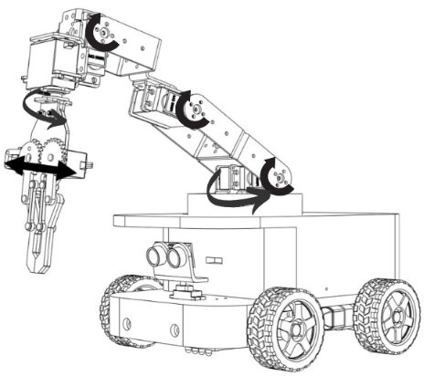
Robotic Arm Reach
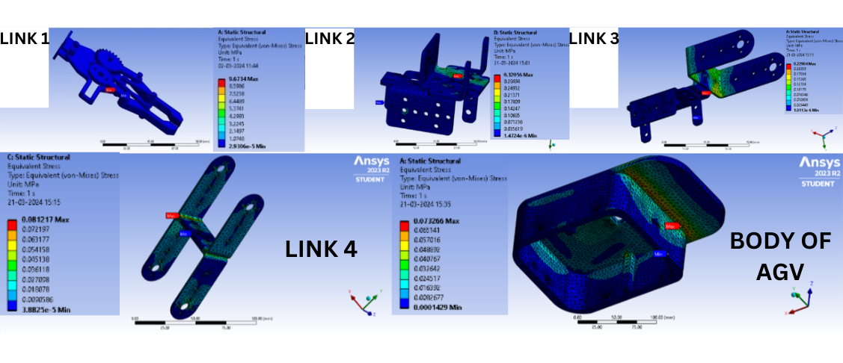

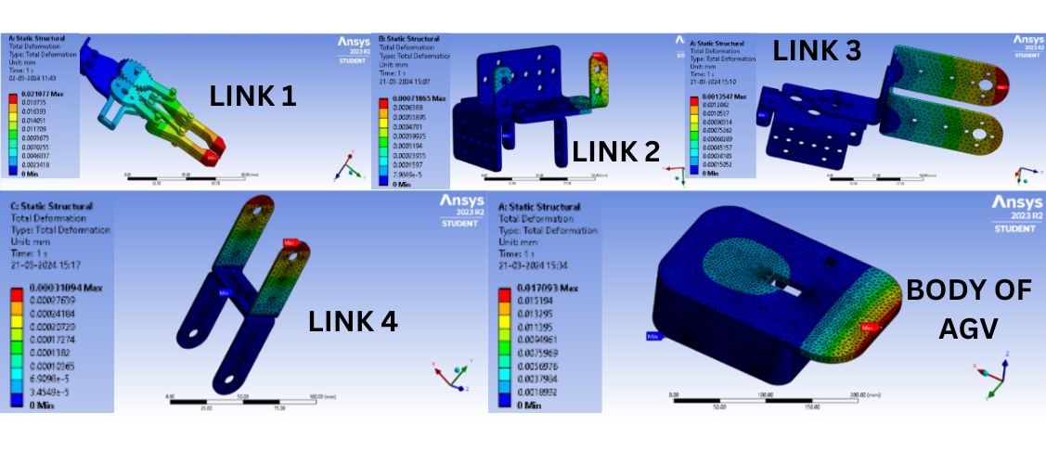
ANSYS Analysis

App Interface

Project Structure
AGRAV/
├── cad/
├── code/
├── analysis/
├── images/
├── report/
└── README.md

Android App
We built an app using MIT App Inventor to manually control AGRAV:
- Buttons for forward, backward, left, right
- Slider for speed control
- Arm joint control
- Option for Line Follower mode

Components Used
• Arduino Uno Rev3 – Microcontroller board
• Arduino Screw Terminal – For secure wire connections
• Arduino Motor Shield – To control motors
• 400 Points Half-Size Breadboard – For prototyping circuits
• 2 × 18650 2600mAh Lithium-Ion Batteries – Power supply
• 2 × 18650 Battery Holder – Holds the batteries
• Li-ion Charger + Type-C Booster Module – For charging the battery pack
• Jumper Wires – For circuit connections
• PCA9685 Servo Motor Driver – To drive multiple servo motors using I2C
• Ultrasonic Distance Sensor (HC-SR04) – For obstacle detection
• Rocker Button Switch (DPDT) – For manual control switching
• Ultrasonic Sensor Mounting Bracket – For sensor placement
• SG90 Continuous Rotation Servo Motor – Controls smaller movements
• MG996R High Torque Servo Motors (×6) – Used in the robotic arm for joint motion
• Aluminum Alloy Brackets and 3D Printed Parts (PLA) – Structural components of the robotic arm and AGV
• Robotic Gripper – For gripping and picking up objects
• BO Dual Shaft DC Motors (×4) – Drive mechanism for the AGV
• 80mm Mecanum Wheels (×4) – Enables omnidirectional movement
• IR Obstacle Avoidance Sensor Modules – For line following and obstacle detection
• 1W LEDs with Heatsinks (×2) – Indicators or lighting
• 5V 1-Channel Relay Module – For controlling higher voltage devices

Advantages
- Works 24/7
- Reduces human effort
- Increases accuracy and efficiency
- Safer and scalable for real warehouses
Limitations
- High initial cost
- Needs a controlled environment
- Limited payload for this prototype

Report & Documentation
- Full Project Report PDF
- Arduino Code and App Code inside /code
- CAD Models inside /cad
- ANSYS Results in /analysis

Team
- Sahil Bhuta (A007)
- Paurash Deboo (A018)
- Ryan Fernandes (A028)
- Guide: Prof. Giridhar Chavan

While AGRAV is currently a small-scale prototype, it is designed with scalability in mind. For industrial deployment, several enhancements would be required — such as stronger materials, higher payload servo motors, programmable logic controllers (PLCs), advanced navigation systems, and integration with Warehouse Management Systems (WMS) and RFID tracking for real-time task automation.
We’ve made this project open source to help students, hobbyists, and engineers learn from our work, build on it, and adapt it to their own ideas or industrial needs. Whether you're exploring robotics, automation, or warehouse logistics — we hope AGRAV gives you a great starting point.

How to Build AGRAV
- Download the Files
Clone or download this GitHub repository to get access to all CAD files, circuit diagrams, Arduino code, and the Android app source.
- 3D Print or Fabricate Parts
  - Use the provided Fusion 360 CAD files to 3D print the AGV body and brackets (preferably in PLA or PETG).
  - The robotic arm structure can be printed or made from aluminum alloy, depending on your available tools and budget.
- Buy the Components
Refer to the Components Used section and source the motors, Arduino boards, sensors, wheels, etc. Most parts are affordable and easily available online.
- Assemble the Hardware
  - Mount the motors, wheels, and chassis as per the CAD model.
  - Assemble the robotic arm and connect it to the AGV platform.
  - Wire up all electronics using the schematic provided.
- Upload the Code
Use the Arduino IDE to upload the respective .ino files to the Arduino Uno (for arm control) and Arduino Mega (for AGV control). Make sure all pins match what's in the code.
- Install the Android App
  - Install the APK provided (or build it using MIT App Inventor files in the repo).
  - Connect via Bluetooth to the HC-05 module and start manually controlling the AGRAV.
- Test and Calibrate
  - Test individual movements of the arm and AGV.
  - Fine-tune servo angles and motor speeds as needed.
  - Optionally, enable line-following mode or build your own autonomous logic.

