Tags versus genetics: identifying which technology provides the best information about Chinook salmon (Oncorhynchus tshawytscha) distributions in the California current.

Introduction
As the quintessential icon of the Pacific Northwest, salmon contribute to the food supply, economy, and health of the United States and are a critical source of spiritual and physical sustenance for Northwest Indian tribes. Pacific salmon (Oncorhynchus spp.) typically exhibit a spatially dynamic life history, expending significant time in both freshwater and marine environments (Groot and Margolis, 1991). While at sea, salmon may travel thousands of kilometers from their natal stream, often crossing state and international boundaries while being subject to multiple commercial, sport and tribal fisheries. The movement of Pacific salmon through space and time, across political boundaries, and through fisheries, creates one of the most complex marine resource management problems in the world.

Background
The growth and survival of salmon is affected by where they migrate and how long they spend in certain areas of the ocean(Pearcy, 1992; Pearcy and McKinnell, 2007; Tucker et al., 2011). Understanding their distribution through space and time helps scientists and managers to distinguish the factors affecting their survival and reproductive success and may improve our ability to effectively manage them as resource. Coded-wire tags (CWTs) and genetic stock identification (GSI) are tools that can provide information on where and when specific stocks of salmon are encountered in the ocean.
Coded-wire tags are minute (1.1 mm) pieces of magnetized steel wire that are inserted into the nasal cartilage of juvenile salmonids. Introduced in the late 1960s as a tool to evaluate experiments carried out by salmon hatcheries, the CWT quickly became the most widely utilized means of tracking the fate of specific groups of Chinook and Coho salmon from release through maturity (Jefferts et al., 1963). The primary function of CWT data is to assist the decision-making process used to manage salmon stocks along the west coast of North America (Nandor et al., 2010). In the late 1970s, management agencies from Alaska, British Columbia, Washington, Oregon, and California developed coast-wide catch sampling and reporting protocols to facilitate sharing of data on where and when fish from individual release groups were harvested (Pacific Salmon Commission, 2005). The coordinated, coast-wide release and recovery of CWTs was followed by the development of cohort analysis methods in the mid-1980s. Cohort analysis methods utilize CWT recovery data to estimate stock-specific, age-specific, and fishery-specific exploitation and survival rates, age specific maturation rates, survival from release to age 2, and total mortality (Chinook Technical Committee, 1988). Results of cohort analysis quantify and characterize the timing and location of fishery impacts for the entire migratory range and life cycle of individual stocks (Pacific Salmon Commission 2005). The information provided by CWT-based cohort analysis is heavily relied upon by management agencies to design salmon fisheries that exploit abundant stocks while avoiding those that are less plentiful (Nandor, Longwill, and Webb 2010). In addition to cohort analysis, CWT data have been used to address a variety of questions about the distribution and migration patterns of adult (Nicholas and Hankin, 1988; Norris et al., 2000; Weitkamp, 2010; Weitkamp and Neely, 2002) and juvenile salmonids (Fisher et al., 2014; Morris et al., 2007; Trudel et al., 2009; Tucker et al., 2011), run timing, in-season survival (Holt et al., 2009), stray rates (Candy and Beacham, 2000; Quinn and Fresh, 1984) and hatchery experiments. Today, all salmon fishery management agencies in the Pacific Northwest depend upon coded-wire tags.
The CWT has provided unrivaled information about the ocean distribution patterns and fishery impacts of Chinook salmon for over four decades. However, CWT data have inherent weaknesses which have caused growing concerns about their quality and the inferences we draw from them. The most obvious drawback of CWT data, and the root of much of the concern surrounding these data, is that they provide specific information only for fish that are tagged and recovered. Because it is not feasible to tag each fish (due to cost and logistics of tagging and recovering sufficient numbers of salmon), and because the vast majority of tagged fish are reared in hatcheries, analysts are forced to rely upon expansion factors and assumptions when estimating fishery impacts for the naturally produced and untagged counterparts of each stock. For instance, one assumption used in all salmon management models built around CWT data, is that tagged salmon behave in the same manner as the untagged individuals they are intended to represent. That belief forms the very first assumption listed in the technical documentation for the PFMC’s “Fishery Regulation Assessment Model” and is also an underlying assumption of the Chinook Technical Committee’s “Exploitation Rate Analysis” (Chinook Technical Committee, 1988; Model Evaluation Workgroup (MEW), 2008). It is difficult to tag and recover sufficient numbers of naturally produced salmon so there have been few attempts to validate the assumption using CWT methods. However, the studies that have been conducted suggest that hatchery indicator stocks and naturally produced stocks are subject to similar fishing patterns, at least at large spatial scales (Satterthwaite et al., 2014; Weitkamp, 2010; Weitkamp and Neely, 2002).
The inability to tag each fish with coded-wires generally requires high exploitation rates to recover adequate numbers of CWTs for statistically reliable analyses. During the 1980s Chinook salmon stocks were considered abundant enough to support high exploitation rates. However, beginning in the early 1990s many naturally produced (presumably wild) stocks began to decline rapidly, spurring managers to reduce fishery impacts in order to meet conservation goals. Survival rates continued to plummet and uncertainty surrounding the ability of some naturally produced stocks to persist led to several stocks being listed under the Endangered Species Act as either threatened or endangered, causing managers to further restrict the extent to which fisheries were allowed to operate. Limited access to hatchery produced salmon stocks, due to concerns for naturally produced stocks, led to fewer CWTs being recovered which increased uncertainty surrounding CWT data and analyses based on them(Pacific Salmon Commission, 2005).
The fishery regulations that were put in place to meet escapement goals for naturally produced salmon not only limited the number of CWTs being recovered, but severely restricted access to hatchery raised salmon. Politicians and fisheries managers came under pressure to provide access to hatchery produced salmon while constraining impacts on the imperiled naturally produced stocks. Many management agencies attempted to address that problem by mass-marking salmon produced at hatcheries and implementing mark-selective fisheries. Mass-marking is a term that describes removing the adipose fin from hatchery produced fish so that they may be detected visually. Mark-selective fisheries operate under the premise that fish bearing an adipose clip may be retained while un-clipped fish must be released with the expectation that catch-and-release mortality will be significantly less than one hundred percent. Unfortunately, the implementation of mass-marking and mark-selective fisheries has proven to be a double edged sword. On the one hand, mark-selective fisheries undoubtedly reduce the total mortality of naturally spawning populations of salmon. However, in a mark selective fishery, exploitation rates for CWT hatchery stocks (marked salmon) are no longer representative of exploitation rates for naturally produced stocks (unmarked salmon) thereby impairing the ability of CWT data to monitor fishery impacts on the naturally produced stocks that fisheries managers strive to conserve. As mark-selective fisheries become more abundant, estimating mortality for naturally spawning stocks becomes more and more dependent on assumptions and methods that cannot be readily validated (e.g. catch-and-release mortality rate), casting further doubt on the reliability of the CWT system to monitor stocks whose exploitation rates are constrained by the Pacific Salmon Treaty and Endangered Species Act (Pacific Salmon Commission 2005).
The ability of the CWT system to provide data adequate for quantifying and characterizing fishery impacts on naturally spawning salmon populations was formally investigated in 2005. Twice during that year, the Pacific Salmon Commission gathered an “Expert Panel” of fishery scientists and tasked them with identifying the weaknesses of the CWT system as well as alternate technologies that might be used in addition to, or in lieu of, the CWT. The findings of the Expert Panel indicated that, at the time, there were no alternative technologies that could provide the Pacific Salmon Commission with the data necessary for cohort analysis and the implementation of fishery regimes as dictated by the PST (Finding 1; Pacific Salmon Commission 2005). However, the Expert Panel noted that several alternative technologies could potentially be used to supplement the information provided by the release and recovery of CWTs. The Expert Panel identified genetic stock identification (GSI) as a technology that showed great potential for providing information that could be used in addition to the CWT system to improve salmon management.
GSI is a tool that utilizes naturally occurring variations in DNA to differentiate between salmon stocks and has been applied to salmon research and management for decades (Shaklee et al., 1999). Advances in the standardization of a microsatellite baseline for Chinook salmon made it possible to accurately estimate (with confidence >90%) the origin of individual Chinook salmon harvested from fisheries along the west coast of North America (Seeb et al., 2007). These genetics-informed individual assignment estimates have been used to explore a wide range of questions pertaining to salmon biology such as marine distribution and migration patterns of adult salmon (Bellinger et al., 2015; Ireland, 2010; Satterthwaite et al., 2014), juvenile salmon (Tucker et al., 2011; Van Doornik et al., 2007), and population specific migration timing (Parken et al., 2008).
Many of the limitations inherent in CWT data are strengths of GSI and vice versa. For example, information pertaining to the natal origin and age of the fish provided by GSI is typically not as precise as CWT data. CWTs inform us of the exact age, stock, hatchery, and release location of tagged fish whereas GSI data typically provide the general geographic region or, at best, the river basin from which a fish originated. GSI also requires the collection of scale samples for age analysis. Conversely, the ability to use genetics-based data to study salmon distributions eliminates the conundrum of not being able to tag every salmon in the ocean. By taking advantage of the genetic “tag” present in every Chinook salmon we are able to expend less fishing and sampling effort to collect the same amount of information pertaining to the location of salmon in the marine environment. Furthermore, it becomes more feasible to gather information regarding where rare, wild and untagged stocks occur. Additionally, because a tissue sample can be harvested from a fish without killing the individual, it is possible to utilize GSI to estimate salmon distributions in space-time areas that may be closed to harvest. Finally, it is relatively easy to design a study that takes advantage of GSI in such a way that it allows the investigation of salmon distributions at fine space-time scales. For instance, a genetics based individual assignment estimate paired with GPS coordinates can provide precise information on the location and time a specific stock was encountered (e.g. Bellinger et al. 2015; Ireland, 2010).

West Coast Salmon Genetic Stock Identification Collaboration
Declining abundance of the Klamath River Fall Chinook stock in 2005, and its negative implications for commercial fisheries and coastal communities, spurred Oregon’s Congressional leaders to meet with members of the Oregon State University faculty to develop a science based solution for avoiding weak salmon stocks without closing the entire fishery. The eventual result of that meeting was the formation of Project CROOS (Collaborative Research on Oregon’s Ocean Salmon), a collaboration between fishermen, scientists and management bodies aimed at evaluating the utility of GSI to provide real-time information on salmon stocks encountered off the Oregon coast. It was hypothesized that availability of real-time data could enable managers and/or industry to make in-season adjustments to the fishery, allowing industry to concentrate fishing effort in areas not inhabited by scarce stocks. Furthermore, it was speculated that information gathered by the project could increase knowledge of the marine distribution and migration patterns of salmon stocks commonly encountered in waters off the Oregon coast. Beginning in 2008, methods developed by Project CROOS were implemented in Oregon and California under the West Coast Salmon Genetic Stock Identification Collaboration (WCS-GSI). In 2010 and 2011 the WCS-GSI attempted to sample all commercial fisheries and areas from Cape Falcon, Oregon to Santa Barbara, California. The GSI data they collected are explored in this study.

Objective
The key objective of this study was to explore, compare, and contrast the capabilities of CWT and GSI data to identify stock-specific distribution patterns of Chinook salmon off the coasts of Oregon and California. In addressing that objective, we described the marine distribution of the Chinook salmon stocks most commonly encountered in Oregon and California’s commercial troll fisheries an devaluated the similarity between CWT- and GSI-based estimates of those distributions. The study concludes with suggestions for how data similar to those collected by the WCSGSI could be used managers to monitor, evaluate, and manage fishery impacts on specific salmon stocks at refined space-time scales.

Methods
Our objective was to compare the capabilities of CWT and GSI data for identifying fine-scale, stock-specific, distributions of Chinook salmon encountered in the commercial troll fisheries operating off Oregon and California. The spatial scope of this study spanned from Cape Falcon, OR (45.76 N) to Point Sur, CA (36.3 N). The main commercial troll fishery typically operates from May through September and therefore we focused on how CWT and GSI data represent Chinook distributions across those months.
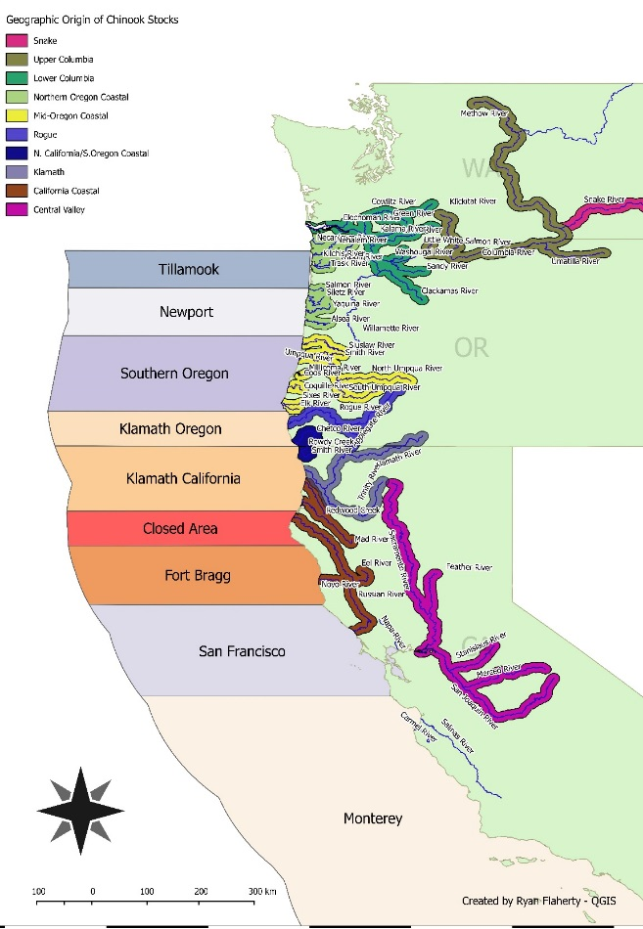
Figure 1. Map depicting the coarse scale catch areas used in this study and the rough geographic origin of the majority of stocks examined in this study.

CWT data
The CWT data used in this study were obtained through the Regional Mark Processing Center’s online Regional Mark Information System (RMIS) database (http://www.rmpc.org/). In this study we define “CWT data” as data that were garnered from the release and recovery of coded-wire tagged Chinook salmon encountered in the commercial troll fishery. The RMIS database provides the user with a large set of variables related to the life history of the release group represented by each tag code. We specifically selected CWTs that were recovered from the commercial troll fishery; excluding any CWTs recovered from purely experimental release groups. Historical effort data for the commercial troll fisheries were acquired via the Pacific Fishery Management Council’s “Historical data of Ocean Salmon fisheries bluebook” (http://www.pcouncil.org/salmon/background/document-library/historical-data-of-ocean-salmon-fisheries/).

Genetic data
The GSI data examined in this study were provided by the WCSGSI collaboration. GSI-based individual assignment estimates and WCSGSI effort data were accessed via the WCSGSI’s online data portal (pacificfishtrax.org). GSI individual assignments were used in the analysis only if the probability that they were correct was greater or equal to ninety percent. Fishermen participating in the collaboration were assigned hand-held global positioning system (GPS) units. Those GPS units served two critical purposes. First, they were used to record the approximate time and location of each fish that was caught and sampled. When a fish was captured, the fisherman collected scale and tissue samples for age and genetic analyses. The second purpose of the GPS unit was to record each fisherman’s “fishing track” which served as a record of how fishing effort was expended through space and time. The GPS units were pre-programmed to record time and location at 5-minute intervals. Each interval equaled a “track point.” For the purpose of this study, a single day of WCSGSI sampling effort equated to 10 or more track points (i.e. at least 50 minutes of fishing was required to qualify as a boat day; that being said most “days” were considerably longer than 50 minutes. The WCSGSI’s individual assignment estimates, in combination with their “track point” based effort data, provided the date, time, location and most likely population of origin for each salmon encountered during 2010 and 2011 as well as the means to estimate the amount of effort expended to collect those samples.

Data preparation
There are four fundamental differences between the information provided by the CWT and WCSGSI databases: 1) the number of salmon that can be represented by a single data point; 2) the spatial scale at which natal origin is identified; 3) the space-time scale at which capture location is identified; and 4) the amount of effort expended to collect the data. Before we compared how CWT and WCSGSI data represented distributions of salmon we processed the data to account for those differences. The methods we used to process the data are described in appendix (x).

Fundamental difference 1
The first fundamental difference between CWT and WCSGSI data is the number of salmon represented by a single data point. While a single data point in the WCSGSI database corresponds to an individual fish, a single CWT recovery typically represents multiple fish from a specific release group. There are two reasons why a single CWT recovery is assumed to represent multiple fish. First, only a fraction of the landed catch is sampled for the presence of CWTs. In Oregon and California, management agencies strive to sample at least twenty percent of the landed catch for the presence of CWTs. Because only a fraction of the catch is sampled, it is assumed that a proportion of tagged fish in the catch go undetected. The CWT database variable, “estimated number” , is calculated by the reporting agency and represents the estimated number of tagged fish in the catch bearing the same code. Equation 1 is the general framework used to generate the variable “estimated number.”
Equation 1 – CWT sampling rate expansion (Johnson and Parker, 1990):
$$R_{T,i,j}=∝R_{o,i,j}$$
Where R_{T,i,j} is the estimated number of recoveries of code (T) during time (i) in area (j), R_{o,i,j} is the observed number of tags of the appropriate code and alpha is the sampling expansion factor (total catch/sampled catch).
The second reason a single CWT recovery is often assumed to represent more than one fish is because, typically, only a fraction of the fish belonging to a release group are implanted with a CWT. The CWT database contains information on the total number of fish belonging to each release group as well as the number of fish in each group that are tagged. With that information, CWT recoveries can be expanded to account for the fraction of fish in the release group that did not receive a tag. The tagging expansion we used was calculated from the following variables which are found in the CWT release database: “cwt 1st mark count”, “cwt 2nd mark count”, “non cwt first mark count”, and “non cwt second mark count.” CWT 1st mark count represents the number of fish that receive a CWT and mark, where “mark” is means of visually identifying the presence of a CWT (typically an adipose fin clip). We applied equation 2, below, to expand CWT recoveries to account for tagging rate.
Equation 2 – CWT tagging rate expansion (from Johnson and Parker 1990):
$$C_{i,j}=bR_{T,i,j}$$
Where C_{i,j} is the total estimated contribution of the release group bearing code (T) to the catch in time (i) and area (j) and b is the tagging expansion factor (total fish released/total fish marked):
$$b=\frac{CWT 1st mark+CWT 2nd mark+Non CWT 1st mark+Non CWT 2nd mark}{CWT 1st mark+CWT 2nd mark}$$

Fundamental difference 2
The second fundamental difference between CWT and GSI data is the scale at which they identify the natal origin of a salmon. CWT data provide us with the specific stock a salmon belongs to as well as the hatchery, and stream where it was reared and released. In contrast, the GSI data used in this study provided an estimate of either the general geographic region a salmon originated from (e.g. Mid-Oregon Coastal) or, at best, the river basin or origin (e.g. Klamath River). To account for this difference, each CWT recovery was assigned to an equivalent GSI reporting group, termed a “CWT GSI equivalent” (CGE). Assignment to CGEs were based on stock location name, run type and release location.

Fundamental difference 3
The third fundamental difference between CWT and GSI data is the scale at which they identify where and when fish are captured. WCSGSI data identify where in space and time a fish is encountered with much greater precision than CWT data. WCSGSI data provide the approximate geographic coordinates and time of an encounter of an individual fish, whereas typical reporting formats for CWT data provide the catch area and date where and when a tagged fish is landed (this is an important note, CWT data tell us where and when a fish is landed at port but not necessarily where and when in the ocean it was caught). To be able to directly compare CWT and WCSGSI based estimates of salmon distribution, CGEs and WCSGSI encounters were assigned to the catch area (Tillamook, Newport, Southern Oregon, Klamath Oregon, Klamath California, Fort Bragg, San Francisco and Monterey) and month (May – September) where they were recovered (Figure 1, appendix?). CWT fish were assumed to have been caught in the same catch area in which they were landed. CWTs that were recovered in historical management areas that overlapped multiple study areas were not included in this analysis (accounted for less than 1 percent of all recoveries initially queried for this study).

Fundamental difference 4
We incorporated fishing effort into our salmon distribution estimates and therefore the fourth and final fundamental difference between the CWT and WCSGSI data used in this study was the amount of fishing effort associated with their collection. All participants of the commercial fishery serve as samplers for the CWT program. Consequently, we used the total fishing effort expended by the commercial fleet in a time and area when estimating our CWT-based distributions of Chinook salmon. Records of historical fishing effort across year, month and area were accessed online via the PFMC’s historical documentation (http://www.pcouncil.org/salmon/background/document-library/historical-data-of-ocean-salmon-fisheries/). The WCSGSI fishing effort is different because not all Oregon and California salmon trollers participated in the WCSGSI collaboration during 2010 and 2011. Additionally, record of the fishing effort expended by WCGSI participants is reported as trackpoints (the 5-minute intervals recorded by GPS units discussed previously). To create indexes for comparison with the CWT data, we estimated stock specific relative abundance across all months and areas using equations 3 and 4.
Equation 3 – Estimate stock specific encounter rate S.
$$S_{c,i,j,d}=\frac{C_{i,j,d}}{E_{i,j,d}}$$
Where S_{c,i,j,d} is the estimated encounter rate of stock c during month i and area j as estimated by data type d (i.e., CWT or GSI) , C_{i,j,d} is the estimated contribution of that stock during month i and area j as estimated by data type d and E_{i,j,d} is the estimated amount of fishing effort that was expended during month i and area j as estimated by data type d.
Equation 4 – Stock specific relative catch rate S!.
$$S_{c,i,j,d}^{!}=\frac{S_{c,i,j,d}}{{MAX(S}_{c,d})}$$
Where MAX(S_{c,d}) is the maximum encounter rate of stock c across all month x area strata as estimated by data type d. Equation 4 serves to standardizes CWT- and GSI-based relative abundance estimates for direct comparison to one another. Values obtained from Equation 4 were assumed to represent how the data, whether it be CWT or GSI, represent distributions of Chinook salmon through space and time.

Data aggregates
We investigated CWT- and GSI- based distribution patterns at the catch-area x month spatiotemporal scale. CWT-based distribution patterns were estimated from CWT data aggregated across two time periods: “historic” (1987 – 2011) and late (2010 – 2011). The “historic” period was chosen to allow comparisons of CWT- and WCSGSI-based distributions across a greater number of individual Chinook stocks. The late period was chosen to facilitate direct comparisons between the information provided by two years of CWT and the information provided by two years of WCSGSI data. All GSI data were aggregated from 2010 – 2011. All plots and statistical analyses in this study were based on these three time- and data-dependent aggregates: historic CWT, late CWT and WCSGSI.

Tileplots
Tileplots were created to illustrate stock-specific relative abundance estimates at the catch-area x month space-time scale. Our tileplots resembled a matrix of colored tiles with catch-area represented by the y-axis and month represented by the x-axis. Each tile represented one catch-area x month stratum (i.e. Tillamook x July). High values of the variable being plotted were represented by hot colors (red) and low values by cool colors (blue).
To be included in this analysis a CWT-GSI equivalent needed to average a minimum of ten physical CWT recoveries per year (before expansion for sampling and tagging rate). This criterion was selected because it allowed for the greatest number of stock-specific relative encounter rate estimate comparisons between CWT and GSI data while still providing enough information to plot CWT-based estimates across the space-time scope of this study.

Statistical comparison of CWT and GSI distribution estimates
We evaluated the similarity between CWT- and GSI-based stock specific distribution estimates by using four tools: Mantel’s test, MRPP (multi-response permutation procedures), non-metric multidimensional scaling (nMDS) ordination, and Spearman’s rho correlation coefficient. Sorensen distance was utilized in instances when a distance matrix needed to be constructed.

Results
Our objective was to investigate the capacity of CWT and GSI data to characterize distribution patterns of specific stocks of Chinook salmon off the coasts of Oregon and California. We utilized tileplots to provide visual representation of CWT and GSI-based distribution patterns. The relationship between patterns provided by each data type was evaluated with Spearman’s correlation, Mantel’s method, ordination and multi-response permutation procedures.

Recovery statistics
We used WCSGSI data aggregated from 2010 - 2011 to CWT data aggregated from two different time periods, “Historic” (1987 - 2011) and “Recent” (2010 - 2011), to compare CWT- and GSI-based estimates of Chinook salmon distributions off the coasts of Oregon and California. This study utilized a total of 67,156 CWT recoveries. Of those, 61,445 were recovered during the historic period and 5,711 recovered during the recent period. We used standard methods to expand CWT recoveries to account for tagging rates. Expanded, the CWT recoveries represented an estimated 1.4 million Chinook salmon. Chinook salmon distributions estimated from CWT data were compared with distribution estimates derived from 15,394 GSI individual assignment estimates gathered by the WCSGSI collaboration during 2010 (6,955) and 2011 (8,439).
Specific stocks were included in this study if there was an average of at least 10 CWT recoveries (before expansion) or 10 GSI encounters per year over the time period the data were aggregated. Twelve stocks met the criterion for the mid-late CWT aggregate and, once again, the majority of recoveries came from the same three stocks. However it was Central Valley Fall (50.4% of total recoveries), rather than Klamath River (21.5%), that made up the greatest proportion of CWTs recovered. Moderate to low numbers of Mid-Oregon coastal, Snake River, Northern California/Southern Oregon coastal and Upper Columbia Summer/Fall were also recovered from 1987 - 2011. The late CWT aggregate featured 11 stocks that met our criterion and was dominated by recoveries of Central Valley Fall stock (71% of total recoveries).
Fifteen stocks from the WCSGSI aggregate met our criterion. Similar to the mid-late and late period CWT aggregates, the greatest number of encounters assigned as Central Valley Fall Chinook (46%; Figure 6). The WCSGSI collaboration encountered low to moderate numbers of Rogue, Klamath, Mid-Oregon Coastal, Mid-Columbia Tule, Northern California/Southern Oregon coastal, and Upper Columbia Summer/Fall Chinook. A notable difference between the CWT and GSI datasets was that the WCSGSI collaboration encountered a relatively large number of California Coastal Chinook (first stock listed in Figure 6). California Coastal Chinook, a stock of wild salmon, have rarely been tagged and therefore CWT data are unable to provide specific information on where and when these fish are encountered. California Coastal Chinook salmon are listed as threatened under the Endangered Species Act.

Comparison of CWT and WCSGSI based stock specific distribution patterns
CWT- and GSI-based stock-specific relative encounter rate estimates were plotted across 40 month x area strata (Figures 10 – 19). These plots were created to provide a visual reference for how catch patterns differ between data types. The plots revealed two key findings: 1) CWT and WCSGSI data appear to provide a similar representation of stock specific catch distribution at the month x area space-time scale and, 2) Chinook salmon encountered in commercial troll fisheries off the coasts of Oregon and California exhibit one of three broad catch patterns: primarily encountered north of the Oregon/California border (“Oregon” pattern), primarily encountered between Southern Oregon and Fort Bragg (“Southern Oregon/Northern California”; “S OR/N CA” pattern) or, historically encountered coast-wide but encountered south of the Oregon/California border during 2010 and 2011 (“Central Valley” pattern).
The “Oregon” pattern consisted of stocks that were encountered primarily north of the Oregon-California border. Seven Chinook stocks exhibited this pattern: Lower Columbia Fall, Lower Columbia Spring, Mid-Columbia Tule, Northern Oregon Coastal, Upper Columbia Summer/Fall, Mid-Oregon Coastal and Snake River. Plots based on CWT (all aggregates) and WCSGSI data both suggested that these stocks were concentrated in waters off the Oregon coast during the commercial troll fishery (Figures 10 - 13). Tileplots created from the Early CWT (Figure 10a) aggregate were difficult to interpret (due to high estimated relative encounter rates in the Tillamook x May stratum, a result of relatively low fishing effort in the Tillamook x May stratum but many fish caught) but nevertheless indicated these stocks were encountered primarily north of the border. Relative abundance estimated from the mid-late (Figure 11), late (Figure 12) and WCSGSI (Figure 13) aggregates suggested that two subgroups existed within stocks that exhibit the Oregon distribution, with one subgroup being encountered further south than the other: Mid-Oregon Coastal, Upper Columbia Summer/Fall and Snake River stocks were consistently encountered, albeit at a low rate, south of the Oregon-California border (Fig. 11e – g, Fig. 12d – e, Fig. 13e – g). Interestingly, the plot of Mid-Oregon Coastal Chinook salmon as estimated by the WCSGSI aggregate depicted a convergence on the Southern Oregon and Klamath Oregon catch areas from the north and south as the season progressed (Figure 13 panel f).
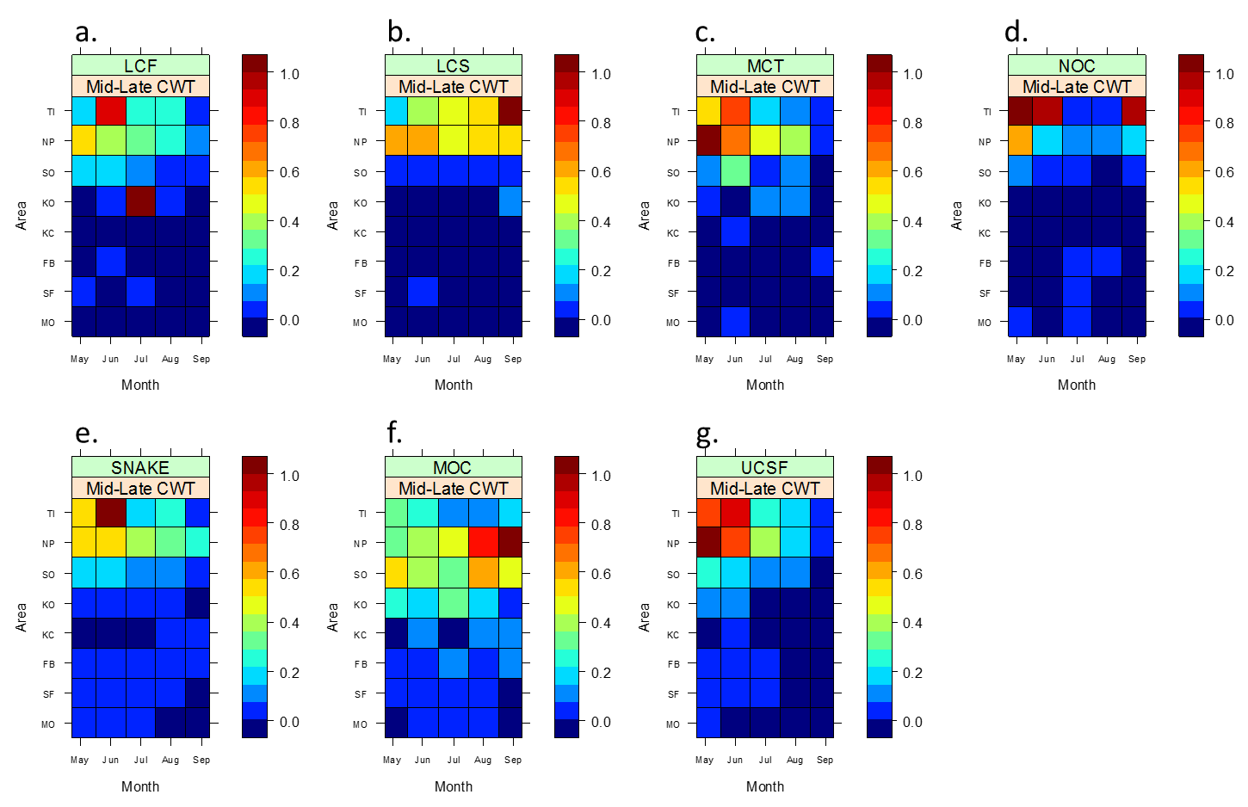
Figure 4. Tileplots illustrating the distribution of relative encounter rate for stocks exhibiting the “Oregon” distribution as estimated by the Mid-Late CWT aggregate (CWT data collected from 1987 – 2011). Seven stocks that exhibit the Oregon distribution can be plotted from the Mid-Late CWT aggregate: Lower Columbia Fall (LCF), Lower Columbia Spring (LCS), Mid-Columbia Tule (MCT), Northern Oregon Coastal (NOC), Snake River (S), Mid-Oregon Coastal (MOC), and Upper Columbia Summer/Fall (UCSF). ). The tile with a value of 1 represents the space-time stratum where the greatest estimated recovery or encounter rate occurred (indicated by deep red). White tiles indicate space-time strata where no fishing effort occurred. Area labels: TI – Tillamook, NP – Newport, CO – Central Oregon, KO – Klamath Oregon, KC – Klamath California, FB – Fort Bragg, SF – San Francisco, MO – Monterey.
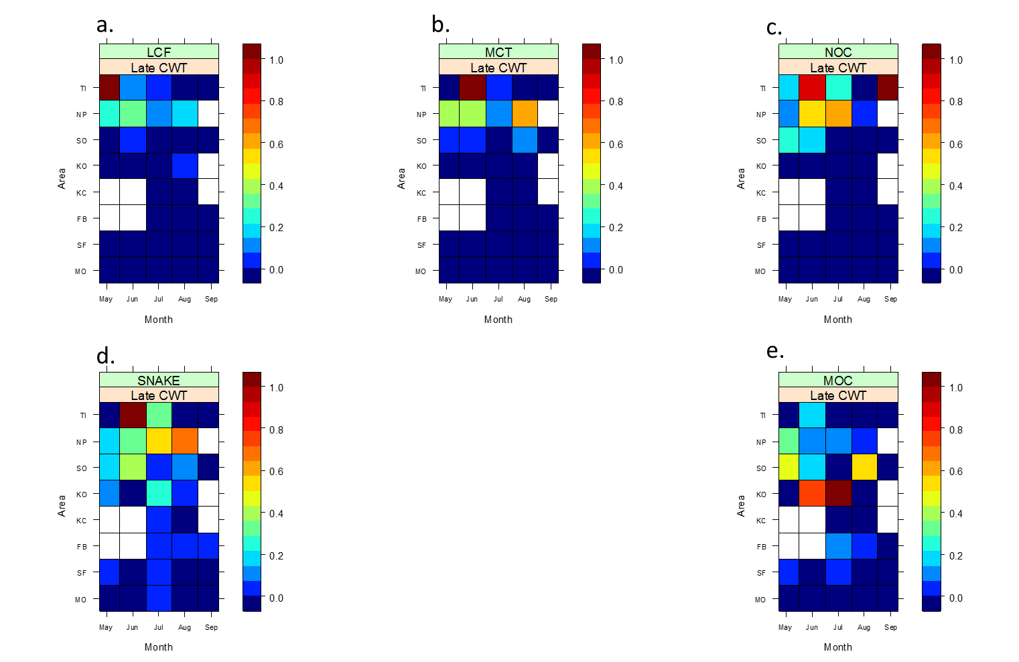
Figure 5. Tileplots illustrating the distribution of relative encounter rate for stocks exhibiting the “Oregon” distribution as estimated by the Late CWT aggregate (CWT data collected from 2010 – 2011). Five stocks that exhibit the Oregon distribution can be plotted from the Late CWT aggregate: Lower Columbia Fall (LCF), Mid-Columbia Tule (MCT), Northern Oregon Coastal (NOC), Snake River (S), and Mid-Oregon Coastal (MOC). The tile with a value of 1 represents the space-time stratum where the greatest estimated recovery or encounter rate occurred (indicated by deep red). White tiles indicate space-time strata where no fishing effort occurred. Area labels: TI – Tillamook, NP – Newport, CO – Central Oregon, KO – Klamath Oregon, KC – Klamath California, FB – Fort Bragg, SF – San Francisco, MO – Monterey.
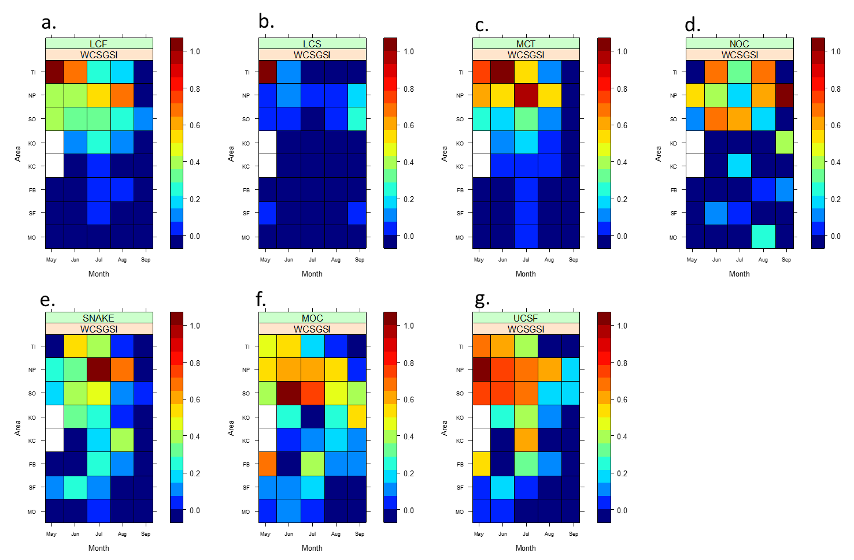
Figure 6. Tileplots illustrating the distribution of relative encounter rate for stocks exhibiting the “Oregon” distribution as estimated by the WCSGSI data aggregate (GSI data collected from 2010 – 2011). Seven stocks that exhibit the Oregon distribution can be plotted from the WCSGSI aggregate: Lower Columbia Fall (LCF), Lower Columbia Spring (LCS), Mid-Columbia Tule (MCT), Northern Oregon Coastal (NOC), Snake River (S), Mid-Oregon Coastal (MOC), and Upper Columbia Summer/Fall (UCSF). ). The tile with a value of 1 represents the space-time stratum where the greatest estimated encounter rate occurred (indicated by deep red). White tiles indicate space-time strata where no fishing effort occurred. Area labels: TI – Tillamook, NP – Newport, SO – Southern Oregon, KO – Klamath Oregon, KC – Klamath California, FB – Fort Bragg, SF – San Francisco, MO – Monterey.
The second pattern distribution pattern, Southern Oregon/Northern California, was exhibited by Rogue, Klamath, Northern California Southern Oregon Coastal and California Coastal stocks of Chinook salmon (Figures 14 - 17). Each series of plots calculated from CWT data (Figures 14 – 16) suggested that, while encountered coast-wide, these stocks were most commonly encountered from Southern Oregon to the Fort Bragg catch area. Conveying a slightly different distribution, tileplots based on WCSGSI relative abundance estimates (Fig. 16) suggested these four stocks were encountered primarily between Klamath Oregon and Fort Bragg, a narrower and more southerly distribution than what was suggested by our plots created from CWT data. Interestingly, WCSGSI tileplots also appeared to hint at a south to north shift in encounter rate as the season progressed from May through September.

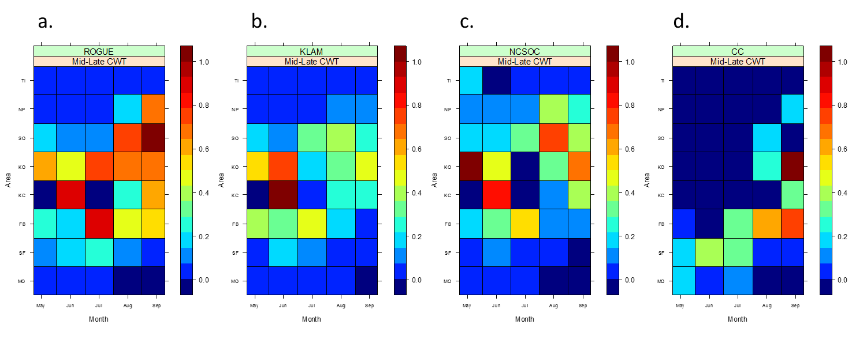
Figure 7. Tileplots illustrating the distribution of relative encounter rate for stocks exhibiting the Southern Oregon/Northern California distribution pattern as estimated by the Mid-Late CWT aggregate (CWT data collected from 1987 - 2011). Relative encounter rate for four stocks of Chinook salmon exhibiting the Southern Oregon/Northern California distribution pattern can be plotted from the Mid-Late CWT aggregate: Rogue River (R), Klamath River (K), Northern California/Southern Oregon Coastal (NCSOC), and California Coastal (CC). The tile with a value of 1 represents the space-time stratum where the greatest estimated recovery or encounter rate occurred (indicated by deep red). Area labels: TI – Tillamook, NP – Newport, CO – Central Oregon, KO – Klamath Oregon, KC – Klamath California, FB – Fort Bragg, SF – San Francisco, MO – Monterey.
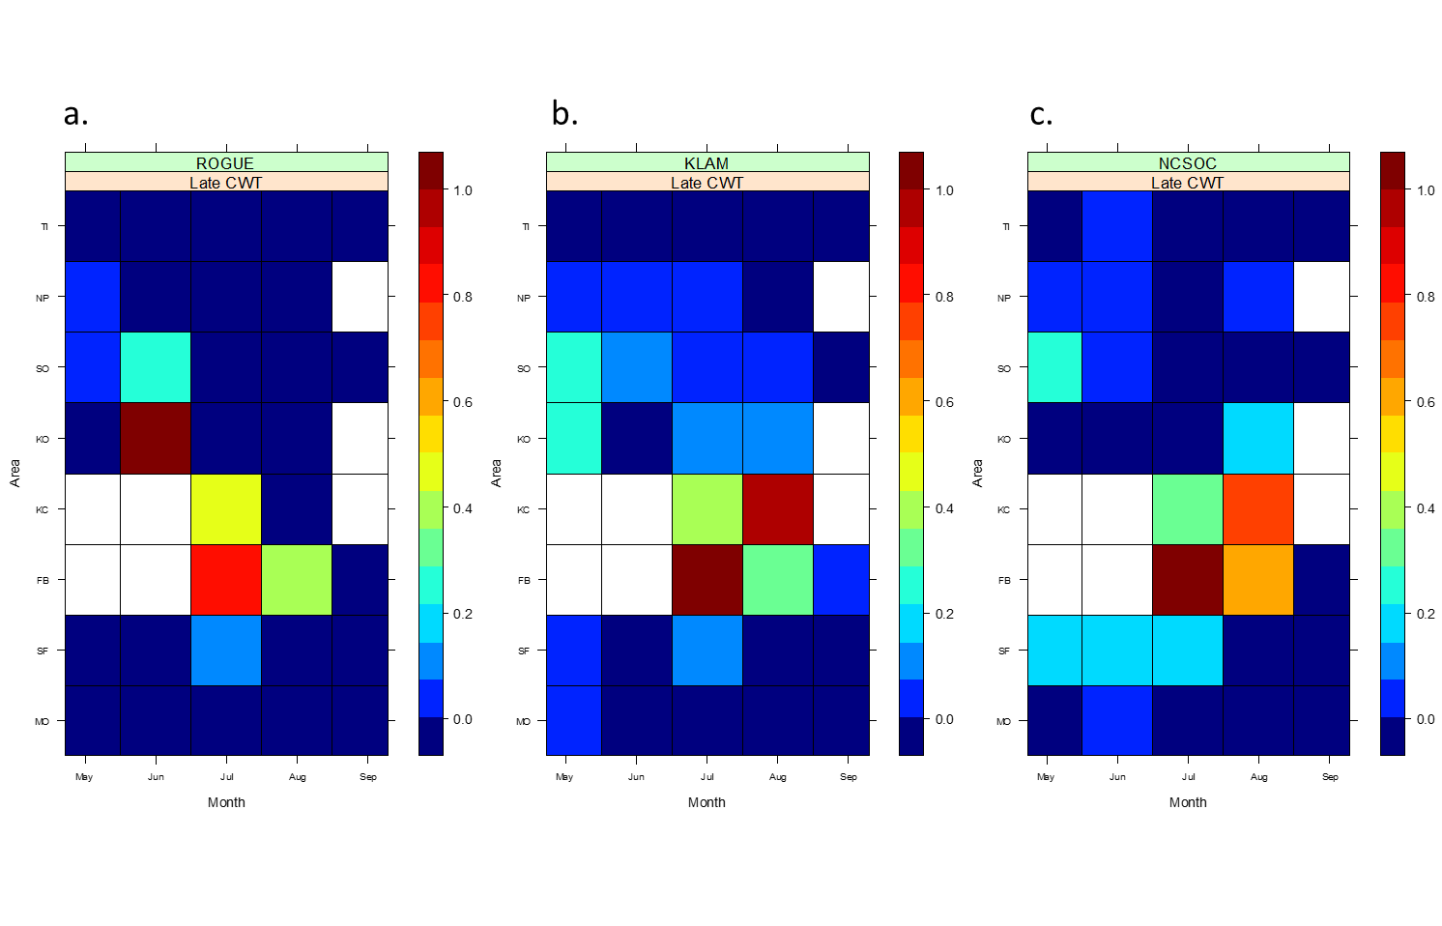
Figure 8. Tileplots illustrating the distribution of relative encounter rate for stocks exhibiting the Southern Oregon/Northern California distribution pattern as estimated by the Late CWT aggregate (CWT data collected from 2010 - 2011). Relative encounter rate for three stocks of Chinook salmon exhibiting the Southern Oregon/Northern California distribution pattern can be plotted from the Mid-Late CWT aggregate: Rogue River (R), Klamath River (K), and Northern California/Southern Oregon Coastal (NCSOC). The tile with a value of 1 represents the space-time stratum where the greatest estimated recovery rate occurred (indicated by deep red). White tiles indicate strata where no fishing effort was expended. Area labels: TI – Tillamook, NP – Newport, CO – Central Oregon, KO – Klamath Oregon, KC – Klamath California, FB – Fort Bragg, SF – San Francisco, MO – Monterey.
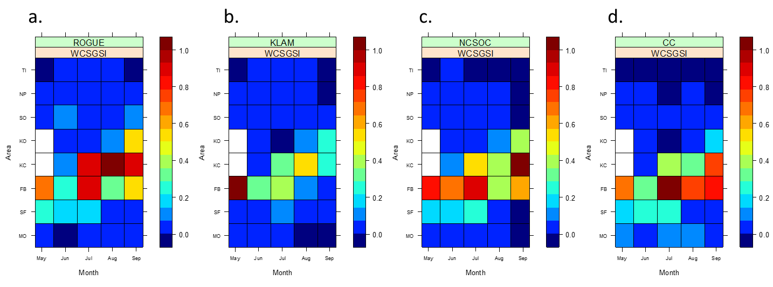
Figure 9. Tileplots illustrating the distribution of relative encounter rate for stocks exhibiting the Southern Oregon/Northern California distribution pattern as estimated by the WCSGSI aggregate (GSI data collected from 2010 - 2011). Relative encounter rate for four stocks of Chinook salmon exhibiting the Southern Oregon/Northern California distribution pattern can be plotted from the WCSGSI CWT aggregate: Rogue River (R), Klamath River (K), Northern California/Southern Oregon Coastal (NCSOC) and California Coastal (CC). The tile with a value of 1 represents the space-time stratum where the greatest estimated recovery rate occurred (indicated by deep red). White tiles indicate strata where no fishing effort was expended. Area labels: TI – Tillamook, NP – Newport, CO – Central Oregon, KO – Klamath Oregon, KC – Klamath California, FB – Fort Bragg, SF – San Francisco, MO – Monterey.
Chinook salmon from California’s Central Valley exhibited a unique catch distribution when compared to stocks belonging to the Oregon or S.OR/N.CA groups. Central Valley fall, and to a lesser degree Central Valley spring Chinook appeared to have two, possibly time-dependent, catch distribution patterns (Figures 18 & 19). Tileplots based on CWT recoveries from the mid-late period suggested Central Valley Fall were caught at relatively even rates off the shores of Oregon and California (Fig 18b). Conversely, early and late period CWT (Figs. 18a and 18c), as well as WCSGSI data (Fig. 18d), suggested that Central Valley Fall stock were encountered more frequently south of the Oregon-California border. The catch distribution of Central Valley Fall Chinook appeared to converge from the north and from the south to either San Francisco (as estimated by the WCSGSI aggregate) or Fort Bragg (as estimated by the CWT aggregates) as the season progressed.
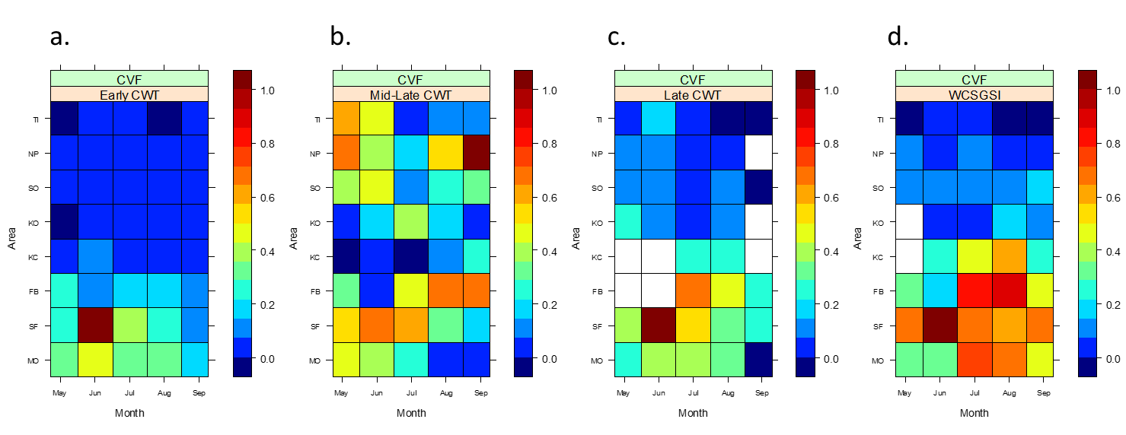
Figure 10. Tileplots illustrating the distribution of relative encounter rate for Central Valley Fall Chinook (CVF) as estimated by four different data aggregates (a. – Early: CWTs 1977 – 1983; b. – Mid-Late: CWTs 1987 – 2011; c. – Late: CWTs 2010 – 2011; d. – WCSGSI: GSI 2010 – 2011). The tile with a value of 1 represents the space-time stratum where the greatest estimated recovery rate occurred (indicated by deep red). White tiles indicate strata where no fishing effort was expended. Area labels: TI – Tillamook, NP – Newport, CO – Central Oregon, KO – Klamath Oregon, KC – Klamath California, FB – Fort Bragg, SF – San Francisco, MO – Monterey.
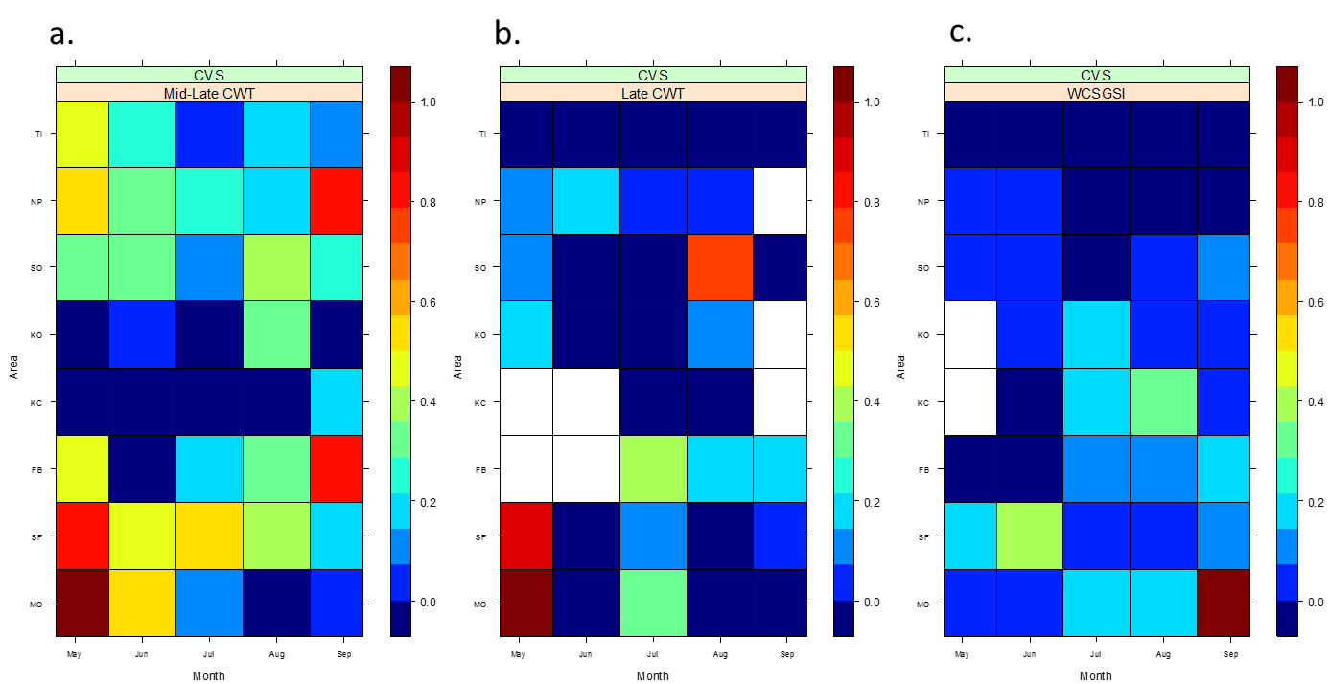
Figure 11. Tileplots illustrating the distribution of relative encounter rate for Central Valley Spring Chinook (CVS) as estimated by three different data aggregates (a. – Mid-Late: CWTs 1987 – 2011; c. – Late: CWTs 2010 – 2011; d. – WCSGSI: GSI 2010 – 2011). The tile with a value of 1 represents the space-time stratum where the greatest estimated recovery rate occurred (indicated by deep red). White tiles indicate strata where no fishing effort was expended. Area labels: TI – Tillamook, NP – Newport, CO – Central Oregon, KO – Klamath Oregon, KC – Klamath California, FB – Fort Bragg, SF – San Francisco, MO – Monterey.

Statistical analyses

Spearman’s Correlation
Spearman’s rho correlation coefficient was used to evaluate the relationship between CWT- and GSI-based estimates of stock-specific relative abundance across catch-area x month space-time strata (Table 4). With few exceptions, and regardless of the time period over which the CWT were aggregated, the results indicated a moderate to strong positive correlation between CWT- and WCSGSI-based estimates. This suggests our CWT- and GSI-based estimates of stock-specific relative abundance are more similar to one another than would be expected by chance.
Table 4. Spearman's rho correlations between CWT and WCSGSI based stock-specific encounter rate estimates. "CWT aggregate" indicates which CWT aggregate was used for comparison against the WCSGSI estimates. WCSGSI data were aggregated across 2010 - 2011. Bold text highlights insignificant correlations. Higher values of (r) denote stronger positive correlation between CWT and WCSGSI based encounter rate estimates.
Stock | CWT Aggregate | r statistic | pvalue
California Coastal | Early (1977 - 1983) | 0.46 | 0.001
Central Valley Fall | Early (1977 - 1983) | 0.76 | <0.001
Central Valley Fall | Mid-Late (1987 - 2011) | 0.16 | 0.15
Central Valley Fall | Late (2010 - 2011) | 0.8 | <0.001
Central Valley Spring | Mid-Late (1987 - 2011) | -0.14 | 0.81
Central Valley Spring | Late (2010 - 2011) | 0.07 | 0.33
Klamath | Early (1977 - 1983) | 0.6 | <0.001
Klamath | Mid-Late (1987 - 2011) | 0.72 | <0.001
Klamath | Late (2010 - 2011) | 0.67 | <0.001
Lower Columbia Fall | Early (1977 - 1983) | 0.64 | <0.001
Lower Columbia Fall | Mid-Late (1987 - 2011) | 0.8 | <0.001
Lower Columbia Fall | Late (2010 - 2011) | 0.72 | <0.001
Mid-Columbia Tule | Early (1977 - 1983) | 0.81 | <0.001
Mid-Columbia Tule | Mid-Late (1987 - 2011) | 0.71 | <0.001
Mid-Columbia Tule | Late (2010 - 2011) | 0.71 | <0.001
Mid-Oregon Coastal | Early (1977 - 1983) | 0.39 | 0.007
Mid-Oregon Coastal | Mid-Late (1987 - 2011) | 0.62 | <0.001
Mid-Oregon Coastal | Late (2010 - 2011) | 0.37 | 0.01
Northern California/Southern Oregon Coastal | Early (1977 - 1983) | 0.35 | 0.01
Northern California/Southern Oregon Coastal | Mid-Late (1987 - 2011) | 0.38 | 0.008
Northern California/Southern Oregon Coastal | Late (2010 - 2011) | 0.56 | <0.001
Northern Oregon Coastal | Mid-Late (1987 - 2011) | 0.51 | <0.001
Northern Oregon Coastal | Late (2010 - 2011) | 0.56 | <0.001
Rogue River | Early (1977 - 1983) | 0.63 | <0.001
Rogue River | Mid-Late (1987 - 2011) | 0.68 | <0.001
Rogue River | Late (2010 - 2011) | 0.47 | 0.003
Snake River | Mid-Late (1987 - 2011) | 0.58 | <0.001
Snake River | Late (2010 - 2011) | 0.61 | <0.001
Upper Columbia Summer/Fall | Mid-Late (1987 - 2011) | 0.65 | <0.001
Upper Columbia Summer/Fall | Late (2010 - 2011) | 0.58 | <0.001

There were three instances when CWT- and GSI- based relative abundance were not correlated to one another. Two such instances existed between CWT- and GSI-based estimates of the distribution of Central Valley Spring Chinook. CWT-based estimates of Central Valley Spring Chinook from both the middle and late periods had weak, and statistically insignificant correlation to the corresponding WCSGSI-based estimate (middle: r = - 0.14, p = 0.81; late: r = 0.07, p = 0.33). The other insignificant correlation existed between relative abundance estimates of Central Valley Fall chinook calculated from mid-late period CWT and WCSGSI data (r = 0.16, p = 0.15).

Mantel test
Mantel’s method was used to evaluate the correlation between pairs of distance matrices calculated from CWT and GSI based stock x area-month matrices of relative abundance (Table 5; see Figure 2 for example of matrix design). Because CWT and WCSGSI data provided information across different strata, which was observed in the tileplots discussed previously, the matrices varied in dimension depending on the time period over which CWT recoveries were aggregated. The historic period CWT aggregate allowed for comparison across the greatest number of stocks and strata (12 and 37, respectively) while the late period allowed for the least (11 and 31). Results of the Mantel’s test indicated that a moderate, positive, correlation existed between the historic CWT data and WCSGSI data (r = 0.71, p < 0.001) suggesting that those data aggregates are more similar to one another than would be expected by chance. Mantel’s test between distance matrices calculated from the late period CWT and WCSGSI data aggregates indicated that there was no correlation (r = 0.1, p = 0.44).
Table 5. Mantel test to evaluate the correlation between Sornesen distance matrices calculated from CWT- and WCSGSI-based estimates of stock specific relative abundance for Chinook salmon. “CWT aggregate” indicates which CWT aggregate was used to estimate the CWT-based stock-specific relative abundance. All WCSGSI data were aggregated over 2010 and 2011. The standardized Mantel statistic (r) is calculated as the Pearson coefficient between the two matrices where higher values denote greater similarity.
CWT aggregate | Stock x Strata | r statistic | p-value
Mid-Late (1987 - 2011) | 12 x 37 | 0.71 | < 0.001
Late (2010 - 2011) | 11 x 31 | 0.1 | 0.44

Non-metric multidimensional scaling (nMDS) ordination and MRPP
Variation between stock specific relative encounter rate estimates based on CWT and GSI data was explored with two multivariate statistical tools: nMDS ordination and MRPP (Figures 20 – 22). The results indicated that WCSGSI and CWT based stock-specific distribution patterns are similar at the catch-area x month space time scale. The nMDS ordinations of CWT and WCSGSI relative abundance estimates represented the data very well in 2 dimensions (final stress for each ordination <= 12). The ordinations tended to plot stocks in clusters that corresponded to the general distribution patterns detected in the stock-specific tileplots (Oregon, Southern Oregon/Northern California, and Central Valley patterns). Polygons were overlain upon the ordinations to define those clusters. The ordinations revealed that Central Valley stocks were not plotted within either the Oregon or Southern Oregon/Northern California clusters, suggesting that their distribution was different than the distribution of stocks belonging to either the Oregon or S.OR/N.CA groups. In general, stocks that exhibited the Oregon catch pattern were plotted further from one another than stocks that exhibited the S.OR/N.CA catch pattern suggesting greater variability between catch distributions of stocks from the Oregon group. CWT- and WCSGSI-based estimates of Central Valley Fall relative abundance were plotted closer to one another in the ordinations of CWT data pooled over the early (1977 – 1983) and late period than in the ordination of CWT data pooled over the mid-late period (1987 – 2011), reflecting patterns observed in our tileplots as well as our calculation of Spearman’s correlation.

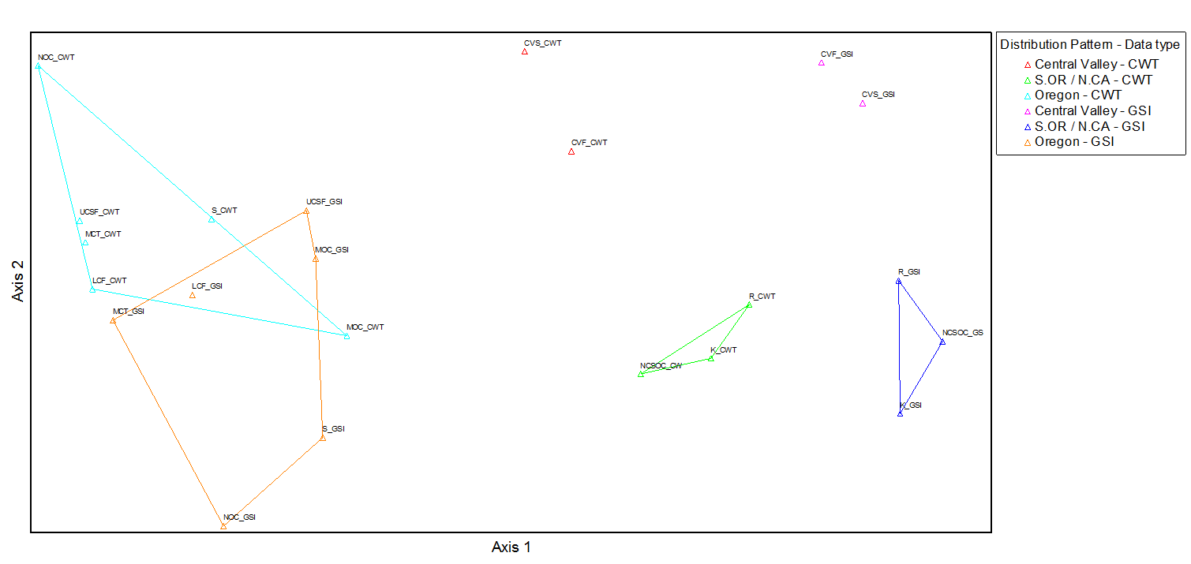
Figure 12. Non-metric multidimensional scaling ordination representing the Sorensen distance between stock specific relative abundance estimates of Chinook salmon calculated from the Mid-Late CWT (CWT data collected from 1987 – 2011) and WCSGSI (GSI data collected from 2010 – 2011) aggregates. Stocks: Central Valley Fall (CVF), Central Valley Spring (CVS) Klamath (K), Lower Columbia Fall (LCF), Mid-Oregon Coastal (MOC), Mid-Columbia Tule (MCT), North Oregon Coastal (NOC), Northern California/Southern Oregon Coastal (NCSOC), Rogue River (R), Snake River (S) and Upper Columbia Summer/Fall (UCSF).
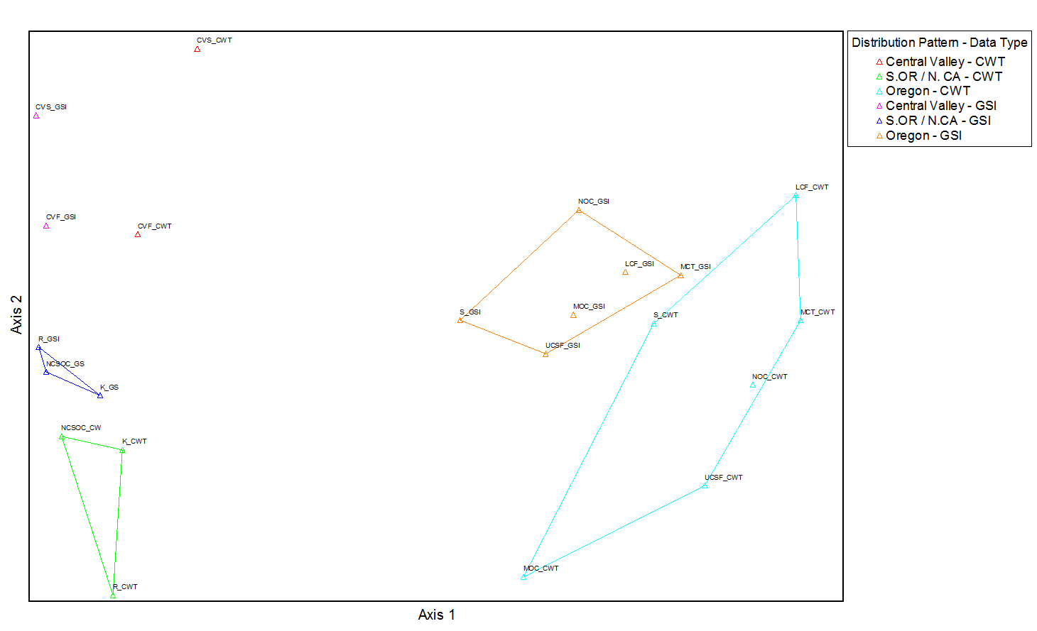
Figure 13. Non-metric multidimensional scaling ordination representing the Sorensen distance between stock specific relative abundance estimates of Chinook salmon calculated from the Late CWT (CWT data collected from 2010 – 2011) and WCSGSI (GSI data collected from 2010 – 2011) aggregates. Stocks: Central Valley Fall (CVF), Central Valley Spring (CVS) Klamath (K), Lower Columbia Fall (LCF), Mid-Oregon Coastal (MOC), Mid-Columbia Tule (MCT), North Oregon Coastal (NOC), Northern California/Southern Oregon Coastal (NCSOC), Rogue River (R), Snake River (S) and Upper Columbia Summer/Fall (UCSF).
MRPP was utilized to test the hypothesis of no difference in average within-cluster ranked distances between the clusters of stock-data objects observed in the ordinations above (Table 6). In essence, MRPP was utilized to evaluate if the stock data objects were more similar to other objects in their cluster than would be expected by chance (i.e. is the distribution of Rogue as estimated by WCSGSI more similar to the distribution of Klamath River and Southern Oregon/Northern California Coastal stock than would be expected by chance?). Regardless of whether CWT or WCSGSI data were used to estimate relative abundance, results of MRPP suggested that the distribution of stocks belonging to the S.OR/N.CA group (these stocks were distributed primarily within and between the Southern Oregon and Fort Bragg areas) were significantly different than the distribution of stocks belonging to the Oregon group (stocks distributed primarily north of the OR/CA border). In our nMDS ordinations the polygons outlining CWT and WCSGSI estimates of the Oregon group overlapped, which may suggest there is no difference between those two groups. MRPP indicated that the average within-group ranked distance for the Oregon groups was significantly different only between estimates calculated from the late CWT and WCSGSI aggregates (Table 6; A = 0.18, p = 0.004). Additionally, MRPP indicated that WCSGSI and CWT (early and mid-late aggregates, but not the late aggregate) estimates for the S.OR/N.CA group were significantly different.
Table 6. Results of Multi-Response Permutation Procedure utilized to test the hypothesis of no difference between groups of CWT- and GSI-based stock specific encounter rate estimates. The groups being compared were comprised either of stocks exhibiting the “Oregon” distribution pattern (encountered primarily off the Oregon coast) or of stocks exhibiting the “Southern Oregon/Northern California” distribution pattern (encountered primarily between Central Oregon and Fort Bragg).
CWT Aggregate | Group comparison | Data comparison | Effect size (A) | p-value
Mid-Late  (1987 - 2011) | Oregon - S.OR/N.CA | CWT vs CWT | 0.42 | 0.008
Mid-Late  (1987 - 2011) | Oregon - S.OR/N.CA | GSI vs GSI | 0.45 | 0.004
Mid-Late  (1987 - 2011) | Oregon - Oregon | CWT vs GSI | 0.09 | 0.12
Mid-Late  (1987 - 2011) | S.OR/N.CA - S.OR/N.CA | CWT vs GSI | 0.42 | 0.008
Late  (2010 - 2011) | Oregon - S.OR/N.CA | CWT vs CWT | 0.41 | 0.008
Late  (2010 - 2011) | Oregon - S.OR/N.CA | GSI vs GSI | 0.42 | 0.004
Late  (2010 - 2011) | Oregon - Oregon | CWT vs GSI | 0.18 | 0.004
Late  (2010 - 2011) | S.OR/N.CA - S.OR/N.CA | CWT vs GSI | 0.11 | 0.44

Discussion
Growing concern surrounding the quality and limitations of CWT data has spurred interest in technologies that can improve stock specific information for Chinook salmon. GSI is one of the rapidly growing technologies with significant potential for generating information that could be used in addition to the CWT data system to improve salmon management. In this research we explored, compared, and contrasted the capabilities of CWT and GSI data to identify fine-scale, stock-specific, distribution patterns of Chinook salmon off the coasts of Oregon and California. We described the marine distribution of the Chinook salmon stocks most commonly encountered in Oregon’s and California's commercial troll fisheries and evaluated the similarity between CWT- and GSI-based estimates of those distributions. Most importantly, we demonstrated how GSI data can provide insight into stock specific distribution patterns at space-time resolutions that cannot be achieved with traditionally reported CWT data.
This study is the first regional-scale comparison of the capability of CWT and GSI data to identify stock-specific salmon distributions and we expect that the information herein will contribute to better informed fishery management in several ways. While management agencies are aware of the general distributions of Chinook stocks commonly encountered in Oregon and California’s fisheries, those distributions have yet to be thoroughly described in the scientific literature at the level of detail found herein. Perhaps more importantly, previous descriptions of Chinook distribution patterns have been estimated from CWT recoveries. Due to the concern surrounding the CWT system and the inferences drawn from analysis of CWT data, and because the Pacific Salmon Commission’s Expert Panel identified GSI as a technology that could potentially replace the CWT system, it is beneficial to compare how CWT and GSI data differ in their ability to provide information on where and when stocks of Chinook are encountered in the study area. Additionally, because we examine the similarity between CWT- and GSI- based distribution estimates, this study will provide a rough evaluation of the key assumption that CWT’d fish behave similarly to the untagged fish they are intended to represent. Finally, we demonstrate the capacity of GSI data to identify distributions of specific stocks of salmon at space-time scales that the current CWT system is unable to investigate, suggesting that GSI can contribute to an improved management of our ocean Chinook salmon fisheries.

Coded-wire tags versus Genetic Stock Identification
The key focus of our study was to compare and contrast the capabilities of CWT and GSI technologies for detecting stock specific distribution patterns of Chinook salmon. To our knowledge, this was the first large scale study to explicitly compare the capability of these technologies to estimate adult Chinook ocean distributions. Because CWT data are the most widely used means for determining where and when salmon are encountered in the ocean we expected CWT and GSI data to provide similar distribution estimates at the relatively coarse area x month space-time scale. Generally, our results indicated that CWT- and GSI-based distribution patterns at the area x month space-time scale are moderately to strongly correlated. If we make the assumption that GSI data are representative of untagged stocks, then this finding lends support to the critical assumption that CWT’d fish are distributed similarly to the untagged fish they are intended to represent.
We demonstrated that two years of GSI data can provide much more information pertaining to Chinook salmon distributions than two years of CWT data. From 2010 – 2011 the WCSGSI was able to gather a sufficient quantity of quality data to estimate Chinook distributions for a greater number of stocks, and across a broader spatial-temporal extent, than was possible with CWTs recovered during the same time period. Furthermore, those GSI data appeared to reveal in-season migration patterns of a number of Chinook stocks whereas no clear patterns were apparent using CWT-based estimates (regardless of the number of years CWT recoveries were aggregated). This results suggests that GSI data are a more powerful tool for detecting variance in salmon distributions over short time scales. For instance, our GSI-based distribution estimates of Rogue River, Klamath River and Northern California/Southern Oregon coastal Chinook salmon indicated that the highest encounter rates shifted north as the season progressed. Analysis of GSI data also indicated that Mid-Oregon coastal Chinook appeared to be widely distributed in areas off both Oregon and California early in the season but became concentrated in the Southern Oregon and Klamath Oregon areas late in the season. While these results are consistent with how salmon are managed, this is the first time these patterns have been empirically demonstrated, and they were detected using only two years of GSI data.

CWT-based results compared to previous studies
We expected that the CWT database would allow us to describe broad-scale distribution patterns of Chinook salmon, an expectation founded on earlier works that applied CWT data to gain insights into the ocean ecology of Pacific salmon. For example, Nicolas and Hankin (1988) analyzed CWT recoveries of Chinook salmon originating from Oregon’s coastal streams. Their results suggested that Oregon’s coastal Chinook salmon exhibit three basic, broad-scale, marine distribution patterns: Chinook from the Elk River and north were distributed from Oregon through Alaska; stocks from the Rogue River and south were distributed off southern Oregon and northern California; and, Chinook from the Umpqua River were distributed both to the north and south. In a more recent study, Weitkamp (2010) utilized CWT data to examine the marine distribution patterns of 77 hatchery and 16 wild populations of Chinook salmon recovered in coastal waters from southern California to the Bering Sea. The results indicated that three broad-scale distribution patterns existed: (1) Chinook from Alaskan hatcheries were largely recovered in Alaska; (2) salmon from hatcheries in northern British Columbia to the Oregon coast were widely dispersed and recovered from the area where their natal stream enters the ocean north to Southeast Alaska; and (3) salmon originating from hatcheries in southern Oregon and California were rarely recovered north of the Columbia River. Furthermore, Weitkamp noted the presence of finer-scale distribution patterns within the three broad-scale distributions. Of interest to this study, Weitkamp’s results suggested that salmon from the Oregon coast, southern Oregon-northern California, and the Central California Valley all had unique distribution patterns. It came as no surprised that we were able to utilize CWT data to illustrate distribution patterns of Chinook salmon, however, because the methods we used were dissimilar from Weitkamp, it was not expected that our results would so closely parallel those described in previous studies.
Our methods differed from those used by either Nicolas and Hankin (1988) or Weitkamp (2010), specifically in the years our CWT data were collected and in our incorporation of fishing effort. We aggregated Chinook salmon populations originating from Oregon’s coastal streams into three groups: Northern Oregon Coastal, Mid-Oregon Coastal and Northern California/Southern Oregon Coastal. Our Northern Oregon Coastal group was comprised entirely of stocks originating from north of, but not including, the Elk River (see Table 1) and our results indicated that those salmon were recovered primarily in the northern most extent of our study area (Tillamook and Newport catch areas). The Mid-Oregon Coastal group consisted of seven salmon stocks and included salmon originating both to the north and south of the Elk River. The Mid-Oregon Coastal group included salmon from the Elk and Umpqua Rivers. Our results indicated that tagged Mid-Oregon coastal salmon were recovered predominately off of Oregon’s coast and to a lesser extent in recovery areas off of northern California. This result is consistent with findings by Nicolas and Hankin (1988) who reported that Umpqua River salmon were recovered in Californian waters, and Weitkamp (2010) who found that Elk River salmon have a more southerly distribution than other stocks originating from the Oregon coast. Finally, our results indicated that Oregon salmon originating from the Rogue River and south were recovered in the ocean off southern Oregon and northern California which mirrored results found in both Nicolas and Hankin (1988) and Weitkamp (2010).
Previous studies demonstrated that CWT data could be employed to examine Chinook salmon distributions at the management area level spatial scale but it was uncertain how well CWT data could be used to estimate salmon distributions at refined temporal scales. There was no evidence in the scientific literature of studies that used CWT data to illustrate how Chinook salmon distribution patterns vary during the commercial fishing season. We were able to utilize CWT data to estimate salmon distributions across months but to do so required a large number of tag recoveries, which limited the number of stocks we could examine to those with a history of tagging and necessitated aggregating CWT recoveries across many years. Furthermore, it was unclear what additional insight was gained by plotting our CWT-based monthly distribution estimates because there were very few instances where there appeared to be a pattern unique to the finer-scale. The exception were plots of Rogue River, Klamath River and Northern California/Southern Oregon coastal stocks of Chinook salmon based on CWT data from the “Early” period which suggested that those fish undertake a south – north migration during the commercial fishing season. Overall, the general patterns we described corresponded closely with the prior studies.

GSI-based results compared to previous studies
The results of this study support previous work conducted by other collaborators in the WCSGSI project. Ireland (2010), utilized GSI data collected during 2007 to examine fine-scale stock-specific Chinook salmon distributions off the Oregon coast. Ireland broke the Oregon coast into 0.25 degree latitudinal bins, a much finer spatial scale than was chosen in the present study, and calculated stock specific relative catch per unit effort for each bin. Ireland’s results indicated that three broad distribution patterns existed off the Oregon coast: those encountered primarily off the northern coast (Lower Columbia Fall, Northern Oregon Coastal, Mid-Columbia Tule and Southern Puget Sound stocks), those encountered primarily off the southern coast (California Coastal, Northern California/Southern Oregon Coastal, Klamath River and Rogue River stocks), and those encountered coastwide (Central Valley Fall, Deschutes Fall, Upper Columbia Summer/Fall, Central Valley Spring and Mid-Oregon Coastal). While our study encompassed a broader spatial scope (addressing distributions along Oregon and California), utilized a coarser spatial scale (catch areas vs. 0.25 degree bins), and analyzed data collected from a different point in time, our results mirrored the findings of Ireland (2010).
More recently, Satterthwaite et al. (2014), utilized the same WCSGSI data collected during 2010 and 2011 to compare the marine spatial distribution of an untagged stock and its indicator: California Coastal and Klamath River Chinook, respectively. Satterthwaite et al. reported that the two stocks shared similar distributions early in 2010 but by August the highest CPUE for Klamath River Chinook occurred in the Klamath California area whereas highest CPUE for California Coastal Chinook occurred to the south in the Fort Bragg area. Similarly, in 2011 Satterthwaite et al. found that by August CPUE for Klamath River Chinook was again highest in the Klamath California area and CPUE for California Coastal Chinook was highest in the Fort Bragg area. They suggest that there was a northward shift in CPUE of Klamath Chinook as the season progressed. Although we used different methods, our distribution estimates for Klamath River and California Coastal Chinook salmon are nearly identical to those reported in Satterthwaite et al. (2014).

Potential management implications
The primary goal of fisheries management is to prevent overfishing while achieving, on a continuing basis, the optimum yield from the fishery. Optimum yield is defined as “the amount of fish that provides the greatest overall benefit to the Nation, particularly with respect to food production and recreational opportunities, while taking into account protection of marine ecosystems” (Pacific Fishery Management Council (PFMC), 2014). Commercial salmon fisheries off the coasts of Oregon and California are under the jurisdiction of the Pacific Fisheries Management Council (Council). On an annual basis the Council recommends management measures designed to achieve the stock conservation objectives for each stock or stock complex while simultaneously seeking to achieve their harvest and allocation objectives. The total catch and mortality that results from recommendations made by the Council represents the optimum yield for the salmon fishery.
GSI data have potential to improve salmon management by providing more precise salmon distributions, resulting in higher yield of targeted stocks. Since the 1970s, information from CWT recoveries has helped structure management plans that result in the optimum yield of Chinook salmon stocks and stock complexes. Historically, those management plans have featured large-scale space and time closures that were implemented to help meet conservation goals for salmon stocks. There is no doubt that large-scale space-time closures are an effective means for restricting access to stocks that have failed to meet, or are projected to fall short of, their conservation goals. However, healthy stocks often times intermingle amongst the weak or rebuilding stocks those large-scale closures are designed to protect, resulting in fisheries that fall short of their potential. We illustrated how GSI provides information pertaining to the distributions of specific stocks and stock complexes of Chinook salmon at space-time scales that cannot be achieved with traditionally reported CWT data. Access to those GSI-based high resolution distribution estimates may allow managers to structure space-time closures more precisely, providing better opportunities to access target stocks while simultaneously avoiding harvest of those stocks that are susceptible to overfishing, are overfished, or are projected to fall short of their conservation goals. A more precisely structured fishery may allow for larger harvests to represent the optimum yield.
Access to GSI data in “real-time” could enhance our ability to harvest target stocks by guiding in-season management decisions. A previous study conducted by the WCSGSI collaboration demonstrated that GSI data can be processed and mapped in 24 – 48 hours, providing detailed, stock-specific, Chinook salmon distributions in near “real-time” (Bellinger and Banks, 2008). In contrast, CWT data often take up to a year or longer to process. Access to high resolution, real-time, information could pave the way for dynamic fisheries that could be augmented in-season to focus harvest on specific stocks and avoid those that have potential to constrain the fishery. For instance, during 2010 there were no fall commercial (September – December) fisheries in waters south of Cape Falcon due to concern over the status of Central Valley Fall Chinook and because Klamath River Fall Chinook were in a rebuilding plan which required restricting fall fishing opportunities (Pacific Fishery Management Council (PFMC), 2011). With access to salmon distributions in real-time managers would have been aware that the encounter rate of Central Valley Fall Chinook was relatively low for entire season in waters off the Oregon coast. Our refined GSI-based Chinook salmon distribution estimates indicated that during September of 2010 Central Valley Fall Chinook were concentrated south of the Fort Bragg North area and Klamath River Chinook were concentrated north of the Klamath California South area. Access to those distribution estimates in real-time may have potentially allowed managers to implement terminal area fisheries designed to target the healthy Oregon Coastal Chinook stocks while avoiding Central Valley Fall and Klamath River stocks. As an added benefit, fish caught later in the season should theoretically be larger, therefore providing greater value to the industry. Finally, real-time salmon distribution estimates could potentially benefit other sectors of the fishing industry by providing them with the means to alter their fishing behavior so as to reduce bycatch of specific salmon stocks. GSI in real-time has the potential to provide benefits to all sectors of the commercial fishing industry.
In contrast to GSI data, CWTs provide the accurate age data which are required for cohort analysis and the models used to help develop and assess the efficacy of fishery regulations. While age data can be obtained via scale analysis, one of the biggest concerns about shifting to GSI for fisheries management has been the lack of reliable age data. A solution to that problem may be the implementation of full parentage genotyping (FPG, also referred to as parentage-based tagging), a genetics-based method that provides both stock of origin and the cohort of the recovered fish (Anderson and Garza, 2005). FPG utilizes a “parent database” which contains the genotypes of all the parents that were used to create a hatchery cohort. This means that under a FPG based system 100 percent of fish originating from a FPG hatchery would be “tagged.” When a fish is harvested it can then be compared to the parent database to determine its exact parents and therefore its origin and age, all the information required to perform cohort analyses. Additionally, FPG can be used in conjunction with GSI to cover both FPG populations as well as naturally producing and non-FPG populations (Anderson and Garza, 2005). Such a system would be able to provide stock of origin for all fish sampled, marked or unmarked, as well as cohort of origin for fish from FPG hatcheries.
GSI has the potential to advance salmon management. Access to more precise salmon distributions could allow us to design more effective management regulations. Knowledge of how salmon distributions vary in real-time would further improve our ability to harvest target stocks, increasing yield from the fishery which would provide greater socio-economic benefits to coastal communities. GSI in conjunction with FPG would provide all the data necessary for cohort analysis allowing current day cohort-based management regimes to no longer rely upon the CWT.

Bibliography
Anderson, E.C., Garza, J.C., 2005. A description of full parental genotyping. Rep. Submitt. Pac. Salmon Comm.
Bellinger, M.R., Banks, M.A., 2008. Section 2, Genetics. In, Oregon Salmon Commission. 2008. Project CROOS Collaborative Research on Oregon Ocean Salmon, 2007. Final Report to the Oregon Watershed Enhancement Board, 214 p.
Bellinger, M.R., Banks, M.A., Bates, S.J., Crandall, E.D., Garza, J.C., Sylvia, G., Lawson, P.W., 2015. Geo-referenced, abundance calibrated ocean distribution of Chinook salmon (Oncorhynchus tshawytscha) stocks across the west coast of North America. PloS One 10, e0131276.
Candy, J.R., Beacham, T.D., 2000. Patterns of homing and straying in southern British Columbia coded-wire tagged chinook salmon (Oncorhynchus tshawytscha) populations. Fish. Res. 47, 41–56.
Chinook Technical Committee, 1988. Exploitation Rate Analysis: A report of the Analytical Work Group of the Chinook Technical Committee (No. 88-2).
Fisher, J.P., Weitkamp, L.A., Teel, D.J., Hinton, S.A., Orsi, J.A., Farley Jr, E.V., Morris, J.F.T., Thiess, M.E., Sweeting, R.M., Trudel, M., 2014. Early ocean dispersal patterns of Columbia River Chinook and coho salmon. Trans. Am. Fish. Soc. 143, 252–272.
Groot, C., Margolis, L., 1991. Pacific salmon life histories. UBC press.
Holt, K.R., Cox, S.P., Sawada, J., 2009. In-Season Forecasting of Coho Salmon Marine Survival via Coded Wire Tag Recoveries. North Am. J. Fish. Manag. 29, 1165–1182.
Ireland, R.R.C., 2010. The distribution and aggregation of Chinook salmon stocks on the Oregon Shelf as indicated by the commercial catch and genetics.
Jefferts, K.B., Bergman, P.K., Fiscus, H.F., 1963. A coded wire identification system for macro-organisms. Washington State Department of Fisheries.
Johnson, J.K., Parker, N.C., 1990. Regional overview of coded wire tagging of anadromous salmon and steelhead in northwest America, in: Am. Fish. Soc. Symp. pp. 782–816.
Legendre, P., Legendre, L.F., 2012. Numerical ecology. Elsevier.
McCune, B., Grace, J.B., Urban, D.L., 2002. Analysis of ecological communities. MjM software design Gleneden Beach, OR.
McCune, B., Mefford, M.J., 1999. PC-ORD: multivariate analysis of ecological data; Version 4 for Windows;[User’s Guide]. MjM software design.
Model Evaluation Workgroup (MEW), 2008. Chinook Fisheries Regulation Assessment Model (FRAM) Base Data Development v. 3.0 (Auxiliary Report to FRAM Technical Documentation for Coho and Chinook).
Morris, J.F., Trudel, M., Thiess, M.E., Sweeting, R.M., Fisher, J., Hinton, S.A., Fergusson, E.A., Orsi, J.A., Farley, E.V., Welch, D.W., 2007. Stock-specific migrations of juvenile coho salmon derived from coded-wire tag recoveries on the continental shelf of Western North America, in: American Fisheries Society Symposium. American Fisheries Society, p. 81.
Nandor, G.F., Longwill, J.R., Webb, D.L., 2010. Overview of the coded wire tag program in the greater Pacific region of North America. PNAMP Spec. Publ. Tagging Telem. Marking Meas. Monit. Fish Popul. Compend. New Recent Sci. Use Informing Tech. Decis. Modalities Pac. Northwest Aquat. Monit. Partnersh. Spec. Publ. 2, 5–46.
Nicholas, J.W., Hankin, D.G., 1988. Chinook Salmon Poputlations in Oregon Coastal River Basins: Description of Life Histories and Assessment of Recent Trends in Run Strengths (No. 88-1). Oregon Department of Fish and Wildlife.
Norris, J.G., Hyun, S.-Y., Anderson, J.J., 2000. The ocean distribution of the Columbia River upriver bright fall chinook salmon stocks. North Pac. Anadromous Fish Comm. Bull. 2, 221–232.
Pacific Fishery Management Council (PFMC), 2014. Pacific Coast Salmon Fishery Management Plan for Commercial and Recreationl Salmon Fisheries off the Coasts of Washington, Oregon, and California as Ameneded through Amendment 18.
Pacific Fishery Management Council (PFMC), 2011. Review of 2010 Ocean Salmon Fisheries.
Pacific Salmon Commission, 2005. Expert Panel on the Future of the Coded Wire Tag Program for Pacific Salmon. (Tech. No. 18).
Parken, C.K., Candy, J.R., Irvine, J.R., Beacham, T.D., 2008. Genetic and Coded Wire Tag Results Combine to Allow More-Precise Management of a Complex Chinook Salmon Aggregate. North Am. J. Fish. Manag. 28, 328–340. doi:10.1577/M06-110.1
Pearcy, W.G., 1992. Ocean ecology of North Pacific salmonids. Books Recruit. Fish. Oceanogr. USA.
Pearcy, W.G., McKinnell, S.M., 2007. The ocean ecology of salmon in the Northeast Pacific Ocean: an abridged history.
Quinn, T.P., Fresh, K., 1984. Homing and straying in chinook salmon (Oncorhynchus tshawytscha) from Cowlitz River Hatchery, Washington. Can. J. Fish. Aquat. Sci. 41, 1078–1082.
Satterthwaite, W.H., Mohr, M.S., O’Farrell, M.R., Anderson, E.C., Banks, M.A., Bates, S.J., Bellinger, M.R., Borgerson, L.A., Crandall, E.D., Garza, J.C., Kormos, B.J., Lawson, P.W., Palmer-Zwahlen, M.L., 2014. Use of Genetic Stock Identification Data for Comparison of the Ocean Spatial Distribution, Size at Age, and Fishery Exposure of an Untagged Stock and Its Indicator: California Coastal versus Klamath River Chinook Salmon. Trans. Am. Fish. Soc. 143, 117–133. doi:10.1080/00028487.2013.837096
Seeb, L.W., Antonovich, A., Banks, M.A., Beacham, T.D., Bellinger, M.R., Blankenship, S.M., Campbell, M.R., Decovich, N.A., Garza, J.C., Guthrie, I.I.I., others, 2007. Development of a standardized DNA database for Chinook salmon. Fisheries 32, 540–552.
Shaklee, J.B., Beacham, T.D., Seeb, L., White, B.A., 1999. Managing fisheries using genetic data: case studies from four species of Pacific salmon. Fish. Res. 43, 45–78. doi:16/S0165-7836(99)00066-1
Trudel, M., Fisher, J., Orsi, J.A., Morris, J.F.T., Thiess, M.E., Sweeting, R.M., Hinton, S., Fergusson, E.A., Welch, D.W., 2009. Distribution and Migration of Juvenile Chinook Salmon Derived from Coded Wire Tag Recoveries along the Continental Shelf of Western North America. Trans. Am. Fish. Soc. 138, 1369–1391. doi:10.1577/T08-181.1
Tucker, S., Trudel, M., Welch, D.W., Candy, J.R., Morris, J.F.T., Thiess, M.E., Wallace, C., Beacham, T.D., 2011. Life history and seasonal stock-specific ocean migration of juvenile Chinook salmon. Trans. Am. Fish. Soc. 140, 1101–1119.
Van Doornik, D.M., Teel, D.J., Kuligowski, D.R., Morgan, C.A., Casillas, E., 2007. Genetic analyses provide insight into the early ocean stock distribution and survival of juvenile coho salmon off the coasts of Washington and Oregon. North Am. J. Fish. Manag. 27, 220–237.
Weitkamp, L.A., 2010. Marine Distributions of Chinook Salmon from the West Coast of North America Determined by Coded Wire Tag Recoveries. Trans. Am. Fish. Soc. 139, 147–170. doi:10.1577/T08-225.1
Weitkamp, L., Neely, K., 2002. Coho salmon (Oncorhynchus kisutch) ocean migration patterns: insight from marine coded-wire tag recoveries. Can. J. Fish. Aquat. Sci. 59, 1100–1115. doi:10.1139/f02-075

