This project requires you to have FPS Animation Baker and Low Poly Shooter Pack to work correctly with.

LPSP Animations Explain
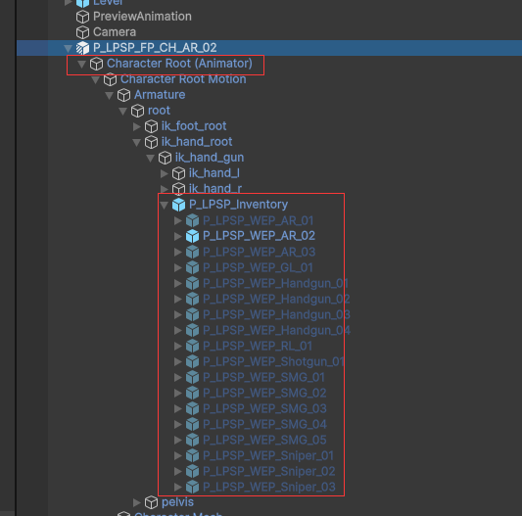
LPSP Prefabs have a character with Animator under the root.
It also contains a inventory GameObject under the ik_hand_root, all weapons are under the inventory GameObject. Each weapon has an Animator on it.

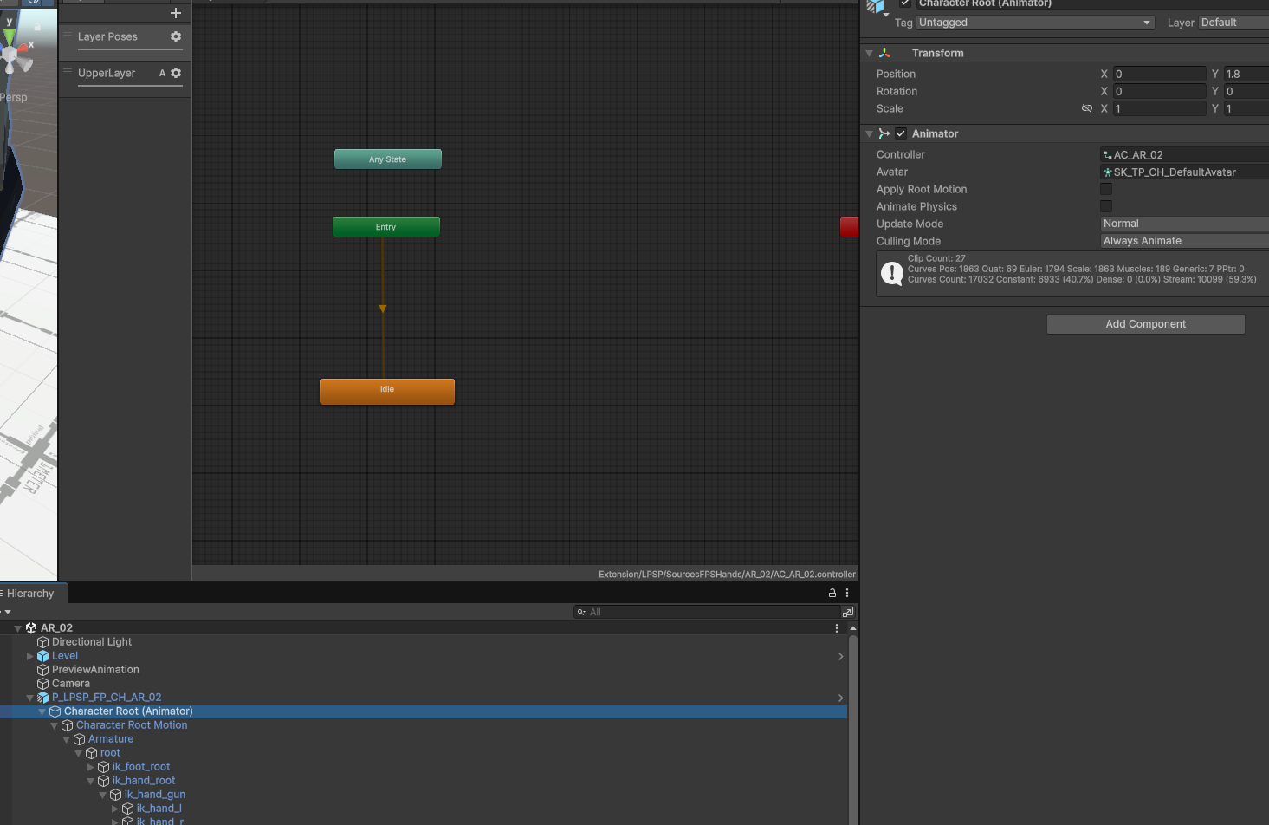
Let’s see the AnimatorController on the character animator.
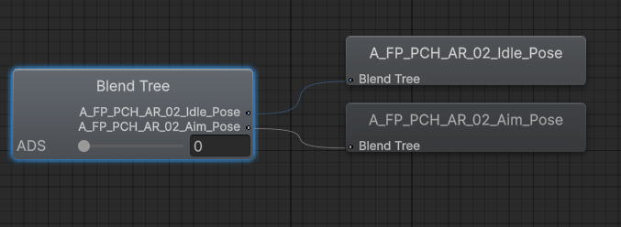
It has 2 layers, the base layer contains a blendshape of Idle Pose and Aim Idle Pose of the FPS character. The parameter is ADS (Aim Down Sight) to interpolate between Idle and Aim Idle.

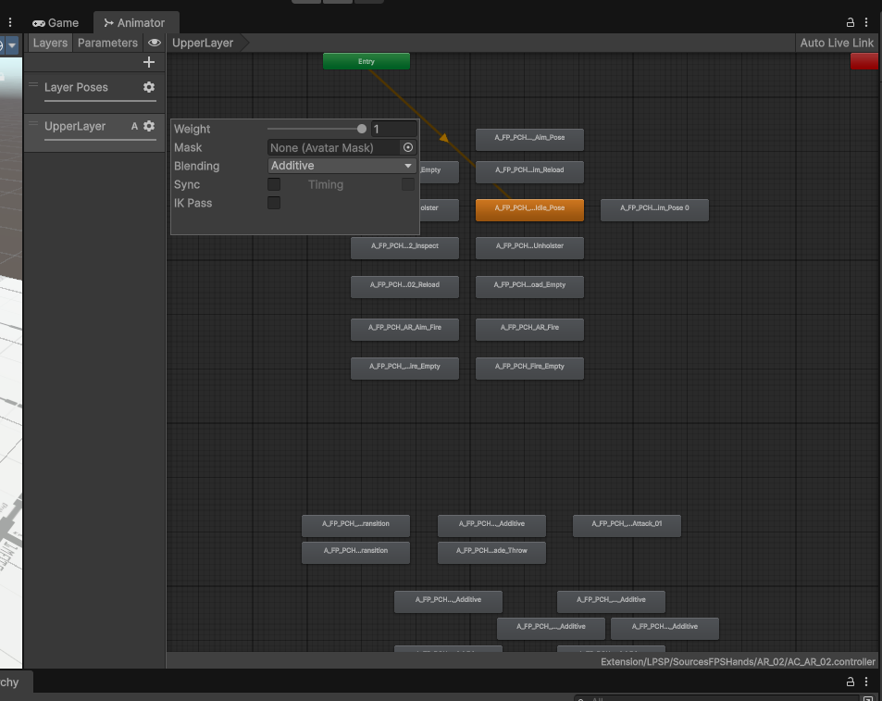
The upper layer contains all action animations. And it uses Additive to blend over the base layer.

In most cases, the upper layer animations will play when base layer is in normal idle (ADS 0). For example like Reload, Fire animations.

Upper layer also contains animations names like Aim_XXX, these animations are for base layer in aim idle (ADS 1) for correct results.

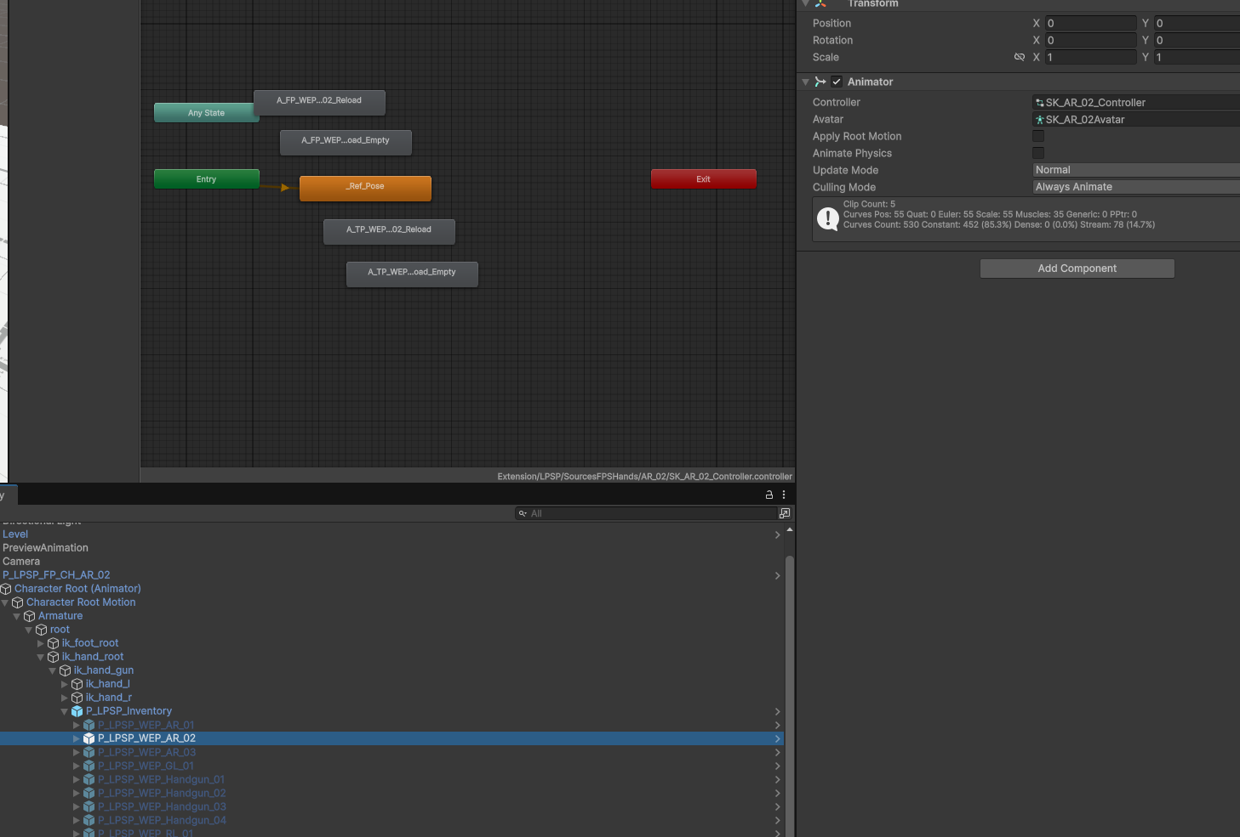
The weapon also contains animations like Reload and Fire, because weapons itself might have behaviors like magazine, bolt movement. These animations should be play along with the character animations like Reload and Fire.

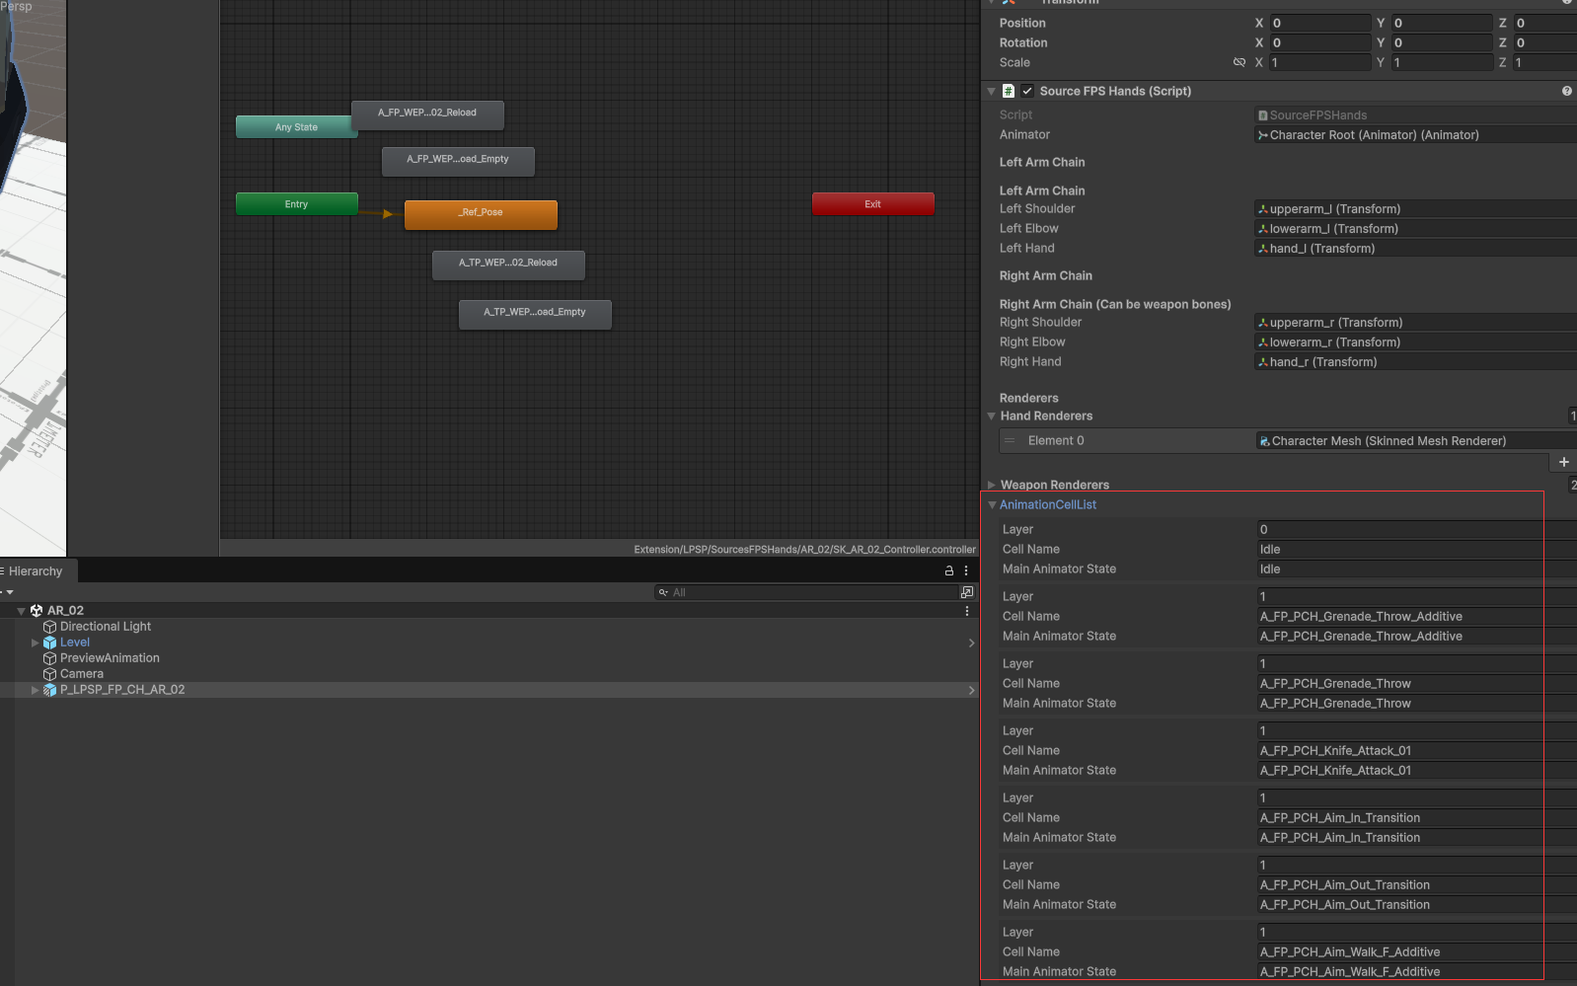
On the Source FPS Hands at prefab root, the AnimationCellList contains the pre-made states data by the character Animator.

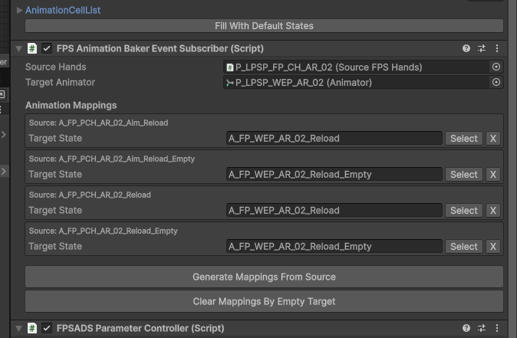
Also we have a FPSAnimationBakerEventSubscriber attached, this script registers event when AnimationBaker start playing character animations, and will call the weapon animator to play a corresponding animation state by the name. The mapping is also pre-made in a list.
For example when character play A_FP_PCH_AR_02_Reload, the weapon animator will play A_FP_WEP_AR_02_Reload. So a wholesome reload display will be carried out together.

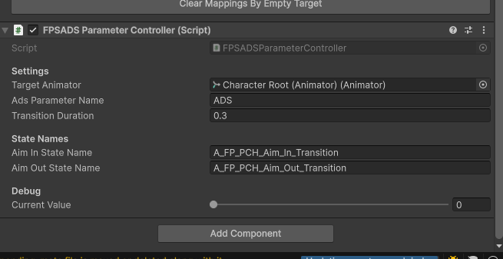
A FPSAdsParameterController is attached to control the ADS parameter on character Animator.
If it detects Aim in/out states are played on character animator. It will automatically set the animator’s ADS parameter between 0 or 1. So the base layer’s blendshape can display a correct result.

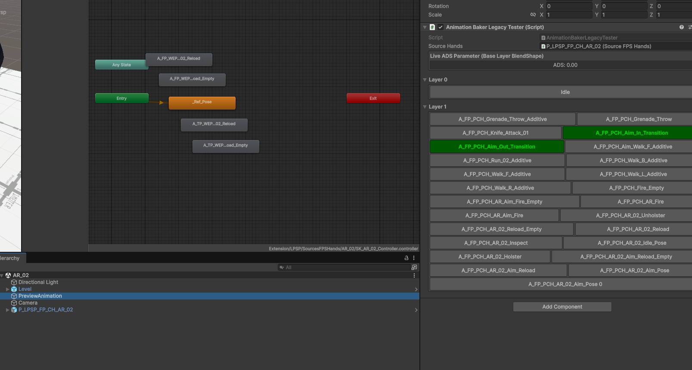
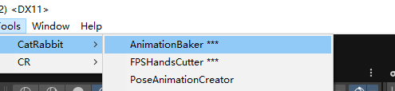
To preview the animations, open AnimationBaker and add a AnimationBakerLegacyTester to the scene, assign the Source Hands as the LPSP GameObject. Then the inspector will display all states as buttons to play (for Play Mode), Aim in/out button will be marked as green.

Then in Play Mode, you can click any weapon to play the state for preview.
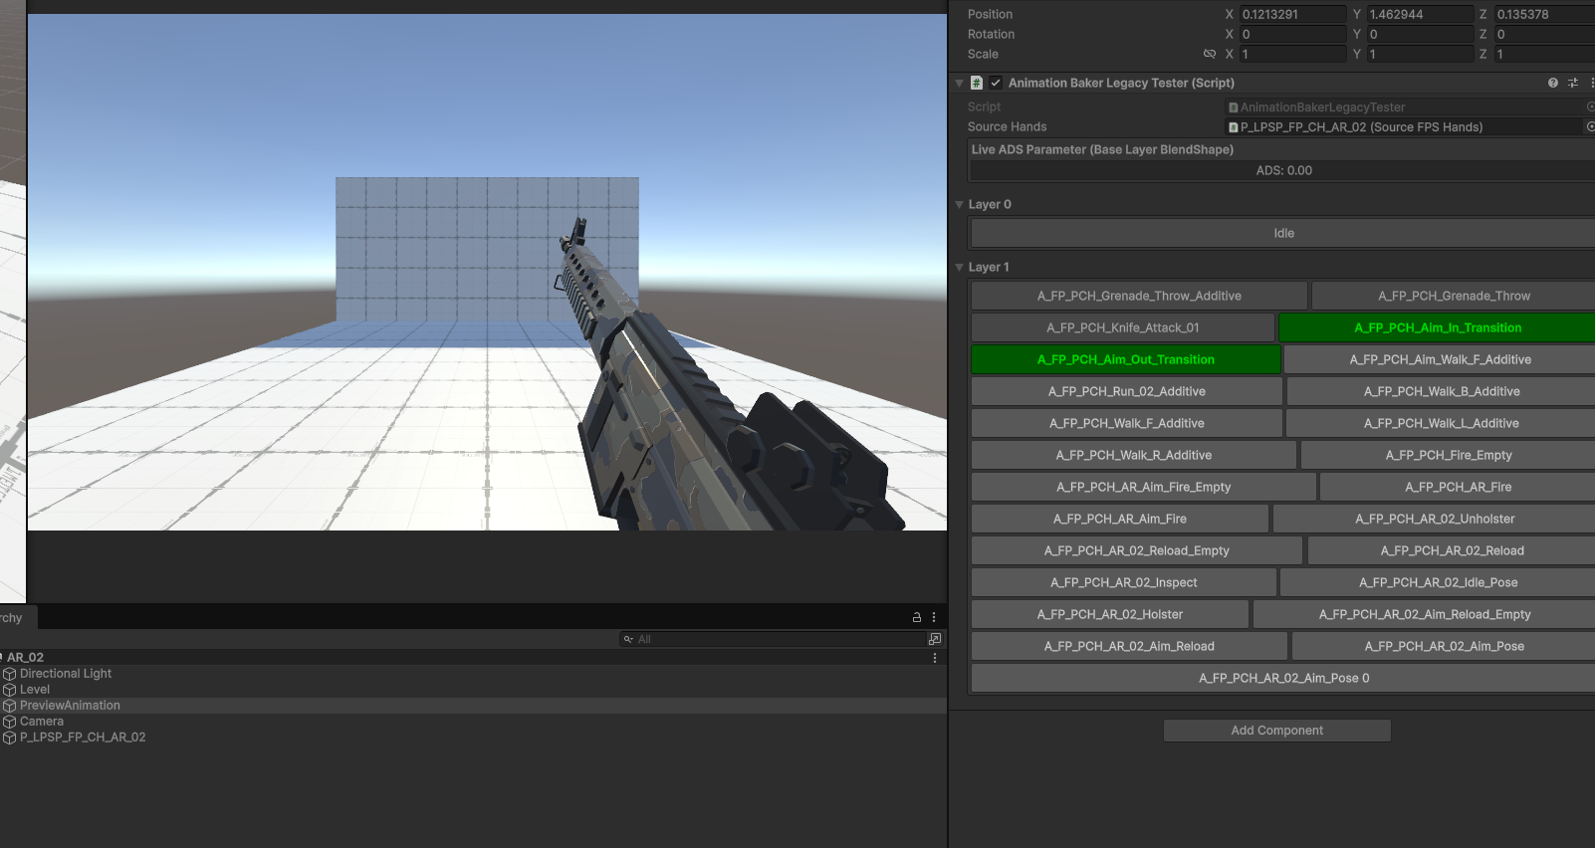

Character Fingers
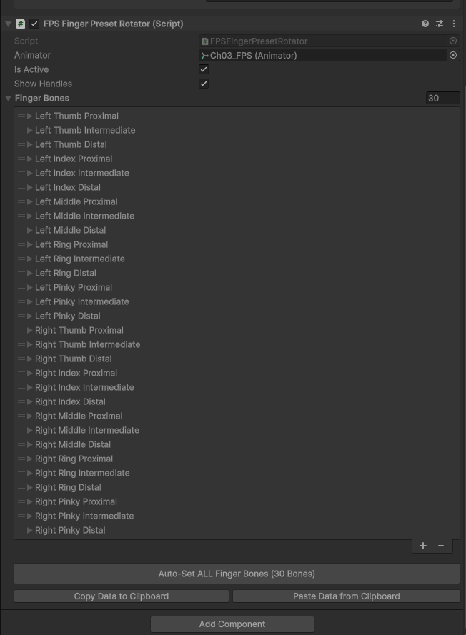
For the target hands, you can add a FPS Finger Preset Rotator to control the fingers of the character.

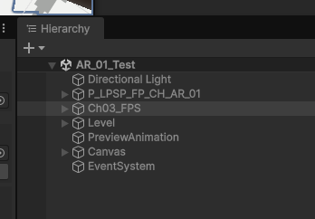
For example in Scene AR_01_Test, you have a source hands (LPSP character) and a target hadns (Ch03), when run in Play Mode. The target character’s hands will align with the source hands.

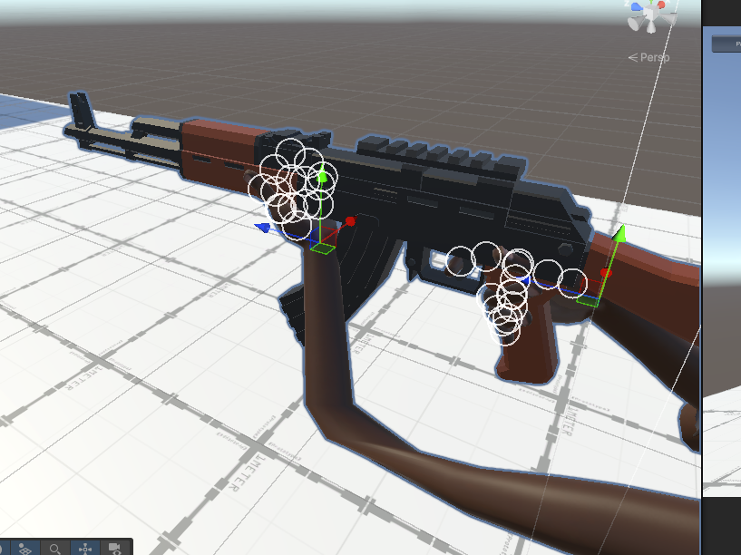

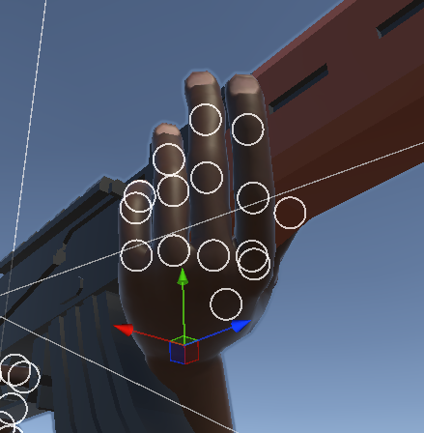
Then you can select Ch03_FPS the target hands character, to modify the rotation data of the fingers to be placed correct on the gun, these data are not saved automatically.
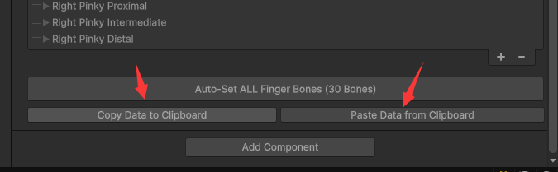
You can tune to the best result in Play Mode and click Copy Data to clipboard, then stop Play Mode and click Paste Data in Editor Mode to apply the data to it.

Re-Use LPSP Weapons

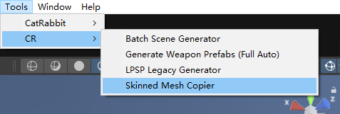
We can copy the LPSP weapon to our target characters.

Open the Skinned Mesh Copier tool.

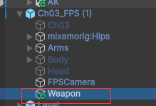
First we add a child GameObject under the target character.

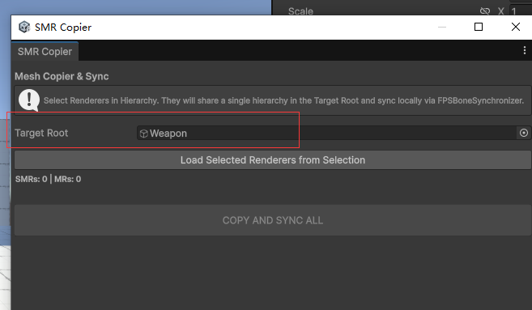
Assign it as Target Root.

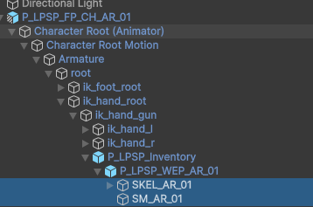
Select the children GameObjects under the source weapon,

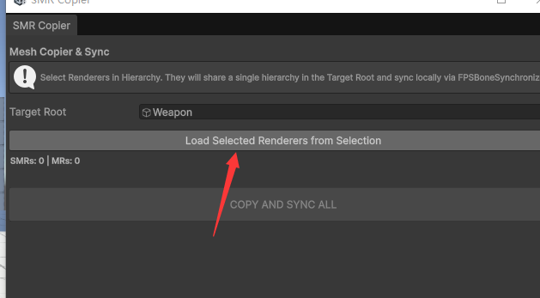
Click Load Selected Renderers from Selection to get all Renderers under the selected GameObjects, including both MeshRenderers and SkinnedMeshRenderers.

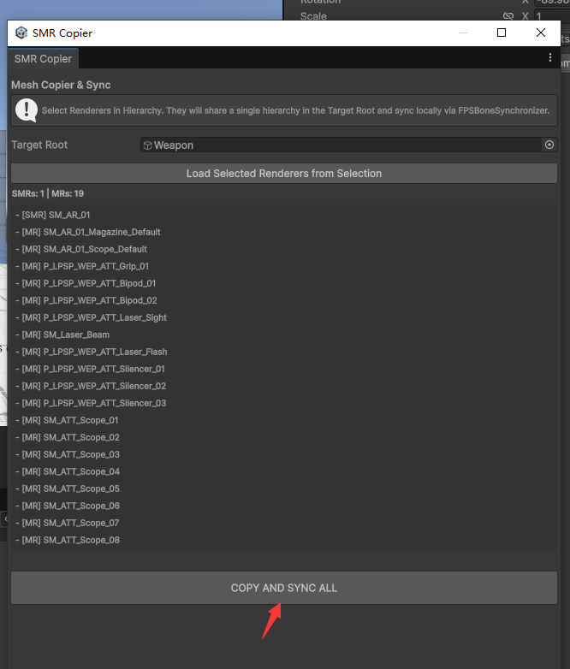
Then click Copy And Sync All, this will copy the renderers and all related bone structures to the target root (“Weapon” as in the picture).

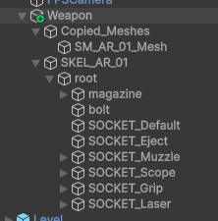
The SkinnedMeshRenderers will be placed under Copied_Meshes.
MeshRenderers will be placed by their old hierarchies. Because they are driven by GameObject hierarchies, not rigged bones.

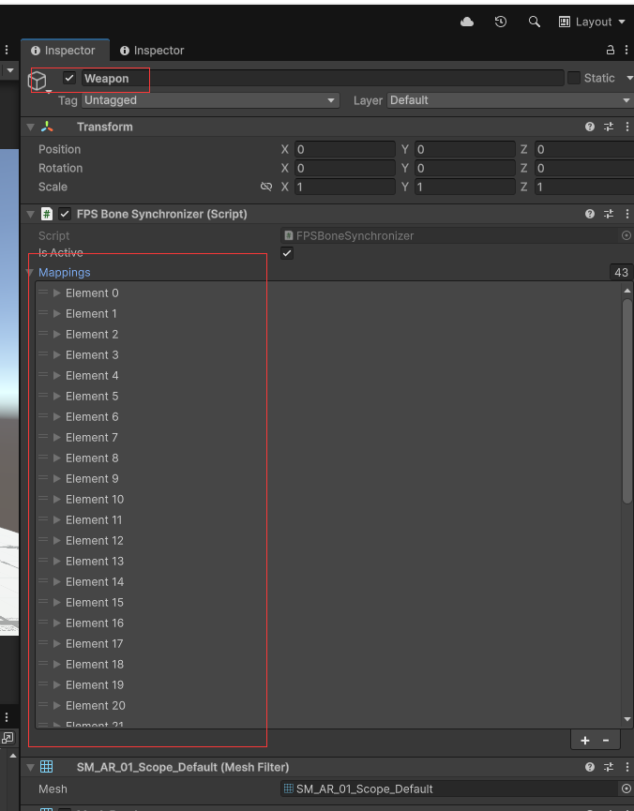
Also , a FPS Bone Synchronizer is added to the root of weapons (“Weapon” GameObject in this case). With all mapping of the source and target transforms. These transforms’s local positions and rotations will be synchronized in Play Mode.
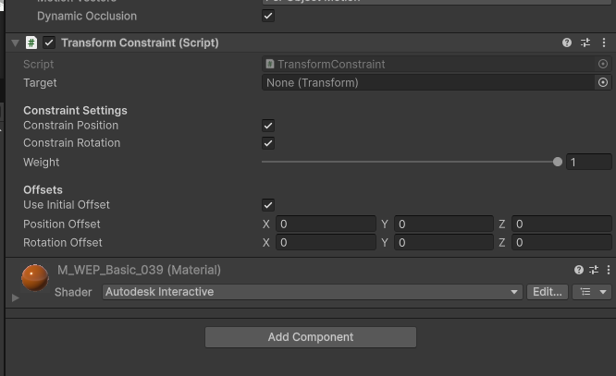
Because FPS Bone Synchronizer only synchronize local transform info, we should manually add a TransformConstraint to it to make it follow the inventory world transformation.

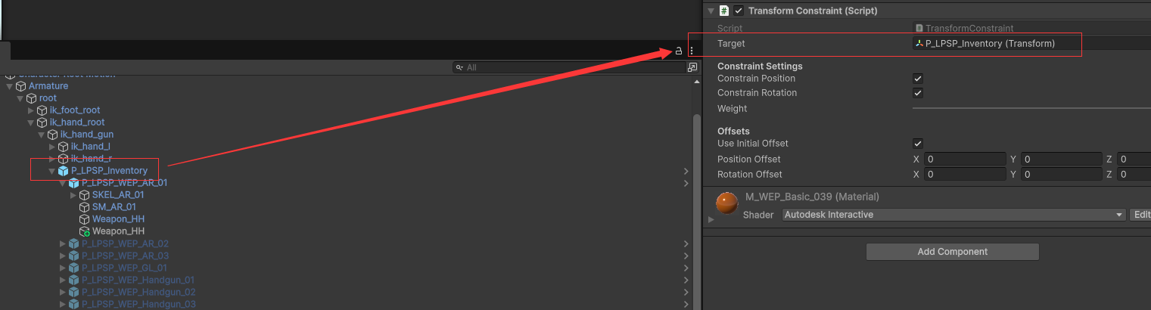
Assign the source hand’s inventory to the Transform Constraint target.

Then run in Play Mode, the created weapon will be driven by the source hand’s weapon.

