Ryan Gamble

Professor Payli

SDEV 153

4/22/2018

Website Documentation

1)

a) Megan’s Dogwalks

b) The mission of this website is to increase revenue for the business Megan’s Dogwalks.

This is achieved by creating pages that explain and showcase all the products and

services offered by the business. The website also provides useful information for

contacting and locating the business so potential leads can become customers. Lastly, the

website helps boost revenue by building credibility particularly through the testimonial

section which shows quotes from previous customers.

c) The goals for this website are as follows: boost revenue, increase brand awareness/

build credibility, reach new customers/convert potential leads to customers. The target

audience for this site are dog owners in the Lafayette and Lebanon areas.

2)

a) Here are some of the most important questions I had for the client:

Q: What is the main topic of the website you want developed?

A: The site will be based around our business, Megan’s Dogwalks.

Q: What are you hoping to achieve with this website?

A: First and foremost, our goal is to increase revenue for our business. We are also a new

business and not that many people know about us so getting our name out is really

important. With that we also need to build trust in our brand since we are still new.

Q: Who is your target audience?

A: Obviously we are targeting dog owners, but specifically we want to reach more people

In the Lafayette and Lebanon areas since that is where we have our two locations.

Q: Do you already have a logo and color scheme to base the design on?

A: Yes, we do have a logo and color scheme for you to work with but other than that the

Design is up to you.

b) The benchmarks for this project are as follows: the site must provide information on

all the products and services offered by Megan’s Dogwalks, provide information on both

locations, provide contact details, and must show testimonies from previous customers.

c) This site must be able to load quickly so that people do not leave the site. The site must

also display well on mobile phones since so many people use their phone to browse the

web.

d) The site is 16 pages, with pages nested up to 3 levels, counting index as level 1. The

pages use either a 1 column or 2 column layout depending on if 2 columns better

represents the information such as when the services are listed. On smaller screen sizes

the 2 column layout is converted to a 1 column layout to fit the screen better. The

pages are not too complex but they do use lists, tables, forms, and on the testimonial

page, a little bit of JavaScript to add new testimonies. Almost every page contains at least

1 image and the main page contains a video.

e) It is being assumed that all sales will be processed over the phone but as the business

grows they may want to add ecommerce capabilities and may decide to use a database to

hold user data or process transactions.

f) The site must be accessible from a mobile device. The site must implement a map to

show the business location. The site must implement an embedded video on the home

page.

3)

|  |  |  |  |  |  |  |  |
| --- | --- | --- | --- | --- | --- | --- | --- |
| Goal | Browsers Tested | Features For Goal | Other Features | Physical  Environment | Software Infrastructure | Server | Client |
| Boost Revenue | Chrome, Edge, Firefox | Product and service information | n/a | Business owner handles | The website does not need any | Server software / hardware is | The client only |
| Brand Awareness | Chrome, Edge, Firefox | Testimonies and contact / location details | n/a | hosting using a third -party service. | high end software at the moment. | hanlded by the hosting | needs to have a |
| New Customers | Chrome, Edge, Firefox | About and home page explain the business | n/a | Ongoing maintenance by me. |  | company. | working web browser. |

4)

a) The genre of this site is a dog service site providing business information. The site is

for a new business that is trying to reach new customers and build their brand awareness

and credibility so that they can create more revenue. This site solves the problem of

people not knowing about their business by creating an online presence for people to find

them at. It also solves the problem of lack of credibility by showing previous customer

testimonies. Lastly, it helps boost revenue by explaining to customers what all the

products and services are and how they work.

b) The first screen is the home page which displays a navigation bar, some content, and a

footer. From the navigation bar users can access the about, services, products,

testimonies, faq, and contact pages. The service page shows each of the 4 services and

clicking dog walking, sitting, or training takes the user to the respective service pages.

Clicking on the dog boarding section takes the user to a page that displays the Lafayette

and Lebanon locations and clicking those takes the user to the full pages for those

locations. The product page shows the DoggyBox subscription and a general product

section. Clicking those takes the user to the full pages for each section.

c) I did not have a graphic template to follow when I designed this website.

d) For this project I had to make the decision between displaying the information in a two

column or one column layout. This lead to carefully deciding the best way to represent

the information for each page. Other than that, there weren’t really any design choices

that limited our goals for the site.

5)

a) Everybody who I showed the site seemed to be overall pleased with the aesthetic and

unified color scheme throughout the site. People responded positively to seeing that the

site is mobile optimized. Everybody liked the video of the dog on the home page. Some

people thought the visual effects are somewhat basic but for what we learned in class I

did the best I could.

b) I will be updating the site for the client as their website needs grow and they decide

they want their website to do more.

c) Advertising will be run by the client and they are planning on using Facebook Ads to

link to their site.

d) The client will be writing their own meta descriptions for each page and submitting the

site to google.

6)

a) I used three sites as external links throughout the site so that users can learn more

about certain topics. These sites are:

<http://www.wildthingspetservices.com/the-top-5-reasons-you-should-hire-a-dog-walker/>

<https://positively.com/dog-training/find-a-trainer/why-should-i-train-my-dog/>

<https://www.petsit.com/owners>

b) The big picture is that I needed to drive more customers to Megan’s Dogwalks. The

way I implemented that goal is by providing information for each product and service

so that people can learn about them and become more likely to become customers. I also

included a testimony section to build trust in the brand and help people make the decision

to buy.

c) As far as I can tell I have met all the requirements set out by the client and I believe

this website will help them reach their business goals. The hardest choice was deciding

what to put on the home page. In the end I decided to put a video of a dog so that people

instantly know the site has to do with dogs. Plus seeing a happy dog on the front page

puts people in a good mood before learning about the services and products.

d) For this site I had to research other dog product/service companies to see what their

websites look like as well as what kind of services they offer. I had to find the best way to

convey all the information the clients wanted their customers to know. In the end I

decided to use a two-column layout with pictures of each service/product with

descriptions and then for the services, clicking those pictures brings the user to a full page

dedicated to that service.

e) As the business grows they may decide that they want more products on their site. At

some point they may decide to implement an ecommerce store as well and maybe use a

database to hold user information. They could even add a review section for each product

where customers can leave their comments.

7)

a) The website appears just as expected on Chrome, Firefox, and Microsoft edge. The

site also works just find on mobile devices and adapts to screen size.

b)

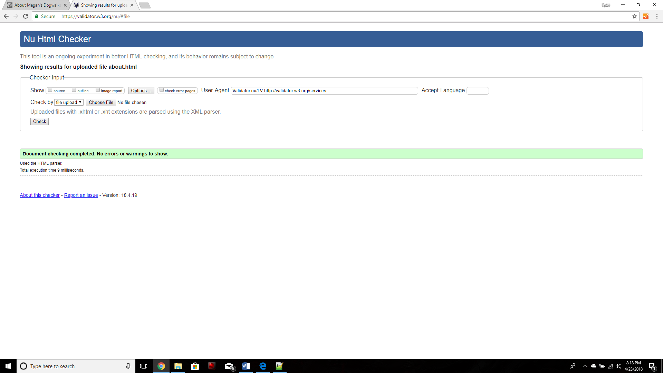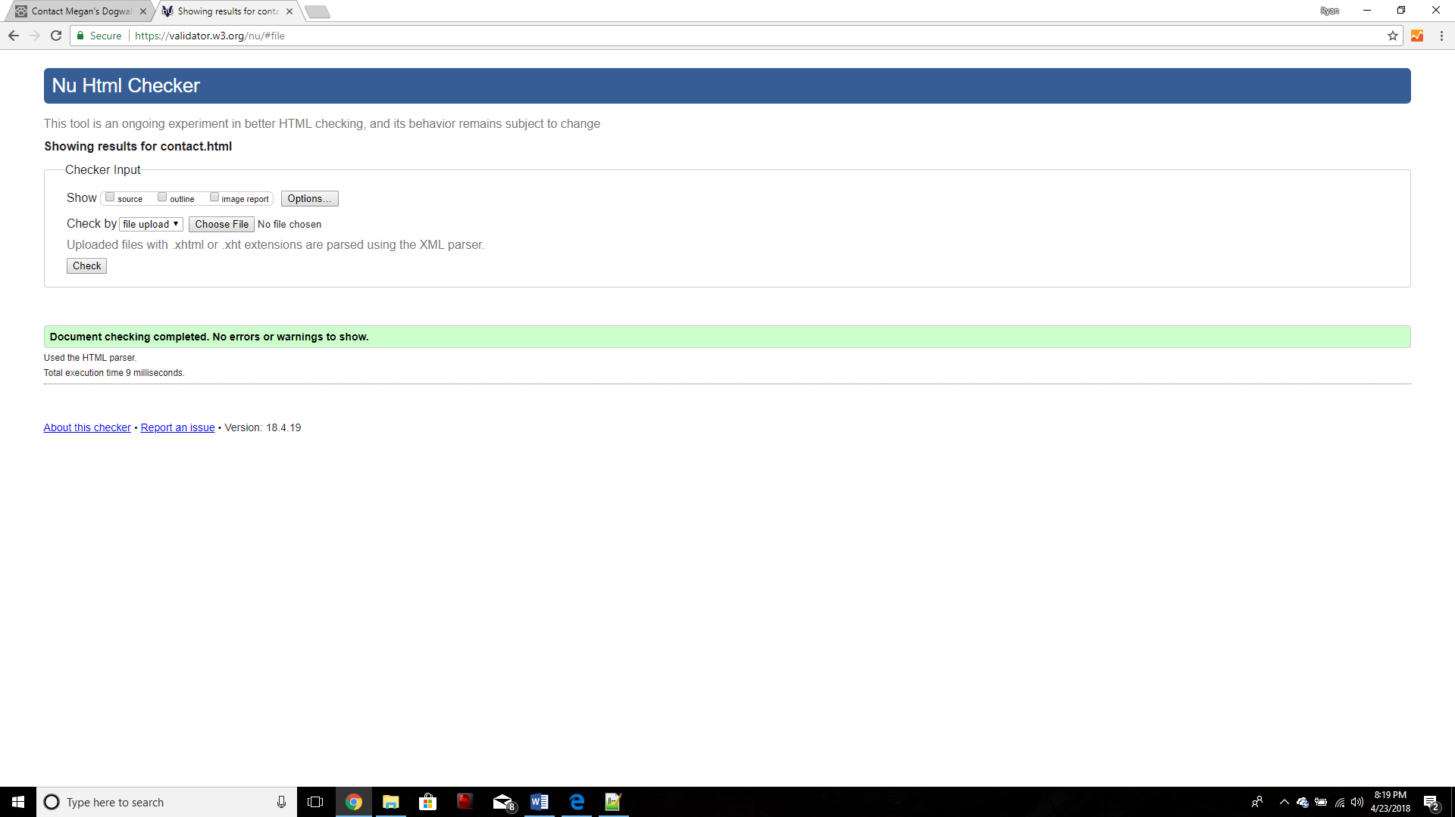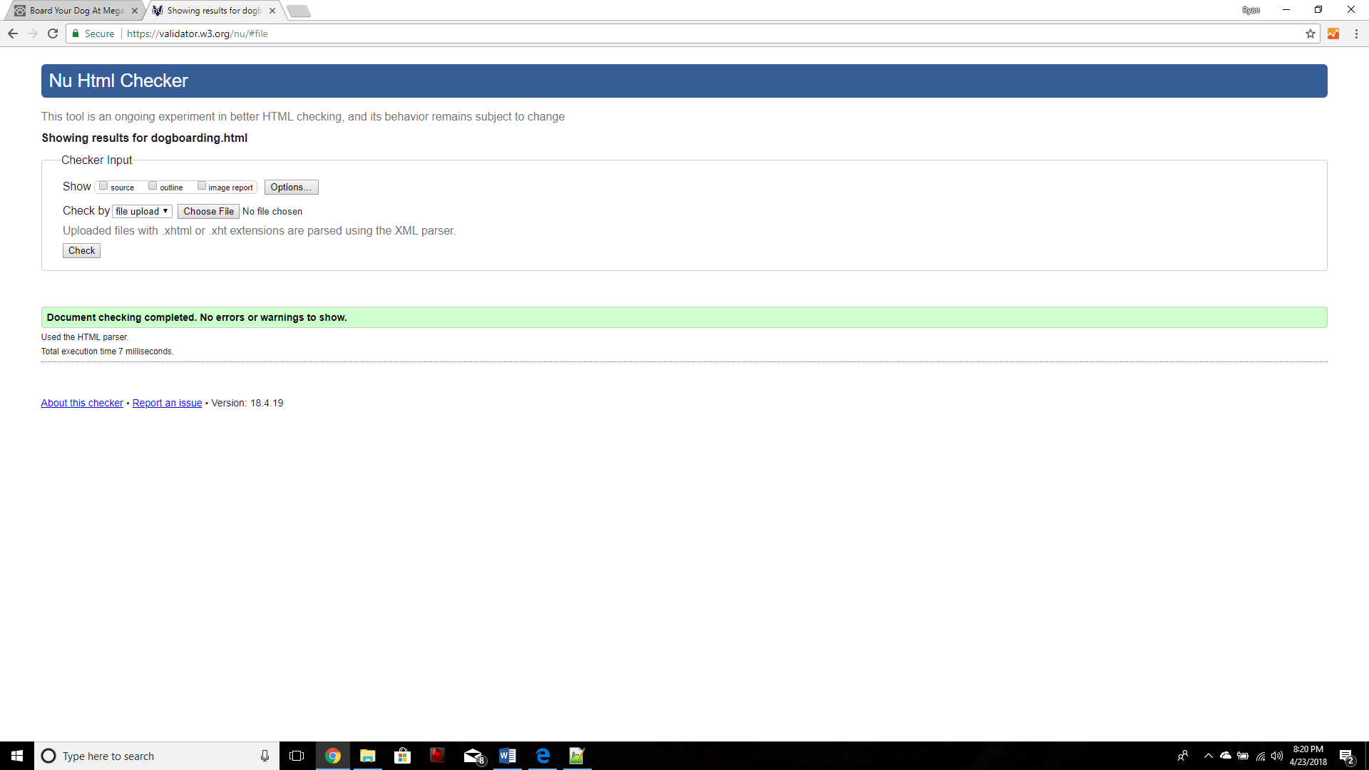

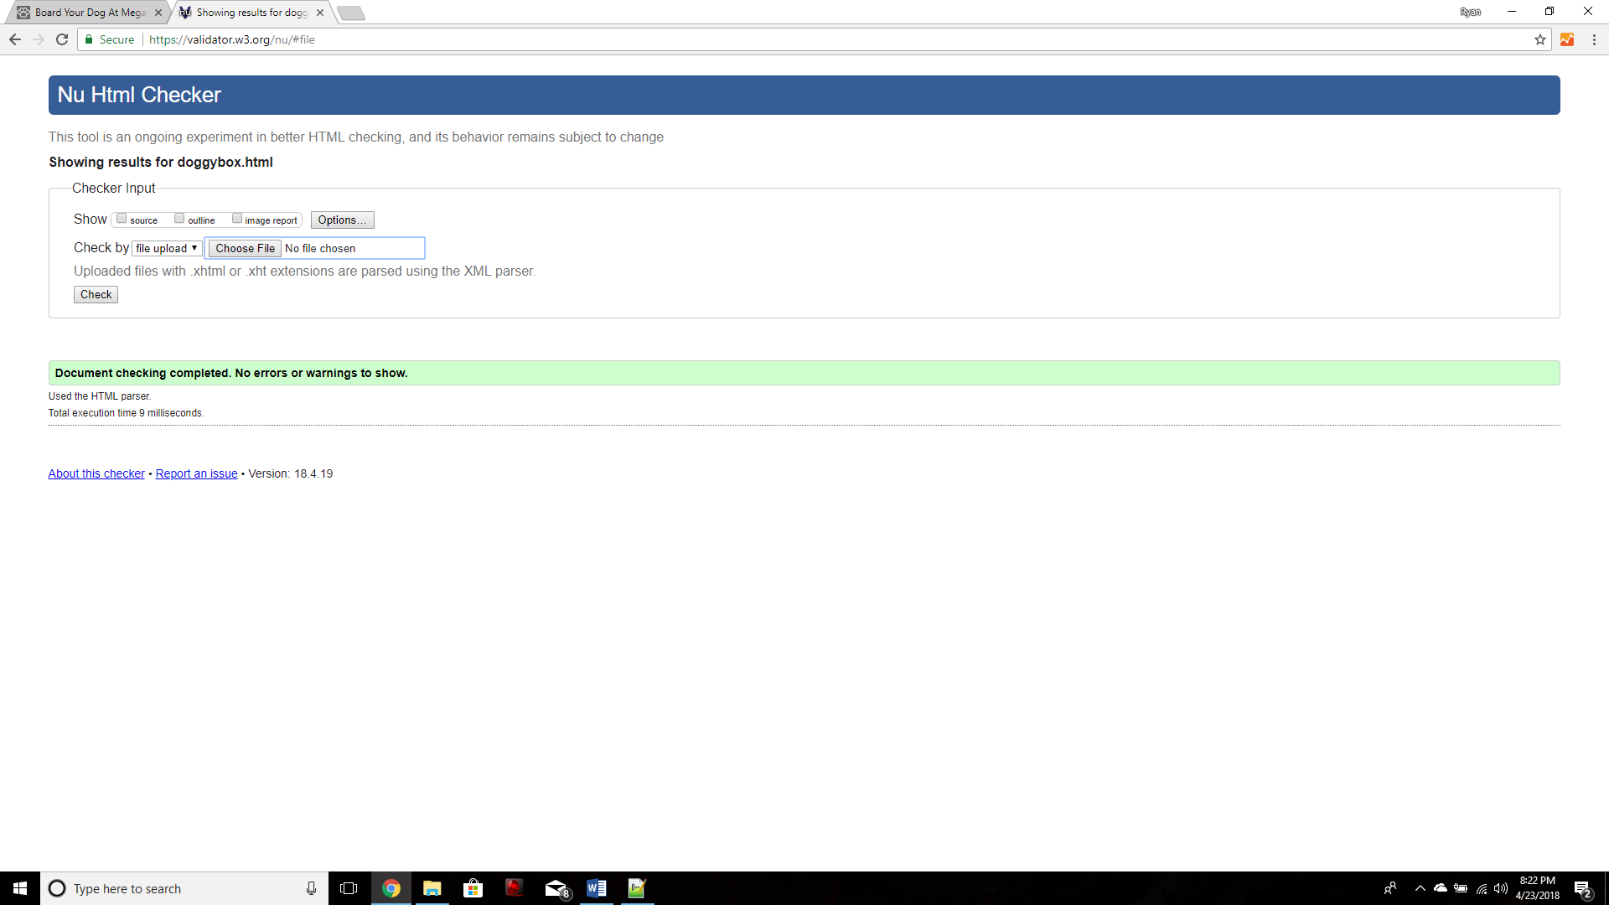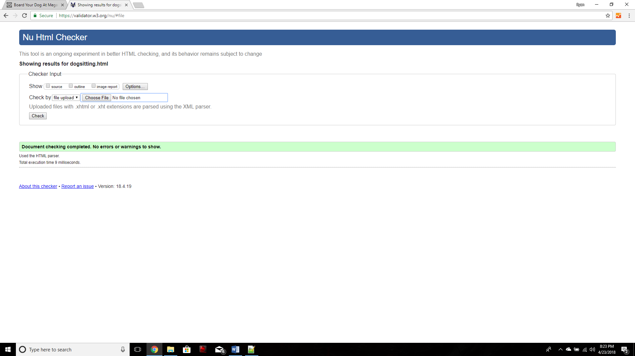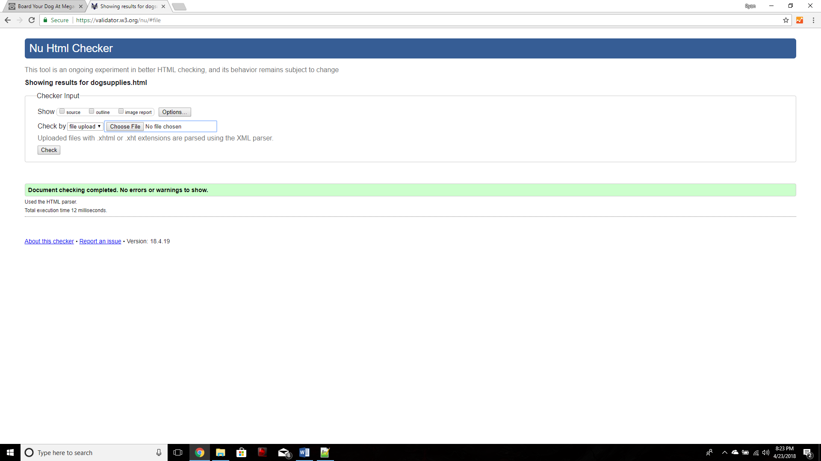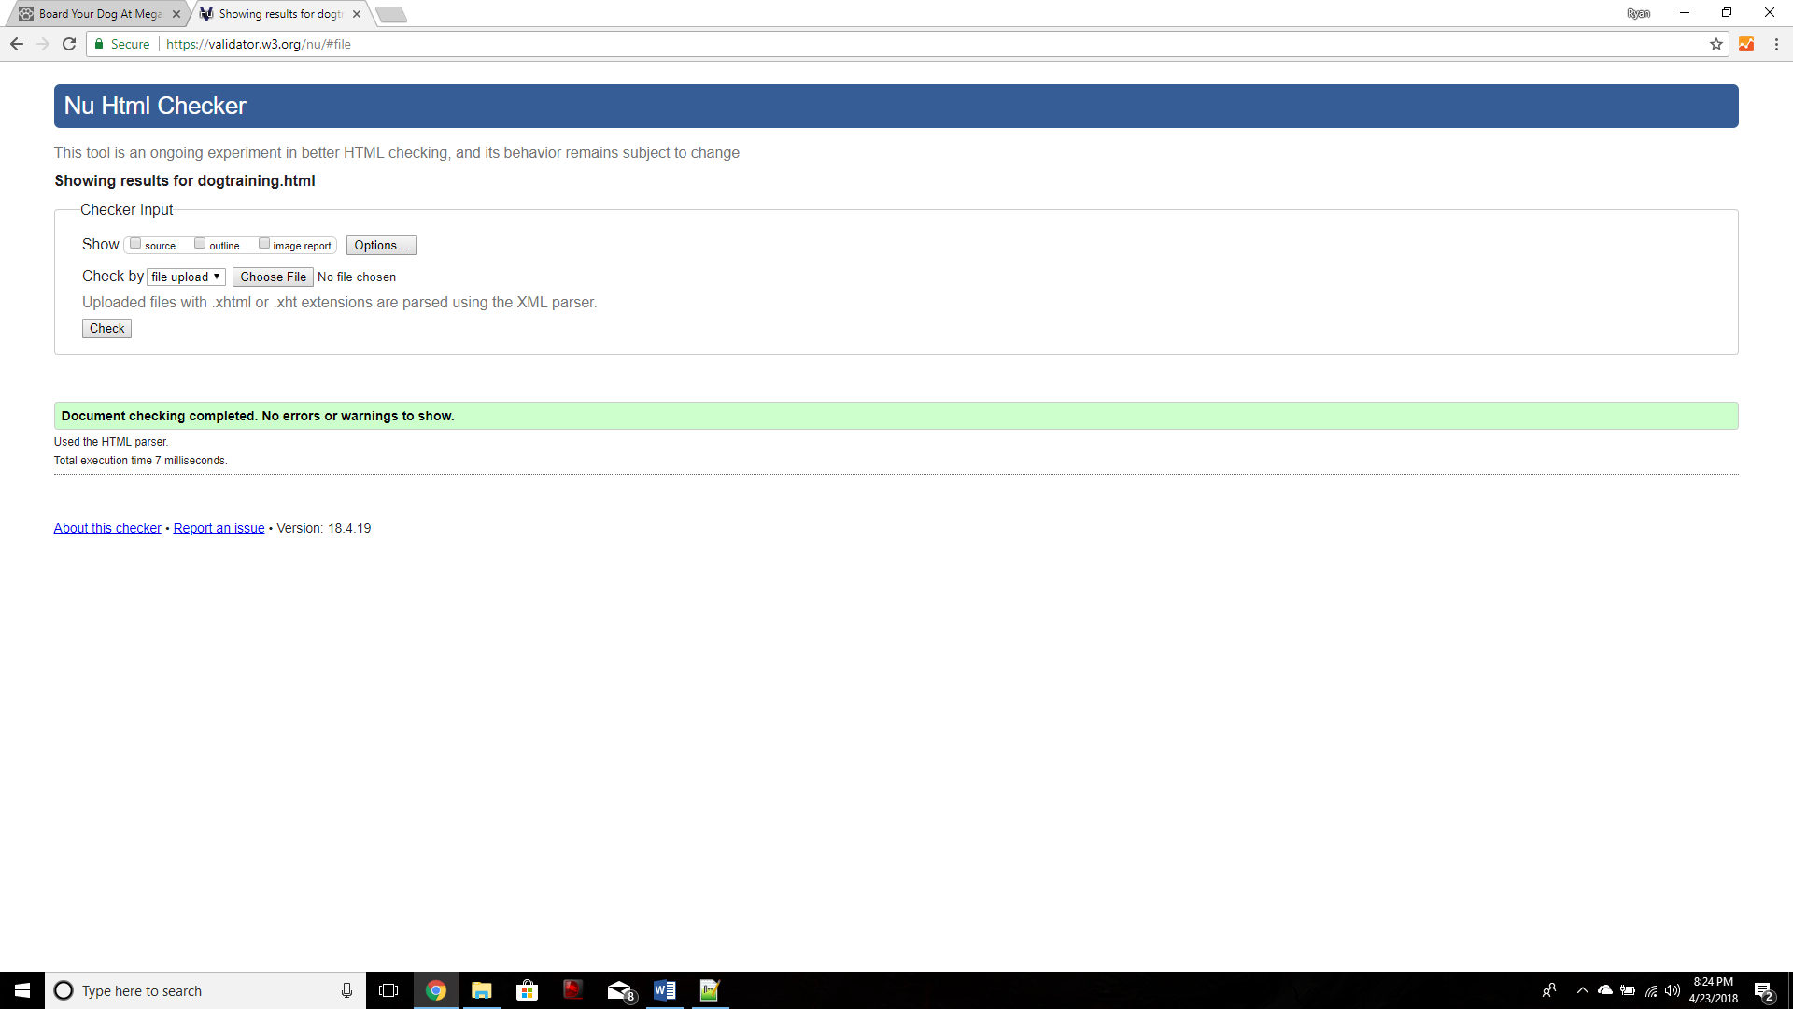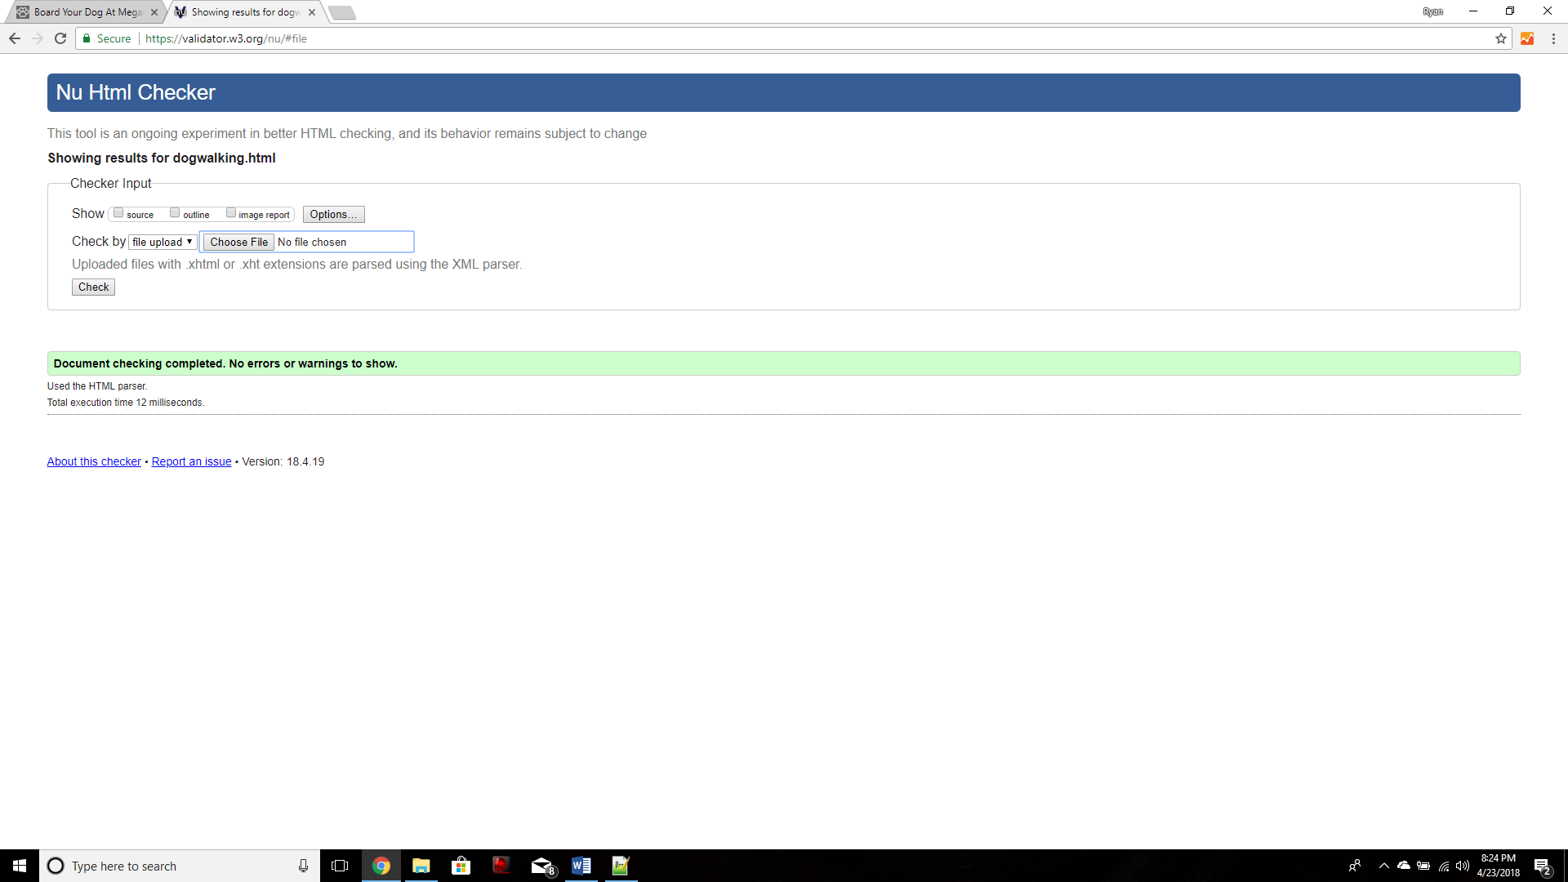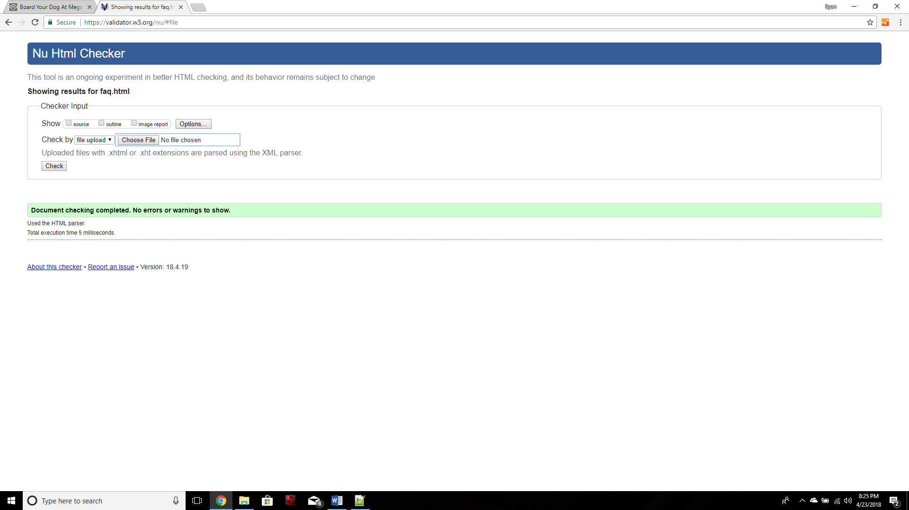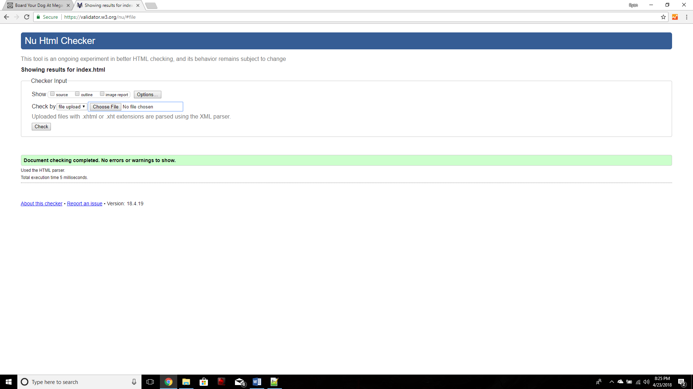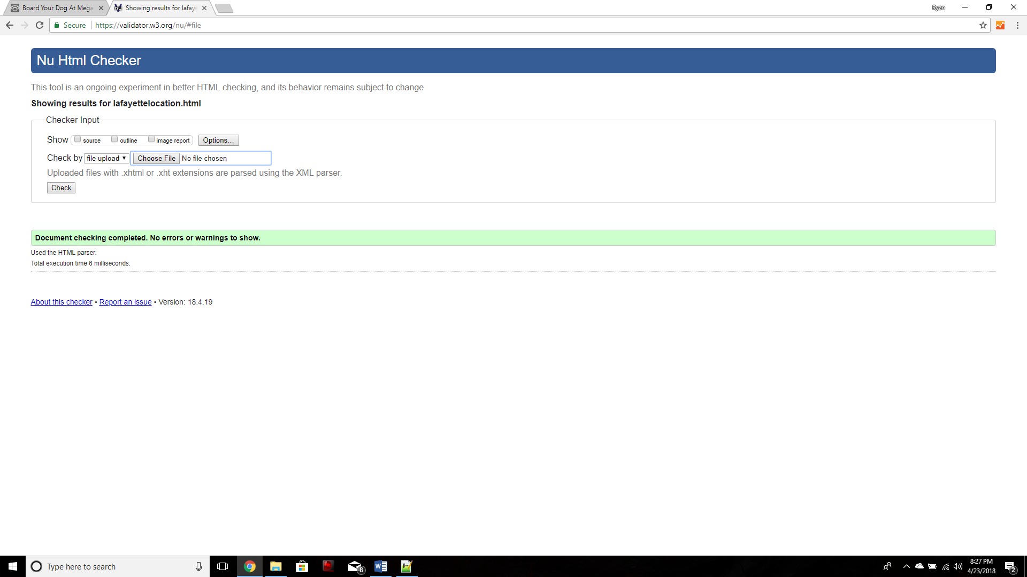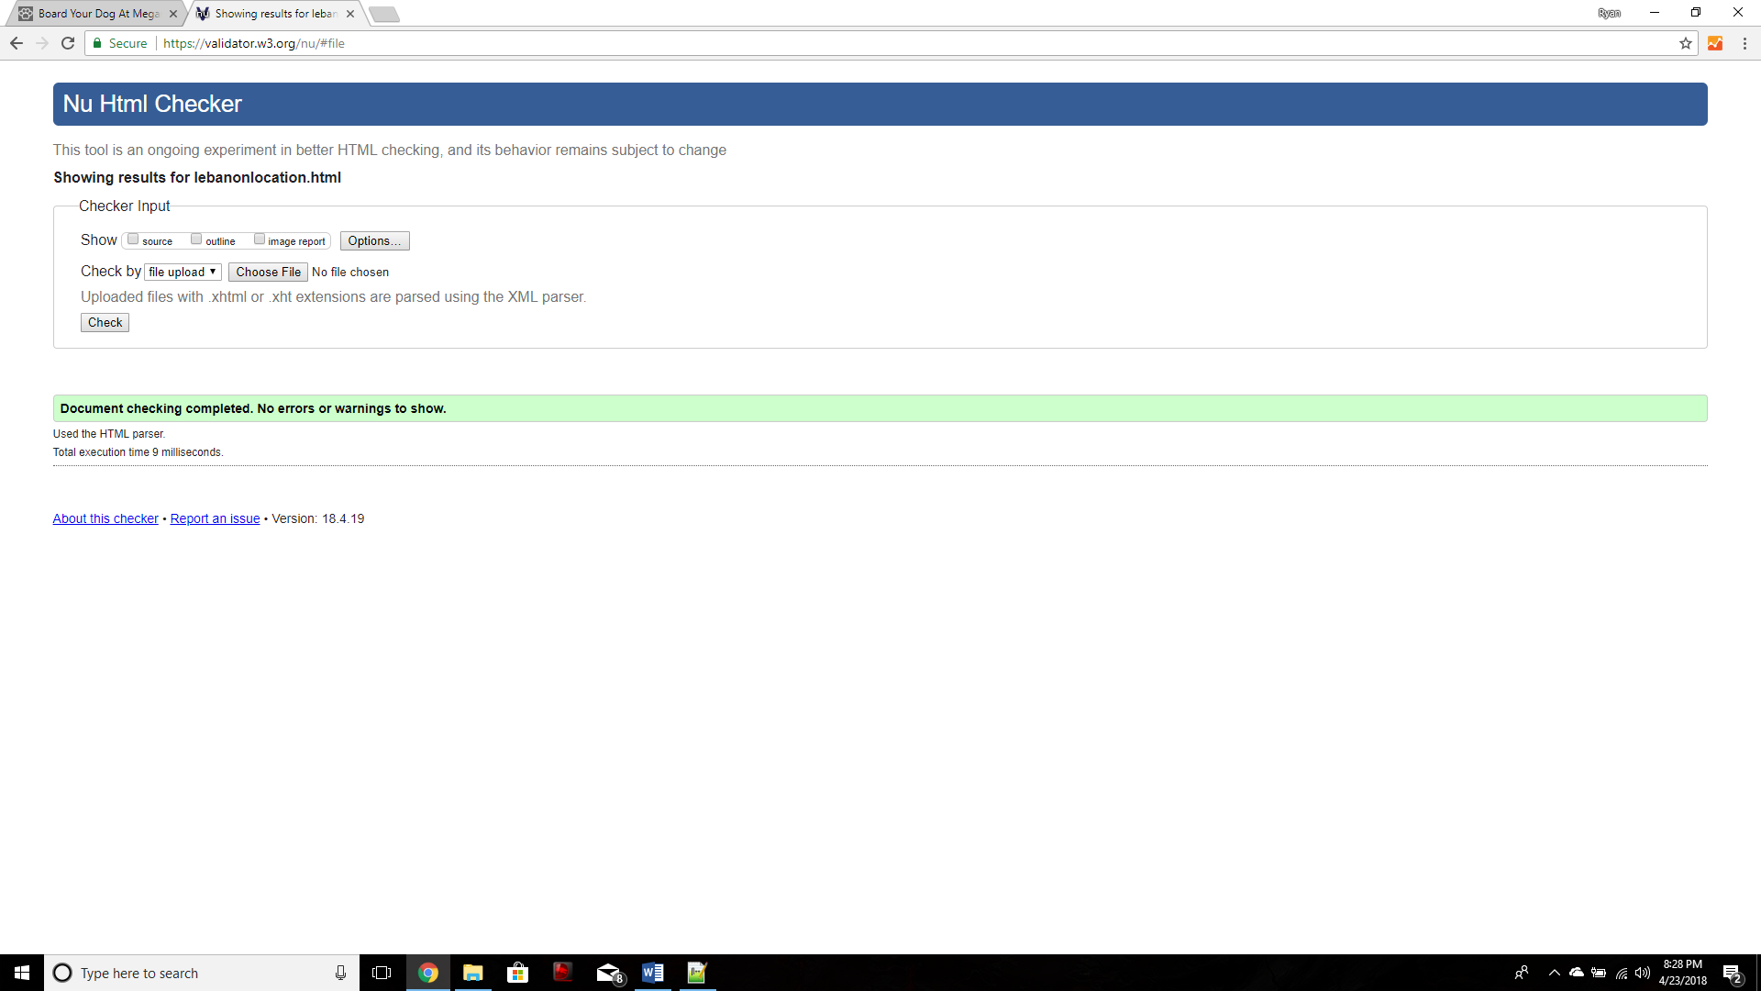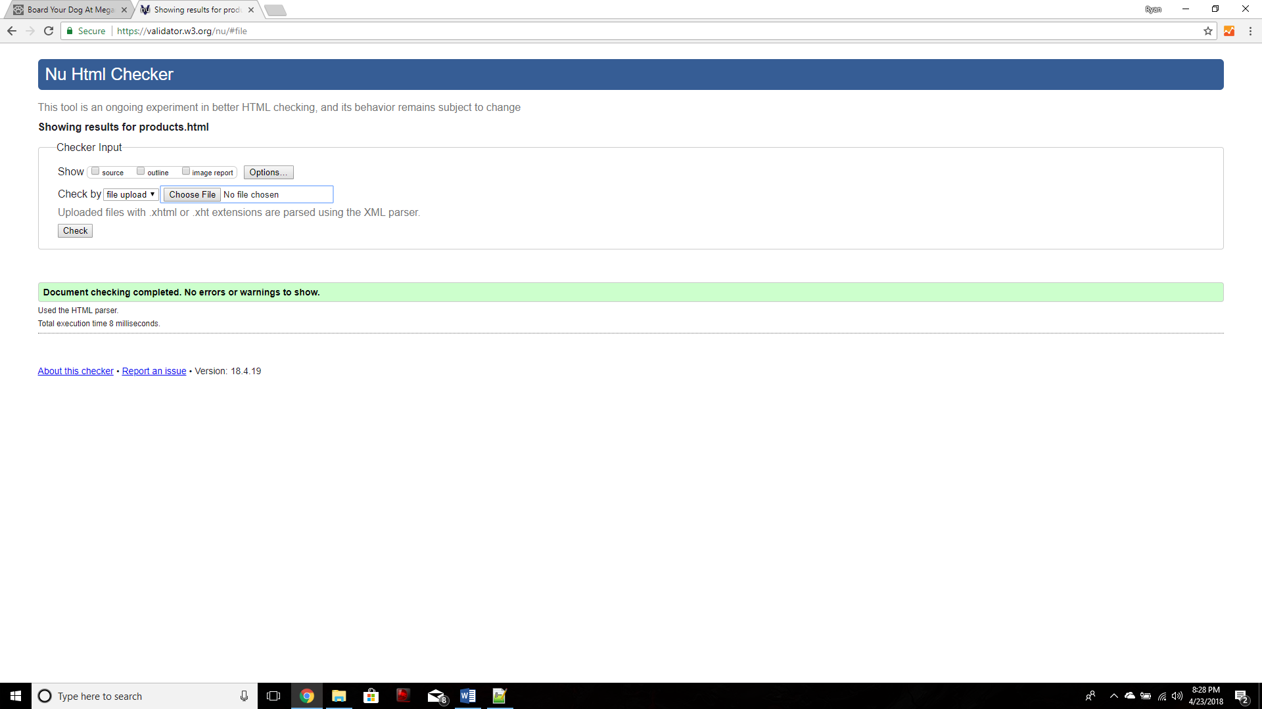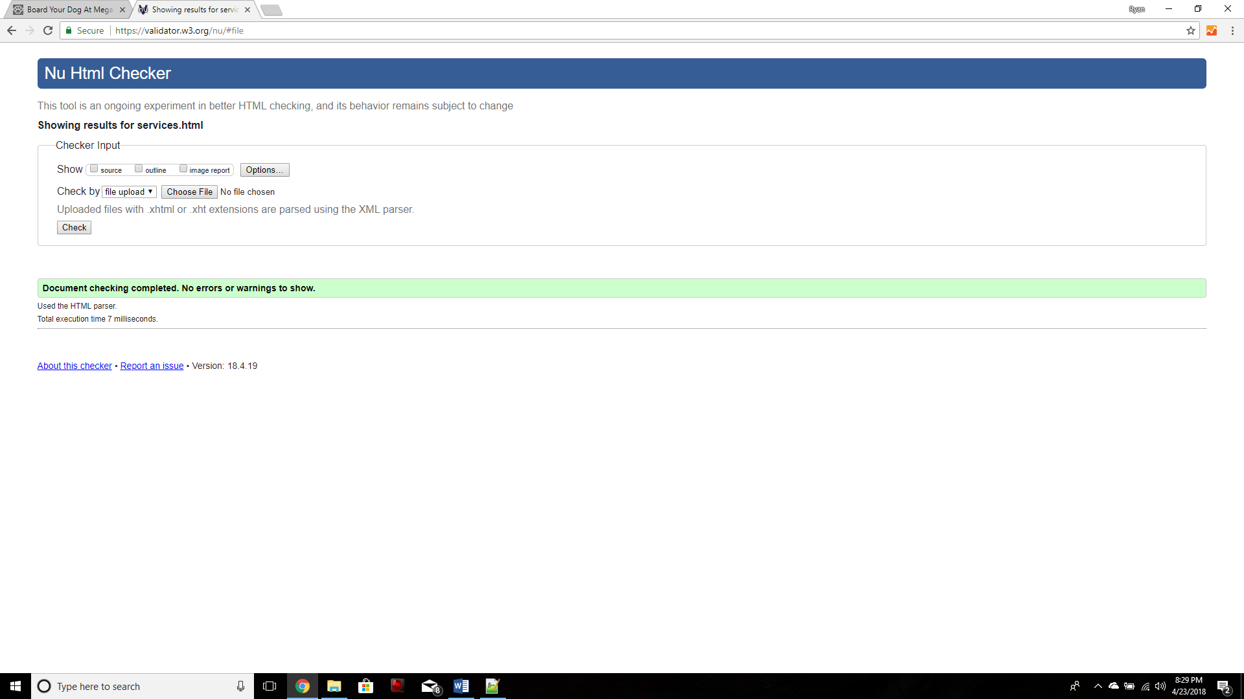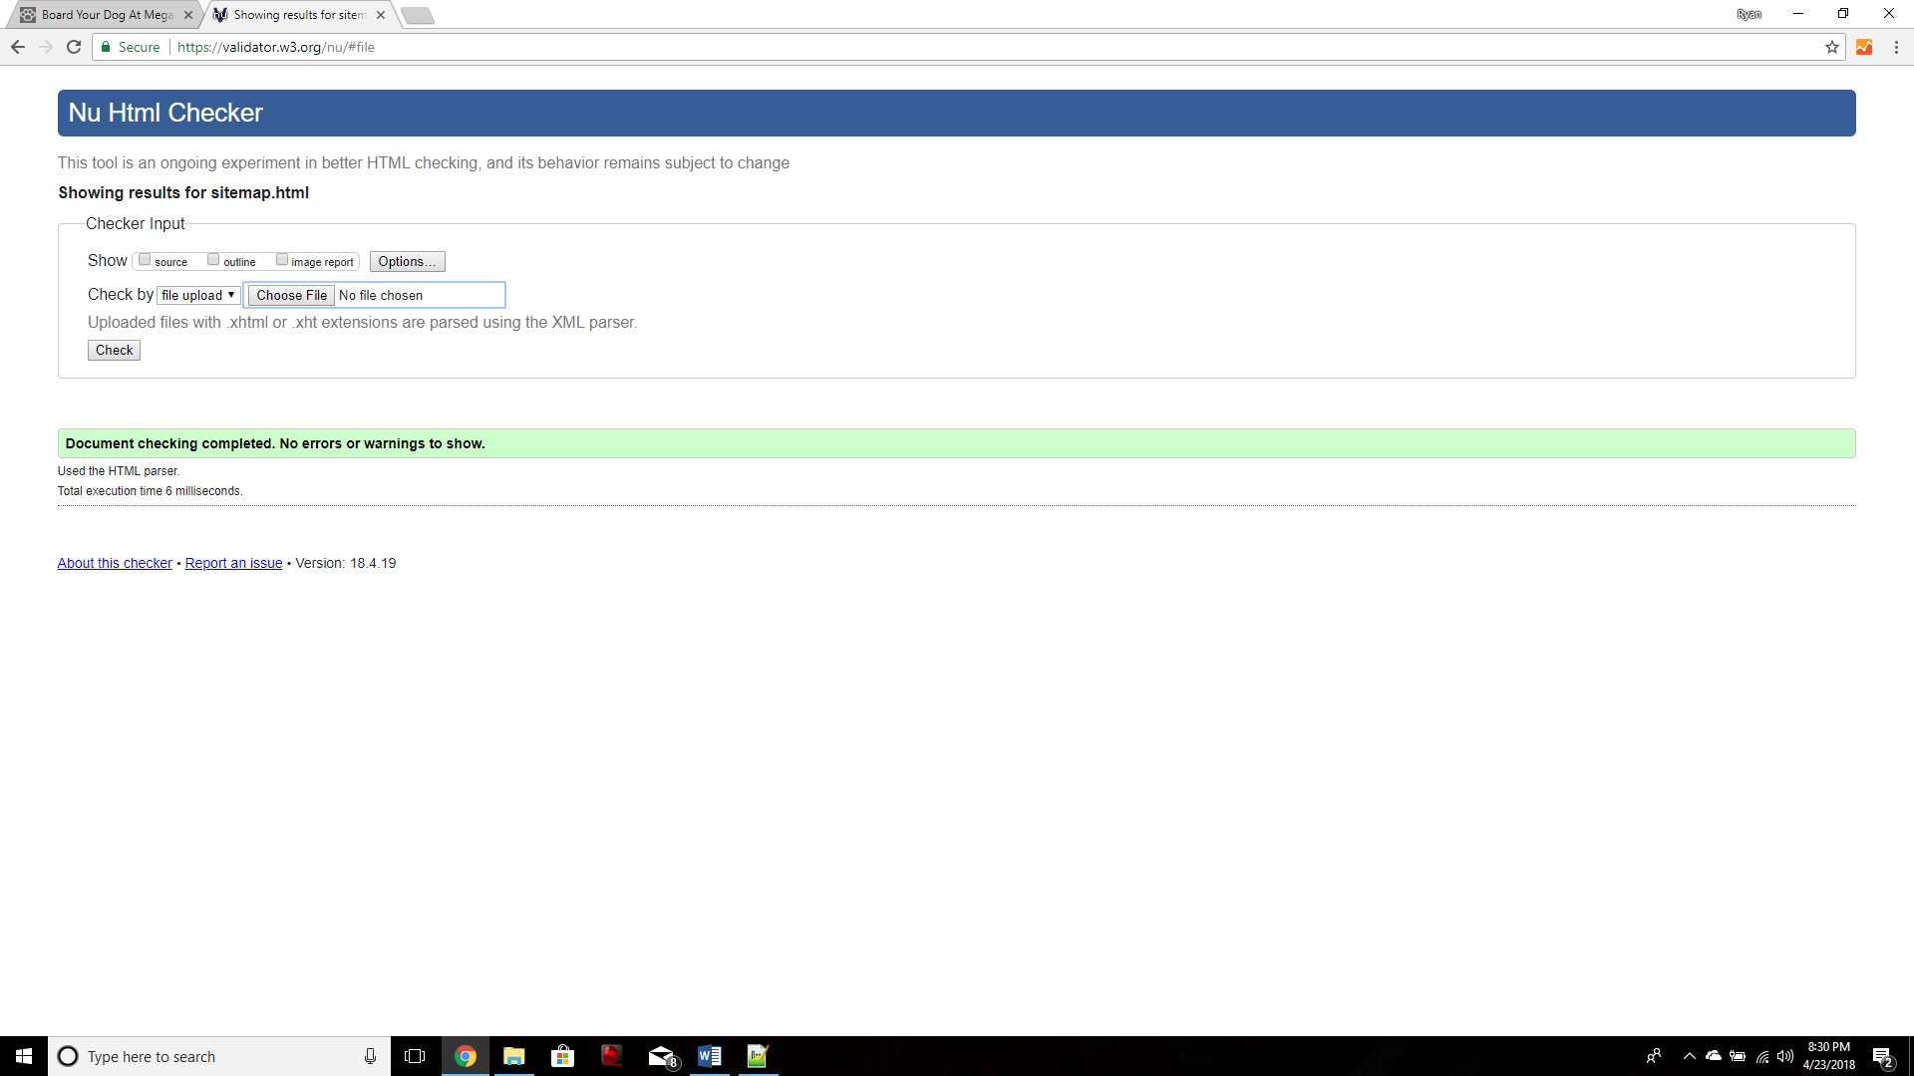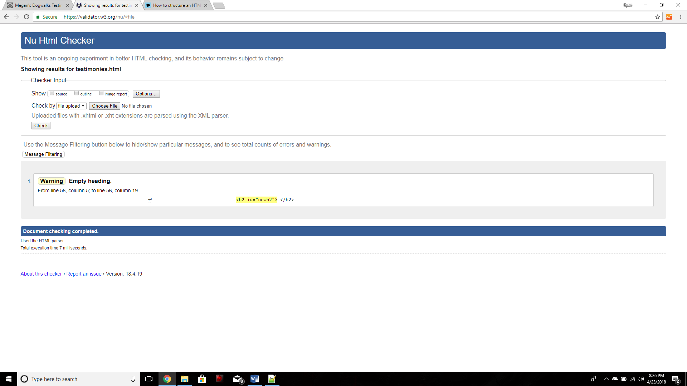

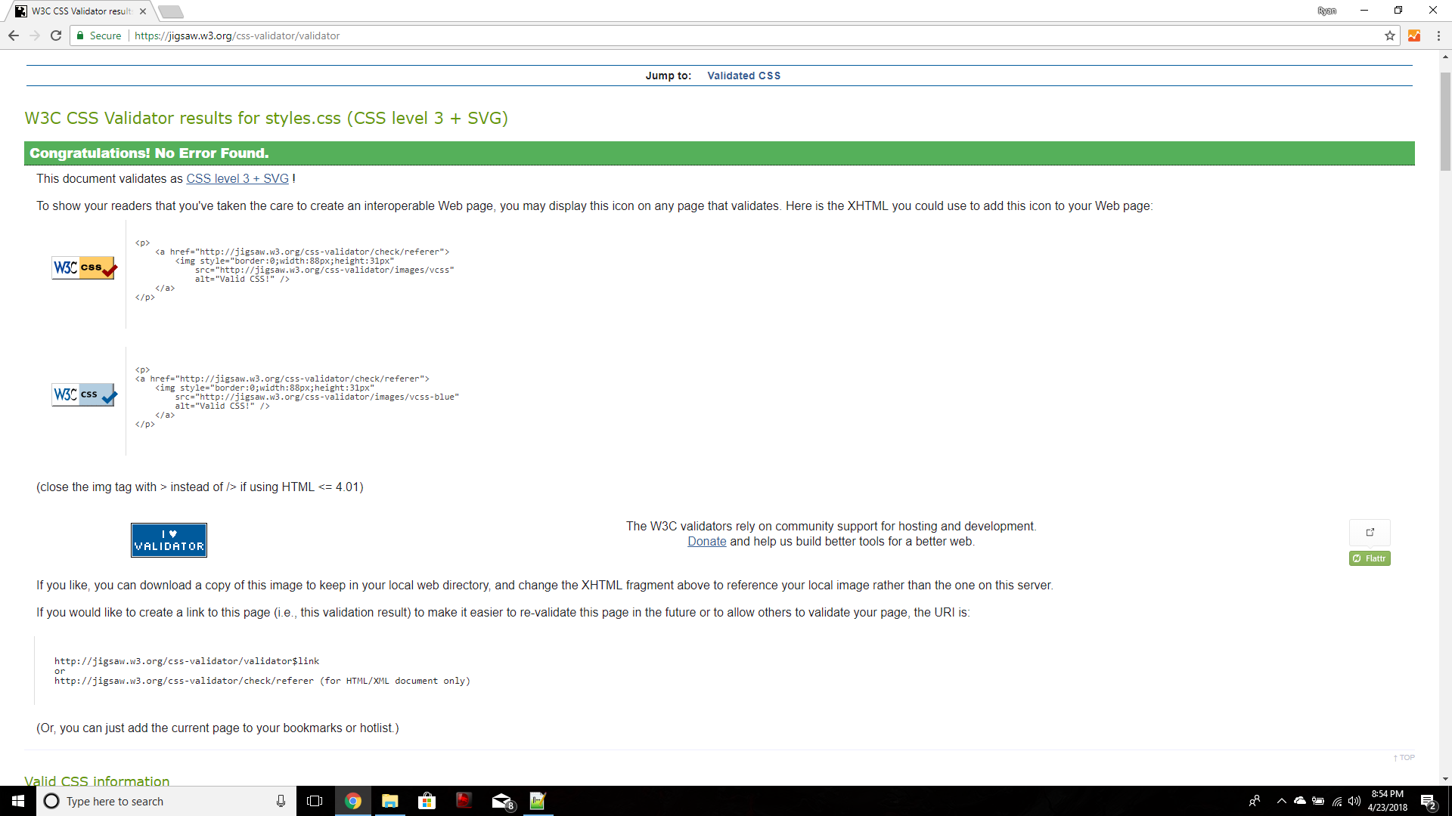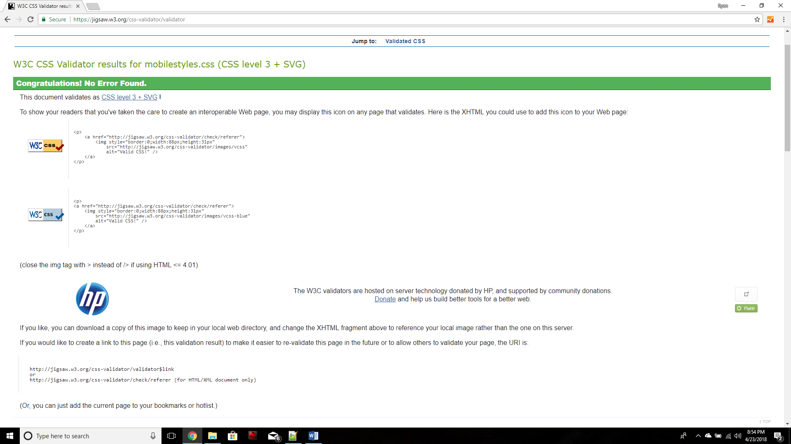

(The empty h2 tag is expected and is later filled using JavaScript)

c) No other documentation.