House Champs Automation – How to use

1 – Leahify Qualifiers
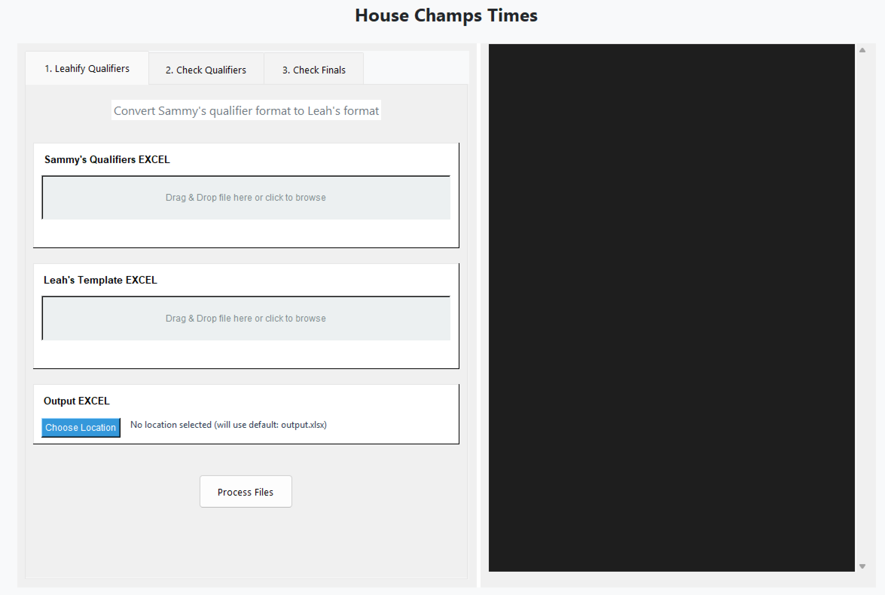
Sammy’s Qualifiers EXCEL: this is the excel document which is entered on the day of the house champs. This looks like this:
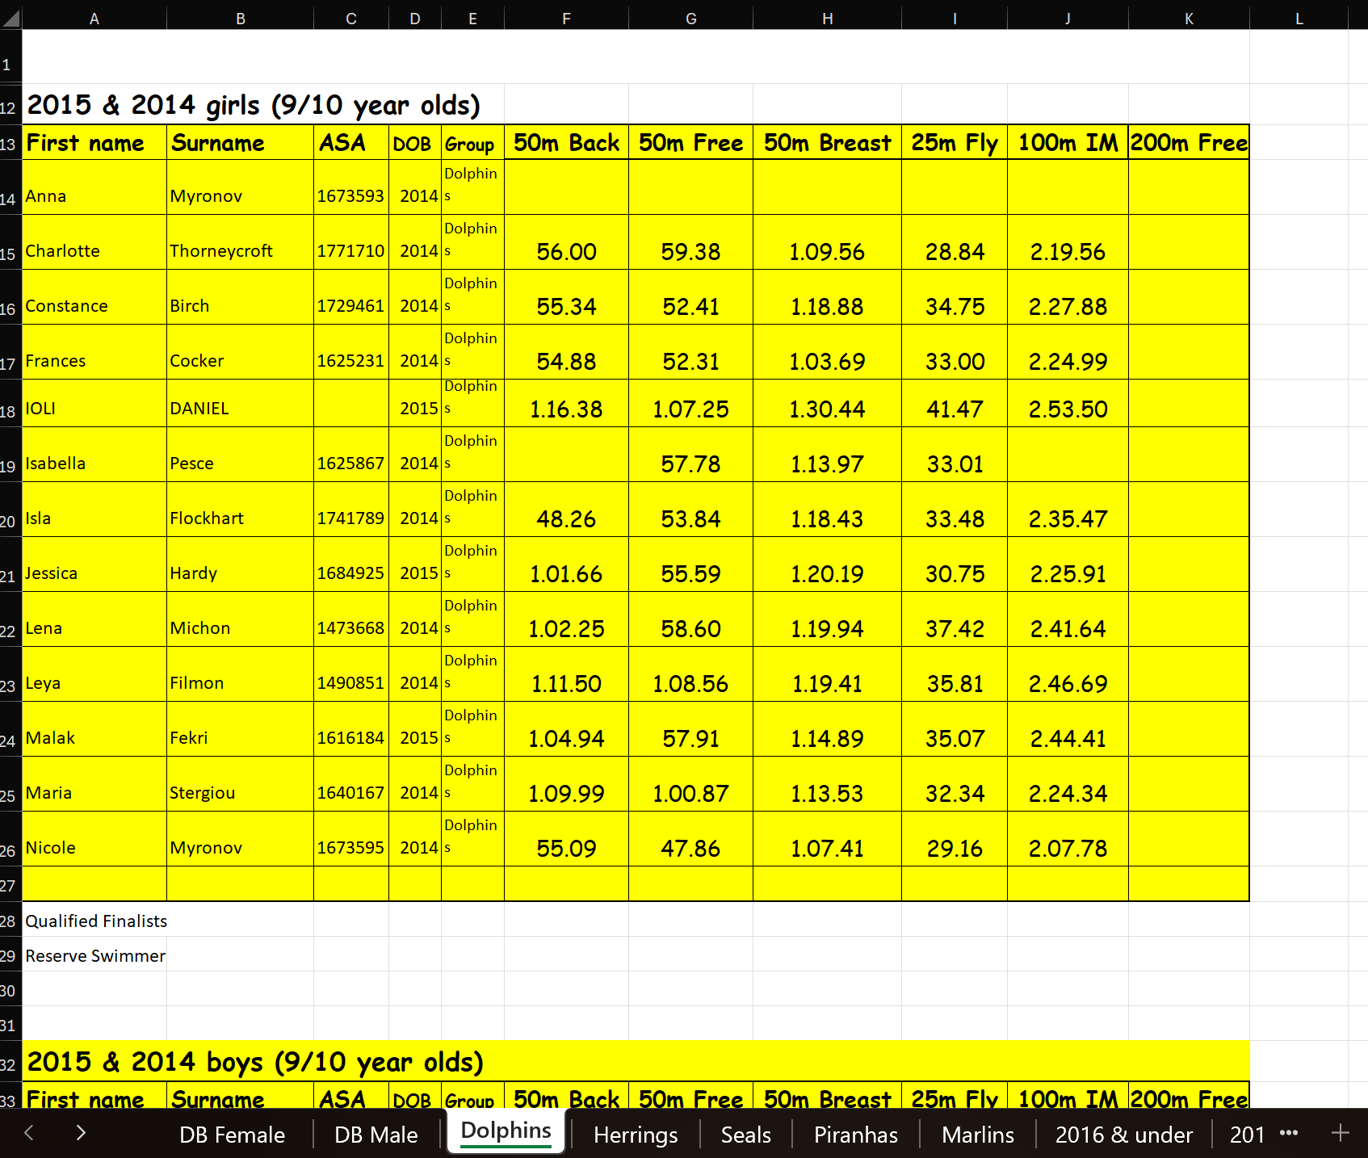
Important:
- The following sheets have to be included: Dolphins, Herrings, Seals, Piranhas, Marlins
- In between each table, there has to be at least one empty row. For example, this is not valid:
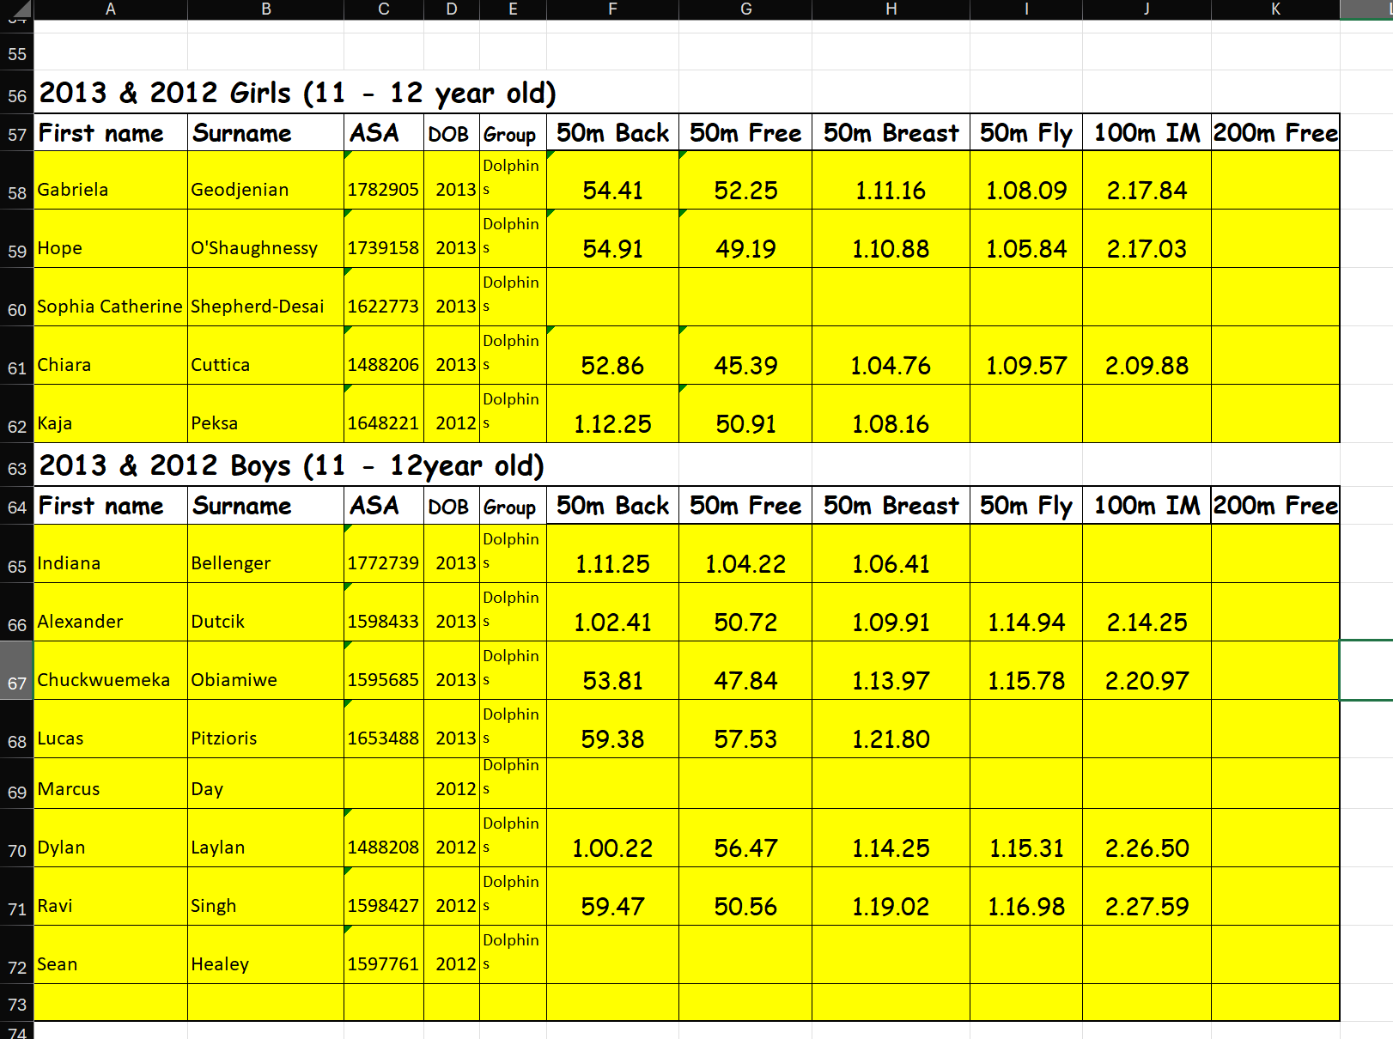
- The event name must be in the first column. For example, this is not valid:
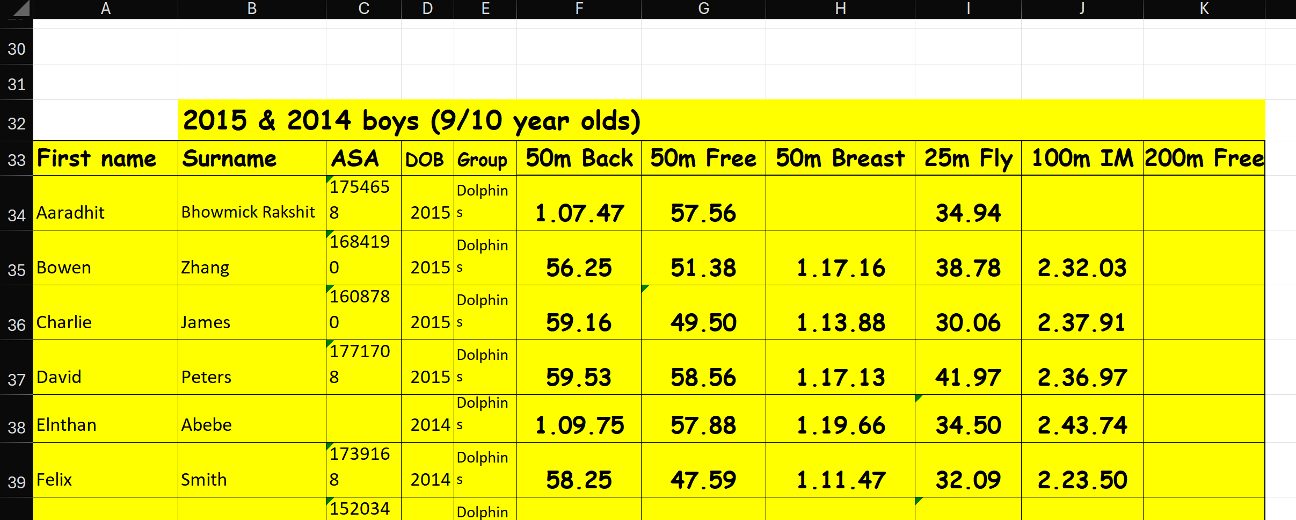
- Do not “hide” columns/rows. They will still be read by the program and may break things. You can just create a copy, delete those columns/rows and use that.

Leah’s Template EXCEL: this is Leah’s empty qualifiers excel sheet that she sends you. This looks like this:
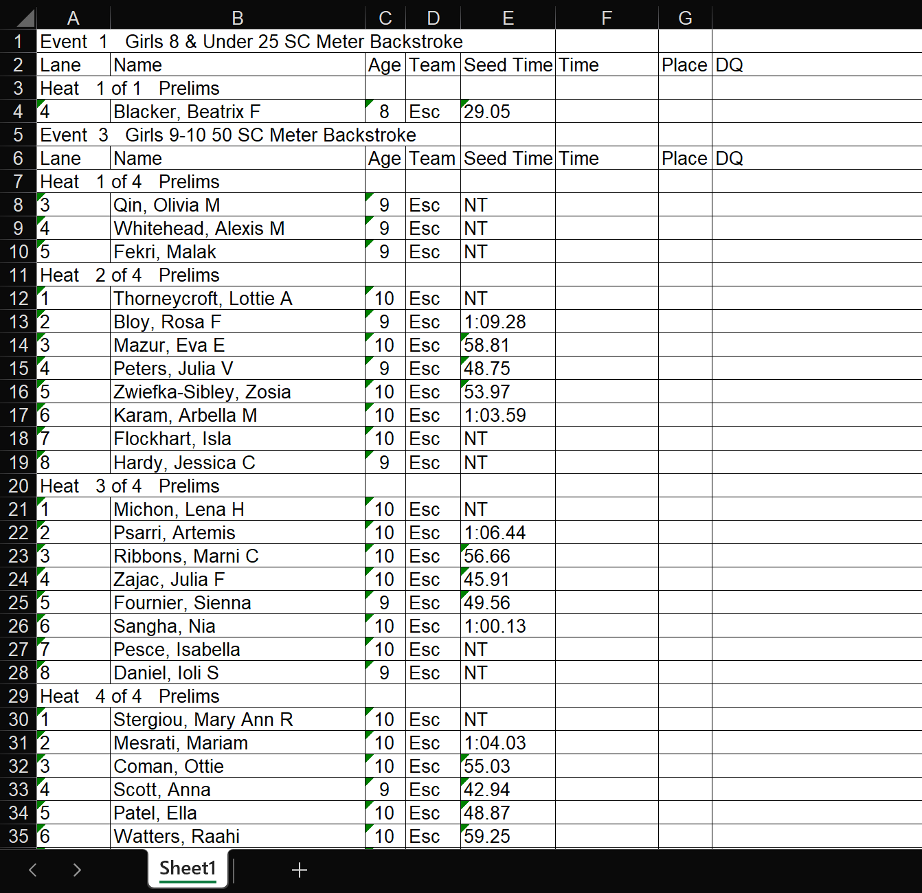
Important:
- This might not have “Place” and “DQ” columns. This is ok. As long as we have the “Lane”, “Name” and “Time” columns, it’s ok.
- The “Time” column can be named anything (e.g. “Prelim Time”, etc.) but needs to be consistent in the whole file (except for finals which need to have “Finals” as the column name).
- All events need to be valid. For example, a “50m IM” event will make the program crash.

Output File Location: Here you can specify the name of your output file and where to download it. If you leave it blank, it will create the output file “output.xlsx” in the same folder as the app.

2 – Check Qualifiers
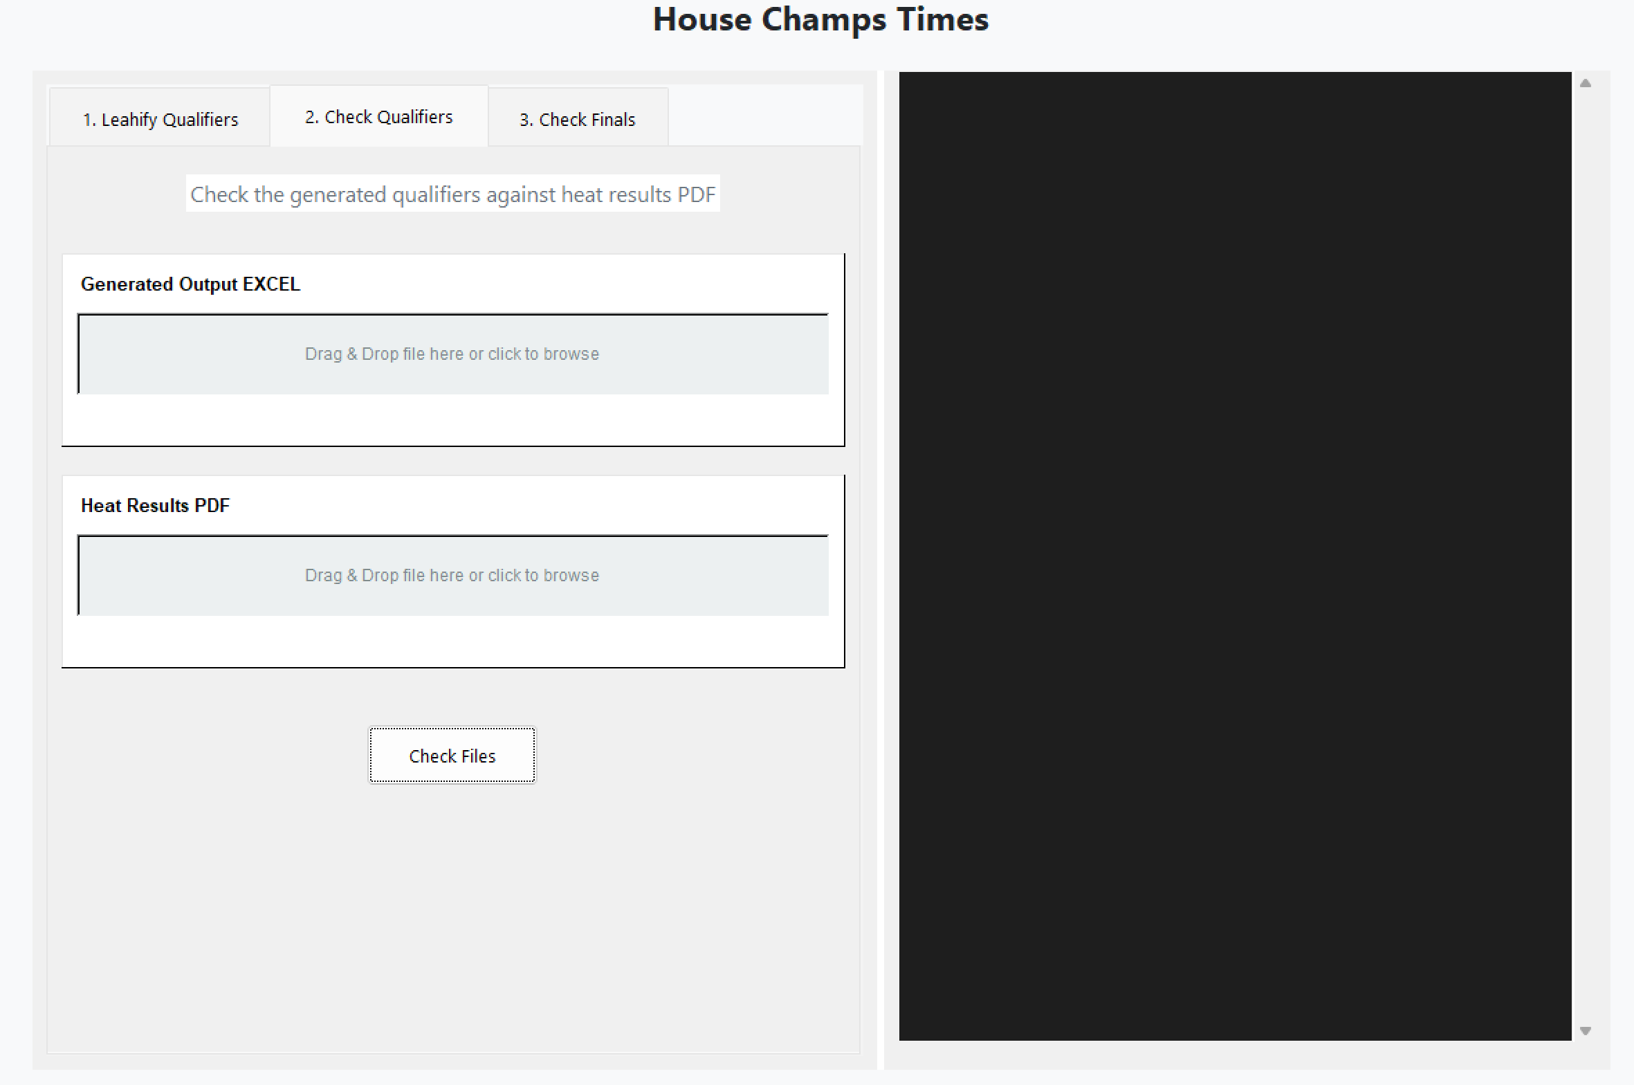
Generated Output EXCEL: this is the output file which is generated in the first part (Leahify Qualifiers). This looks like this:
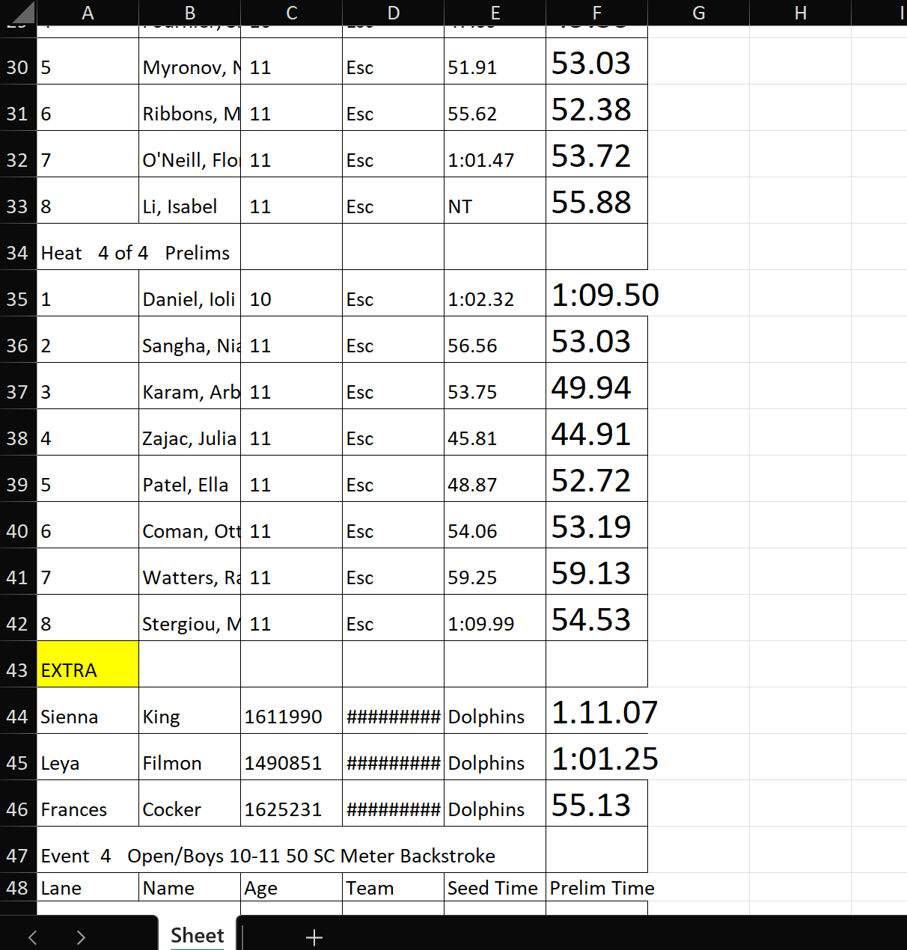

Heat Results PDF: this is the heat results PDF that Leah sends you after you send her all the qualifier times. This looks like this:
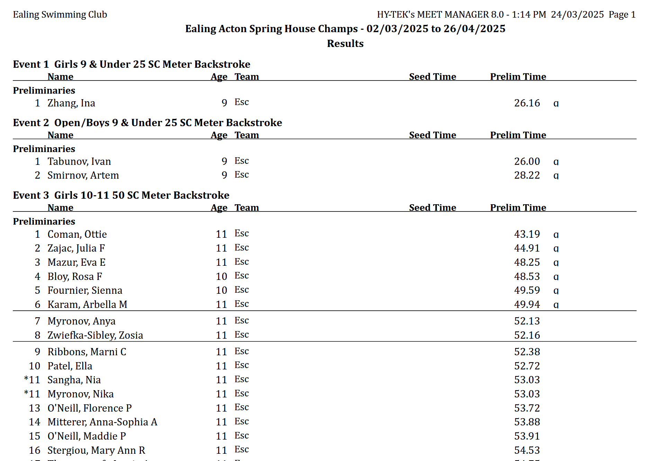
3 – Check finals
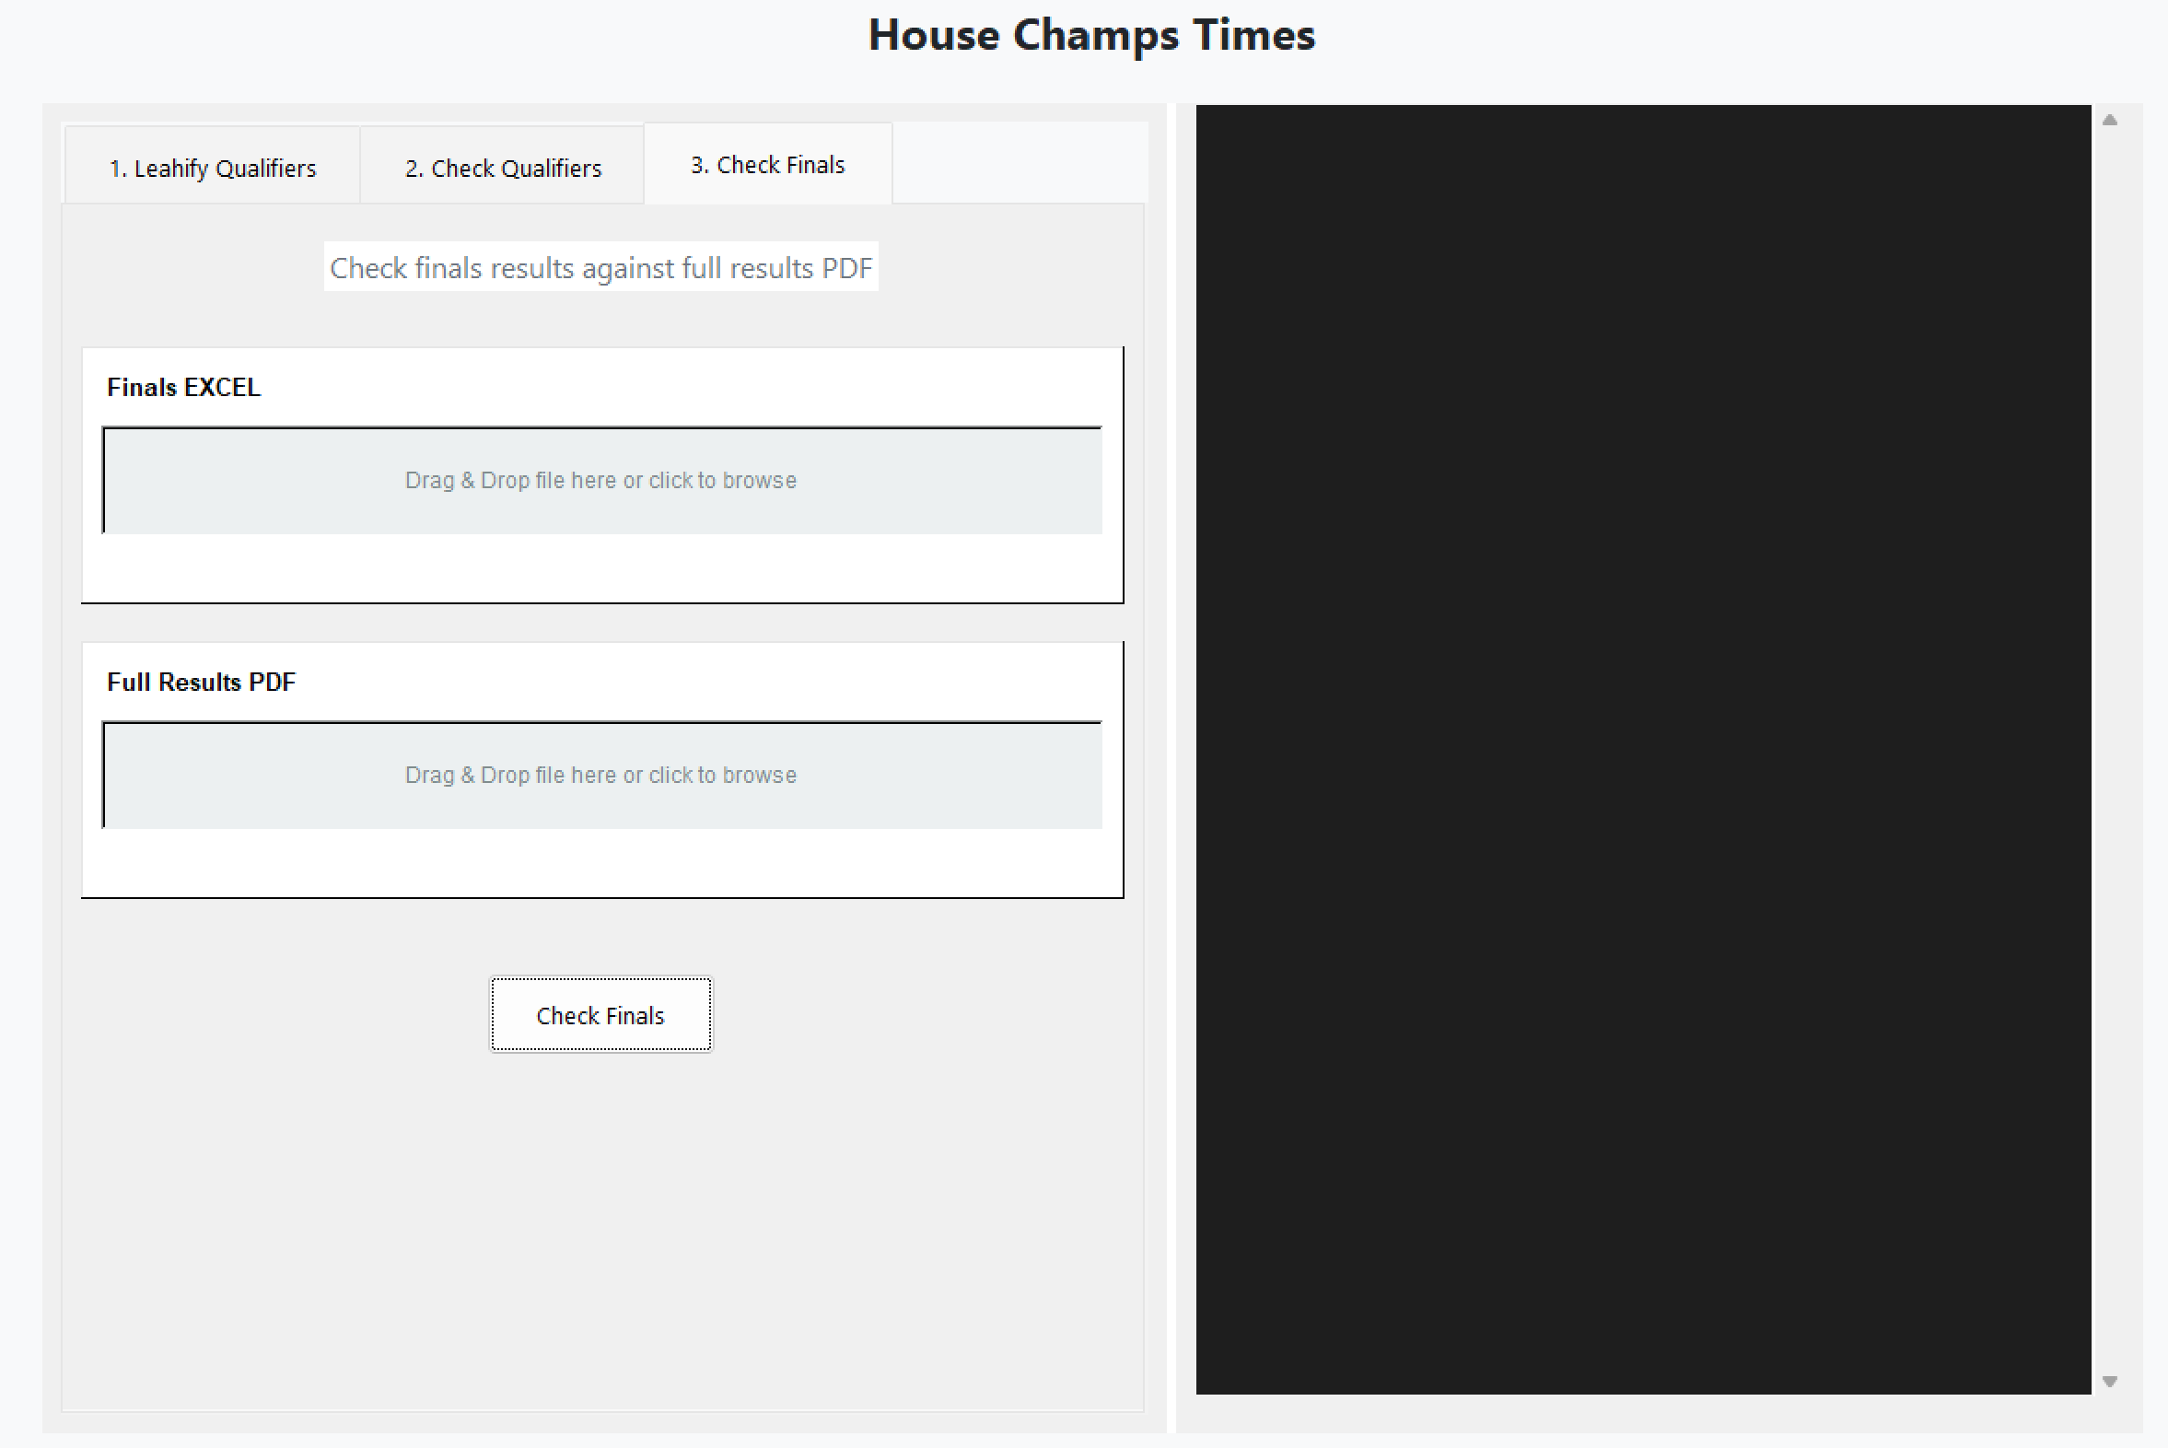
Finals EXCEL: this is the finals excel file that you would use on the day of the finals. This looks like this:
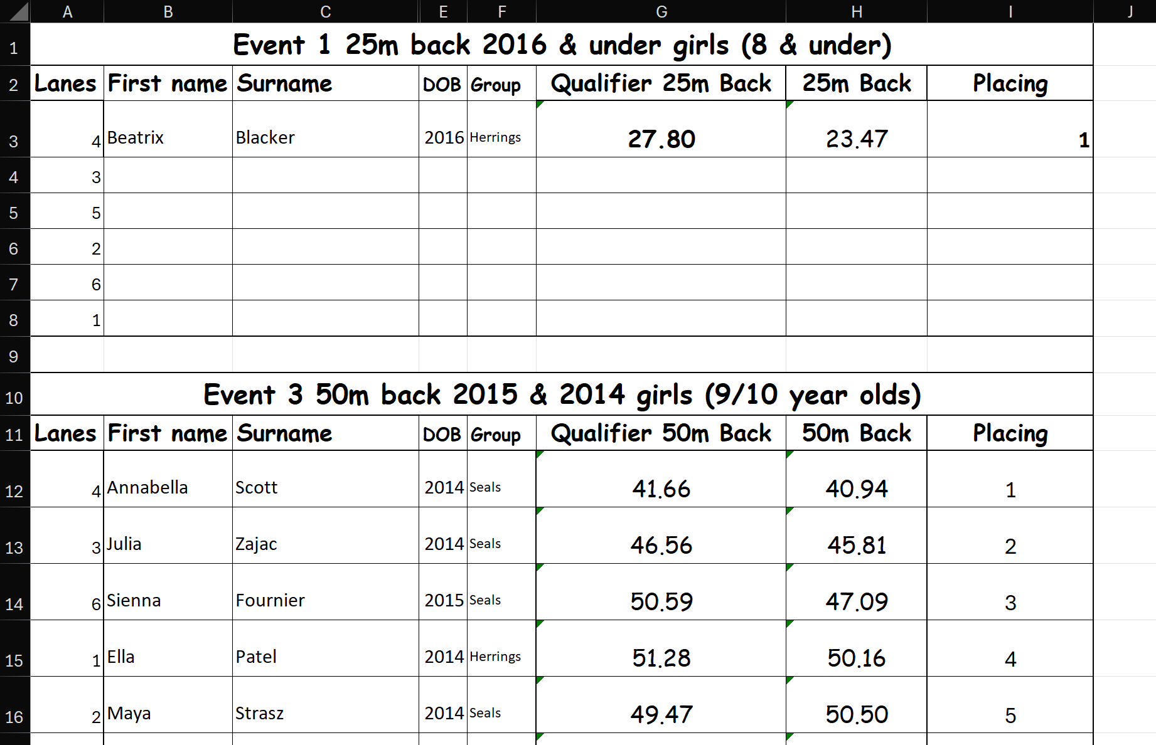
Important:
- There has to be at least one empty row between each event.
- Do not “hide” columns/rows. They will still be read by the program and may break things. You can just create a copy, delete those columns/rows and use that.

Full Results PDF: this is the full results pdf that Leah sends you after you send her your finals excel file. This looks like this:
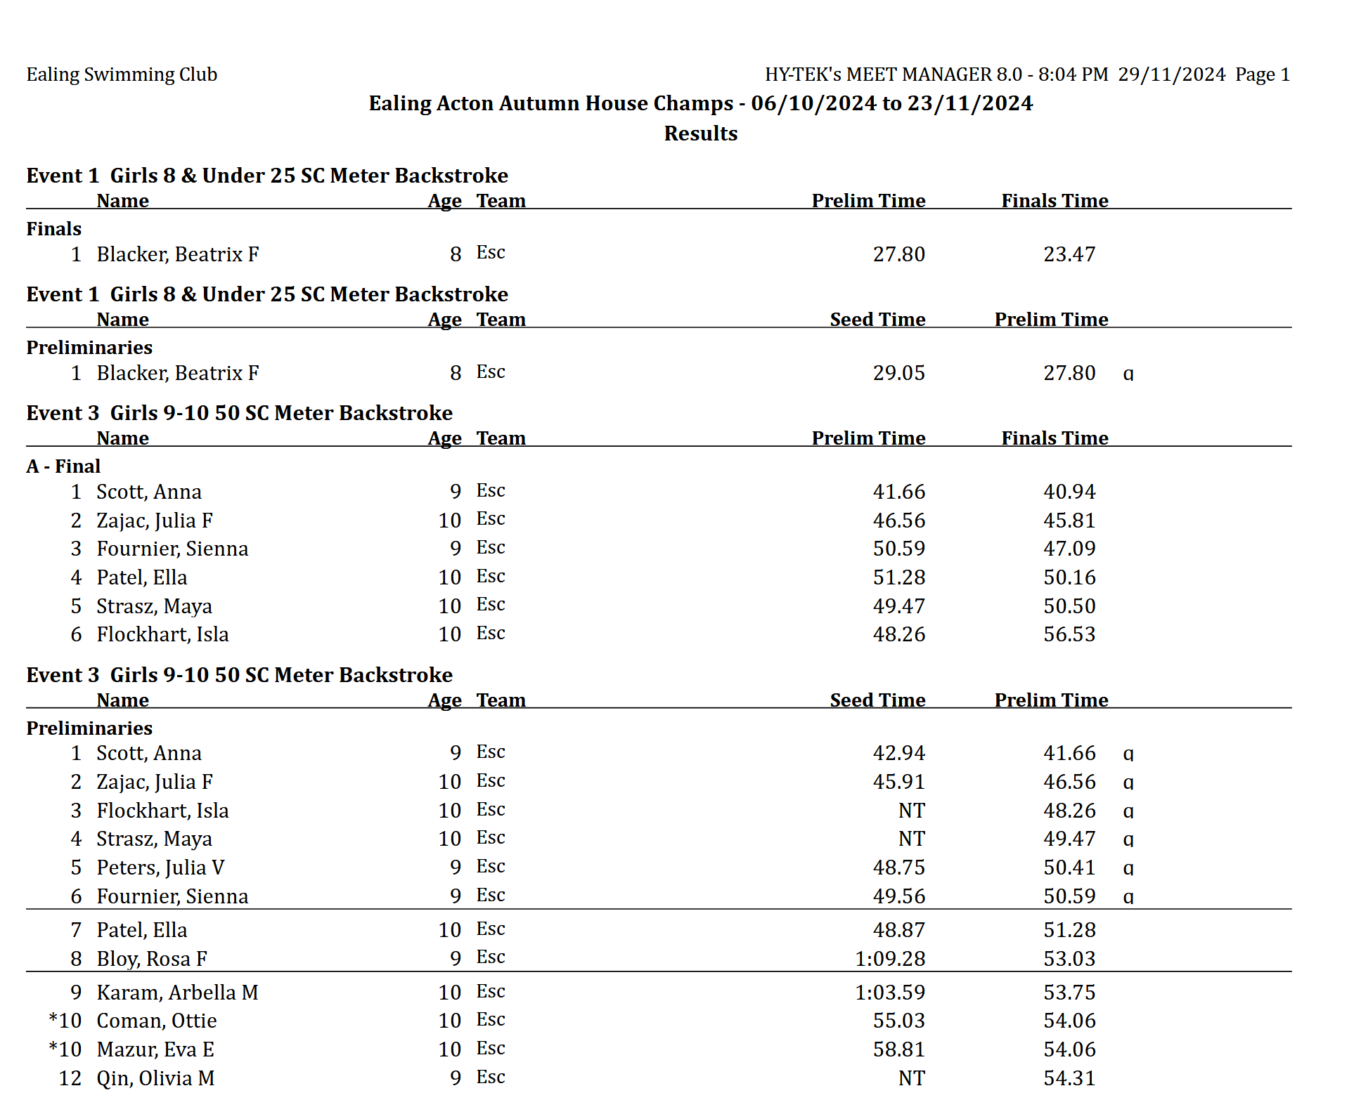
Important:
- This contains both the finals and qualifiers times. This is fine. But if it ever changes, then I’ll need to change the program.

