Ryan Haines

Assignment #3

3/8/16

Dr. Pulimood

**Proposal**

My proposed project will be to develop a web application that allows you to manage photos. A user will be able to upload and download their photos as well as organize and edit them. There already exist tools that allow a user to store photos but the ability to edit them is lacking. Putting an emphasis on editing functionality will help make this project more innovative than some other existing systems. For example, Adding the ability to crop and rotate photos and change filters like sepia or gray scale. The project will be written using the Ruby programming language. The algorithms being used in this project are involved with creating many different filters as well as sorting the photos. Creating filters, managing a database, and file conversions are some of the new concepts that I will learn from this project. In order to create a bigger toolkit for editing I will need to explore different editing techniques like filtering. I will need to have a place to store and manage all of the uploaded photos so utilizing a database is a something new. Learning how to change the formatting of pictures for downloading will be beneficial if a user wants to conserve space with a more compressed file type. This project is a web based photo management and editing application. This will allow users to store, organize, download, and edit their own photos.

**Licensing**

The three types of open source licenses that will be discussed are the MIT license, the Eclipse public license, and the common development and distribution license. The MIT license is very simple. Anybody who wants to use the software with this license can do what they please with it as long as the license is present in the initial or modified source code. The authors of the initial software will also not be held accountable for any damages that may occur when someone else uses it. The Eclipse license is similar to the MIT license in that all damages are responsible to the person selling any form of the licensed open source software not any other contributors. The Eclipse license also needs to be present for any source code. However this license states that you need to credit yourself as a contributor for any modifications made to the source code. The license also states that you cannot alter the license in any way. The common development license is more like the Eclipse license except for a couple of things. An initial developer can modify the license if they remove all references to the original license steward except for the reference explaining the modifications. The other thing that differs is that all parties are responsible for damages and contributors and original developers work together to distribute responsibility. For the project, the MIT license seems to be the best fit. The license it straight forward and simple to understand. If someone wants the ability to edit and organize their photos online or if someone wants to improve upon the work I have done, there should not be a lot of legal jargon to worry about. People already have the ability to organize photos freely with other software, this project should be no different.

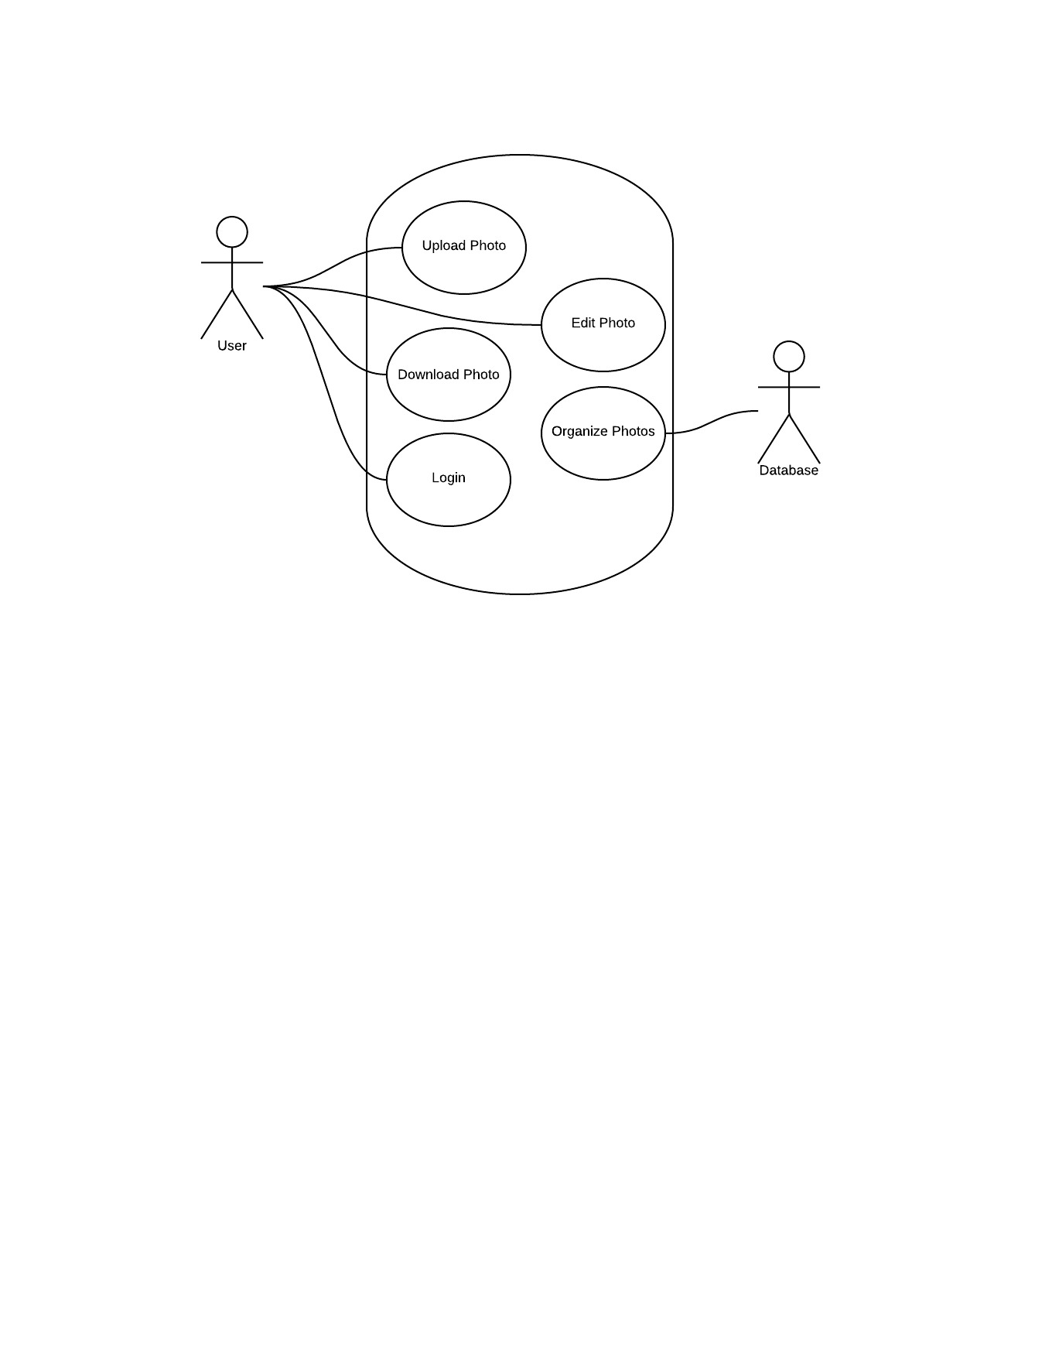

Github Repository

SE_Individual_Project: <https://github.com/ryanhaines55/SE_Individual_Project->

MIT License

Permission is hereby granted, free of charge, to any person obtaining a copy of this software and associated documentation files (the "Software"), to deal in the Software without restriction, including without limitation the rights to use, copy, modify, merge, publish, distribute, sublicense, and/or sell copies of the Software, and to permit persons to whom the Software is furnished to do so, subject to the following conditions:

The above copyright notice and this permission notice shall be included in all copies or substantial portions of the Software.

THE SOFTWARE IS PROVIDED "AS IS", WITHOUT WARRANTY OF ANY KIND, EXPRESS OR IMPLIED, INCLUDING BUT NOT LIMITED TO THE WARRANTIES OF MERCHANTABILITY, FITNESS FOR A PARTICULAR PURPOSE AND NONINFRINGEMENT. IN NO EVENT SHALL THE AUTHORS OR COPYRIGHT HOLDERS BE LIABLE FOR ANY CLAIM, DAMAGES OR OTHER LIABILITY, WHETHER IN AN ACTION OF CONTRACT, TORT OR OTHERWISE, ARISING FROM, OUT OF OR IN CONNECTION WITH THE SOFTWARE OR THE USE OR OTHER DEALINGS IN THE SOFTWARE.