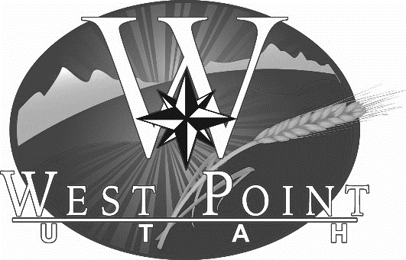
City Council Staff report

Subject: Quarterly Financial Report (July – Sept 2025)
Author: Ryan Harvey
Department: Administrative Services
Meeting Date: November 18, 2025

Background
City staff monitors revenues and expenditures on an ongoing basis throughout the year. We issue a quarterly financial report to give the City Council a snapshot of our financial state and as a report on our financial progress for the fiscal year. The attached report contains expenditure, revenue, budget, and balance sheet data for each City fund for the first quarter of Fiscal Year 2026, representing July 1 – September 30, 2025. This information is summarized in the graphs below.

Analysis
As shown in the first graph, revenues exceed expenditures in every fund within the City except for the Capital Projects Fund, which receives its funds through the transfer at the end of the year. With 25% of the year elapsed, revenues exceed 25% in every fund, except the Capital Projects Fund. All of the funds continue to benefit greatly from the interest that the City has earned in the PTIF account so far this year.

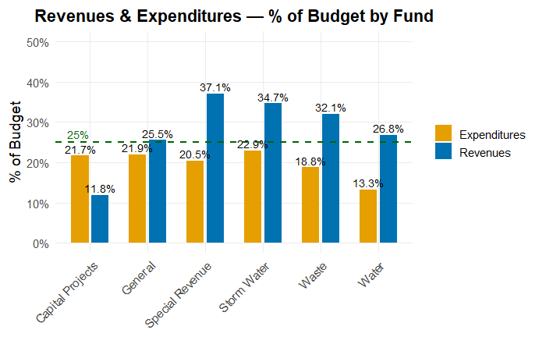
Year-to-date revenues are generally ahead of a straight-line 25% benchmark. Special Revenue (37.1%), Storm Water (34.7%), Waste (32.1%), Water (26.8%), and the General Fund (25.5%) are all at or above pace, while Capital Projects is lower at 11.8% due to timing.

Expenditures remain below the straight-line 25% benchmark across all major funds: General 21.9%, Special Revenue 20.5%, Capital Projects 21.7%, Waste 18.8%, Water 13.3%, and Storm Water 22.9%.

Overall, the City is tracking within appropriations with revenues modestly ahead of pace and spending below pace, indicating healthy operating cushions across funds at this point in the fiscal year.

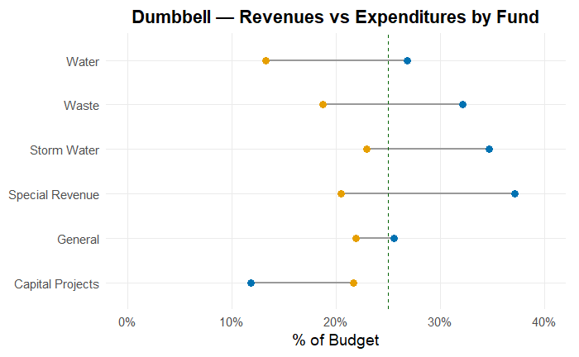

Within the General Fund, most departments are currently below the straight-line 25% benchmark for year-to-date expenditures. Engineering (20.7%), Recreation (19.9%), Community Development (19.7%), General Government (17.4%), Parks & Cemetery (17.3%), and Public Works (17.0%) are all materially under pace. Public Safety (23.5%) and Executive (23.5%) remain close to benchmark but still below it. Only Administrative Services is above benchmark at 27.5%. This is due to the insurance through the Local Government Trust for the year being already paid.

Overall, General Fund operating spending is well-controlled at this point in the fiscal year.

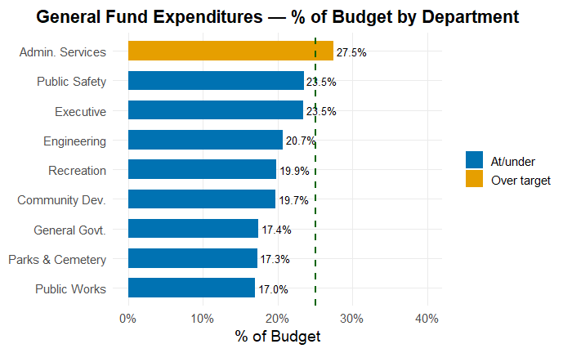

Recommendation
No action required. This report is for discussion/information purposes. Staff would appreciate any feedback or direction the Council may have.

Significant Impacts
There are no significant impacts at this time.

Attachments
FY2026 Q1 Financial Statements

