Student Performance Prediction Using Machine Learning

Ryan Harvey
October 1, 2025

Project Summary & Problem Framing

Overview of the Project
This project develops machine learning models to predict final student grades using demographic, behavioral, and academic features. The objective is to support targeted academic interventions for students at risk of underperforming.
In analyzing the data early on, there were two features that particularly jumped out as being very predictive of the final grade, and those were the first term grade and the second term grade. Because there are times when we may want to intervene before we have those numbers, I decided to split the analysis into two scenarios: “With Grades” and “Without Grades.”

Results of the Project
The “With Grades” models quickly stood out as the clear winners in predicting final grades. The best model that I created with prior-term grades included was able to predict the grades within two points of the final grade. If early intervention is not necessary, then this model could be useful.
“Without Grades” on the other hand, was much more limited in its accuracy. The best model that I was able to create without using prior-term grades only predicted the final grades within a little over four points. While not as accurate as the “With Grades” models, this model can still be useful, especially for identifying students that might be at-risk rather than predicting their final scores in the class.

Recommendations
- Use “With Grades” model to identify students in need of intervention when it is later in the year.
- For early-year detection, use the “Without Grades” model to identify students that need additional help.
- Focus on reducing absences by holding meetings with students and parents of the students that rank high.
- Hold required seminars on the importance of higher education, encouraging the students to plan on attending.
- Incorporate structured in-school study blocks to increase weekly study time among at-risk students.

Data Overview

Overview of the Data
The data that I used in my analysis comes from UC Irvine’s machine learning repository and has been slightly modified for this analysis. It contains student performance data from two Portuguese schools, originally collected from school reports and questionnaires. The dataset contains 395 entries, across 35 features. The following four features contain some missing data: age (12), absences_G1 (13), absences_G2 (9), absences_G3 (14). The absences represent the prior-year absences from the specified term.
After splitting the data into an 80/20 train/test split, I was left with 316 entries across 35 features. The following features still contained missing data, but a little less for each feature: age (9), absences_G1 (10), absences_G2 (7), absences_G3 (9).

Target Variable and Correlations with other Features
The target variable that I identified is the final grade. It was noticeably clear early on that the two features that were most highly correlated were the grades from the previous two terms. Outside of those two features, I ran some other correlation tests and found the following features showed some correlation, and as such included them in my models:
- Absences_G1, Absences_G2, Absences_G3 (number of school absences for previous year’s G1, G2, and G3 terms)
- Failures (number of past class failures)
- Age (student's age from 15-22)
- Higher (wants to take higher education, yes or no)
- Internet (Internet access at home, yes or no)
- Schoolsup (extra educational support, yes or no)
- Address (student's home address type ("U" - urban or "R" - rural))
- Medu (mother's education (0 - none, 1 - primary education (4th grade), 2 – 5th to 9th grade, 3 – secondary education or 4 – higher education))
- Fedu – (father's education (0 - none, 1 - primary education (4th grade), 2 – 5th to 9th grade, 3 – secondary education or 4 – higher education))
- Studytime (weekly study time (1 - <2 hours, 2 - 2 to 5 hours, 3 - 5 to 10 hours, or 4 - >10 hours)
- Famrel (quality of family relationships (from 1 - very bad to 5 - excellent))

Two-Model Approach
As mentioned, the grades from terms one and two had the highest correlation with the final grade. One of the purposes of the project, however, was to determine if there was a way to intervene early in the school year for students that might need the help. Therefore, I found it necessary to run two separate sets of models, one with the grades of terms one and two included, and another set of models without the grades included.
The two-model approach will have a significant impact on the usefulness of the models. The model with grades will only be useful later in the school year, after a student has received final grades for the first two terms. The model without grades included will be useful much sooner in the school year since it is not based on those grades. While the model without grades will be less predictive of the final grade, it will be much more useful earlier in the school year.

Analytical Insight

Main Findings of Data Exploration
In exploring the dataset, I decided to use four different charts and graphs to visually show what is going on with the data.
The first chart is a histogram that shows the Final Grade distribution:
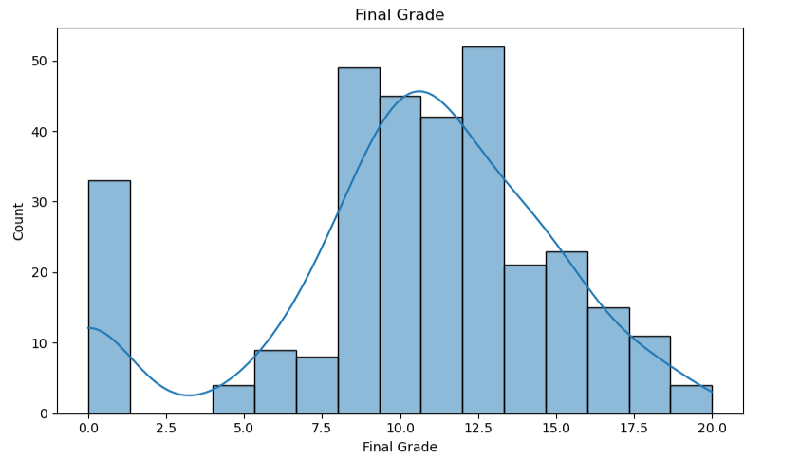
The Final Grade is on a scale from 0-20, with the following scale, and the U.S. Equivalent:
Portuguese Grade U.S. Grade Equivalent
18 – 20 A+
16 – 17.99 A
14 – 15.99 B
10 – 13.99 C
0 – 9.99 F
From the distribution chart, we can see that there are many students that are on the cusp of a failing grade (<10). This could suggest that if we do just a little more to help those students, it could possibly have a large effect on the passing rate of the class. There are also many students in the 10 – 13.99 range that could also benefit from a little extra intervention to get them up to the 14 – 15.99 range.
The next chart shows some of the top correlations with the ordinal data in the dataset:
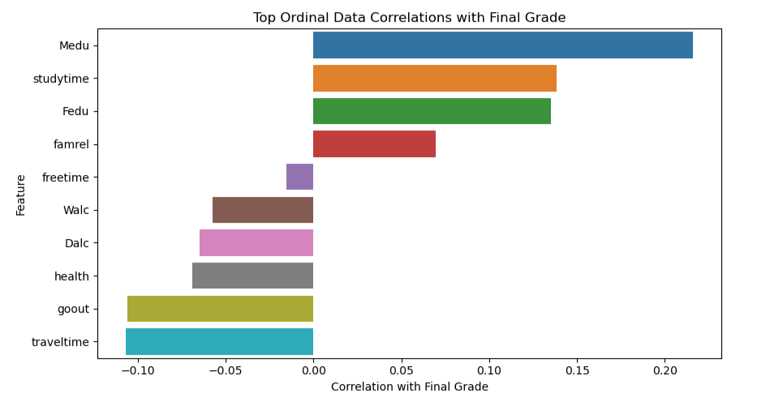
This chart is extremely helpful in determining what ordinal data is correlated with the final grade. We see here that the level of education that the mother of the student received has the highest correlation with the final grade. That is followed by weekly study time, then the level of education the father received, then the quality of the student’s family relationships.
It is interesting that two of the four highest correlated ordinal features are ones that the student has no control over. The student cannot control to any degree what level of education their parent’s receive. Additionally, while the student may have some control over the quality of their family relationships, in many cases they might have little to no control depending on the other family members. I think that it is still important to keep those features as part of the prediction model, even though those are not areas where we can have a major impact.
As far as the study time goes, that is an area where I see great potential. Since it is so highly correlated with the final grade, it is an area where we can really help the students improve. In addition to teaching them the importance of studying at home, we could give them opportunities to study during school time to help them get the hours that they need to succeed.

The next visual is a series of boxplots showing how categorical data correlates with the Final Grade:
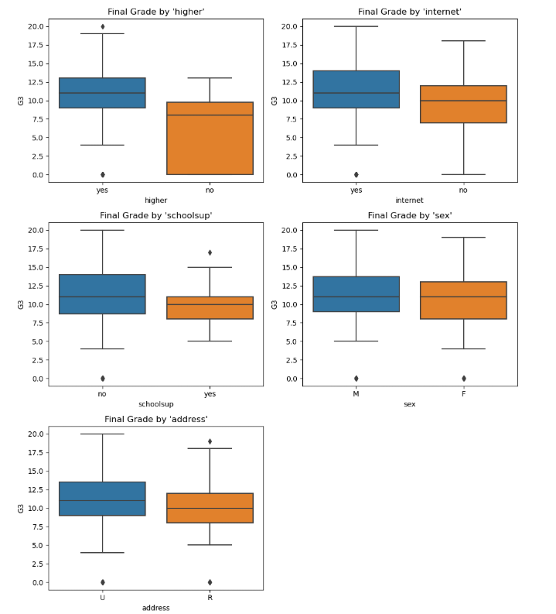
It is interesting to see how these various categories correlate to the Final Grade. There is a visual difference in the means in all of them, outside of “sex”, with the biggest difference shown in “higher,” which is whether the student wants to take higher education or not. Not only is there a large difference in the means of that category, but there is a large difference in the entire box, which represents the middle 50% of the data.
Another noticeable difference in the “internet” feature, which represents whether a student has access to the internet in their home. Students with internet access tend to have a higher final grade than those without it.
Thinking about those two features, there is a lot of potential for action. With the “higher” feature, the school could put a lot of emphasis on getting students to want to take higher education. The school could put on seminars and have the teachers take time during their classes to discuss the benefits of higher education to get the students to realize how important it is.
Regarding those students without access to the internet in their homes, the school could encourage those students to stay after school and use the school’s internet. We could have an hour or two each day before and/or after school when students can come and use the school’s internet. We could advertise this with the parents so that they are aware of the additional study time offered by the school. This would go right along with helping students increase their overall study time, since that was one of the key features of the previous chart.

The final chart is a scatterplot showing the relationship prior-year absences have with the Final Grade:
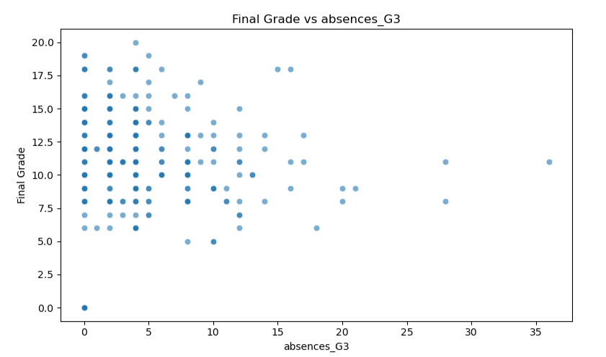
There is a negative correlation between number of prior-year absences in the 3rd term, and the Final Grade, but it’s not a perfect correlation. From the scatterplot it is clear to see that there are many students that have 10 or more absences and still receive a Final Grade of 10 or higher. However, because of the negative correlation, it is a feature that would be important to use in the model.
It is also something that we could focus on moving forward. If we can help students miss less school, that could have a significant impact on their final grade. Not only does being there and participating help, but it would go along with our plan to help the students have more study time as we talked about in the past two sections.

Additional Insights
A few additional insights from the data that are not shown in the visuals:
- There is very little missing data. As stated in the Data Overview section, there is only minimal missing data in the training set, and not enough that simple imputation can’t handle without distorting the results.
- There are not any duplicate or constant columns. There is enough variation in the columns, so that it is not necessary to drop any columns for being constant.
- The total sample size of 316 is relatively small. Small datasets risk overfitting, so that is something to be aware of as we go through and build our predictive models.
- Outliers exist in the data but are not dominant. Because of that, I have not spent a lot of time accounting for them in the data.
- Self-reported behaviors are always subject to internal bias. Features like study time and alcohol use should be studied carefully due to self-reporting issues.

Feature Selection
I selected the following features, and grouped them into the three different types of data, Numeric, Categorical, and Ordinal:
Numeric:
- Prior-Year Absences (I combined the absences for all three terms into one feature)
- Term 1 Grades (took out for the “Without Grades” Models)
- Term 2 Grades (took out for the “Without Grades” Models)
- Past Class Failures
- Age
Categorical
- Higher Education
- Internet Access
- School Support
- Address (Urban or Rural)
Ordinal
- Mother’s Education
- Father’s Education
- Study Time
- Family Relationships
The reason for selecting these thirteen features (15 original features but combining absences into one feature) is because after doing my analysis of the data, these are the top features from each of the three types of data. There are some that have stronger correlation than others, but I felt like this was a good range. If I included more features, I felt that it would be too many to create good, reliable models. On the other hand, if I stripped it down to only the strongest four or five features, it may not have been enough data to create reliable models.
It would be interesting to run the models again but only using one or two of the strongest features from each section. On the other hand, it would be interesting if I were to just use all the features in the dataset.

Methodology

Overview of Machine Learning Models
I used three different Machine Learning Models:
Linear Regression – This uses all the inputs and combines them into a straight-line model to predict the outcome. Each input that you add to the model will adjust the prediction slightly up or down, depending on the strength of the input. This type of model works well when the relationships between the variables are mostly linear. It is also the easiest to understand and show visually.
Lasso Regression – This is very similar to Linear Regression, but with a built-in penalty for variables that add little to the model. The model automatically minimizes the weight of those variables and can sometimes zero them out completely. This works well when you don’t know if a variable will add to the overall model or not.
Support Vector Machine Regression – This uses the inputs to be able to fit a curved relationship between the variables. It is a model that can notice patterns beyond just straight lines, unlike the two models listed above. It is particularly good for modeling nonlinear data and inputs.

Model’s Performance
I used two main metrics to measure the performance of the models:
Root Mean Squared Error (RMSE) – We can think of this as how much the average “miss” will be for the model. For example, if the RMSE is 2, then the model will generally predict the correct score within two points. The lower the RMSE is, the better the model is at predicting what the final grade will be.
R-squared (R²) – This explains the variation we can explain. For example, if the R² is 0.78, then the model explains 78% of the variation in grades. The remaining 22% can be thought of as noise or factors that do not appear in the data. The higher the R² the better the model is at predicting the final grade accurately.

Key Results

The Results for all Models
The results of the six different models on the Training Data are as follows:
“With Grades”:
RMSE R²
Linear – 1.870 83.2%
Lasso – 2.171 77.4%
SVM – 2.378 72.8%

“Without Grades”:
RMSE R²
Linear – 4.281 11.8%
Lasso – 4.381 8.0%
SVM – 4.274 12.3%
Based on the predictions above, I chose to use the Linear Regression model for the “With Grades” model, and the SVM Regression model for the “Without Grades" model. When applying those models to the Test Data the results are as follows:
“With Grades”:
RMSE R²
Linear – 2.142 77.6%

“Without Grades”:
RMSE R²
SVM – 4.154 15.8%

As you can see the Linear Regression “Without Grades” Model performed slightly worse in the test data than in the training data. Even with the lower scores, it still does a decent job of predicting the final grades with an RMSE of 2.142, and an R² of 77.6%.
The SVM Regression “Without Grades” Model performed slightly better in the test data then in the training data. With an RMSE of 4.154 and an R² of 15.8%, it is not the greatest tool for predicting final grades, but it can function as a good starting point at identifying potential problems before the term one and two grades are known.

Model Implementation
The two models that have been created should be implemented, as long as the limitations are understood. The Linear Regression “With Grades” Model performs very well and can be relied upon to predict grades within two points. The limitation is that it can only be used later in the year when the term 1 and term 2 grades are known.
The SVM Regression “Without Grades” Model should be implemented as well. This model does not predict final grades with the accuracy of the “With Grades” model, but it serves as a starting point before the terms 1 and term 2 grades are known. It can be used at the beginning of the year to flag potential problem students, knowing that the range is just over four points. It can be especially useful for those that are hovering right around a passing grade of 10, because even with the model being off by an average error of four points, those students could use help. The ones as far down as 6 need help getting to a passing grade, while the ones closer to 14 could use the help to bump their grade up to a more proficient level.

Business Recommendations
- Use “With Grades” model to identify students in need of intervention when it is later in the year.
- For early-year detection, use the “Without Grades” model to identify students that need additional help.
- Focus on reducing absences by holding meetings with students and parents of the students that rank high in this category.
- Hold required seminars on the importance of higher education, encouraging the students to plan on attending.
- Give students 1-2 hours during school time to use as their Study Time
- Since “With Grades” was such a strong predictor, add a mid-term grade to the data, so that we can get a stronger indicator sooner.

Conclusion

Successful Aspects of Project
The most successful part of the project was separating the data into “With Grades” and “Without Grades.” Separating the models by intervention timing proved to be the most valuable design decision in the project. It made so much sense to take out the data that would not be relevant until later in the term and then try to figure out if the data was still useful without the term grades.
The models that I used to evaluate the two different sets of data were very helpful. It made sense that the Linear Regression Model would be the strongest for the “With Grades” data. It was also interesting to see how the three models differed for the “Without Grades” data.

Unsuccessful Aspects of Project
The most unsuccessful part of the project was developing a reliable model for the “Without Grades” data. All three of the models had a high RMSE, along with a very low R². Possible reasons include the sample size being low, a large amount of self-reported measures, using only three types of models, and the possibility that the data collected just does not allow for good predictions of the final grade.
I wanted to be able to recommend a solid model that could predict final grades not only at the end of the year, but also early in the year. The data and the models that I used just did not allow me to do that.

Next Steps
- Implement the Recommendations: There are enough insights from the models that were created to implement some changes. Implementing the recommendations should help the school to target the right students and help them to improve their final grades.
- Collect Better Data: It would be helpful to add data, such as mid-term grades, or mid-year assessments that would help to predict final grades sooner. It would also be helpful to investigate if there are already other features that are not being used, such as prior-year grades.
- Use Additional Models: We could go back to the data and try additional models beyond the three that we already created. Models such as RandomForest or Ridge Regression could possibly predict the final grades better than what we used.

