Flow Cytometry Data Reader and Plotting Example
Flow cytometry is a method for quantitating components or structural features of cells primarily by optical means. Although it makes measurements on one cell at a time, it can process thousands of cells in a few seconds. Since different cell types can be distinquished by quantitating structural features, flow cytometry can be used to count cells of different types in a mixture[1].

Importing data 1
Visualization 1
References 5

Importing data
The standard output of a flow cytometry machine is an FCS file. This is somehow related to FACS (Fluorescence-Activated Cell Sorter) machines, which are made by Becton-Dickinson. These are binary files with a fairly complex format. The function fcsread can read what seems to be the most common flavour of FCS files. The output is an array with each column representing a different parameter. Some of these are measured on a linear scale, others are measured on a log scale. The second output is a structure giving information about the parameters.

[data,params] = fcsread('SampleFACS.fcs');

Visualization
A histogram of one parameter is one way to look at the data.

hist(data(:,1),max(data(:,1))-min(data(:,1)));
title(params(1).LongName);

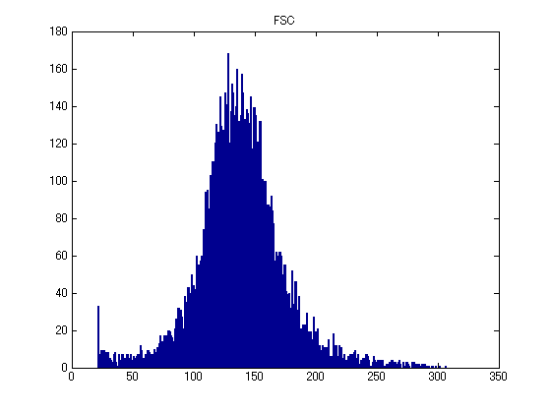

A more interesting way to look at the data is to create a scatter plot of two of the parameters. In this case the second paramter is measured on a log scale.

numDecades = params(2).Amplification(1);
theRange = params(2).Range;
semilogy(data(:,1),10.^(data(:,2)/(theRange/numDecades)),'+');
xlabel(params(1).Name); ylabel(params(2).Name);

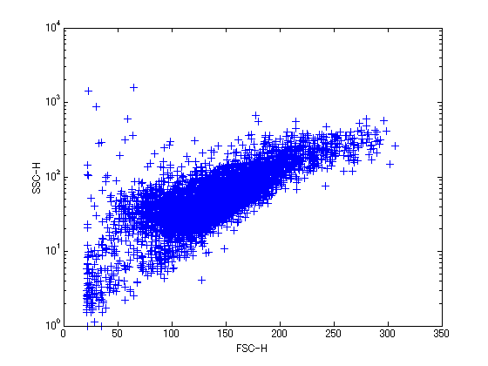

An even better visualization is to look at the scatter plot coloured by density of the scatter. The function dscatter does this.

dscatter(data(:,1),10.^(data(:,2)/256),'log',true)
xlabel(params(1).LongName); ylabel(params(2).LongName);

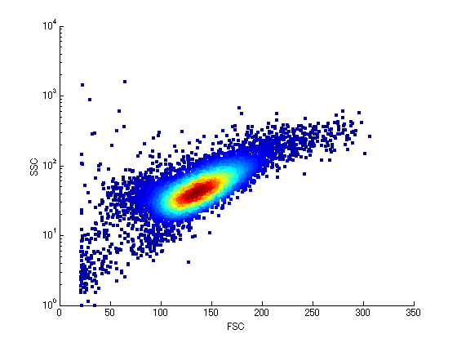

A second call to dscatter adds contours.

hold on
dscatter(data(:,1),10.^(data(:,2)/256),'log',true,'plottype','contour')
hold off

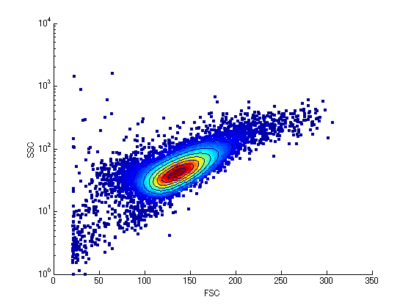

References
[1] http://www.bio.umass.edu/mcbfacs/intro.htm

