Show Stream Data Aggregation and Analysis with SQL
*All SQL Query and Table generation done in BigQuery

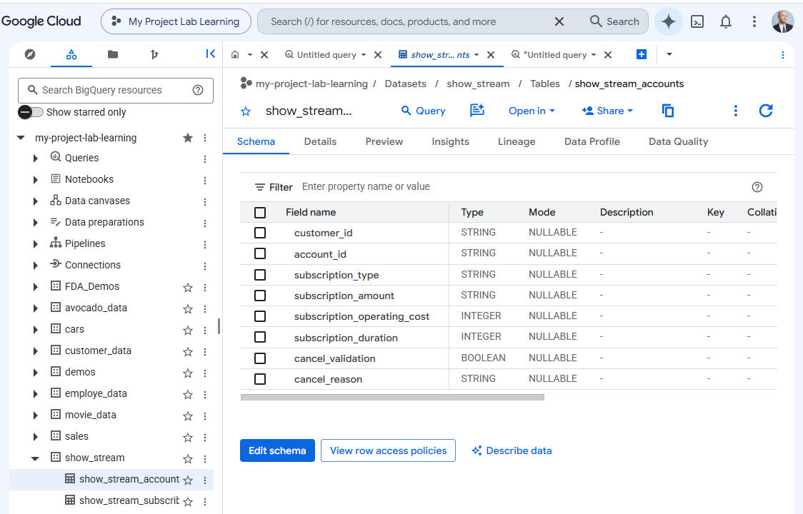

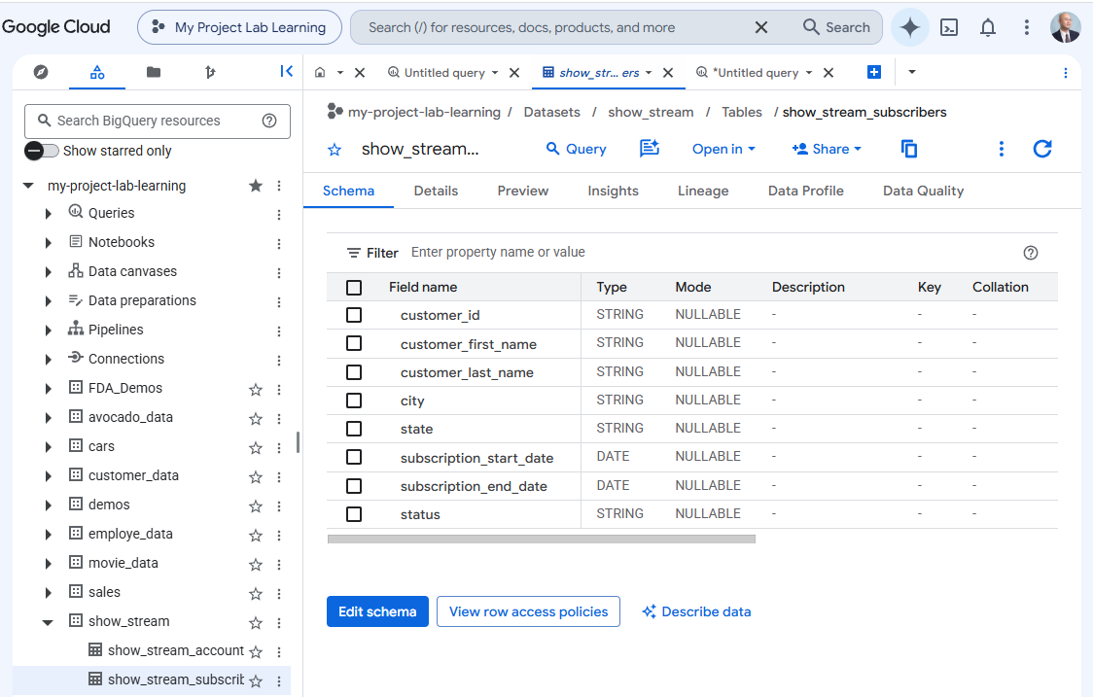

Code Block
Selecting all relevant columns from t1 show_stream_accounts table and t2 show_stream_subscribers table.

SELECT DISTINCT -- Distinct to avoid duplicates
t1.customer_id,
t1.account_id,
t1.subscription_type,
t1.subscription_amount,
t1.subscription_operating_cost,
t1.subscription_duration,
t1.cancel_validation,
t1.cancel_reason,
t2.customer_first_name,
t2.customer_last_name,
t2.city,
t2.state,
t2.subscription_start_date,
t2.subscription_end_date,
t2.status
FROM `my-project-lab-learning.show_stream.show_stream_accounts` AS t1
FULL OUTER JOIN -- Full outer join to include all rows from both tables
`my-project-lab-learning.show_stream.show_stream_subscribers` AS t2
ON t1.customer_id = t2.customer_id
WHERE t1.customer_id IS NOT NULL; -- Filter to only include rows where customer_id is not null

Code Block
4 Year Analysis
Creating New Table for with calculation for the following Columns:
Year, New Signups, Cancellations, Net Growth, Revenue, Cost, Gross Profit, Profit Margin

SELECT
EXTRACT(YEAR FROM t2.subscription_start_date) AS Year, -- Set up for Years 2022, 2023, 2024, 2025
COUNT(DISTINCT t1.customer_id) AS New_Signups,
COUNT(
DISTINCT
CASE
WHEN t2.status = 'Cancelled' OR t1.cancel_validation = TRUE -- Set up for New Signups vs Cancellations
THEN t1.customer_id
END)
AS Cancellations,
COUNT(DISTINCT t1.customer_id)
- COUNT(
DISTINCT
CASE
WHEN t2.status = 'Cancelled' OR t1.cancel_validation = TRUE -- Set up for Net Growth
THEN t1.customer_id
END)
AS Net_Growth,
SUM(SAFE_CAST(t1.subscription_amount AS FLOAT64)) AS Revenue, -- Revenue
SUM(t1.subscription_operating_cost) AS Cost, -- Cost
SUM(SAFE_CAST(t1.subscription_amount AS FLOAT64))
- SUM(t1.subscription_operating_cost)
AS Gross_Profit, -- Gross Profit
SAFE_DIVIDE(
(
SUM(SAFE_CAST(t1.subscription_amount AS FLOAT64))
- SUM(t1.subscription_operating_cost)),
SUM(SAFE_CAST(t1.subscription_amount AS FLOAT64)))
AS Profit_Margin -- Profit Margin
FROM `my-project-lab-learning.show_stream.show_stream_accounts` AS t1
FULL OUTER JOIN
`my-project-lab-learning.show_stream.show_stream_subscribers` AS t2
ON t1.customer_id = t2.customer_id
WHERE t1.customer_id IS NOT NULL AND t2.subscription_start_date IS NOT NULL
GROUP BY Year
ORDER BY Year;

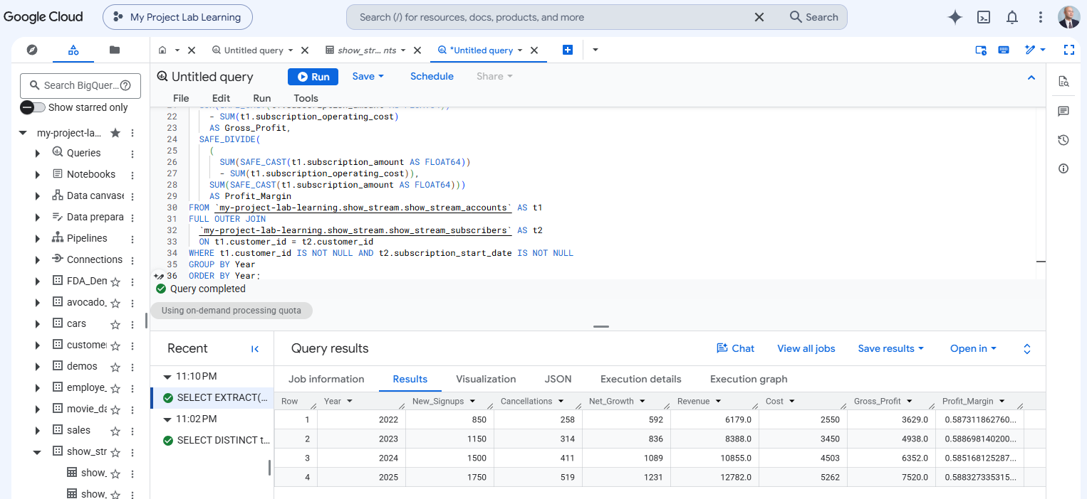

Code Block
2022 Analysis
Creating New Table for with calculation for the following Columns:
Year, New Signups, Cancellations, Net Growth, Revenue, Cost, Gross Profit, Profit Margin

WITH
months AS (
SELECT month_num, FORMAT_DATE('%B', DATE(2022, month_num, 1)) AS month_name
FROM UNNEST(GENERATE_ARRAY(1, 12)) AS month_num
),
signups AS (
SELECT
EXTRACT(MONTH FROM subscription_start_date) AS month_num,
COUNT(DISTINCT customer_id) AS new_sign_ups,
SUM(CAST(t1.subscription_amount AS FLOAT64)) AS revenue,
SUM(t1.subscription_operating_cost) AS cost
FROM `my-project-lab-learning.show_stream.show_stream_subscribers` AS t2
JOIN `my-project-lab-learning.show_stream.show_stream_accounts` AS t1
USING (customer_id)
WHERE EXTRACT(YEAR FROM subscription_start_date) = 2022
GROUP BY month_num
),
cancellations AS (
SELECT
EXTRACT(MONTH FROM subscription_end_date) AS month_num,
COUNT(DISTINCT customer_id) AS cancellations
FROM `my-project-lab-learning.show_stream.show_stream_subscribers`
WHERE EXTRACT(YEAR FROM subscription_end_date) = 2022
GROUP BY month_num
),
monthly_metrics AS (
SELECT
2022 AS Year,
m.month_name AS Month,
COALESCE(s.new_sign_ups, 0) AS New_Sign_ups,
COALESCE(c.cancellations, 0) AS Cancellations,
(COALESCE(s.new_sign_ups, 0) - COALESCE(c.cancellations, 0))
AS Net_Growth,
COALESCE(s.revenue, 0) AS Revenue,
COALESCE(s.cost, 0) AS Cost,
(COALESCE(s.revenue, 0) - COALESCE(s.cost, 0)) AS Gross_Profit,
SAFE_DIVIDE(
COALESCE(s.revenue, 0) - COALESCE(s.cost, 0), COALESCE(s.revenue, 0))
AS Profit_Margin,
m.month_num
FROM months AS m
LEFT JOIN signups AS s
ON m.month_num = s.month_num
LEFT JOIN cancellations AS c
ON m.month_num = c.month_num
)
SELECT
Year,
Month,
New_Sign_ups,
Cancellations,
Net_Growth,
Revenue,
Cost,
Gross_Profit,
Profit_Margin
FROM monthly_metrics
UNION ALL
SELECT
2022 AS Year,
'Total' AS Month,
SUM(New_Sign_ups),
SUM(Cancellations),
SUM(Net_Growth),
SUM(Revenue),
SUM(Cost),
SUM(Gross_Profit),
SAFE_DIVIDE(SUM(Gross_Profit), SUM(Revenue)) AS Profit_Margin
FROM monthly_metrics
ORDER BY(
CASE
WHEN Month = 'Total' THEN 13
ELSE (SELECT month_num FROM months WHERE month_name = Month)
END);

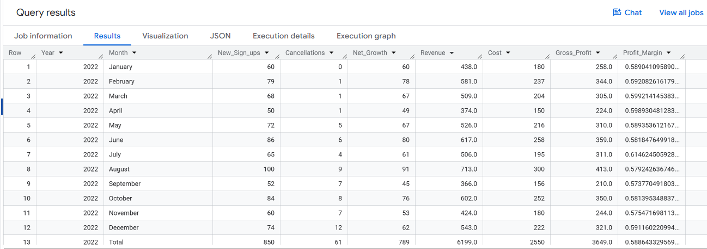

Code Block
2023 Analysis
Creating New Table for with calculation for the following Columns:
Year, New Signups, Cancellations, Net Growth, Revenue, Cost, Gross Profit, Profit Margin

WITH
months AS (
SELECT month_num, FORMAT_DATE('%B', DATE(2023, month_num, 1)) AS month_name
FROM UNNEST(GENERATE_ARRAY(1, 12)) AS month_num
),
signups AS (
SELECT
EXTRACT(MONTH FROM subscription_start_date) AS month_num,
COUNT(DISTINCT customer_id) AS new_sign_ups,
SUM(CAST(t1.subscription_amount AS FLOAT64)) AS revenue,
SUM(t1.subscription_operating_cost) AS cost
FROM `my-project-lab-learning.show_stream.show_stream_subscribers` AS t2
JOIN `my-project-lab-learning.show_stream.show_stream_accounts` AS t1
USING (customer_id)
WHERE EXTRACT(YEAR FROM subscription_start_date) = 2023
GROUP BY month_num
),
cancellations AS (
SELECT
EXTRACT(MONTH FROM subscription_end_date) AS month_num,
COUNT(DISTINCT customer_id) AS cancellations
FROM `my-project-lab-learning.show_stream.show_stream_subscribers`
WHERE EXTRACT(YEAR FROM subscription_end_date) = 2023
GROUP BY month_num
),
monthly_metrics AS (
SELECT
2023 AS Year,
m.month_name AS Month,
COALESCE(s.new_sign_ups, 0) AS New_Sign_ups,
COALESCE(c.cancellations, 0) AS Cancellations,
(COALESCE(s.new_sign_ups, 0) - COALESCE(c.cancellations, 0))
AS Net_Growth,
COALESCE(s.revenue, 0) AS Revenue,
COALESCE(s.cost, 0) AS Cost,
(COALESCE(s.revenue, 0) - COALESCE(s.cost, 0)) AS Gross_Profit,
SAFE_DIVIDE(
COALESCE(s.revenue, 0) - COALESCE(s.cost, 0), COALESCE(s.revenue, 0))
AS Profit_Margin,
m.month_num
FROM months AS m
LEFT JOIN signups AS s
ON m.month_num = s.month_num
LEFT JOIN cancellations AS c
ON m.month_num = c.month_num
)
SELECT
Year,
Month,
New_Sign_ups,
Cancellations,
Net_Growth,
Revenue,
Cost,
Gross_Profit,
Profit_Margin
FROM monthly_metrics
UNION ALL
SELECT
2023 AS Year,
'Total' AS Month,
SUM(New_Sign_ups),
SUM(Cancellations),
SUM(Net_Growth),
SUM(Revenue),
SUM(Cost),
SUM(Gross_Profit),
SAFE_DIVIDE(SUM(Gross_Profit), SUM(Revenue)) AS Profit_Margin
FROM monthly_metrics
ORDER BY(
CASE
WHEN Month = 'Total' THEN 13
ELSE (SELECT month_num FROM months WHERE month_name = Month)
END);

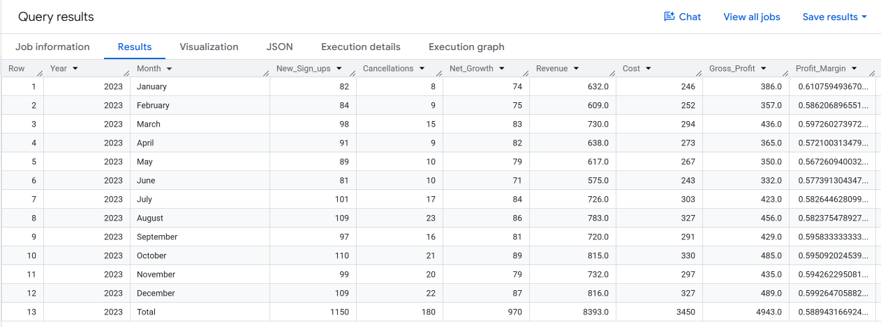

Code Block
2024 Analysis
Creating New Table for with calculation for the following Columns:
Year, New Signups, Cancellations, Net Growth, Revenue, Cost, Gross Profit, Profit Margin

WITH
months AS (
SELECT month_num, FORMAT_DATE('%B', DATE(2024, month_num, 1)) AS month_name
FROM UNNEST(GENERATE_ARRAY(1, 12)) AS month_num
),
signups AS (
SELECT
EXTRACT(MONTH FROM subscription_start_date) AS month_num,
COUNT(DISTINCT customer_id) AS new_sign_ups,
SUM(CAST(t1.subscription_amount AS FLOAT64)) AS revenue,
SUM(t1.subscription_operating_cost) AS cost
FROM `my-project-lab-learning.show_stream.show_stream_subscribers` AS t2
JOIN `my-project-lab-learning.show_stream.show_stream_accounts` AS t1
USING (customer_id)
WHERE EXTRACT(YEAR FROM subscription_start_date) = 2024
GROUP BY month_num
),
cancellations AS (
SELECT
EXTRACT(MONTH FROM subscription_end_date) AS month_num,
COUNT(DISTINCT customer_id) AS cancellations
FROM `my-project-lab-learning.show_stream.show_stream_subscribers`
WHERE EXTRACT(YEAR FROM subscription_end_date) = 2024
GROUP BY month_num
),
monthly_metrics AS (
SELECT
2024 AS Year,
m.month_name AS Month,
COALESCE(s.new_sign_ups, 0) AS New_Sign_ups,
COALESCE(c.cancellations, 0) AS Cancellations,
(COALESCE(s.new_sign_ups, 0) - COALESCE(c.cancellations, 0))
AS Net_Growth,
COALESCE(s.revenue, 0) AS Revenue,
COALESCE(s.cost, 0) AS Cost,
(COALESCE(s.revenue, 0) - COALESCE(s.cost, 0)) AS Gross_Profit,
SAFE_DIVIDE(
COALESCE(s.revenue, 0) - COALESCE(s.cost, 0), COALESCE(s.revenue, 0))
AS Profit_Margin,
m.month_num
FROM months AS m
LEFT JOIN signups AS s
ON m.month_num = s.month_num
LEFT JOIN cancellations AS c
ON m.month_num = c.month_num
)
SELECT
Year,
Month,
New_Sign_ups,
Cancellations,
Net_Growth,
Revenue,
Cost,
Gross_Profit,
Profit_Margin
FROM monthly_metrics
UNION ALL
SELECT
2024 AS Year,
'Total' AS Month,
SUM(New_Sign_ups),
SUM(Cancellations),
SUM(Net_Growth),
SUM(Revenue),
SUM(Cost),
SUM(Gross_Profit),
SAFE_DIVIDE(SUM(Gross_Profit), SUM(Revenue)) AS Profit_Margin
FROM monthly_metrics
ORDER BY(
CASE
WHEN Month = 'Total' THEN 13
ELSE (SELECT month_num FROM months WHERE month_name = Month)
END);

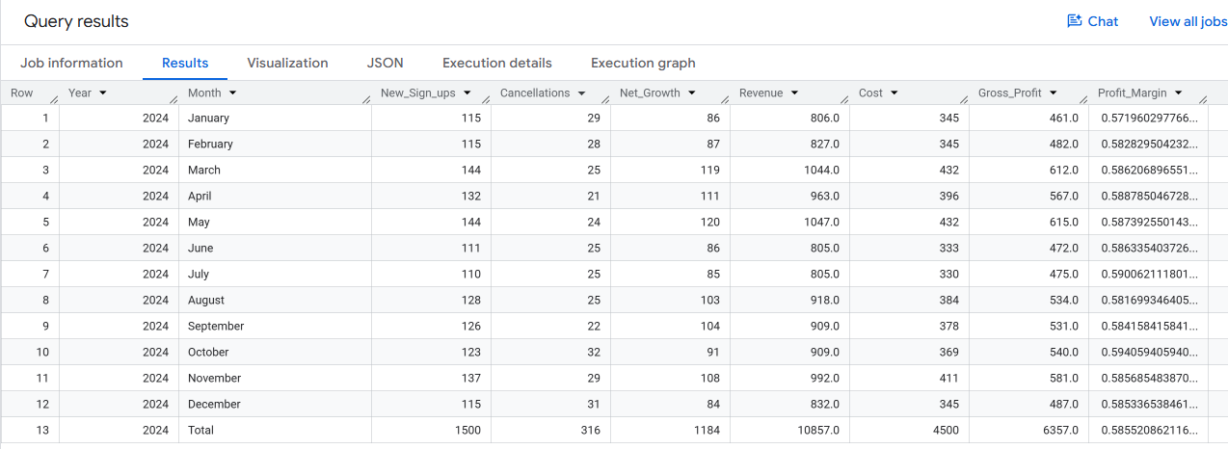

Code Block
2025 Analysis
Creating New Table for with calculation for the following Columns:
Year, New Signups, Cancellations, Net Growth, Revenue, Cost, Gross Profit, Profit Margin

WITH
months AS (
SELECT month_num, FORMAT_DATE('%B', DATE(2025, month_num, 1)) AS month_name
FROM UNNEST(GENERATE_ARRAY(1, 12)) AS month_num
),
signups AS (
SELECT
EXTRACT(MONTH FROM subscription_start_date) AS month_num,
COUNT(DISTINCT customer_id) AS new_sign_ups,
SUM(CAST(t1.subscription_amount AS FLOAT64)) AS revenue,
SUM(t1.subscription_operating_cost) AS cost
FROM `my-project-lab-learning.show_stream.show_stream_subscribers` AS t2
JOIN `my-project-lab-learning.show_stream.show_stream_accounts` AS t1
USING (customer_id)
WHERE EXTRACT(YEAR FROM subscription_start_date) = 2025
GROUP BY month_num
),
cancellations AS (
SELECT
EXTRACT(MONTH FROM subscription_end_date) AS month_num,
COUNT(DISTINCT customer_id) AS cancellations
FROM `my-project-lab-learning.show_stream.show_stream_subscribers`
WHERE EXTRACT(YEAR FROM subscription_end_date) = 2025
GROUP BY month_num
),
monthly_metrics AS (
SELECT
2025 AS Year,
m.month_name AS Month,
COALESCE(s.new_sign_ups, 0) AS New_Sign_ups,
COALESCE(c.cancellations, 0) AS Cancellations,
(COALESCE(s.new_sign_ups, 0) - COALESCE(c.cancellations, 0))
AS Net_Growth,
COALESCE(s.revenue, 0) AS Revenue,
COALESCE(s.cost, 0) AS Cost,
(COALESCE(s.revenue, 0) - COALESCE(s.cost, 0)) AS Gross_Profit,
SAFE_DIVIDE(
COALESCE(s.revenue, 0) - COALESCE(s.cost, 0), COALESCE(s.revenue, 0))
AS Profit_Margin,
m.month_num
FROM months AS m
LEFT JOIN signups AS s
ON m.month_num = s.month_num
LEFT JOIN cancellations AS c
ON m.month_num = c.month_num
)
SELECT
Year,
Month,
New_Sign_ups,
Cancellations,
Net_Growth,
Revenue,
Cost,
Gross_Profit,
Profit_Margin
FROM monthly_metrics
UNION ALL
SELECT
2025 AS Year,
'Total' AS Month,
SUM(New_Sign_ups),
SUM(Cancellations),
SUM(Net_Growth),
SUM(Revenue),
SUM(Cost),
SUM(Gross_Profit),
SAFE_DIVIDE(SUM(Gross_Profit), SUM(Revenue)) AS Profit_Margin
FROM monthly_metrics
ORDER BY(
CASE
WHEN Month = 'Total' THEN 13
ELSE (SELECT month_num FROM months WHERE month_name = Month)
END);

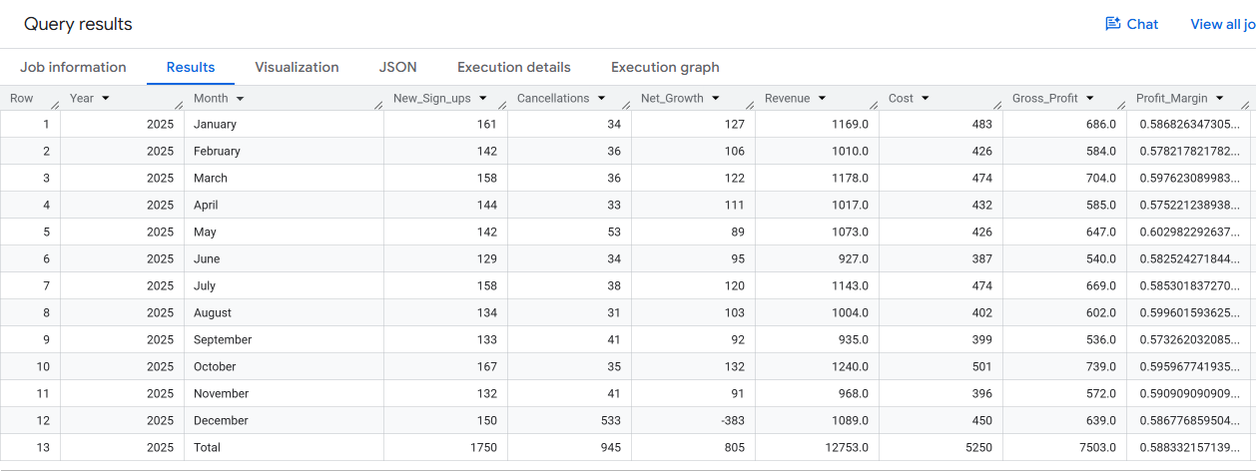

Code Block
Tier Level and Cancellation Analysis
Creating New Table for with calculation for the following Columns:
Tier 1, Tier2, Tier 3, Tier Total, Cancellation Reason

SELECT
EXTRACT(YEAR FROM s.subscription_start_date) AS year,
COUNTIF(LOWER(a.subscription_type) = 'tier 1') AS `Tier 1`,
COUNTIF(LOWER(a.subscription_type) = 'tier 2') AS `Tier 2`,
COUNTIF(LOWER(a.subscription_type) = 'tier 3') AS `Tier 3`,
(
COUNTIF(LOWER(a.subscription_type) = 'tier 1')
+ COUNTIF(LOWER(a.subscription_type) = 'tier 2')
+ COUNTIF(LOWER(a.subscription_type) = 'tier 3'))
AS `Tier Year Total`,
COUNTIF(LOWER(a.cancel_reason) = 'not enough content')
AS `not enough content`,
COUNTIF(LOWER(a.cancel_reason) = 'switch to competitor')
AS `switch to competitor`,
COUNTIF(LOWER(a.cancel_reason) = 'too expensive') AS `too expensive`,
(
COUNTIF(LOWER(a.cancel_reason) = 'not enough content')
+ COUNTIF(LOWER(a.cancel_reason) = 'switch to competitor')
+ COUNTIF(LOWER(a.cancel_reason) = 'too expensive'))
AS `reason year total`
FROM `my-project-lab-learning.show_stream.show_stream_accounts` AS a
JOIN `my-project-lab-learning.show_stream.show_stream_subscribers` AS s
ON a.customer_id = s.customer_id
WHERE EXTRACT(YEAR FROM s.subscription_start_date) IN (2022, 2023, 2024, 2025)
GROUP BY 1
ORDER BY 1;

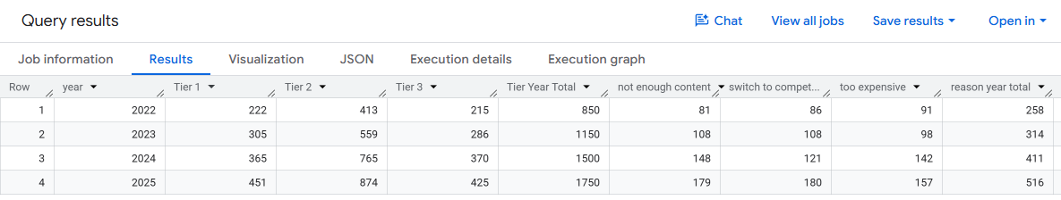

Code Block
New Signups By State

SELECT state, COUNT(*) AS subscriber_count
FROM `my-project-lab-learning.show_stream.show_stream_subscribers`
GROUP BY state
ORDER BY state ASC;

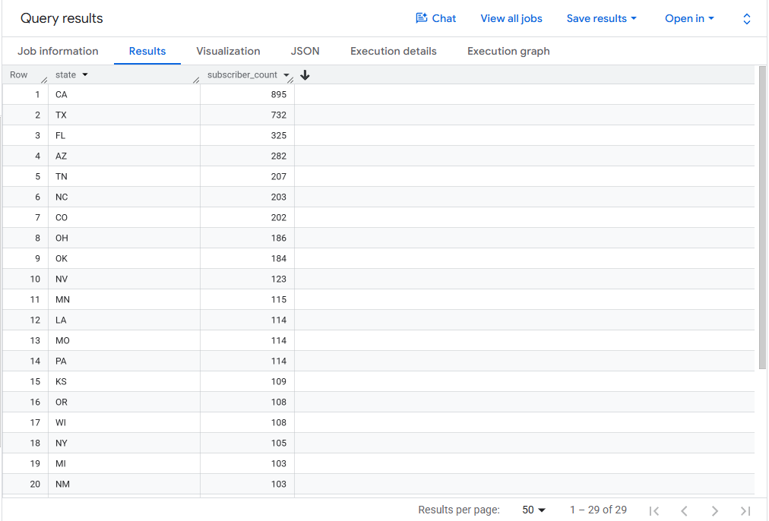
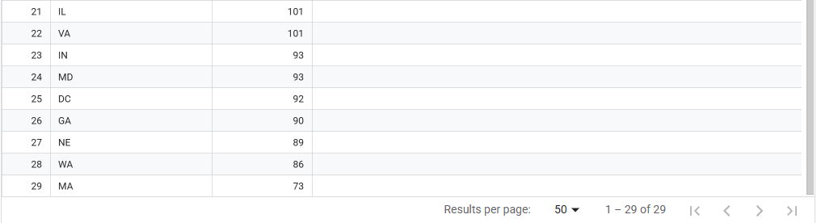

Code Block
Average Subscription Duration by Year

SELECT
EXTRACT(YEAR FROM t2.subscription_start_date) AS subscription_year,
AVG(t1.subscription_duration) / 30.44 AS average_subscription_duration_months
FROM `my-project-lab-learning.show_stream.show_stream_accounts` AS t1
INNER JOIN `my-project-lab-learning.show_stream.show_stream_subscribers` AS t2
ON t1.customer_id = t2.customer_id
WHERE EXTRACT(YEAR FROM t2.subscription_start_date) IN (2022, 2023, 2024, 2025)
GROUP BY subscription_year
ORDER BY subscription_year;

