Show Stream Data Cleaning Change Log:

08-13-2026
show_stream_subscribers table and show_stream_accounts table
Removing Duplicate customer_id from dataset. Original Dataset contains 5255 rows. After removing duplicate customer_id there are now 5250

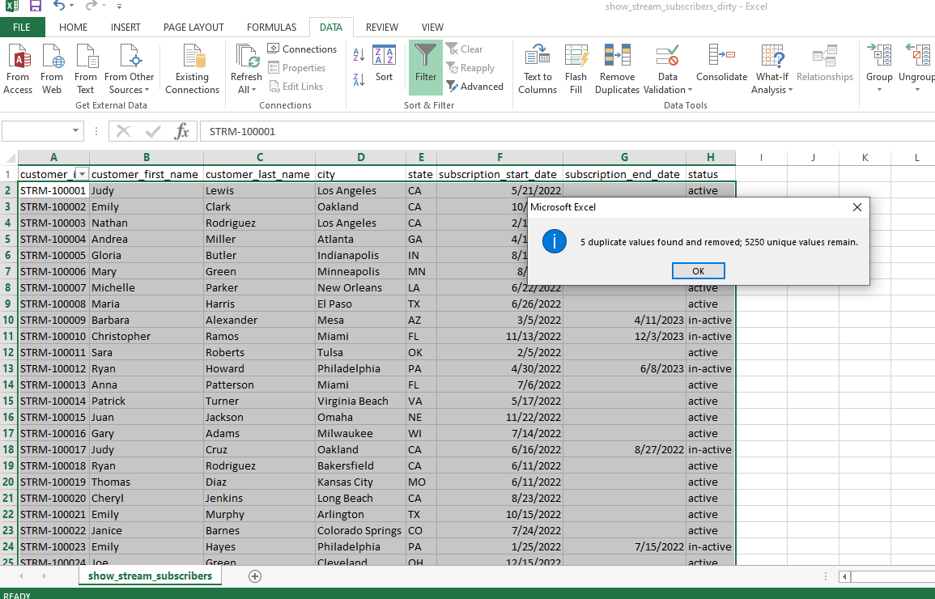

08-13-2026
show_stream_subscribers table
Filtering and sorting column subscription_start_date for consistency, 3 invalid formats found, no change on row amount

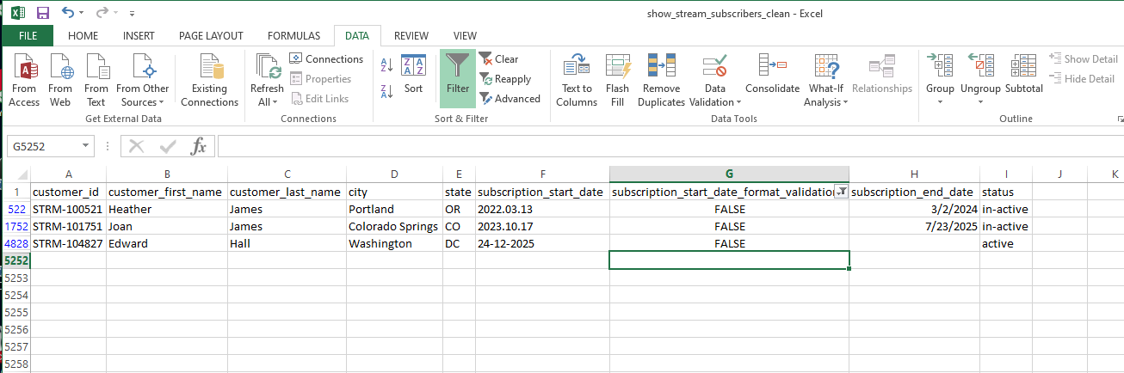

08-13-2026
show_stream_subscribers table
Filtering and sorting column subscription_end_date for consistency, 1 invalid format found, no change on row amount

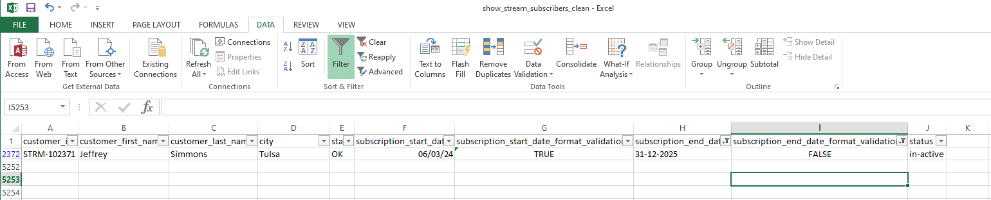

08-13-2026
show_stream_subscibers table
Used the Trim function on the following columns to remove any extra spaces to ensure consistent formatting on the following columns
customer_first_name
customer_last_name
city
state

08-13-2026
show_stream_accounts table
Filtering and sorting column subscription_amount for consistency, 4 invalid format found, no change on row amount

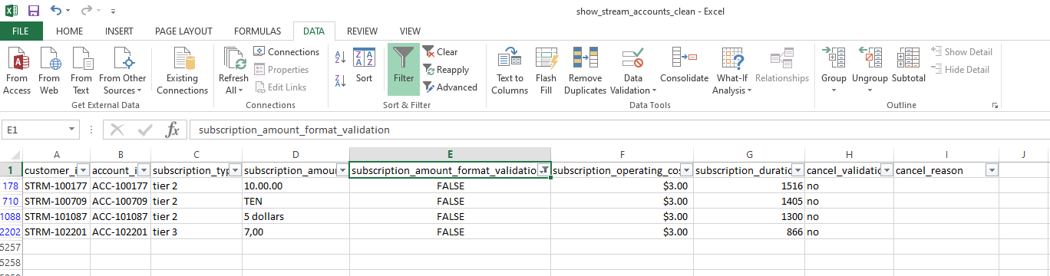

08-13-2026
show_stream_accounts table
Identified 3 fields for cancel_reason where cancel_validation column = yes, as blank, after further research able to identify the cancel_reason and input the data in appropriate field

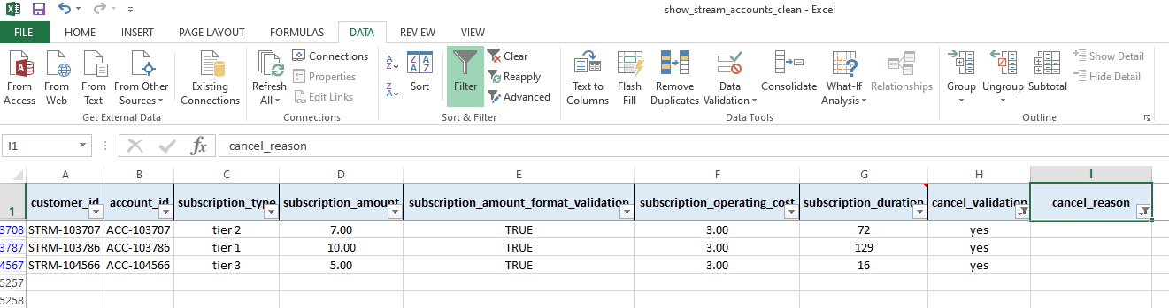

08-13-2026
show_stream_accounts table
Identified 5 account_id rows not associated with a customer_id. After research these accounts were all input as duplicates that need to be deleted from the dataset. This reduces the entries from 5255 to 5250

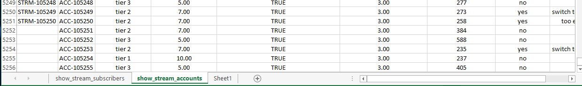

08-13-2026
Combine both tables: show_stream_subscribers and show_stream_accounts formatted subscription_amount column and subscription_operating_cost column as currency and subscription_start_date and subscription_end_date as Date MM/DD/YY

