Show Stream Performance Report (2022 through 2025)
Recurring Revenue Analysis: ARPU (Average Revenue Per User) & MRR (Monthly Recurring Revenue)

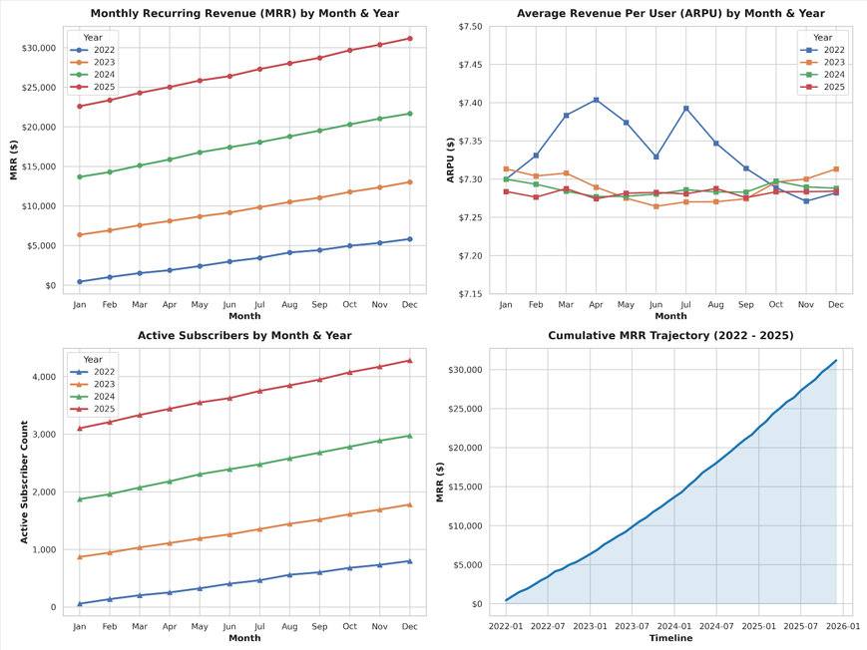

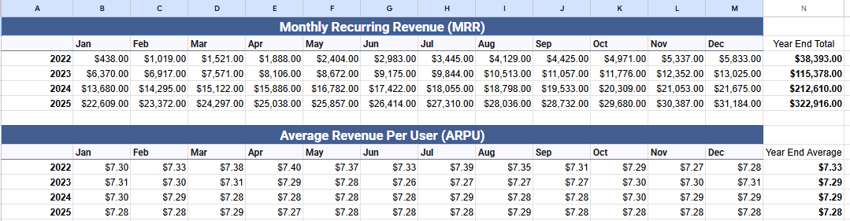
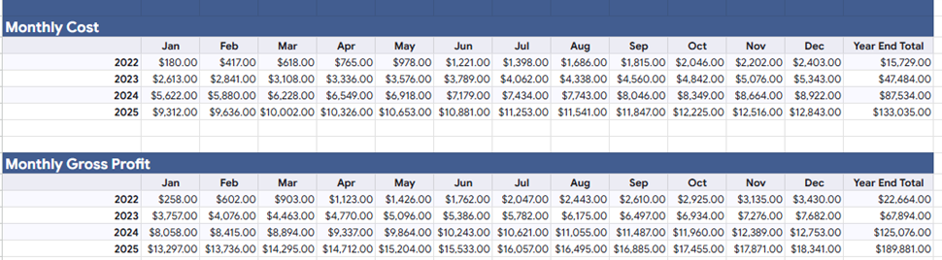

Revenue Performance Summary:

MRR Growth: Monthly Recurring Revenue grew from $438 in January 2022 to $31,184 by December 2025 driven by consistent subscriber acquisition.

Subscriber Base: Active subscribers expanded from 60 in January 2022 to 4,281 in December 2025.

ARPU Stability: Average Revenue Per User (ARPU) remained exceptionally stable across all 48 months, between $7.26 and $7.40 (averaging $7.29/month). This stability is driven by a balanced subscriber mix across Tier 1 ($10/month, 25.6%), Tier 2 ($7/month, 49.7%), and Tier 3 ($5/month, 24.7%).

Total Annual Recurring Revenue Realized:

2022: $38,393
2023: $115,378
2024: $212,610
2025: $322,916

4-Year Cumulative Totals

Metric | 2022 | 2023 | 2024 | 2025 | 4-Year Total
Total Revenue | $38,393 | $115,378 | $212,610 | $322,916 | $689,297
Total Operating Cost | $15,729 | $47,484 | $87,534 | $133,035 | $283,782
Total Gross Profit | $22,664 | $67,894 | $125,076 | $189,881 | $405,515
Gross Margin % | 59.03% | 58.84% | 58.83% | 58.80% | 58.83%

2022 to 2025 Dashboard Summary:

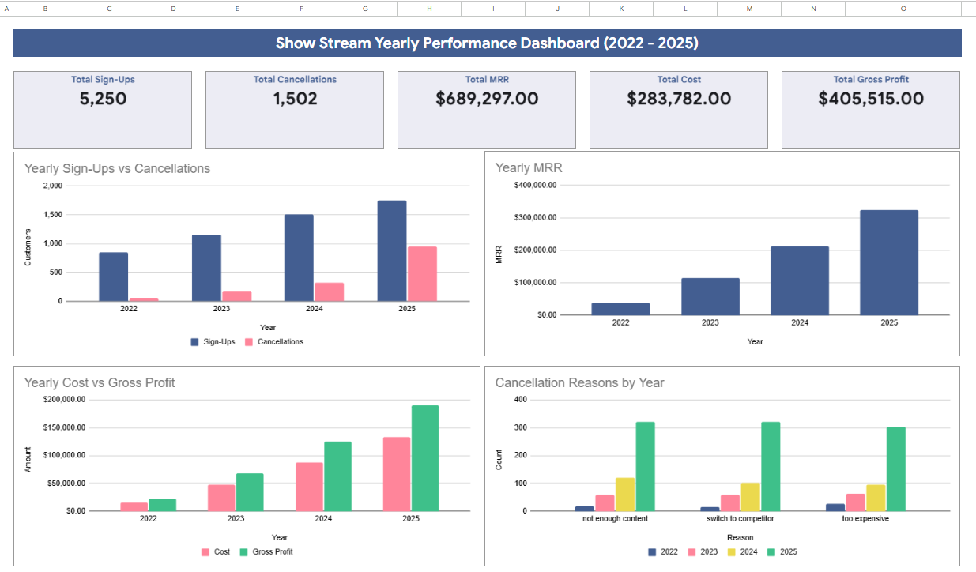

Financial Trajectory:
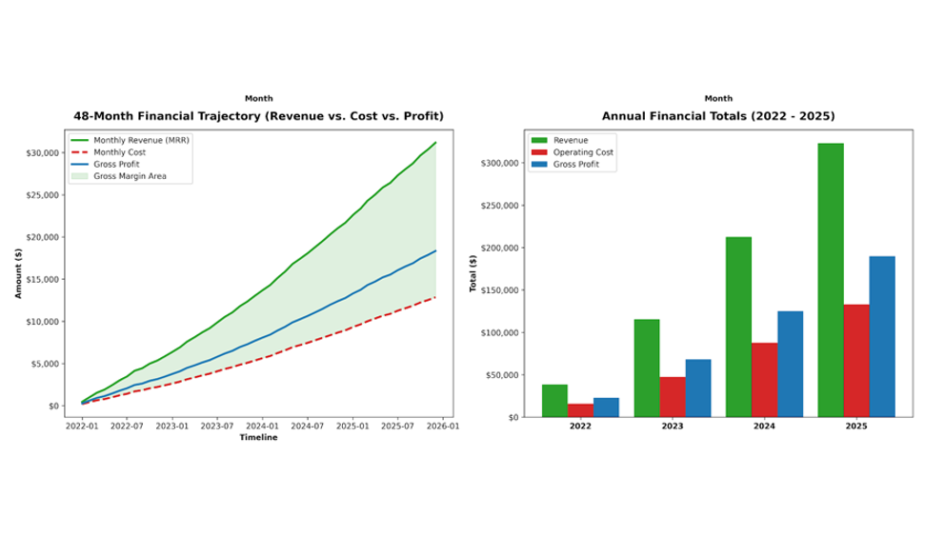

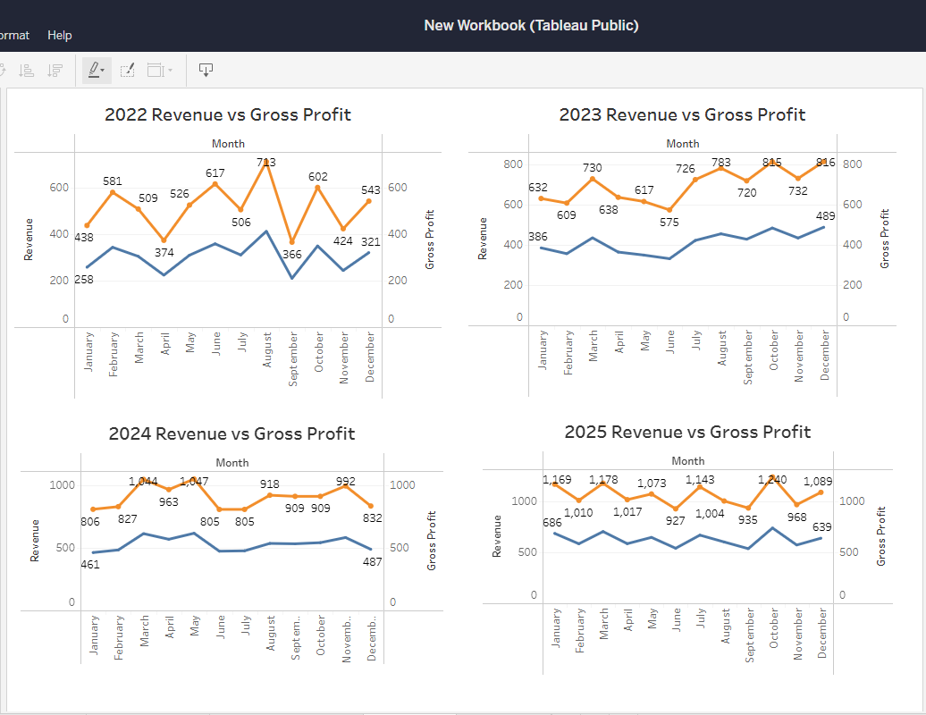

Subscriber Tracking Charts:

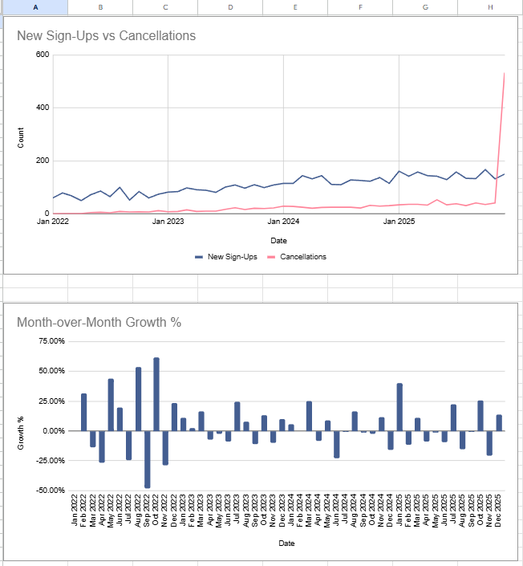
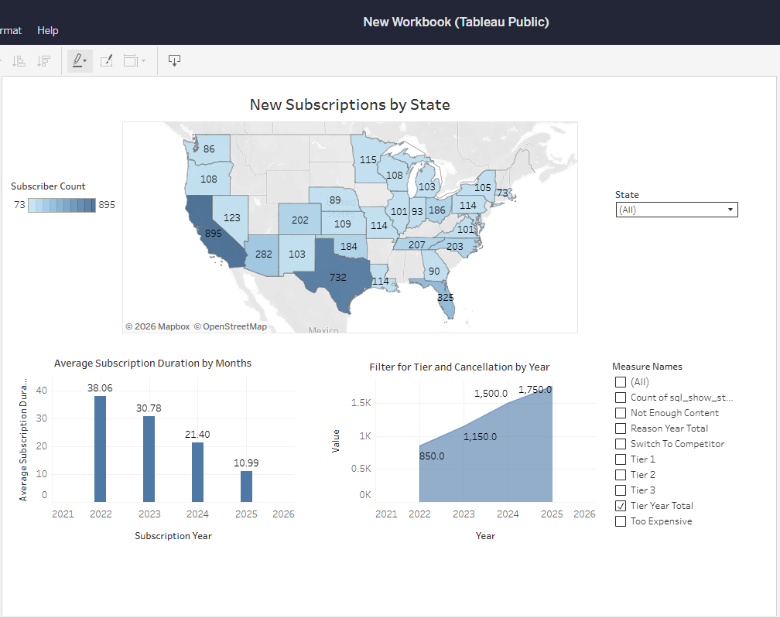

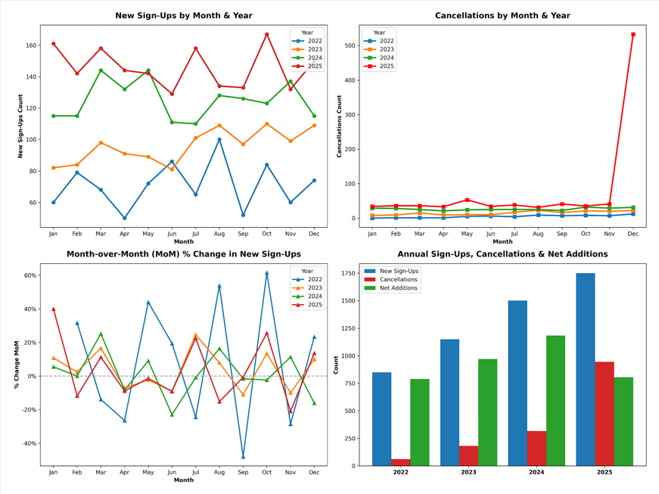

Cancellations Tracking:

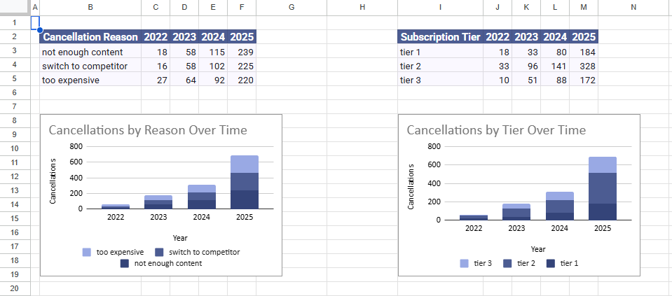

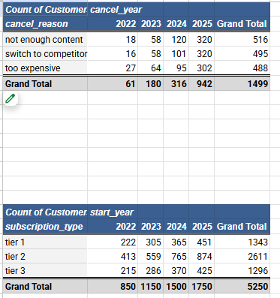

Subscriber and Cancellation Metrics:

- There is a spike in cancellations in 2025 reaching 942 cancellations
  - Primary reason by a combination of not enough content and switching to competitor
  - Yearend new subscriptions percentages have dropped over previous years
    - 2022 indicating an average of 7.70% growth
    - 2023 indicating an average of 3.89% growth
    - 2024 indicating an average of 1.28% growth
    - 2025 indicating an average of 3.74% growth

