**Design for Change**

**Keep the Toilets Clean!**

**Served from: Matan, Tal, Liam, Yonatan, (Mark).**

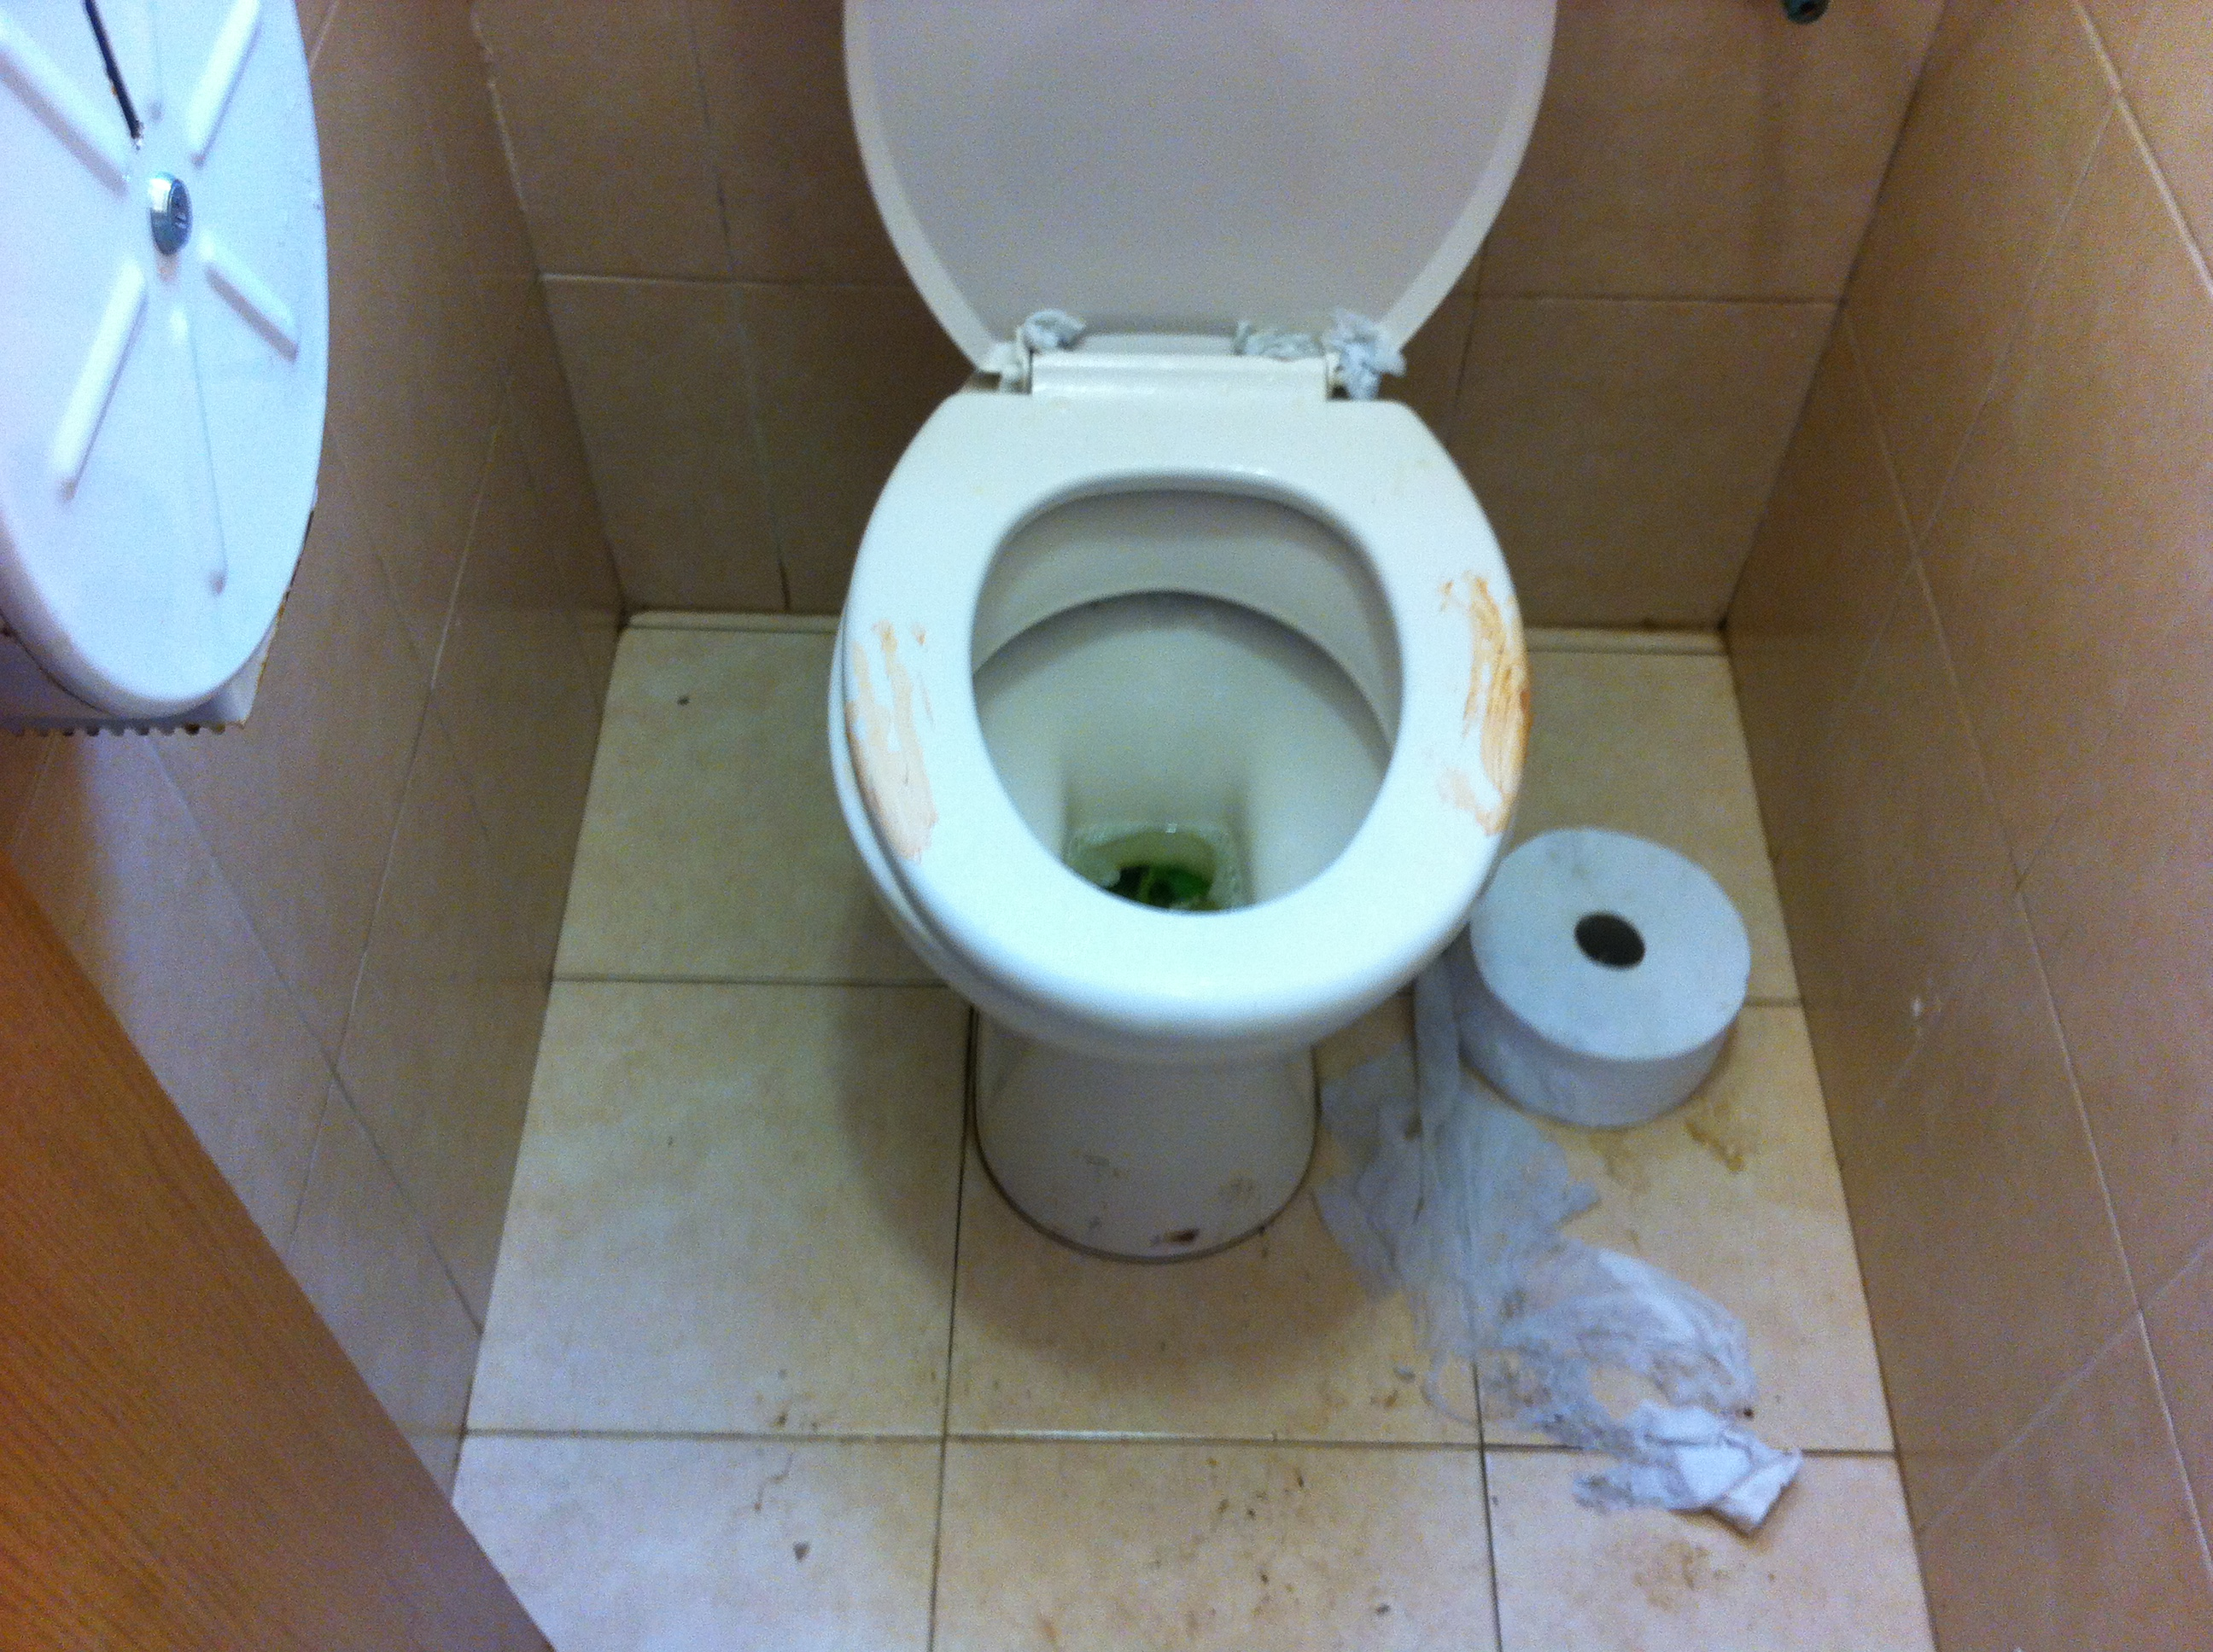

**Before :**

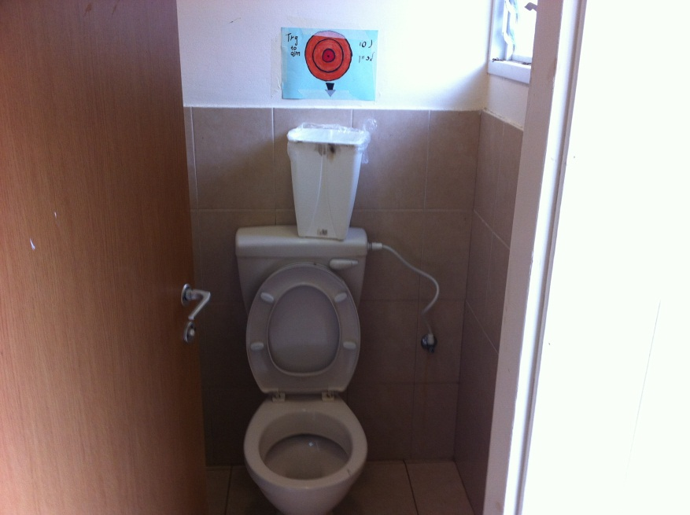

**: After**

**2. Process**

The thing we decided to change is the situation of the schools bathrooms. First, we went to the bathrooms and took pictures. We saw that the bathrooms are dirty, and we tried to think what we can do in order to change it.

We decided to go interview the vice principle Nitzan and ask his opinion about the bathrooms situation. After talking to Nitzan, we realized that the change should come from us, the students.

We made signs and hang the up in the bathrooms to make the students aware to the problem and to make them begin the change with us, and help us to keep the bathrooms clean.

Finally, we hang up bigger signs near our classes to publicize what we are doing and to recruit more people to help us with our change and join us.

In the end, we didn’t achieve our goal completely, but I think we raised the awareness to the problem.

**3. Goal (Matan and Liam)**

Our goal was to keep the toilets clean, we didn’t reach that goal but, however we did raise awareness about the subject.

Our ultimate goal was to keep the toilets clean. We think that we can reach this goal but it will take more than a short project of five kids to change how people treat the toilets. We think if we had more people and time we could change something.

We feel a little disappointed about the fact we didn’t reach our goal but we did raise awareness and got people talking about the issue.

**4. Yonatan**

First of all, I would like to say that I really enjoyed doing the project, I enjoyed the project because we could choose to do our project about something we care apout.

Even though at the end I enjoyed, at the beginning I was a little worried and pessimistic about the project, and I wasn’t sure if we will succeed.

After finishing the project, I saw that we didn’t achieve our original goal. I wasn’t disappointed at all because I thought that we did achieved to raise the awareness to the problem, and we did the first step for changing the situation.

After all, I feel good about what we did and I think we did our best.

**4. Matan**

In my opinion this project is makes you think different about problems, now when I encounter a problem I know that I can solve it, if I want to. I'm a little disappointed because we didn’t really reach our goal. We did raise the awareness for the problem but the toilet is still dirty.

Honestly, I knew we are not going to reach our goal before we are started the project. Before we began the project I was worried that I'm not going to give you anything with this team, but we actually did. I think we did everything we can with the limited time and resources we had.

I think our project was harder than the other teams because my team, they did work but they had problem with concentrating. I tried to do my best to help them concentrate and work.   
At the end I did enjoy the project because the lessons and the team work were fun.

**4. Liam**

At the beginning of our project, our goal was to make the toilets in the school clean. The toilets are very dirty and the students were too disgusted to use them.

Now we have finished the project, I do feel that we reached our ultimate goal, clean toilets. With all due respect to ruthie, we who was as supportive as can be, and helped us with anything we needed, I do not think we had enough time r people to reach our goal. However, we did raise awareness and got people talking on the issue.

Before the project I really did not know what to expect. I enjoyed the working on the project, and I think we should more of this in the future.