A little greener, together
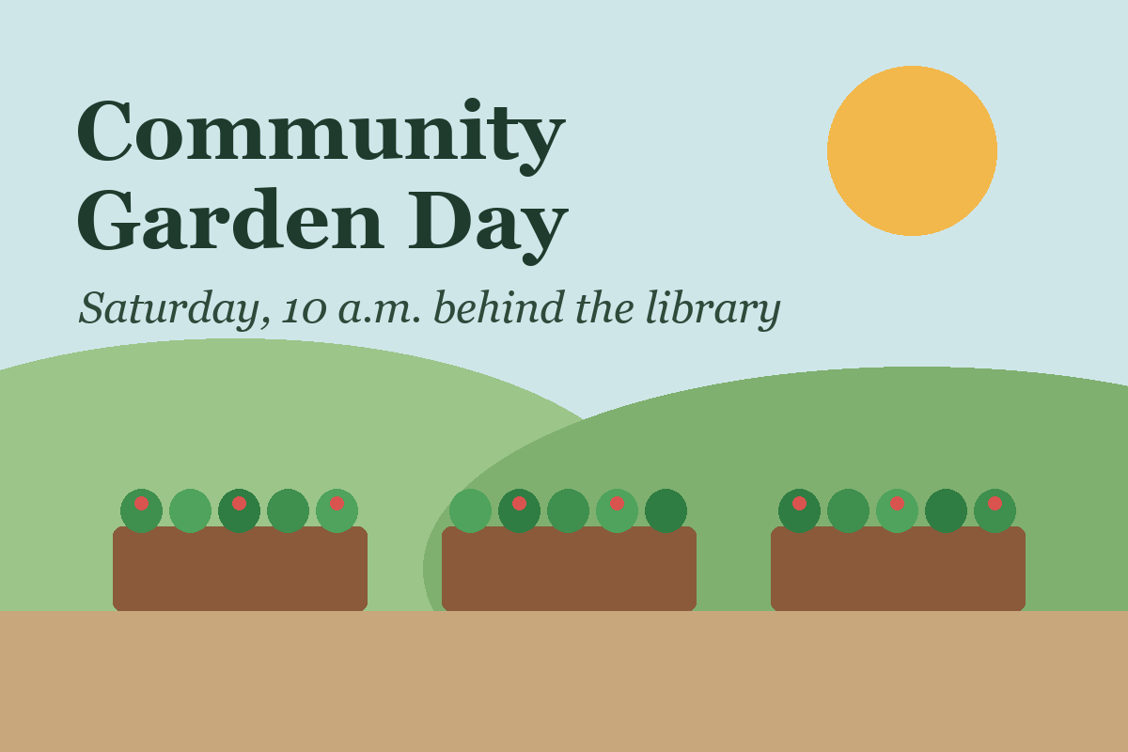
There is a patch of unused land behind the community library that most of us walk past without giving it much thought. Right now, it is mostly gravel, a few weeds, and a bench that has seen better days. But it could become something that brings our neighborhood together: a small community garden.
The idea is simple. We would build a few raised beds, plant seasonal vegetables and flowers, and invite neighbors to help look after them. No gardening experience would be necessary. People could contribute in whatever way works for them, whether that means watering on a Tuesday morning, sharing seeds, or helping someone carry a bag of soil.
A garden would give us more than fresh tomatoes. It would create a place where people can meet without needing to buy anything. Children could discover where food comes from. Older residents could share the knowledge they have gathered over years of growing things. And people who have recently moved here would have an easy way to get to know their neighbors.
We should start small. Before we plant anything, we need permission to use the land, a reliable water source, and a plan for keeping the space accessible. We also need to understand the soil conditions and decide who will maintain the garden through different seasons. A few well-cared-for beds would be better than a large project that becomes difficult to manage.

What we need first
Need | Why
Permission to use the land | The lot belongs to the library.
A reliable water source | Raised beds dry out quickly in summer.
A care schedule | Someone has to look after the beds every season.
This is a proposal, not a finished plan. The next step is to gather ideas from the people who would use the garden and find out who wants to take part. If there is enough interest, we can work together on a practical design and a modest budget.
An overlooked corner of our neighborhood could become a place to grow food, friendships, and a stronger sense of belonging.

