Project2 : 3D Solar System Animation (2 weeks)
Project 2 Due Feb 14th 2012

Using examples sun.c and material.c as a starting point create the following graphics program using C, OpenGL and GLUT. As always be creative and have fun.

Create the following Objects
- 1 Sun – make this object bigger than the other objects
  - A binary Star System would also be fine and a nice addition
  - Use a Composite Object (no simple spheres allowed)
- 3 Planets – use different colors for each Planet
  - At least ½ your planets must be a Composite Object
- 5 Moons – use a different color for each Moon
  - At least ½ your moons must be a Composite Object
- Be creative with your Composite Objects. I have seen a melting ice cream cone and a blocky little robot used as Composite Objects.
- 2 Light Sources (A, B)
  - Light Source A should emit white light
  - Light Source B should emit a non-white light
- Use some composite objects as in material.c
- Consider creating objects using sphere.c, hp.c or ellipse3d.c

Initial placement of objects should be as follows:
- I’m going to be broad with this.
- Place Light Source A in the upper left corner
- Place Light Source B somewhere else.
  - I am interest in what if any effect you can cause.
  - Consider alternating which light source you are using!
- Place the Camera in a position so I can watch the Planets orbit the Sun. You WILL need to move the Camera around so I can see the wondrous things you have done.
  - Moving the Camera around is much less disorienting than jumping from location to location.
- Place the Sun in the middle of the scene.
- Place the 3 Planets around the Sun.
- Place the 5 Moons around various Planets; at least one Planets must have multiple Moons.

Animate objects as follows:
- Planets must orbit the Sun in elliptical orbits (No circles allowed)
  - Elongate the elliptical orbits so that it is obvious to the viewer (me) that the orbits are elliptical.
    - Zoom in close to the sun the sweep out far from it!
    - The center of the elliptical orbit should NOT be the Sun.
- All Planets must spin on an axis.
  - The more faceted a sphere is the more easy it is to see it spin.
- One Planet must circle (orbit the Sun) in the reversion direction to all the other Planets.
- One Planet must have an orbit incline to the orbital plane of the other Planets.
- Moons can orbit Planets in elliptical or circular orbits.
- Moons need not spin.
- Inner Planets should orbit the Sun faster than Outer Planets.
- Visually check that objects do not collide while being animated. However, there is “No need to check this mathematically”. Just make sure they don’t collide all the time!
- Move the camera around to show your Solar System.
  - The simplest acceptable camera animation would be the following:
    - Start out above the solar system so I can see all of the objects (sun, planets, and moons) and their orbits.
    - Move the camera until it is just above the orbital plane of the planets so I can see the planets closer as they orbit around the sun and see that at least one planet is orbiting incline to the plane.
    - Zoom the camera in on the sun so I can what a wonderful job you have done on your sun and get a better view of the planets as they fly past.
    - Reverse the process and then repeat.
  - Slick camera movement would involve flying the camera around the solar system and looking at all of the planets.
    - Think of a fly-by, where you zoom in on a planet and the rotate the camera so you can watch it as you fly away.

Extra Credit Ideas:
- Create a Comet that flies through the Solar System.
  - Make the Comet have an irregular shape.
  - Tumble the Comet.
  - Create an ion tail for the Comet.
  - The ion tail should always point away from the Sun regardless of which direction the Comet is moving.
  - Don’t worry about checking if the Comet hits another object.
  - Don’t worry about gravity.
- Real nice rings around a planet
- Volcanoes or geysers on planets or moons.
- Really cool camera movement
Hints:
- Start with the program sun.c then add and remove elements as needed to create the program.
- Use glutSolid* fuctions to create simple 3D object that can be shaded.
- Use camera.c to help in moving your camera around the scene.
- I strongly suggest you use material properties for some of your objects. Can be very nice!
  - See material.c for help in doing this and well as sun.c for getting an object to glow (GL_EMISSION).
- Line Drawing
  - 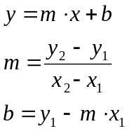
- Circle Drawing
  - 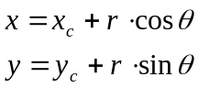
    - r is the radius of the circle
    - (x_{c},y_{c}) is the center of the circle
  - Rotation of a point about the z-axis
- Ellipse Drawing
  - 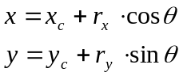
    - r_{x} is the radius along the x-axis
    - r_{y} is the radius along the y-axis
    - (x_{c},y_{c}) is the center of the circle
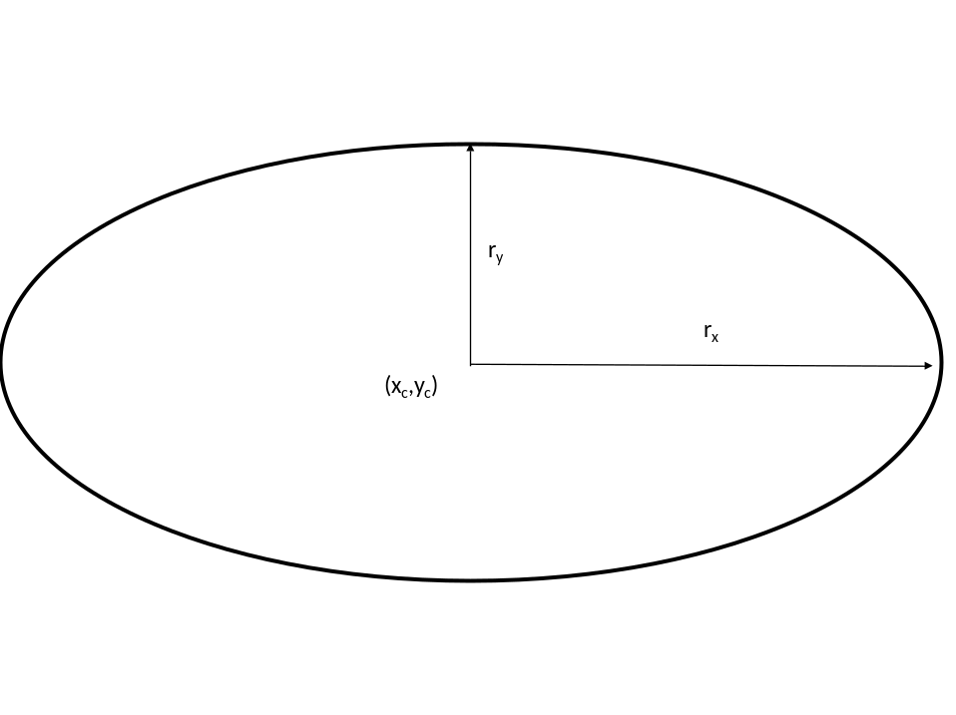

- A 2D shape can be draw anywhere and along any plane by translating and rotating the coordinate system before drawing the shape. This can make the 2D shape appear in 3D space..
- GL_LIGHT0 emits white light by default
- Planets are positioned using World Coordinates.
- Moons are positioned using Planet (Object) Coordinates.
- The following material definitions come from Lund University
  - The program material.c uses many of these material definitions. Not all of them are as interesting as you might first expect.

# Copyright (C) 2002-2006 Computer Science, Lund University

blackPlastic = ambient = (0, 0, 0),
diffuse = (0.01, 0.01, 0.01),
specular = (0.5, 0.5, 0.5),
shininess = 32.0

blackRubber = ambient = (0.02, 0.02, 0.02),
diffuse = (0.01, 0.01, 0.01),
specular = (0.40, 0.40, 0.40),
shininess = 10

brass = ambient = (0.329412, 0.223529, 0.027451),
diffuse = (0.780392, 0.568627, 0.113725),
specular = (0.992157, 0.941176, 0.807843),
shininess = 27.8974

bronze = ambient = (0.2125, 0.1275, 0.054),
diffuse = (0.714, 0.4284, 0.18144),
specular = (0.393548, 0.271906, 0.166721),
shininess = 25.6

chrome = ambient = (0.25, 0.25, 0.25),
diffuse = (0.4, 0.4, 0.4),
specular = (0.774597, 0.774597, 0.774597),
shininess = 76.8

copper = ambient = (0.19125, 0.0735, 0.0225),
diffuse = (0.7038, 0.27048, 0.0828),
specular = (0.256777, 0.137622, 0.086014),
shininess = 12.8

emerald = ambient = (0.0215, 0.1745, 0.0215),
diffuse = (0.07568, 0.61424, 0.07568),
specular = (0.633, 0.727811, 0.633),
shininess = 76.8

gold = ambient = (0.24725, 0.1995, 0.0745),
diffuse = (0.75164, 0.60648, 0.22648),
specular = (0.628281, 0.555802, 0.366065),
shininess = 51.2

jade = ambient = (0.135, 0.2225, 0.1575),
diffuse = (0.135, 0.2225, 0.1575),
specular = (0.316228, 0.316228, 0.316228),
shininess = 12.8

obsidian = ambient = (0.05375, 0.05, 0.06625 ),
diffuse = (0.18275, 0.17, 0.22525 ),
specular = (0.332741, 0.328634, 0.346435),
shininess = 38.4

pearl = ambient = (0.25, 0.20725, 0.20725),
diffuse = (1.0, 0.829, 0.829),
specular = (0.296648, 0.296648, 0.296648),
shininess = 11.264

pewter = ambient = (0.105882, 0.058824, 0.113725),
diffuse = (0.427451, 0.470588, 0.541176),
specular = (0.333333, 0.333333, 0.521569),
shininess = 9.84615

polishedBronze = ambient = (0.25, 0.148, 0.06475),
diffuse = (0.4, 0.2368, 0.1036),
specular = (0.774597, 0.458561, 0.200621),
shininess = 76.8

polishedCopper = ambient = (0.2295, 0.08825, 0.0275),
diffuse = (0.5508, 0.2118, 0.066),
specular = (0.580594, 0.223257, 0.0695701),
shininess = 51.2

polishedGold = ambient = (0.24725, 0.2245, 0.0645),
diffuse = (0.34615, 0.3143, 0.0903),
specular = (0.797357, 0.723991, 0.208006),
shininess = 83.2

polishedSilver = ambient = (0.23125, 0.23125, 0.23125),
diffuse = (0.2775, 0.2775, 0.2775),
specular = (0.773911, 0.773911, 0.773911),
shininess = 89.6

ruby = ambient = (0.1745, 0.01175, 0.01175),
diffuse = (0.61424, 0.04136, 0.04136),
specular = (0.727811, 0.626959, 0.626959),
shininess = 76.8

silver = ambient = (0.19225, 0.19225, 0.19225),
diffuse = (0.50754, 0.50754, 0.50754),
specular = (0.508273, 0.508273, 0.508273),
shininess = 51.2

turqoise = ambient = (0.1, 0.18725, 0.1745),
diffuse = (0.396, 0.74151, 0.69102),
specular = (0.297254, 0.30829, 0.306678),
shininess = 12.8

whitePlastic = ambient = (0, 0, 0),
diffuse = (0.55, 0.55, 0.55),
specular = (0.70, 0.70, 0.70),
shininess = 32.0

Send me (Curtis.Welborn@uvu.edu) a zip file containing your source, makefile and an executable version of your program before midnight of the due date. The Title of your email should be “3D – Proj2”. The zip must be named <name>_p2v#.zip where name is your first and last name, and # is the version number for your project 0 … 1000.

