Project3 : Breaking Glass (3 weeks)
Project 3 Due March 6th 2012

Using examples blend.c, bump.c, (i2height.c, bumpMap.c) and texture.c as a starting points create the following graphics program using C, OpenGL and GLUT. As always be creative and have fun.

Create the following Objects
- A 3D object covered with a texture map
- A 3D object colored with a single color
  - At least 2 of the flat surfaces are to be tessellated.
  - Perturb the surfaces normals in some way so as to make the flat surfaces not appear flat. I have observed that:
    - Normalized normals provide normal shading
      - Changing the direction and magnitude of the normal both effect shading.
    - Non-normalized normals provide non-normal shading
      - Magnitudes > 1.0 are like high points
        - A vertex with normal (0.0, 0.0, 5.0) will appear brighter than vertex with normal (0.0, 0.0, 1.0) if the light source is at a positive Z.
      - Magnitudes < 1.0 are like low points
        - A vertex with normal (0.0, 0.0, 0.5) will appear dimmer than vertex with normal (0.0, 0.0, 1.0) if the light source is at a positive Z.
- A 3D pane (width, height, and depth) of Glass
  - The pane of glass should not cover the entire screen only a portion of it.
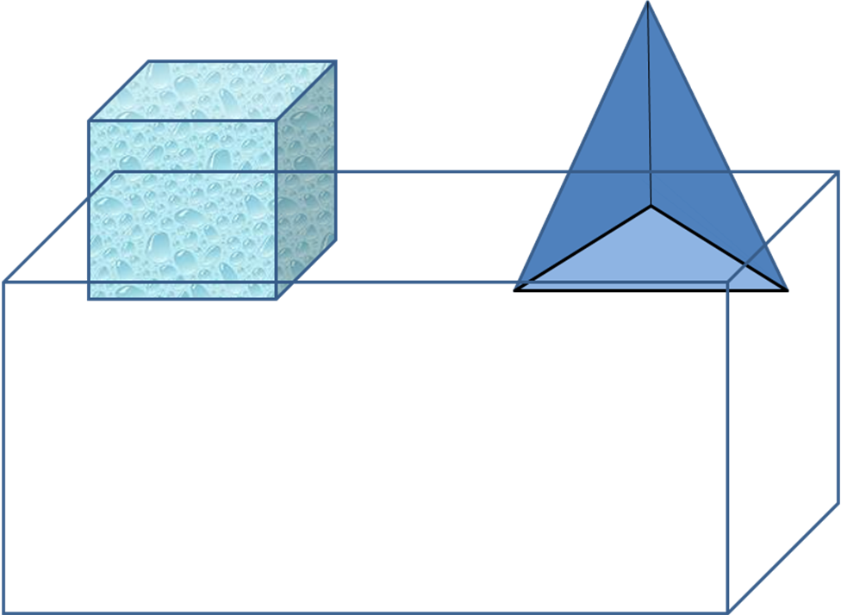
- 3D Spiral
  - This algorithm is from Keith Olson and me. Wikipedia has other cool spirals, must be 3D not just 2D.
  - You must somehow use a spiral in your program.
  - Either create a spiral object or make some object move alone a 3D spiral path.
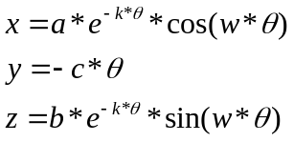
  - a is a constant you define, is like the radius of an ellipse alone the x-axis
  - b is a constant you define, is like the radius of an ellipse alone the z-axis
  - e is known constant
  - k is a constant you define, rate of decay
  - w is another constant, using 1.0 is a simple choice or just remove w
  - 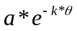is like the radius of an ellipse alone the x-axis only it will decay as theta gets larger
  - 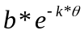is like the radius of an ellipse alone the z-axis only it will decay as theta gets larger
  - 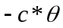will cause the spiral to spiral down the y-axis as theta gets larger.
- Lighting sources are up to you

Initial placement of objects should be as follows:
- Place the two 3D objects behind the pane of glass.
- The pane of glass should obscure part of the 3D objects but not all of the 3D objects.

Animate objects as follows:
- The 2 3D objects must be tumbling in the background is such a manner that parts of the objects are to be obscured by the pane of glass and other time not to be obscured.
- Perturb the surfaces normals to create some type of effect.
- The pane of glass is to change from translucent to opaque and back to translucent.
- The Event
  - Create an obvious visual event which will perturb the orbit of at least one of the 3D objects and cause it to fly into the pane of glass.
- The Glass
  - When the glass is struck by the flying 3D object it must break into at least 3 pieces and fly toward the camera.
- Once your animation is complete start it over again.
  - Just make it run forever…

Hints:
- Use the i2raw program to convert images for texture mapping.
- Don’t worry about true gravity.
- Use i2height and bumpMap.c to map a more interesting bump map from an image onto your surface.
- Try to perform collision detection to determine when the glass is struck.
  - Imagine your flying 3D object surrounded by a sphere.
  - Any object within the radius of the sphere is struck by the 3D object.
Spiral Math

3D Spiral, Dr. Olson and Dr. Welborn creation

2D Wikipedia Spirals

Archimedean spiral
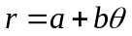
In polar coordinates 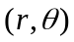
a will turn the spiral
b controls distance between turning
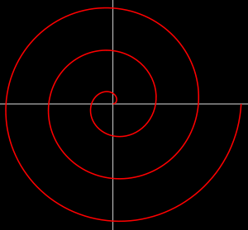

Fermat’s Spiral
In polar coordinates
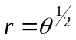
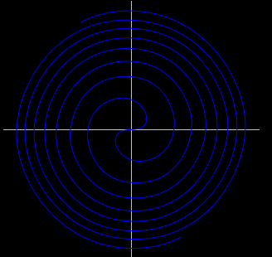

Hyperbolic Spiral
In polar coordinates
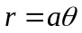
Or in Cartesian coordinates
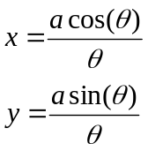
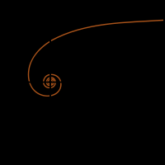

Rhumb line or loxodrome 3D Spiral
Rotated around the z-axis.
See the loxodrome.c program I have provided.

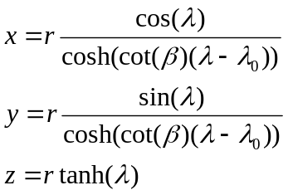
Or
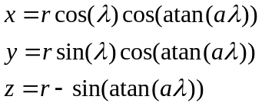
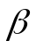 is the constant bearing from true north of true north.
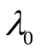 is the longitude where the loxodrome passes the equator.
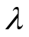is the longitude of the current position of the loxodrome.
is the radius of the sphere which we are inclosing in the loxodrome.
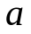is a constant.

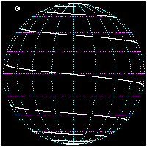

Send me (Curtis.Welborn@uvu.edu) a zip file containing your source, makefile and an executable version of your program before midnight of the due date. The Title of your email should be “3D – Proj3”. The zip must be named <name>_p3v#.zip where name is your first and last name, and # is the version number for your project 0 … 1000.

