**LabVIEW and Data Acquisition**

Ryan Kim

*Department of Mechanical and Aerospace Engineering*

*Rutgers University, Piscataway, New Jersey 08854*

**The objective of this lab is to experience basic computer controlled instrumentation and data acquisition. LabVIEW (Laboratory Virtual Engineering Workbench) is a systems engineering programming software which is used in this lab. There is a DAQ (data acquisition) board that measures a time varying signal and then a thermocouple signal. The data is relayed to the LabVIEW program that is designed according to the signal. This is physically possible because the DAQ board is plugged into a PCI slot on the computer (with NIDAQ board-controlling drivers, operating on Windows 7), and the DAQ board is connected to a BNC terminal block with a 68-pin cable. The BNC terminal block provides terminals to connect the DAQ board to measurement instruments such as a thermocouple probe in order to receive data. In the first part of the experiment, the BNC terminal block outputs signals of adjusted frequencies and magnitudes using its function generator. In order to get accurate waveform plots on LabVIEW, the frequency of the data acquisition should be at least double the sample frequency; this doubled frequency is the Nyquist frequency which is necessary to get the same wave frequency as the sample. Otherwise, there is aliasing which connects the data points in a shape that differs from the true sample waveform. Raising the rate of data acquisition gives more resolution to the waveform, thus forming a more accurate magnitude. Consequently, a sample rate of 10,000 Hz was used to collect data from input signals with frequencies 500, 1000, and 3000 Hz. Afterwards, an input signal of 1000 Hz is received with sampling rates of 500 Hz and 2500 Hz. In the next part of the experiment, room temperature and hand temperature are measured with a thermocouple plugged into the BNC terminal block, and the data is plotted on LabVIEW.**

**INTRODUCTION**

Computer development gives the ability to store and process a huge amount of data and quickly produce analytical calculations. Instrumentation is now controlled with computers, and data acquisition is quick. In this first part of the lab, a BNC terminal block is used for creating wave signals.

|  |
| --- |
|  |
| **Figure 1. BNC Terminal Block. Orange Box around Function Generator. Blue Circle is Thermocouple Input Connector.** |

The BNC terminal block as shown above has a function generator that includes adjustment knobs for amplitude and frequency, a sine/triangle waveform selection switch, and a frequency range selection switch. The wave signals are analog. The DAQ board switches the analog signal to digital for the computer to process it, being an A/D converter, so amplitudes are equated to integers based on the resolution of conversion. To ensure good data, the resolution of acquisition must be high. This means more data samples taken per second, leaving small voltage differences between each voltage measurement; the result is a digital waveform with enough data to represent the analog signal.

With an analog output being converted to a digital input through the DAQ board, the computer directly receives the data. To do this, LabVIEW must be setup. A block diagram is created to control channels on the DAQ board, perform calculations on data, and save it all to a text file.

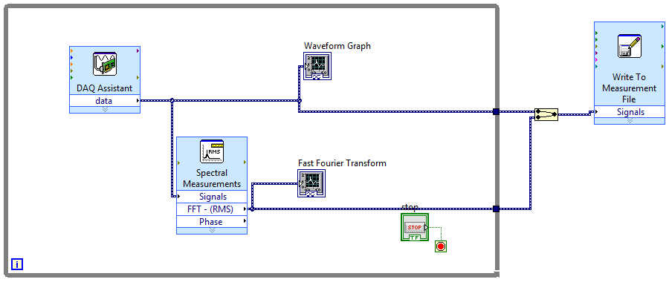

|  |
| --- |
|  |
| **Figure 2. Block Diagram for creating Waveform Graph and Fast Fourier Transform** |

The above waveform acquisition block diagram includes multiple functions connected and represented graphically to work as a system that produces graphs and data lists. The DAQ board’s A/D converted signals enter the while loop (the rectangular boundary) until the Stop button ends the sampling. The DAQ Assistant acquires the voltage measurements, which are plotted over time in the Waveform Graph. The data is also run through a Fast Fourier Transform function which outputs the RMS voltages to be plotted over frequency in the FFT Graph. The FFT Graph displays RMS voltage peaks at the frequencies that a series of sine waves would have if they could superimpose to create the original voltage/time waveform. All data produced leaves the loop when sampling ends, and it is written into a Measurement File.

When plotting a sine wave with the samples recorded, it is important to keep in mind the Nyquist Frequency. This is the sampling frequency that is required to display enough points to create a waveform with the same frequency as the input sine wave. Consider one phase of a sine wave; it has a top peak and a bottom peak. To portray the correct frequency, the data points must include both the upper and lower parts of the sine phase. Otherwise, for example, if only one data point is plotted per sine phase (such as top peak to top peak), there would be no display of a sign wave with the same number of ups and downs. Thus, the displayed waveform would have a frequency that is less than the input sine frequency; this is called an alias frequency. For this reason, the Nyquist Frequency must be at least twice the frequency of the input sine wave to ensure the correct waveform frequency.

*fs* ≥ 2*f*wave [1]

**Eq. [1]. Nyquist Sampling Theorem states that sampling frequency must be at least twice the frequency of the input signal’s wave frequency.**

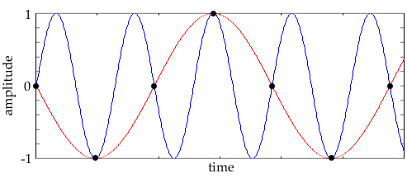

|  |
| --- |
|  |
|  |
| **Figure 3. Signaled sine wave in blue, aliased frequency in red due to inadequate sampling rate** |

|  |
| --- |
|  |
| **Figure 4. Block Diagram for Thermocouple Measurements** |

The next program is designed to measure temperature by acquiring data from a thermocouple (through the BNC terminal block). A plot is created by temperature/time measurements.

Figure 4 shows the block diagram involving the thermocouple. A temperature difference in the thermocouple creates a potential difference which is converted into a digital value for temperature, which is data acquired by the DAQ Assistant. The temperature is directly represented by the thermometer which is a numerical indicator. The same data is converted to dynamic form through the DDT function before entering a Waveform Chart which plots the temperature over time. Time Delay defines the time between samples, and samples and operations stop when the Stop button is pressed and ends the while loop.

**RESULTS AND DISCUSSION**

For the waveform acquisition, the BNC terminal block’s amplitude adjustment knob (on the function generator) is used to output a sine wave on the waveform graph (on the Front Panel) so that the amplitude is approximately ±1. The frequency adjustment knob then sets the sine wave frequency to 500 Hz, 1000 Hz, and then 3000 Hz. This frequency is found by matching the FFT graph’s peaks with the desired wave frequency. Recall that the FFT peaks describe the frequencies of all the sine waves that combine to create the displayed waveform; there is only one sine wave, so a single peak’s frequency is the same frequency of the single sine waveform. This is all done with the DAQ Assistant (on the block diagram) set to take samples at a rate of 10,000 Hz. The following graphs show the sine waves that result from the functions:

**Figure 5. Waveform Graphs. Sample Rate of 10,000 Hz, Sine Input Signal at 500 Hz, 1000 Hz, and 3000 Hz.**

As seen in the graphs, there are a sufficient amount of samples plotted to create the correct frequency in the waveform plot. The sample rate is 10,000 Hz, which is far more than twice the input signal frequencies, so the Nyquist Sampling Frequency criterion is met.

Next are two waveforms created from an input sine wave frequency of 1000 Hz. The sampling rates are 500 Hz and 2500 Hz. Just from this information, it is known that 500 Hz is 0.5 times the input, so that sampling rate is insufficient for creating a sine wave of the same frequency as the input. The sampling rate of 2500 Hz is 2.5 times the input, which is greater than twice the input frequency; this yields an adequately sampled sine wave that matches the frequency of the input.

**Figure 5. Waveform Graphs. Sample Rate of 500 Hz and 2500 Hz, Sine Input Signal at 1000 Hz.**

In Figure 5, the first waveform graph is a straight line that takes a sample for every two input sine phases. Since the frequency of the sine input was determined through an analog control with respect to an FFT graph, there is a bit of error since the peak cannot be exactly matched with the correct 1000 Hz frequency. Therefore, rather than a horizontal straight line from a perfectly constant position on each sine phase, the samples create a slope as the amplitude varies.

The graph below it has a sine wave that matches the frequency but does not keep a constant amplitude. This is because the peaks are not all matched since the sampling is 2.5 times the input rather than 2 (or a multiple of 2) times the input frequency. There are 5 points for every 4 peaks, so 3 peaks are created for every 2 non-peaking points.

On the final waveform graph, the BNC function generator switches from the sine waves to a triangle wave.

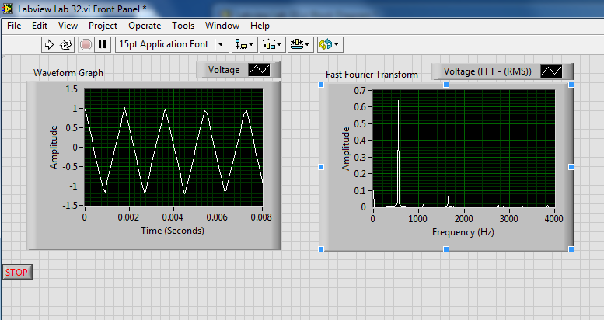

**Figure 6. Triangle Wave manually plotted with data points, followed by the Front Panel view with the Waveform Graph and the FFT Graph.**

As shown in the front panel (the output view of the LabVIEW program), the FFT shows a peak at the triangle wave frequency input. Also, there are 10 times as many samples than necessary to plot the triangle wave with the correct frequency without any aliasing. Again, if the sampling frequency were any less than 2 times the input frequency of 500 Hz, then the triangle wave would not have the correct frequency, nor would it have the same triangle shape.

Finally, using the thermocouple on the BNC terminal block to measure the room temperature and then the temperature between two fingers, the second block diagram is used. There is a time delay of 0.5 seconds for each sample, so the sampling rate is 2 Hz. First, the room temperature is measured for a minute. For the next one, the room temperature is measured for 10 seconds, and then the thermocouple is held between two fingers for 50 seconds. The resulting temperatures are plotted on a Waveform Chart on the Front Panel of the LabVIEW program.

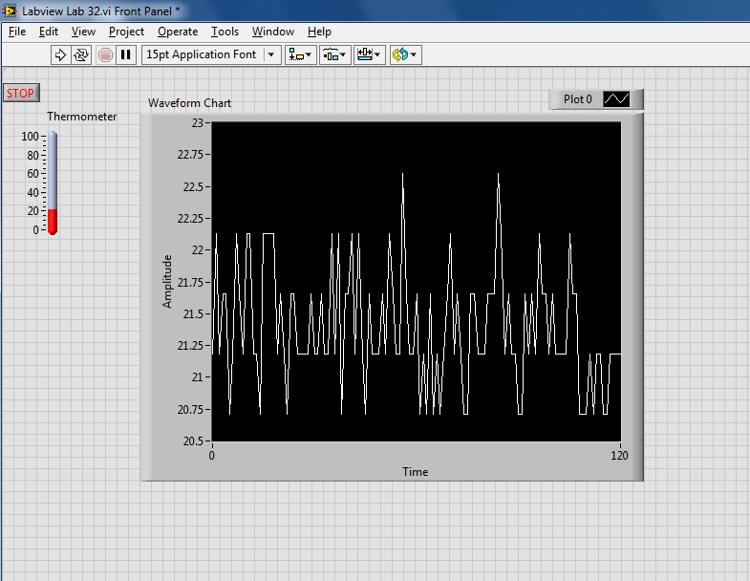

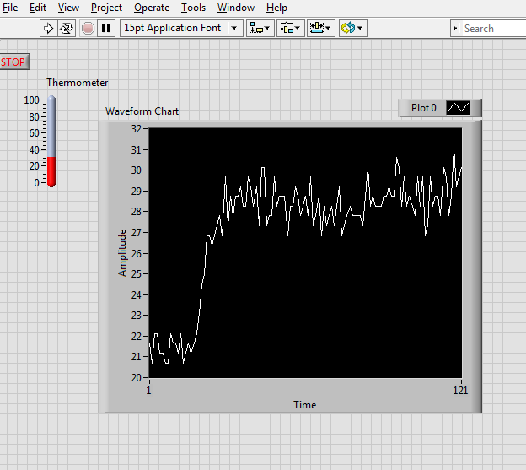

**Figure 7. Room Temperature (top) and Body Temperature (bottom) vs. Time [Celsius/sec]**

In the room temperature measurement, the plotted amplitude is only about ±1ºC. It has fluctuation from a low sampling rate and perhaps slight variance in the thermocouple signals. Maybe moving air causes some convection. For the body temperature measurement, there is about ±2ºC of varying amplitude due to a low sampling rate also. The first 10 seconds is the same as the regular room temperature measurement with the same variance, and then it increases at an almost linear rate until it stays around the same body temperature.

**CONCLUSIONS**

This lab has demonstrated the use of analog-to-digital conversions with a BNC terminal block, utilizing adjustable waveform signals from the function generator and measuring temperatures from the thermocouple connection. This is relayed to the computer (through direct physical connection of hardware) and processed by the LabVIEW programs. The block diagrams made sampling adjustments and visual representations very quick and easily analyzed. The concept of aliased signals and the Nyquist Frequency were visually demonstrated with different input and sampling frequencies. Correct wave frequencies can be matched using Eq. [1], but amplitudes can only be matched by having either a sampling frequency of twice the input (or a multiple of that) or having a very large amount of samples to cover the true shape of the input sine/triangle wave. Also, the temperature measurements had very little variance even with a low sampling rate. LabVIEW makes measurement/graphing easy, and higher sampling rates lead to higher accuracy.

**REFERENCES**

[1] Lab Manual

[2] LabVIEW screenshots/data

[3] Excel plots from data